Packages detail
SH10: 5 Days Private Tour of Shanghai - Suzhou – Hangzhou
Picturesque South China Towns Tour USD1039
An additional fee of $200 will be charged during China's legal holidays and the summer vacation (July and August).

Overview
Trip Highlights：
• Personalized private tour tailored to your own schedule and interests.
• English-speaking private guide, air-conditioned private car with experienced driver.
• Cruise on Huangpu River to see Shanghai's modern vibes and its iconic skyline.
• Appreciate Ming-era aesthetics at the classical Humble Administrator's Garden.
• Boat on the immense West Lake and spot breathtaking sceneries.
• Visit Lingyin Temple and hundreds of Buddha statues carved in mossy rocks.

Included & Excluded
Price Includes
• Private English-speaking guides
• Private drivers & air-conditioned vehicles
• Train fares
• Hotel accommodation with breakfasts
• Entrance fees to tourist sites

Price Excludes
• International airfares
• Entry visa fees
• Personal expenses
• Tips or gratuities for guides and drivers

Itinerary
Day 1 Arrival in Shanghai
Welcome to the magical metropolis, Shanghai! Upon your arrival today, your private guide will meet you outside the customs of the airport and then transfer you to the hotel in downtown with a private air-conditioned vehicle. The rest of the day is free for you. You can either rest in the hotel to recover from jet lag or venture out to explore the neighborhood.
Day 2 Shanghai
Your private Shanghai Suzhou Hangzhou tour will start from the Shanghai Museum. As one of the most prestigious museums in China, it will dazzle you with a vast storage of historical items, including bronzeware, chinaware, jade, Chinese paintings and calligraphy works, and even ethnic minority clothes and furniture of the Ming (1368 - 1644) and Qing (1644 - 1911) dynasties. Continue to Shanghai’s old town to visit the most famous ancient site in Shanghai, the Ming-era Yu Garden. Here, you will see what a typical Jiangnan-style Chinese garden looks and admire its ingenious layout and delicate architecture. Also learn from your guide how to appreciate Chinese rockery art like the treasure of the garden Yu Ling Long (literally “crispy sound of jade”), a curious naturally-eroded limestone considered as one of the three most well-known of its kind in South China. Out of the Yu Garden, you will have some free time to explore the Yuyuan Bazaar.
In the afternoon, you will be transferred to the Bund area to take a one-hour cruise on the Huangpu River to enjoy different iconic scenes on either bank. Look to the west and you will find 52 colonial-era edifices in varied western styles and turn to the east to look up to modern high-rise buildings, including the Oriental Pearl TV Tower, Shanghai World Financial Center, and Shanghai Tower. After disembarking, enjoy some free time to wander around the Bund and take beautiful pictures. Next is Tianzifang, a cultural block with boutiques, art studios and cafes juxtaposing traditional culture with modern creativity, evolved from a Shikumen residential complex that dates back to the 1920s.
► Recommended Dining Option for Dinner (at your own expense):
Try some Shanghai-style noodles to boost your energy after a long day’s trip! We recommend you visit Bless & Harmony Noodles Restaurant (Kunshan Huayuan Road branch), a famous noodle restaurant with a branch that is only a 10-15 minutes’ taxi ride from your hotel. The restaurant specializes in rich and savory locally-flavored noodles, which are accompanied by an abundance of toppings and a separate seaweed soup, providing a noodle experience hardly found elsewhere. It is located in a residential area and frequented by locals. The only minus is that during peak dining hours, you will expect a wait time of around 30 minutes.
Average cost per person: CNY 45 (USD 6)
Address: No.15, Huayuan Road, North Bund Street, Hongkou District
Meals: Western buffet breakfast
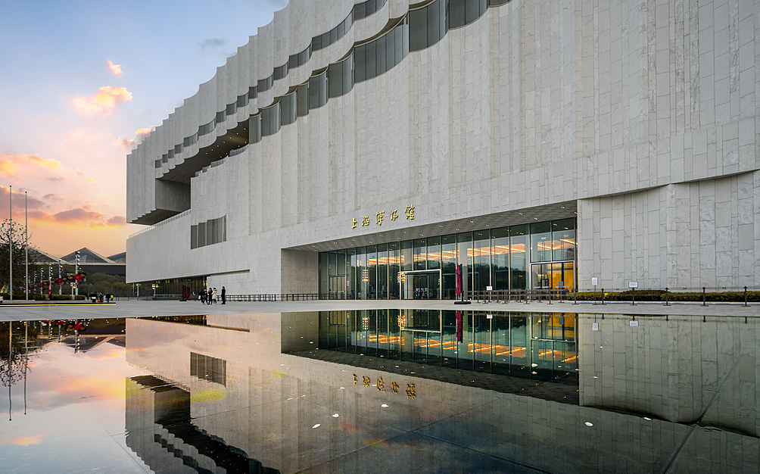
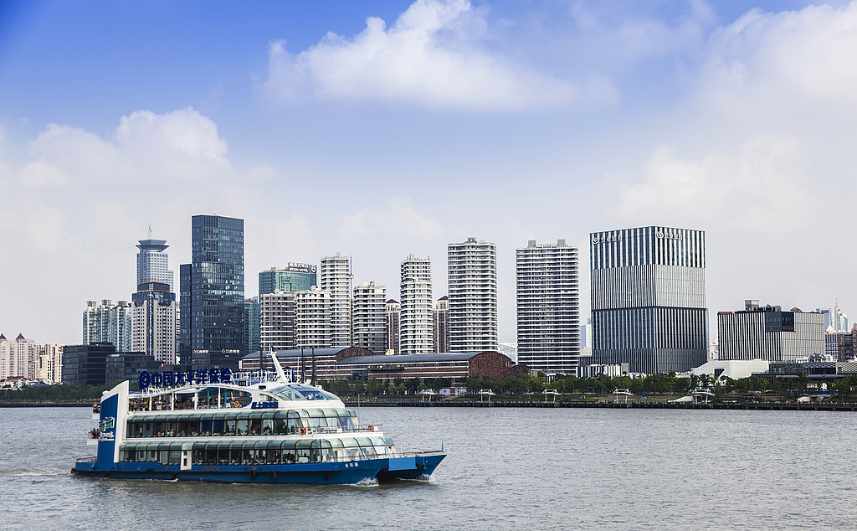
Day 3 Shanghai to Suzhou by High Speed Train
Embark on a one-hour high-speed train ride to Suzhou. On arrival at Suzhou’s railway station, you will be transferred to the hotel. After a short rest, we will take you to the ancient Tongli Water Town. Imagine you walk in a landscape where there are paint-peeling buildings from ancient China, sampans on green canals, arch stone bridges and lively life scenes - this would be your experience of Tongli, whose origins can be traced to the Song Dynasty (960 -1279).
Next is our biggest highlight for today, the Humble Administrator's Garden in the northeast of Suzhou. Like the Yu Garden in Shanghai, it is also a Ming-dynasty heritage but twice larger. Although both represent Jiangnan-style gardens, the former enjoys more original Ming architectural style, while the latter incorporates elements from different eras as it was expanded several times through history. The overall landscape is centered upon water, around which you will visit corridors-connected pavilions and halls and discover fantastic views through perforated windows. Go on a rickshaw ride through Suzhou Old Town. You can keep an eye on the white-walled, grey-tiled low-rise architecture that characterizes the streetscape, which is made all the more charming by dense vegetation. Overnight in Suzhou.
Meals: Western buffet breakfast
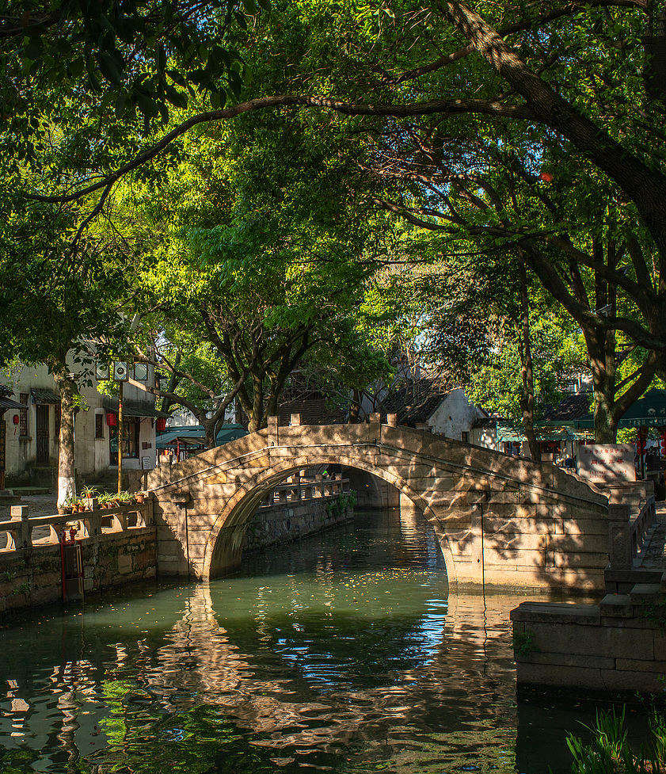
Day 4 Suzhou to Hangzhou by High Speed Train
This morning, jump on a high speed train to Hangzhou. At Hangzhou’s railway station, meet your local guide who will escort you to your hotel. Have a break and you will be taken to the West Lake. To take in the surrounding sceneries celebrated in ancient Chinese poetry throughout history, nothing compares a boat ride, and this is what we have arranged for you. Onboard, enjoy some leisurely time to meditate on the splendid landscape as well as historical sites that dot everywhere. Off the boat and after a few minutes' walk, we will arrive at the Red Carp Pond, one of the most beautiful sites around the West Lake. Small and large red carps here like to swim just below the surface and often you can spot mandarin love ducks roaming above. Everything would be fabulous if you come during lush seasons.
It would be afternoon as we visit Lingyin Temple (Temple of Soul's Retreat), one of the ten most renowned Buddhist temples in China. Perhaps mingle in locals to pray for blessings from the deities, who according to locals can really hear you! Facing the temple is the Peak Flown From Afar (Feilai Peak), which your guide will also take you to see. More than four hundreds of vivid Buddha statues can be found carved into rocks. With moss cover, the whole scene will make you wonder.
► Recommended Dining Option for Dinner (at your own expense):
Tickle your taste buds with local cuisine to make your Hangzhou tour more memorable! You are suggested to dine at Zhao’s Mansion Private Kitchen, which has served Hangzhou cuisine for over 40 years. There is a branch nestled by the Hefang Street, the aged cultural and commercial center of Hangzhou, known for its traditional-style buildings in which many time-honored shops can be found. Braised Dongpo Pork is a local specialty and this restaurant offers the most authentic taste. With a balance of fat and lean meat, the dish is carefully prepared and ensures each bite is rich yet not greasy. It is best enjoyed with rice. Wash them down with Peach Blossom Wine and fill your mouth with a subtle floral sweetness! Later, maybe take a stroll along Hefang Street to soak in in local life.
Average cost per person: CNY 60 (USD 8)
Address: No.111, Gaoyin Street, Shangcheng District
Meals: Western buffet breakfast
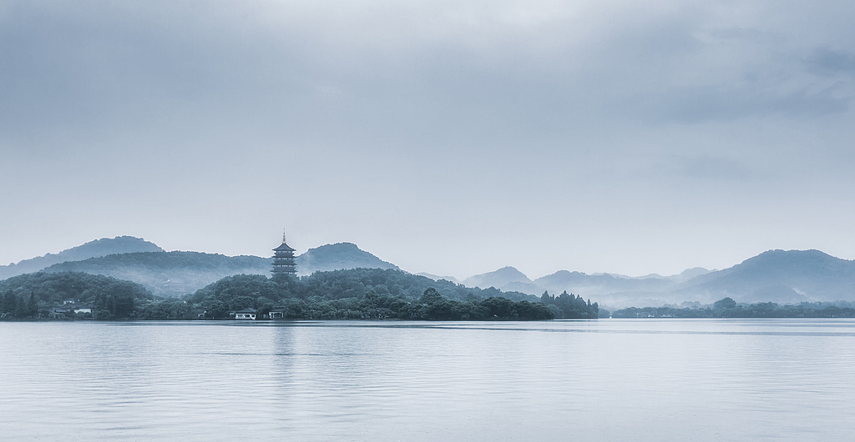
Day 5 Departure from Hangzhou
The tour will end as the guide and driver transfer you to the airport or railway station according to your following plan. Bon Voyage! If you want to see more of China, just feel free to contact us to extend your tour.
Meals: Western buffet breakfast
