Packages detail
One Day Shanghai Highlights Tour, No Shopping
USD249（A minimum order of 2 people is required）

Overview
Shanghai Museum - Yu Garden - Yuyuan Market - The Bund - Huangpu River Cruise - Nanjing Road

Included & Excluded
Price Includes
• Private English-speaking guide
• Private driver & air-conditioned vehicle
• Entrance fees to tourist sites

Price Excludes
• Hotel accommodation with breakfasts
• Lunches and dinners
• Tips or gratuities for guide and driver

Itinerary
Our private guide and driver will meet you in your hotel at around 09:00 in the morning, and then transfer you to Shanghai Museum to start today’s Shanghai day tour.

- Shanghai Museum
Our private guide and driver will meet you in your hotel at around 09:00 in the morning, and then transfer you to Shanghai Museum to start today’s Shanghai day tour.

This museum, covering an area of 40,000 square meters (47,840 square yards), is a huge treasure house of ancient Chinese art. It has 12 themed showrooms displaying over 120,000 exquisite exhibits, including varied bronze wares, ceramics, calligraphy works, jade wares, and paintings. You will have enough time to explore these fantastic collections. Among them, the most valuable treasure is Da Ke Ding, an ancient Chinese bronze ding vessel, once used as ritual ware in the Shang and Zhou dynasties (1600 - 256 BC). Through its inscriptions, visitors can learn about the etiquette, land system and slavery 3,000 years ago.
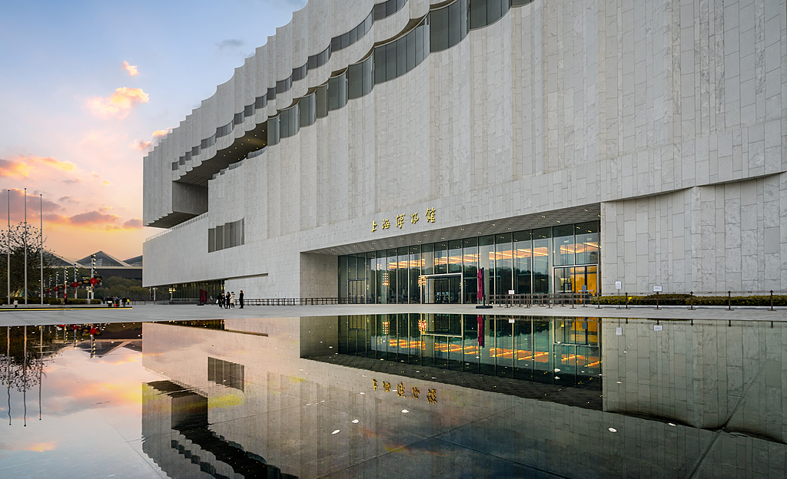
2. Yu Garden
After that, your guide will accompany you to visit the Yu Garden, with a history of about 400 years. Occupying an area of over 20,000 square meters (24,000 square yards), the Yu Garden was once a private garden owned by a court official. It was considered a jewel of the classical gardens along the southern Yangtze River. The buildings in the architectural style of the Ming and Qing dynasties (1368 - 1911 AD) are worthy of close appreciation. Here you will also see the clear ponds, magnificent rockeries and lush plants harmoniously blend together, which creates a natural atmosphere throughout the garden.
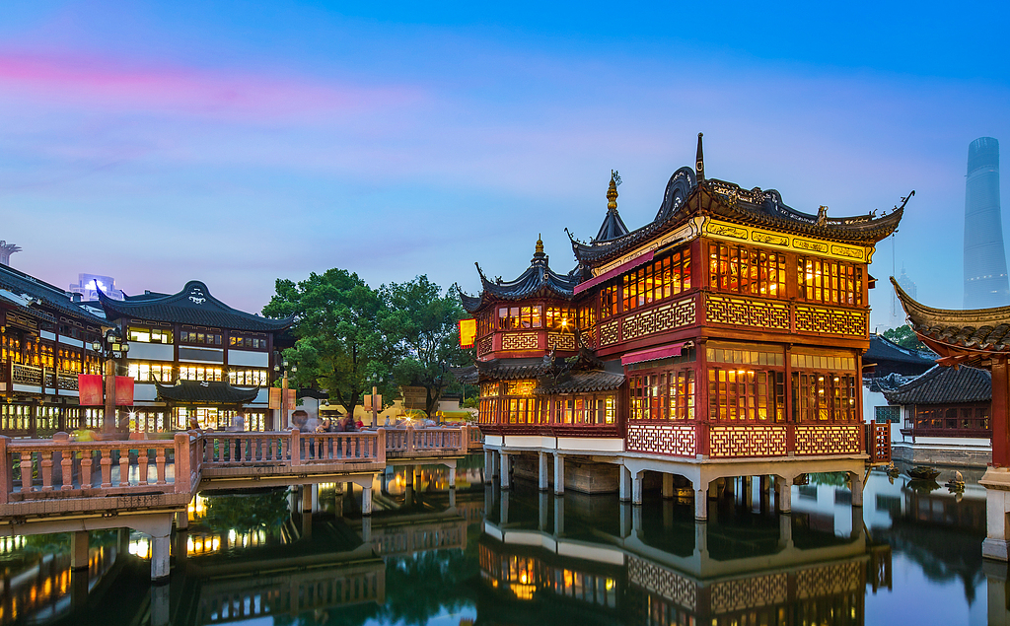
3. Yuyuan Bazaar
Leaving the garden, you will come to the nearby Yuyuan Bazaar, a place that blends history and art, tradition and modernity, where you can also have lunch at your own expense. Your guide will be glad to offer some dining suggestions. The most famous snack here is Soup Dumpling, a kind of steamed stuffed soupy bun. It has a thin wrapper and rich fillings with juicy broth. Be careful when you bite into it since the tasty hot soup may ooze out.

4. The Bund
In the afternoon, we will continue the visit to the Bund, where you can capture the essence of both old and modern Shanghai. The Bund, about 1.5 kilometers (0.9 miles) long, is known for dozens of distinctive buildings in different styles and the charming view of the Huangpu River. To the west of the Bund, you will see a total of 52 exotic and classic buildings, which have earned the Bund the title of International Architecture Exhibition. To the east of the Bund, you will see the amazing Huangpu River. Across the river is the most prosperous Pudong area, where stands the Oriental Pearl TV Tower, Jinmao Tower and many other high-rise buildings.
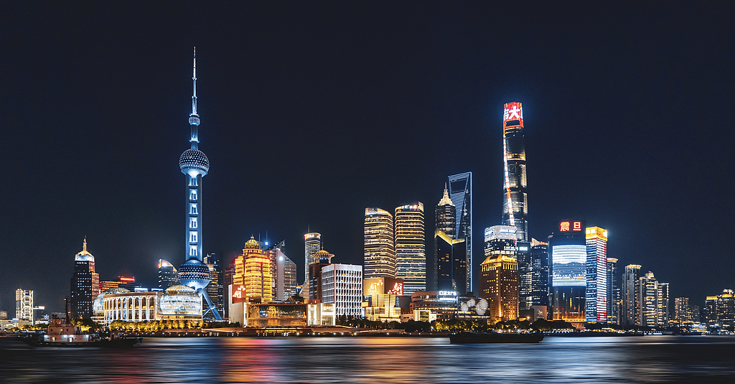
5. Huangpu River cruise tour
From there you will take a one-hour Huangpu River cruise tour. Cruising on the river will provide you with a superb experience of viewing the Bund, enjoying the beauty of the river and taking marvelous photos of the high-rise architectural complex of Pudong from a different perspective.
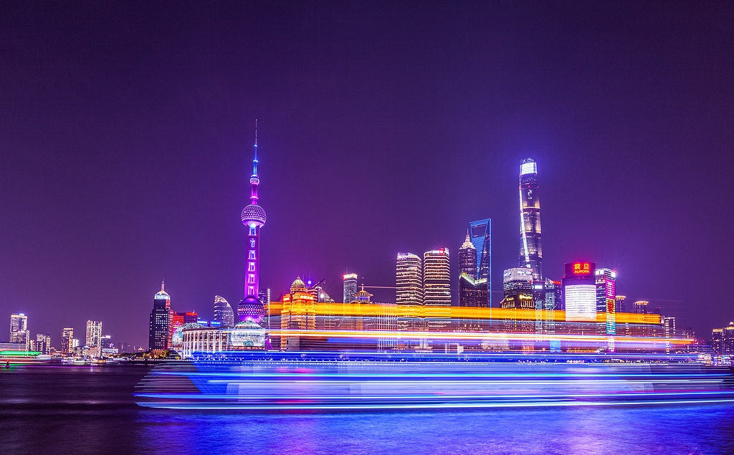

6. Nanjing Road
Finally, we will pay a visit to the famous Nanjing Road to fully experience the city's prosperity and jolly atmosphere.

This Shanghai 1 day tour will end here, and we will escort you back to the hotel. We sincerely hope that you have had an exhilarating day!
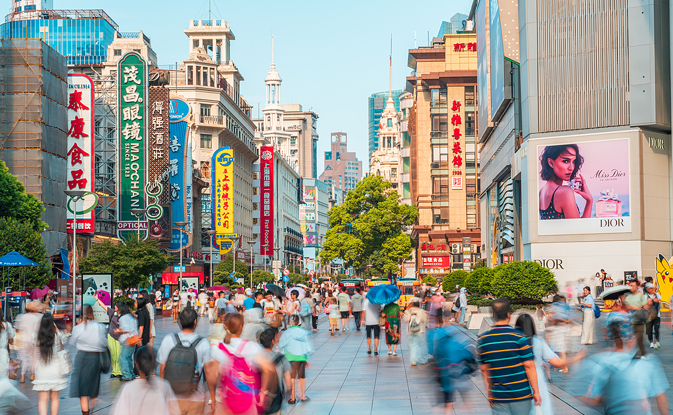
Dinner Recommendation (at your own expense)
For noodle enthusiasts, don’t hesitate to visit Yuxingji Noodles Restaurant, a century-old brand with origins tracing back to the Qing Dynasty (1644 - 1911). It was first established in Suzhou and for the high popularity it has expanded in recent years to have branches in several nearby cities like Hangzhou and Shanghai. You must try its signature Crab Roe Noodles, a dish ordered almost by every table. Many patrons would travel for hours from other cities just to enjoy a bowl, which further demonstrates this is a culinary experience found nowhere else. The ambiance may interest you as well, as it reflects traditional Jiangnan style with architecture emphasizing on delicate beauty.
Average cost per person: CNY 100 / USD 14
Address: No. 830 Weihai Road, Jing'an District

Want to have some luxury dining experience? Do drop by Shanghai Hengshan Moller Villa Hotel, around 15 minutes’ drive from Nanjing Road. If you are interested in history and want to find something different from the typical downtown, you may try a dinner to taste classy Chinese flavors here. This villa was built in 1936 by a merchant as a private house, featuring a three-story Norwegian castle-like style. Enjoying dinner here, you will feel like a step back in time because of its classical features.
Average cost per person here is CNY 350 / USD 49 or so.

Note: If you want to enjoy a big dinner at Moller Villa Hotel, we are glad to make a dinner reservation for you and escort you there after the trip. If you prefer a dinner around Nanjing Road by yourself and enjoy night views of the Bund, we may leave you free time and you can get back to hotel by taxi. The schedule is flexible to adjust and please contact your travel consultant for arrangements.

