Packages detail
3 Days Private Shanghai & Water Town TourUSD599（A minimum order of 2 people is required）

Overview
Trip Highlights
• Personalized private tour tailored to your own schedule and interests.
• English-speaking private guide, air-conditioned private car with experienced driver.
• Glide on the Huangpu River by ferry to see Shanghai’s modern landscape unscroll and mingle with locals.
• Appreciate 52 grand European colonial architectures at the Bund.
• Explore a picturesque ancient water town of your own choice, Tongli, Zhouzhuang or Xitang.
• Enjoy a nostalgic stroll in the meticulously-designed Yu Garden, a classical Southern China garden.

Included & Excluded
Price Includes
• Private English-speaking guide
• Private driver & air-conditioned vehicle
• Hotel accommodation with western buffet breakfasts
• Entrance fees to tourist sites
Price Excludes
• International airfares
• Lunches and dinners
• Entry visa fees
• Gratuities to guide and driver

Itinerary
Day 1 Arrive in Shanghai; Enjoy the Panoramic View of Shanghai, Visit the Bund
Welcome to Shanghai! Your English-speaking private guide will warmly greet you at the airport, and then the 3-day Shanghai tour will begin. We can also arrange private pick-up from the port or the railway station if you need.
Our first stop today is the world’s highest bookstore, Duo Yun Bookstore, on the 52nd floor of China’s tallest building - Shanghai Tower, where you will enjoy a stunning panoramic view of the city and Huangpu River. You can have a drink here and leisurely enjoy the city’s outstanding skyline, including famous buildings like Shanghai World Financial Center, Jinmao Tower and Oriental Pearl TV Tower.
After that, take a short walk at the Bund and then enjoy a one-hour cruise on the Huangpu River. For your information, your cruise will both start from and end at 16th Pier, past dozens of landmarks including Oriental Pearl TV Tower and Garden Bridge of Shanghai. You might have heard the tower for its futuristic design and iconic status, but the latter? Get your camera ready, because you are going to greet China’s first all-steel bridge, which was constructed in 1908.
As the most popular landmark of Shanghai, the Bund is a section of the waterfront along the Huangpu River, known as the World Exhibition of Architecture with 52 buildings in different styles, like Gothic and Baroque. Besides, the Bund is a good place to take photos of Lujiazui, the most prosperous area in Shanghai. After your leisurely waterfront stroll, a comfortable drive will take you to the hotel in downtown location.
► Where to Explore the Nightlife of Shanghai
As a glamorous city full of diversity, Shanghai’s nightlife is fascinating, lively and colorful. If you are interested, after your trip, we can transfer you to some popular bars in Shanghai, like M1NT with sharks in front of the dancing floor, or VUE Bar on the top of Hyatt at the Bund Hotel, where you can get great views of both sides of the Huangpu River. If you would like to be dropped off at a bar, you will need to get back to the hotel by taxi.
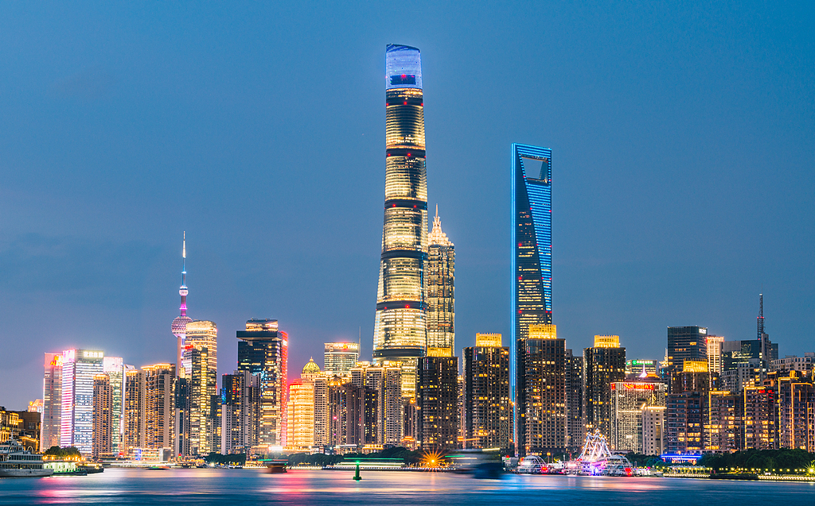
Day 2 Shanghai to Tongli Water Town
Today, we will drive out of Shanghai for around 1.5 hours to the "Venice of the Orient", Tongli Water Town, with a history of over 1,000 years. It features various styles of stone bridges, old waterfront residential houses as well as bucolic canals. Surrounded by water, this photogenic town is divided into 7 islands by 15 rivers, and linked by 49 ancient bridges. Escorted by our private tour guide, you can walk around the ancient town and experience its unique charms.
It will be an unforgettable experience to take a boat ride and see the local people going about their daily lives from a different view. The brown wooden sculling boats shuttle down the water lanes, which once were the main means of transportation for local people to transplant rice, harvest, as well as dig river silt. Nowadays, the boats are used for tourism only, which brings benefits to local people.
Wandering around the town, you may see local residents washing vegetables and clothes by the river. The white-haired old lady, sitting on a cane chair, knits a sweater in the tender sunshine. The old man lights the stove for cooking. The artist plays traditional musical instrument Erhu beside the stone bridge. They still maintain their traditional way of life, which reflects the core of Chinese traditional culture, harmony and peacefulness.
► There are many famous water towns around Shanghai. You also have the flexibility to choose either of the following two towns without any extra charge.
Zhouzhuang Water Town: Though known as the No. 1 Water Town in China, Zhouzhuang is also the most crowded and commercialized. It features the profound culture. The ancient buildings like Shen House, Milou Tower and Chengxu Taoist Temple enjoy very high historical and cultural value.
Xitang Water Town: The most distinctive feature of Xitang is the “Rain Corridor”. In ancient times, every family would put up a ceiling over the flagstone road in front of their own houses, and then the ceilings connected to form the corridor.
Meals: Western buffet breakfast
► Dinner Suggestion (at your own expense):
On your way back to the hotel in downtown, you can ask your driver to drop you off at the Michelin-recommended restaurant Virtue & Thrive Restaurant (Guangdong Road main branch). When it comes to authentic Shanghai cuisine, it tops the must-visit list. Established as early as 1878, the brand can be said as the mother of local cuisine. It has two stories: the first floor is dedicated to noodle dishes, while the second floor allows for a la carte ordering. Serving delicious tastes at affordable prices, the restaurant is attracting a steady stream of diners every day. You must try its Fresh Meat Mooncake, a local specialty, priced at just CNY 6 or USD 0.8 each!
Average cost per person: CNY 60 (USD 8)
Address: No.471, Guangdong Road, Nanjing East Street, Huangpu District
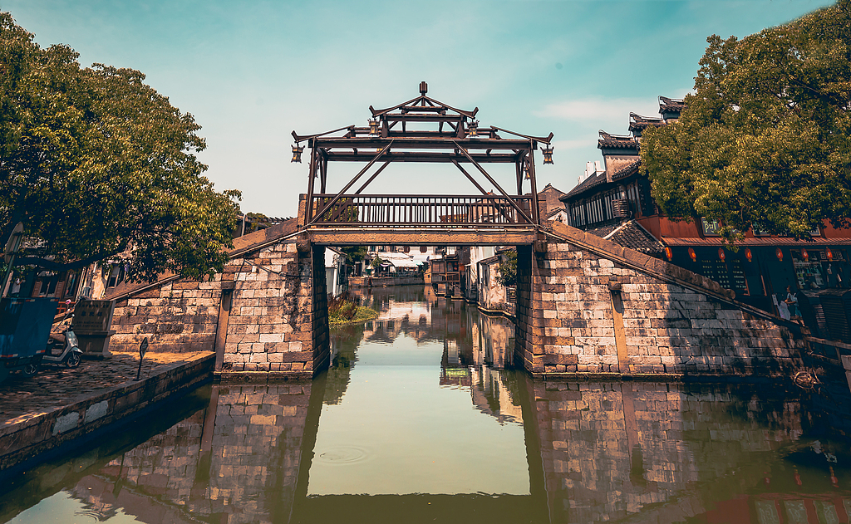
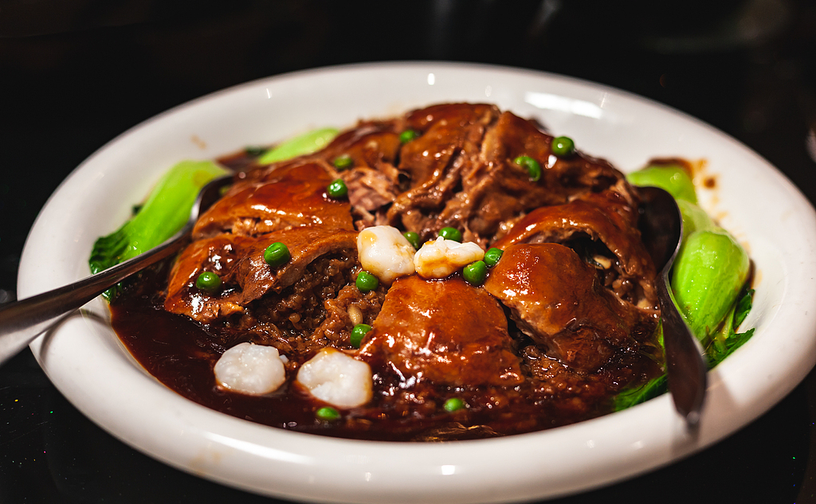
Day 3 Visit Shanghai Urban Planning Exhibition Hall, Yu Garden & Tianzifang; Airport See-off
After checking out from hotel, your guide and driver will meet you at 09:00. First, we’ll visit the Shanghai Urban Planning Exhibition Hall, where you can clearly see how the city was planned, constructed and how it will be developed through the pictures, models, touch screens as well as multimedia. You will finally have a deep and comprehensive understanding of how a little village transferred to an international metropolis.
Getting out of the Exhibition Hall, we will go to the Yu Garden, a classical garden initially built by an official to satisfy his parents over 400 years ago. The Dragon Wall, the Nine-Turning Bridge and a pavilion in the middle of the pond make up the highlights of this garden.
In the afternoon, we will continue our visit to Tianzifang Old Block, a typical residential area of Shanghai Shikumen architectural style. With nearly 100 years of history, it is a perfect place to enjoy a relaxing stroll, and the street is lined with small shops and bars. You can have a drink while experiencing the living environment of local residents who still live here.
Upon completion of the trip, your guide and driver will transfer you to the airport and help you board the flight back home. We can also transfer you to the port or the railway station if you need. Wish you a pleasant onward journey!
Meals: Western buffet breakfast
