Packages detail
11 Days Small Group Tour of Beijing - Xi'an - Guilin - Yangshuo - Guilin – Shanghai

China Delights USD1859
An additional fee of $200 will be charged during China's legal holidays and the summer vacation (July and August).

Overview
Tour Type: Small Group of max 18, guaranteed departures
Guide: Professional English-speaking tour guide in each city
Transportation: Spacious air-conditioned coach with experienced driver
Accommodation: 10 nights at good 5-star hotels
Trip Highlights
• Must-see sights in China - Mutianyu Great Wall, Forbidden City, Terracotta Army.
• Take a Li River cruise down to Yangshuo & admire essence of Guilin landscape.
• View the soaring city skyline and feel the pulse of modern Shanghai.
• Enjoy a la carte meals, Acrobatic Show & Tang Dynasty Music and Dance Show.

Included & Excluded
Price Includes
• Domestic airfares
• Hotel accommodation with breakfasts
• A la carte lunches as itinerary specifies
• Professional English-speaking guides
• Drivers & air-conditioned vehicles
• Entrance fees to tourist sites
• Tips or gratuities for hotel porters

Price Excludes
• International airfares
• Entry Visa fees
• Personal expenses
• Tips or gratuities for guides and drivers

Itinerary
Day 1 Arrival in Beijing
Welcome to join our tour to discover the true essence of China! After reclaiming your luggage at Beijing airport, you will be met by your guide outside customs, who will be holding a sign with your name on it. You will then be escorted to your hotel. Now some free time for you to rest and recover from the plane ride.
Accommodation: Hotel New Otani Chang Fu Gong
Day 2 Beijing
At 08:30, a 30-minute tour briefing will be given in the hotel lobby and you will meet your traveling companions. Your guide will introduce the tour briefly and share some guidelines and tips for travelling in a group. You are welcome to ask any questions regarding the trip.
Your first stop today is Tiananmen Square, from where you will walk to the Forbidden City, one of the largest imperial palace complex in the world. Travelers are always impressed by its grand architecture featuring high red walls and golden roofs. Constructed during early Ming Dynasty (1368 to 1644 AD), this was the home of 24 emperors. There are many secrets about the place that contribute to its enigmatic vibes, like its capability of surviving 200 plus earthquakes intact through over 600 years of history. Follow your guide to take a look at roofs of the palaces, and you will find out a key to solve the mystery lies in those flexible joints used to connect small wooden strips to build the roofs. The main gist is to digest the whole kinetic energy and thus neutralize the impact of earthquakes. An example is the roof of Hall of Supreme Harmony, the emperors’ throne hall, where you can find tens of thousands of those wooden strips.
★ We offer a special visit to the Treasury Gallery
A main feature about the Forbidden City would be its trove of priceless antiques. Today, we will have a special tour in the Treasury Gallery at the northeastern corner, where you get to witness the most luxury side of the imperial life from those historical relics on display.
★ A la carte welcome lunch is served with Peking Duck
You will enjoy an a la carte welcome lunch (valued at CNY150.00 per person and included in our price) at a carefully-selected restaurant that is popular even among locals. You get to taste some authentic Chinese foods, including Peking Roast Duck, a world-famous Beijing specialty and the restaurant’s signature dishes. The cook will carve the duck in front of you and teach you how to eat the slices. Hope you will enjoy!
In the afternoon, you will visit the Temple of Heaven, where the emperors of the Ming and Qing dynasties worshipped the Gods of Heaven. Tonight, you will be entertained by the exciting Chinese Acrobatic Show at the Red Theater, which will draw a perfect period of the day tour. After appreciating the show, we will drive you back to hotel.
Meals: Western buffet breakfast, A la carte welcome lunch
Accommodation: Hotel New Otani Chang Fu Gong
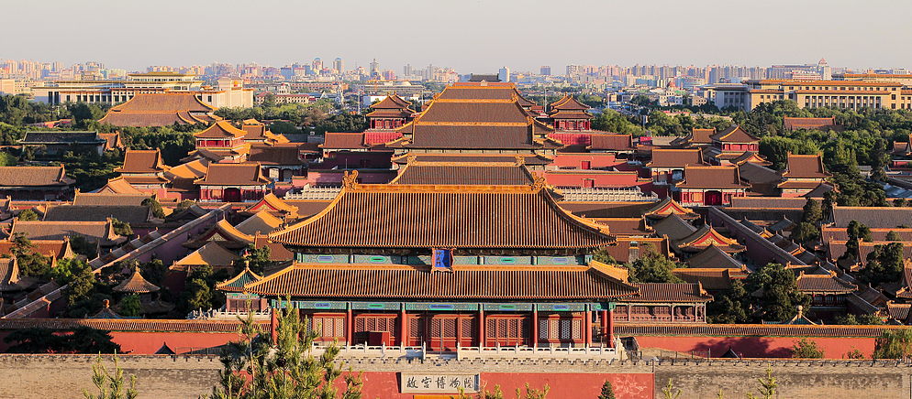
Day 3 Beijing
You might want to have a big breakfast at the hotel and prepare some snacks to provide you with energy, as you will spend much time on the Mutianyu Great Wall. It is the most splendid and one of the best preserved sections of the Great Wall of China, and less crowded if you compare it with its alternative, the Badaling section. You can take a round-trip cable car ride up and down from the wall with assistance of your guide. After getting down, your guide will invite you to drink a toast to your adventure with red wine.
► A warm reminder: At the Great Wall area, there are many peddlers selling souvenirs, but we suggest you just ignore them if you have no interest in their goods, otherwise they may persist in talking to you.
In the afternoon, we will go back downtown and drive by the National Stadium, or Bird’s Nest, for you to take pictures as mementos of this grand sports venue and a landmark of Beijing.
Then we will take you to enjoy a classic Hutong rickshaw tour, which allows you to experience the traditional Hutong alleys of Beijing and its old culture. Through the narrow winding lanes of Hutongs, you get to have a glimpse into the locals' daily life. Then your tour here will culminate with a visit to a family in one of the courtyard houses lined on both sides of the alleys. Afterwards, we will drive you back to hotel.
Meals: Western buffet breakfast
Accommodation: Hotel New Otani Chang Fu Gong
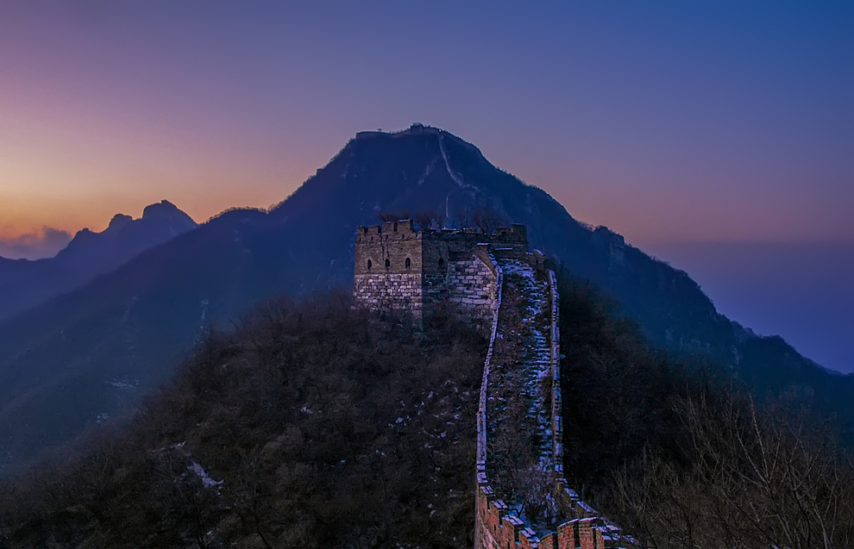
Day 4 Beijing to Xi'an by Flight
Before heading for the next city, you will get the opportunity to visit adorable gifts the nature bestowed up on us - giant pandas, in Panda Hall, Beijing Zoo. Then we will go to the Summer Palace, to take in the elegant landscape the largest imperial garden in China has to offer.
After having some local food for lunch, you will take a flight to the ancient city of Xi'an. Upon arrival, you will be driven to your hotel. Your guide will help you with the check-in procedure and introduce the hotel layout to you so that you will have a pleasant and enjoyable stay.
Meals: Western buffet breakfast, Lunch
Accommodation: Crowne Plaza Xi'an
Day 5 Xi'an
Today you will be driven to the suburb area to marvel at the spectacle of the Terracotta Army for the whole morning. Dubbed as the eighth wonder of the world, it is certainly one of the highlights of your 11 days China tour package. Witness a great army made of terracotta or bronze serving the afterlife of Emperor Qin Shi Huang (259 – 210 BC), the first emperor in China’s history. About these terracotta figures, one thing that never fails to capture everyone’s attention is their enigmatic lifelike details - take a close look to notice they all have single-edged eyelids, which were perhaps crafted so to make the whole army more formidable or less cute. Now, at a newly-set permanent exhibition hall, you can examine the details right in front of each warrior preserved within glass cases, among 230 collections, many of which have never been shown to the world before! All the relics are the most valuable and representative archaeological finds ever excavated, and how they are arranged to demonstrate in-depth Emperor Qin’s daily life and Qin people’s craftsmanship will blow your mind. With your guide, wonder at and gain more insights through the lately-introduced bronze cranes, colored figures, and gold and silver artifacts.
What makes us different:
1. Pay a visit to the discoverer of the first terracotta warrior
We will arrange a special family visit for you to the home of Mr. Yang Zhifa, the discoverer of the very first terracotta warrior. The hoe and the cart that he used to dig and carry the warrior are still well preserved and can be examined in his house. Have a short talk with him or his family, and get to know how this surprising discovery changed their life.
2. Make your own miniature warrior and take it home
Making a terracotta warrior figure was quite complicated and time-consuming in Qin Dynasty. You will come to a local workshop to hear the detailed procedure from a local traditional artisan. Then, you will have a unique experience of making your own mini warrior figure under his help. It takes around 40 minutes and, with the help of molds, would be not that difficult. Of course, you can take your cute masterpiece home to memorize this special moment.
Continue your exploration to the Giant Wild Goose Pagoda, a renowned Buddhist temple built in the Tang Dynasty (618–907 AD) missioned to introduce Buddhism. But the real use may go beyond that. The pagoda is also called the Da Ci’en Pagoda, which Ci’en in Chinese means the kindness of the loving mother, so its founding reflects Tang Emperor Gaozong’s memory of his deceased mother when he was still the crown prince. With your guide, you will delve into other imperial stories of the temple. During dinner time, you will be invited to a theater to enjoy a traditional dumpling dinner and a splendid Tang Dynasty Music and Dance Show.
The trip for today reaches its end. Now we will drive you back to your hotel.
Travel Tip: Guests visiting in Jan, Feb, Mar and Dec need to arrange dinner and evening activities on your own for today, since the theater is usually unavailable during these periods.
Meals: Western buffet breakfast, Dumpling dinner
Accommodation: Crowne Plaza Xi'an
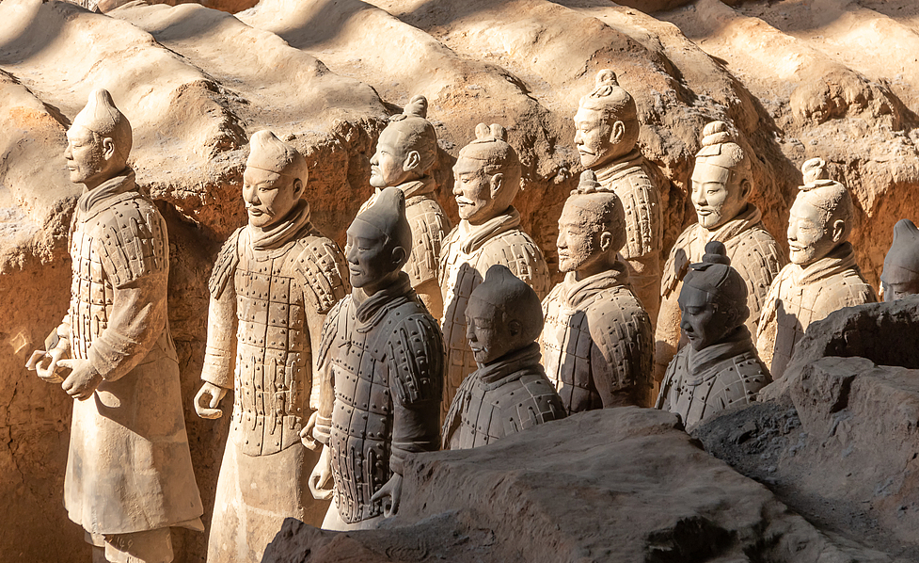
Day 6 Xi'an
After breakfast, we will first head to the City Wall Park, a popular venue for local people to relax and take part in various activities. It is the best place to experience the daily life of the locals. We also arrange a Tai Chi exercise – a meditative type pf Chinese traditional martial arts that aims to nurture both body and mind - for you in the park. You will learn some basic moves with the master. After that, we will visit the ancient City Wall, where you can take a leisurely walk or rent a bike to ride on the wall. Please note the bike rental fee is at your expense.
Around noon, we will treat you to some local food at Muslim Quarter at a well-known restaurant. The quarter, or rather, a bazaar, is the liveliest snack street of its genre in China where you can pick up souvenirs and taste local cuisine. Here you will find various local snacks or flavors, like sweet steamed rice, green bean cake, persimmon cake, rice cake, etc. It is indeed a heaven for foodies.
Then, let’s go further deep into the bustling area, to visit the Great Mosque, a tranquil mosque complex featuring classical Chinese garden architecture. Afterwards, visit Shaanxi History Museum, known as the pearl of Xi'an and the treasury of China for storing and exhibiting historical relics unearthed from this land, where the capital of thirteen ancient dynasties of China is located. If the Shaanxi History Museum is not available, alternatively, the famous Forest of Stone Steles Museum will be arranged instead.
After the visits, we will drive you back to hotel. Have some fun private time during your last day staying in Xi’an.
Meals: Western buffet breakfast, Local flavor lunch
Accommodation: Crowne Plaza Xi'an

Day 7 Xi'an to Guilin by Flight
This morning, your guide and driver will escort you to the airport for a flight to Guilin. Upon arrival, you will meet your local guide at Guilin airport. A driver will then take you to hotel. After the hotel check-in and a short rest, you will have a half day sightseeing trip in the Reed Flute Cave and around the Elephant Trunk Hill, cult destinations that draw the world’s attention for their breathtaking beauty. As the sun sets, we will take you back to your hotel.
Meals: Western buffet breakfast
Accommodation: Sheraton Guilin Hotel
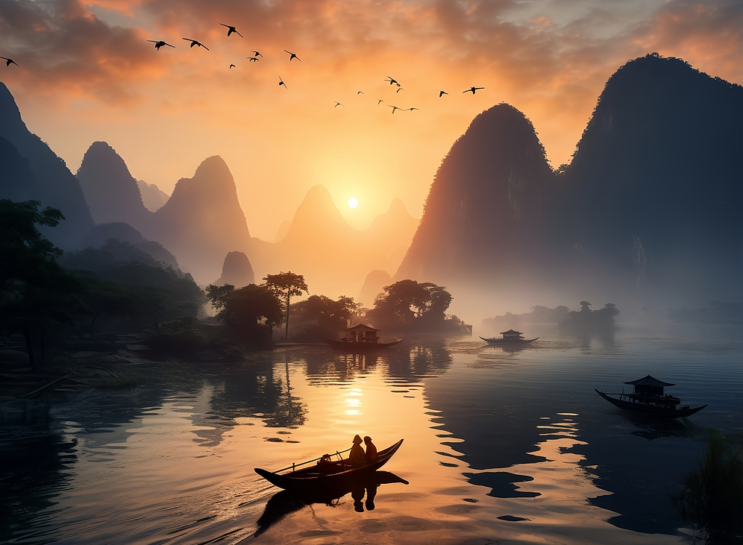
Day 8 Guilin - Yangshuo - Guilin
Enduring memories are created as you cruise down the Li River to Yangshuo County. Views around Li River are the essence of landscape in this area, especially the section from downtown Guilin to Yangshuo, which is reputed as 'A Hundred Mile Gallery'. Immerse yourself in the picturesque scenery along the river, and in the tranquility leave all your cares behind. The cruise ship will arrive at Yangshuo in about 4.5 hours. Disembark and then have a tour around the famous West Street. After that, you will be driven to the countryside of Yangshuo to soak up the amazing rural scenery.
★ Special visit to a local family in the countryside
Your trip in the countryside of Yangshuo will be enriched by a visit to a local villager's home, where you will see many scenes that can only be experienced in some old Chinese movies. You get to visit a courtyard with moss covered floor, a kitchen in which people still burn wood to cook, and rooms with Chinese style antique furniture. This is the best chance for you to learn about real rural life of China. You will be welcomed to ask whatever questions you like by the family members.
After your tour for today, you will be driven back to Guilin.
Meals: Western buffet breakfast, Lunch
Accommodation: Sheraton Guilin Hotel
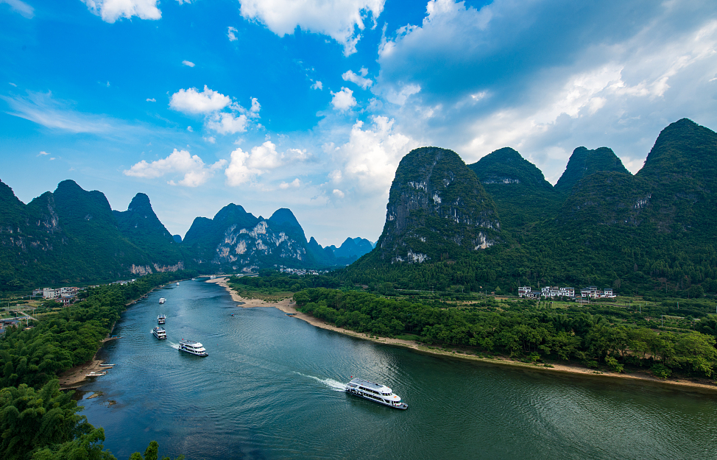
Day 9 Guilin to Shanghai by Flight
This morning we will transfer you to Guilin airport for your flight to Shanghai, the last stop of your China tour. Upon arrival, you will find your local guide waiting for you outside the baggage claim area of the airport to take you to the hotel. The remainder of the day is left free for you.
► Activity Suggestion:
Your hotel in Shanghai, the Radisson Blu Hotel New World, is ideally located in the city center, just steps away from historic People’s Square and world famous Nanjing Road. About 1200 meters (0.7 miles) long, this prosperous pedestrian street is lined with malls, stores, restaurants, and cafes, satisfying all your shopping needs and local food hunting. Especially at night, when neon lights are on, the view is amazing here with a taste of old Shanghai. So just walk out from your hotel, you will experience vibrant atmosphere of this international metropolis.
Meals: Western buffet breakfast
Accommodation: Radisson Blu Hotel Shanghai New World
Day 10 Shanghai
Today's trip will start from Shanghai Museum which specializes in ancient art works of China, especially bronze ware, ceramics, calligraphic works and paintings. Later, take a trip to the Yu Garden and its nearby bustling bazaar featuring ancient Chinese architecture. As a private garden that is over 400 years old, Yu Garden embodies the architecture and design of classical Chinese gardens.
Around noon, enjoy an a la carte farewell lunch of authentic Shanghai cuisine (valued at CNY150.00 per person and included in our price) at a well reputed restaurant.
In the afternoon, you will be guided to the Bund and have a one-hour cruise tour along the Huangpu River. Enjoy some free time on the Bund. Finally, your guide and driver will escort you back to the hotel and say goodbye.
Meals: Western buffet breakfast, A la carte farewell lunch
Accommodation: Radisson Blu Hotel Shanghai New World
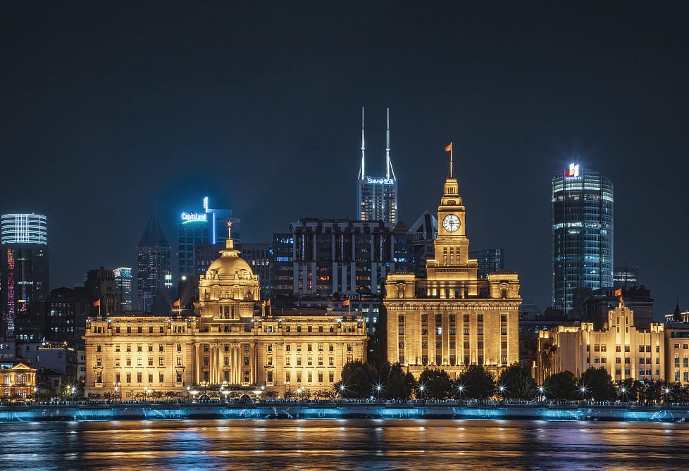
Day 11 Departure from Shanghai
Please check out from hotel before 12:00 pm and arrange your own transfer to the airport. Please verify which airport your flight will depart from before you leave, as there are two airports in Shanghai: Pudong International Airport (PVG) and Hongqiao Airport (SHA). Both destinations can be reached by the Metro Line 2 just outside your hotel. If you prefer to take a taxi, we kindly suggest you reserve one with the hotel bell desk beforehand to save time. Wish you a nice trip home!
Also if you wish to stay on in China, please contact your travel consultant about an extension tour, and we shall be pleased to arrange it for you.
Meals: Western buffet breakfast
