Packages detail
14 Days Small Group Tour of Beijing - Xi'an - Guilin - Chongqing - Yangtze River Cruise - Yichang – Shanghai
Classic China with Yangtze Cruise USD2499

Overview
Tour Type: Small Group of max 18, guaranteed departures
Guide: Professional English-speaking tour guide in each city
Transportation: Spacious air-conditioned coach with experienced driver
Accommodation: 10 nights at good 5-star hotels, 3 nights on Yangtze River cruise
Trip Highlights：
• Must-see sights in China - Mutianyu Great Wall, Forbidden City, Terracotta Army.
• Fantastic cruise tour on the Li River from Guilin to rural Yangshuo.
• Unwind with a Yangtze River cruise tour and see the Three Gorges.
• Enjoy a la carte meals, Acrobatic Show & Tang Dynasty Music and Dance Show.

Included & Excluded
Price Includes
• Domestic airfares & train fares
• Hotel accommodation with breakfasts
• A la carte lunches as itinerary specifies
• Professional English-speaking guides
• Drivers & air-conditioned vehicles
• Entrance fees to tourist sites
• Yangtze River cruise with full board
• The service charge recruited by the cruise company
• Tips or gratuities for hotel porters

Price Excludes
• International airfares
• Entry Visa fees
• Personal expenses
• Tips or gratuities for guides and drivers

Itinerary
Day 1 Arrival in Beijing
When you arrive in Beijing today, your two weeks China group tour officially begins. Claim your luggage, clear customs, and you will find your guide waiting for you with a welcome sign bearing your name at the airport arrival hall. The driver will then escort you to your hotel and help you register for three nights. The rest of the day is free time for your own use.
Accommodation: Hotel New Otani Chang Fu Gong
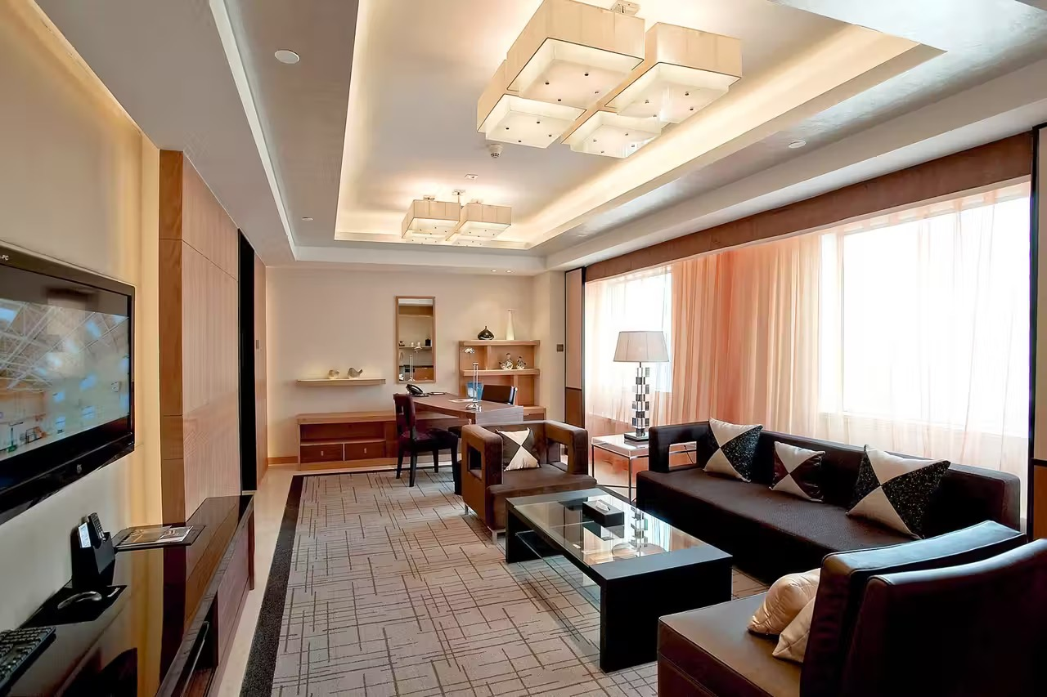
Day 2 Beijing
Your Beijing group tour now kicks off. The guide will host a short pre-trip meeting in your hotel lobby this morning after breakfast. This includes a briefing and preparations for your trip. The group travel guidelines and tips will also be shared. After that, your tour will begin with a visit to Tiananmen Square and the Forbidden City.
We will stroll all the way from city square until we reach the entrance of the Forbidden City, where Chinese emperors of Ming and Qing dynasties (1368 – 1911 AD) once lived and worked. Now, its trove of countless imperial treasures has made it a museum to exhibit the royal luxury before common eyes. Today, we will take a side tour to the Treasure Gallery to witness the most precious relics left by Chinese imperial ancestors. An interesting fact about this place is that, the real life of emperors seemed to be the opposite of their material extravagancy. Like Emperor Yongzheng (1678 – 1735 AD), who devoted himself to country management and was said to die of overwork.
★ Enjoy an a la carte welcome lunch with Peking Duck
A welcome lunch will be served at a celebrated restaurant with an a la carte menu (valued at CNY150.00 per person and included in our price). You will taste authentic Beijing food, including the ever popular Peking Roast Duck. Normally, it takes 2 hours to roast an already air-dried duck, but our guide will arrange it for you ahead of time. So, just enjoy it the moment you sit at the table!
Your will spend your afternoon in the Temple of Heaven, a majestic altar complex for Ming and Qing emperors to offer sacrifices to Heaven and pray for good harvests. The sight will lend insight into the traditional spiritual world of Chinese people. The highlight of the evening will be a brilliant Chinese Acrobatic Show presented at the Red Theater.
This is our itinerary for today. We will take you back after the performance finishes.
Meals: Western buffet breakfast, A la carte welcome lunch
Accommodation: Hotel New Otani Chang Fu Gong
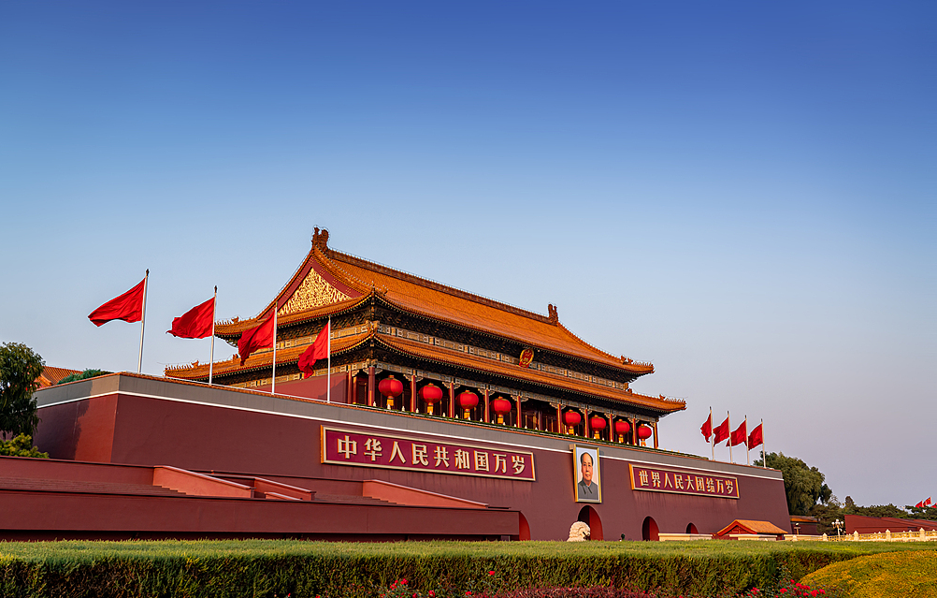
Day 3 Beijing
Today you are going to hike on a Wonder of the World - the Great Wall of China. We will drive from downtown Beijing to visit the Great Wall at Mutianyu, sung as the most picturesque among all the sections. A round-trip cable car ride will be arranged for you to tour the Wall. After getting down, your guide will arrange for you to clink glasses with red wine and drink a toast to your visit to this engineering feat!
After lunch, we will go back downtown and drive by the National Stadium, widely-known as the Bird’s Nest, a landmark of Beijing used for national and international track-and-field competitions like the Beijing Olympic Games in 2008.
A Hutong tour by rickshaw and a visit to a local family will be followed. Hutongs are alleys or backstreets with both sides lined with courtyard houses - a traditional way of living for Beijing people, where multiple generations of an extended family live together. Today, you get to step into a courtyard, talk with locals, observe its layout, and learn the cultural connotations behind it. You will discover another side of this metropolis. After that, we will drive back to hotel.
Meals: Western buffet breakfast
Accommodation: Hotel New Otani Chang Fu Gong
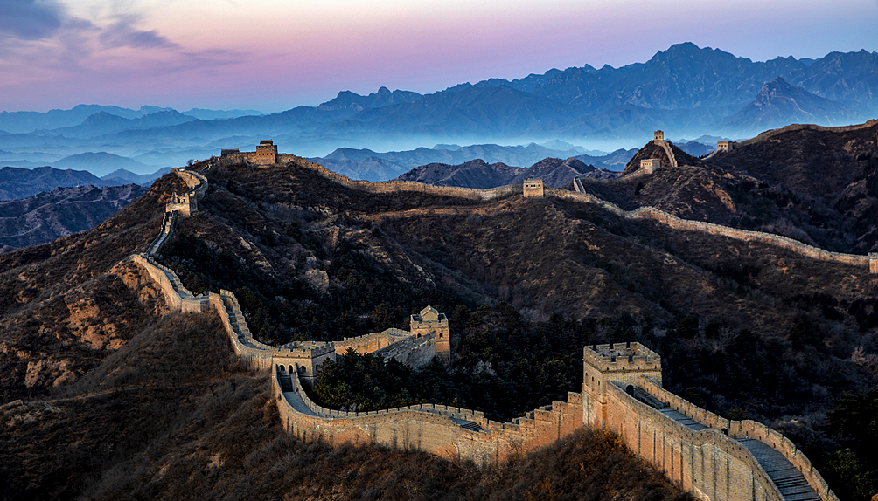
Day 4 Beijing to Xi'an by Flight
Today, you are going to watch adorable pandas at one of their homes on earth – Panda Hall of Beijing Zoo. We are leaving this morning, when giant pandas are most active during the day. About pandas there is an intriguing fact - they only weigh around 100 grams when they are born, the equivalent of two eggs. Why an adult could be bizarrely 900 times bigger remains a puzzle for scientists.
Then you will have the rest of the morning spent in the Summer Palace, an imperial garden which includes famous Longevity Hill and Kunming Lake. Its design embodies the solemnity and grace of a royal garden that incorporates the joy of nature and is a monument to classical Chinese architecture.
Enjoy a lunch featuring local flavors, and you will be off to the next destination of your two-week China tour - Xi'an. Our local guide will greet you at the airport and transfer you to the hotel for a three-night stay.
Meals: Western buffet breakfast, Lunch
Accommodation: Crowne Plaza Xi'an
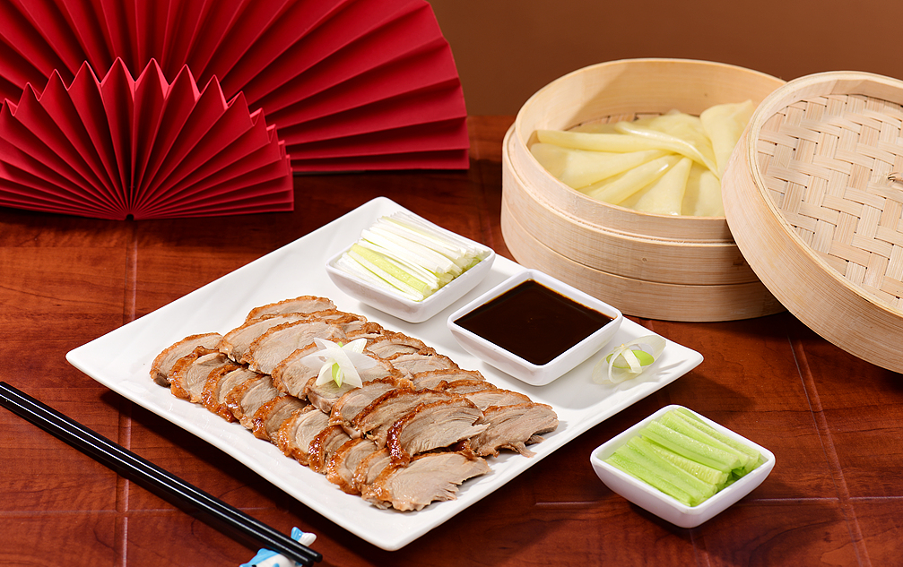
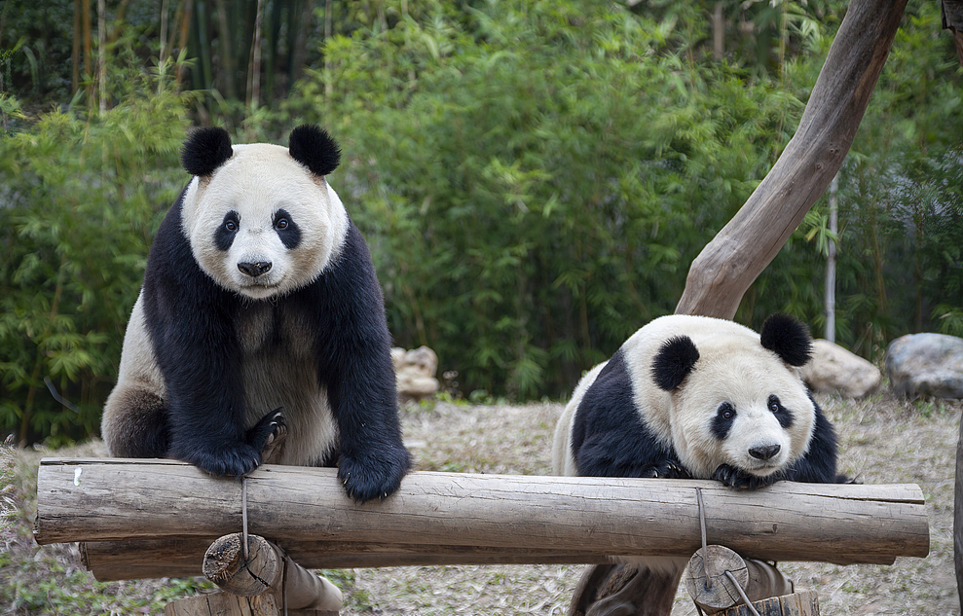
Day 5 Xi'an
In the early morning, be escorted to the Terracotta Army and enjoy an astounding moment before life-sized terracotta warriors, which serve as funeral objects, assembled in thousands to protect the tomb of Emperor Qin Shi Huang (259 – 210 BC) of Qin Dynasty (211 – 206 BC), the first Emperor in China’s history. This enigmatic site is drawing people from all over the world - there was even an incident years ago where a German, so fascinated by the Qin culture, intruded into an excavated pit and disguised himself as a warrior just to fulfill his childhood dream of standing among real terracotta warriors.
★ Privilege of Our Guests:
1. Many people have seen terracotta warriors and horses, but few know and meet the first discoverer of it. By taking this tour, you will have a special opportunity to visit the home of Mr. Yang Zhifa, the first discoverer of this world’s wonder. Spend a few minutes talking with him or his families about this great discovery.
2. Imagine you are an artisan, making your own terracotta warriors in 21st century... Today, you are going to make your mini versions of warriors in a local workshop, and use the same kind of clay that was used 2,000 years ago. With the help of a local expert, you can get your handmade warrior done within 40 minutes.
The rest of your afternoon will be spent touring the Giant Wild Goose Pagoda – the most famous pagoda in Xi’an that witnessed the unprecedented cultural diversity of Tang Dynasty (618–907 AD). There are also many statements about the real reason for the construction of the Da Ci’en Temple, the pagoda’s nest. Some say that Emperor Gaozong Li Zhi built it to commemorate his dead mother, some say that it originated from a political show after he was elected crown prince, some say that he built it to relieve his father Li Shimin's pain over the loss of his empress, and some say that it is actually Li Shimin built it to pay tribute to his dead wife, but in the name of his son. After listening to the vivid explanation of your guide, which one are you more inclined to believe? After that, a splendid evening is also in store. You will be entertained by the Tang Dynasty Music and Dance Show over a great Chinese dumpling dinner. You will be escorted back after the show.
Travel Tip: Since the theater for the show and dumpling dinner is usually not open in Jan, Feb, Mar and Dec, we will not arrange the activities for tours during these periods.
Meals: Western buffet breakfast, Dumpling dinner
Accommodation: Crowne Plaza Xi'an
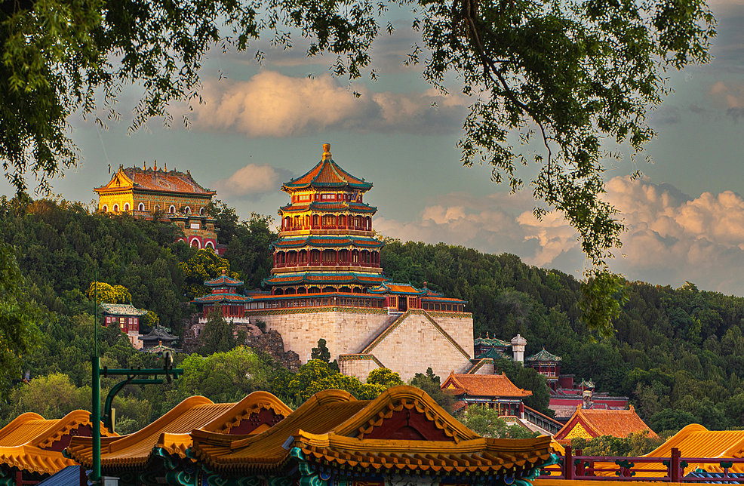
Day 6 Xi'an
Traveling is not just for sightseeing. It is also a journey to experience life and explore different cultures. Today's tour will begin with a leisurely walk in the City Wall Park, which encircles the center of Xi’an. It is where you may see locals do exercises, dance, play instruments, play ping-pong or just spend their leisure time chatting. You can even join them for fun, just as our previous guests do! We will also invite a Tai Chi Master to teach you some basic moves of Tai Chi Quan, a symbol of Chinese traditional culture in the form of martial arts that integrates mediation, which is still practiced across China as a common physical exercise.
Afterwards, you will ascend the well-preserved ancient City Wall to appreciate the panorama of the city of Xi’an. Perhaps you also want to take a cycle ride on the wall for a special experience - please note that the bike rental fee is at your expense.
During lunch time, we will take you to taste local dishes at the Muslim Quarter, the liveliest snack street in China where you will find Islamic customs, intertwining alleyways, and countless Muslim snack stalls. Then continue to spend some hours in the tranquil Great Mosque, which features classical Chinese architecture. Out from the mosque, we will head for one of the most renowned museums in China – Shaanxi History Museum or the Forest of Stone Steles Museum. Today’s trip now reaches its end, and we will give you a ride to your hotel.
Meals: Western buffet breakfast, Local flavor lunch
Accommodation: Crowne Plaza Xi'an
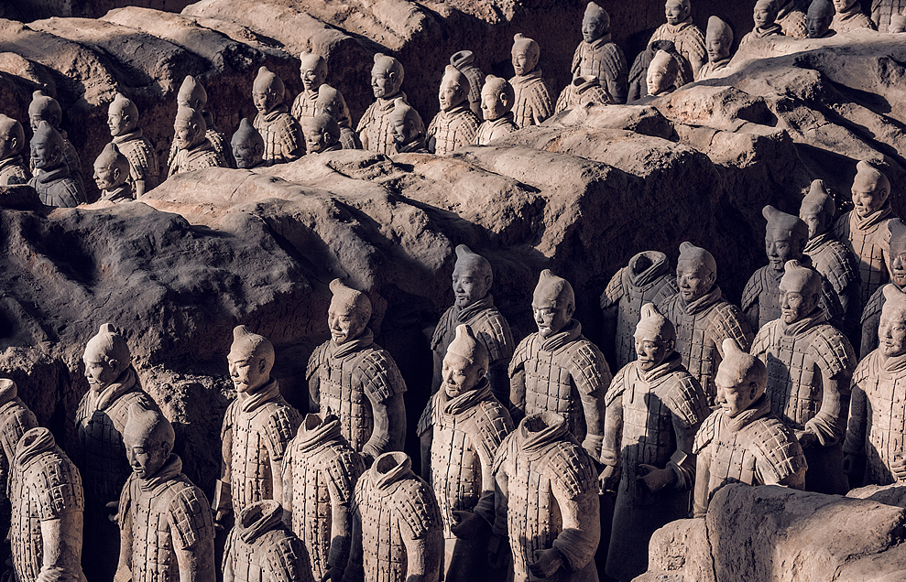
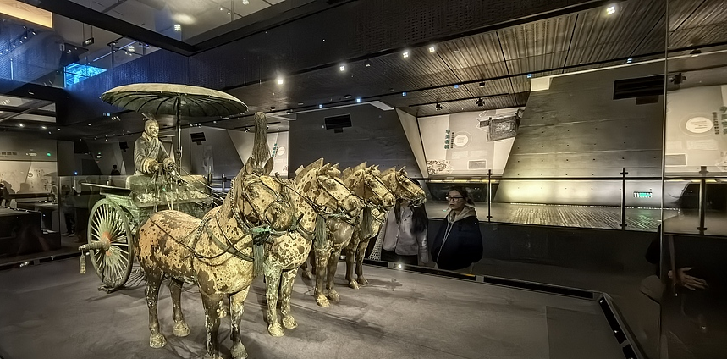
Day 7 Xi'an to Guilin by Flight
Today, you will board a flight to Guilin. Upon your arrival, your local guide will pick you up at the airport and transfer you to your hotel for a two-night stay. Have a break, and then you will visit Reed Flute Cave and Elephant Trunk Hill - the picturesque landmarks of Guilin City.
Meals: Western buffet breakfast
Accommodation: Sheraton Guilin Hotel
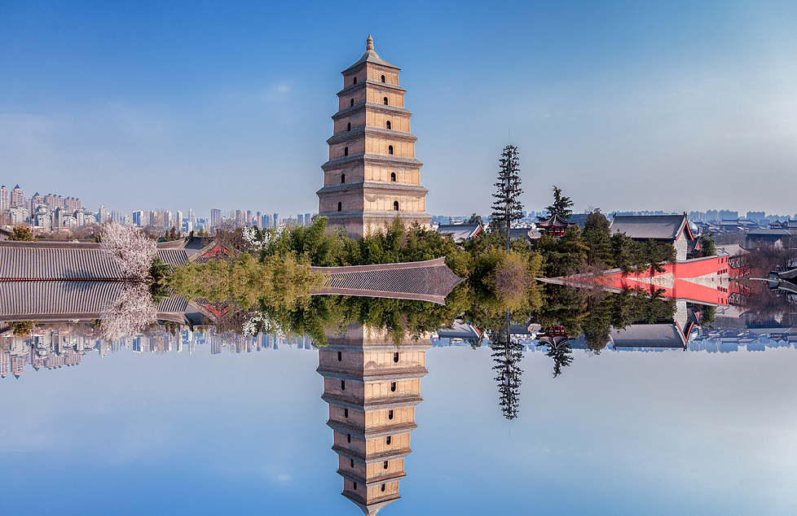

Day 8 Guilin - Yangshuo - Guilin
Today will be one of the unforgettable experiences as you cruise down the beautiful Li River from Guilin to Yangshuo County. The river, with its serene sparkling water, is the essence of the city's landscape and known as the "Hundred Mile Gallery". After cruising about 4.5 hours and docking at Yangshuo, you will walk through the well-known West Street. Then you get to enjoy amazing rural scenery as we drive along the country roads of Yangshuo. En route, you will be invited to visit a villager's home. Finally, we will transfer you back to Guilin.
Travel Tip: The cruise company offers a box lunch of Chinese food onboard. It’s a simple one but it provides enough calories for your next hours’ cruise. You can also prepare for it with a generous breakfast at the hotel.
Meals: Western buffet breakfast, Lunch
Accommodation: Sheraton Guilin Hotel
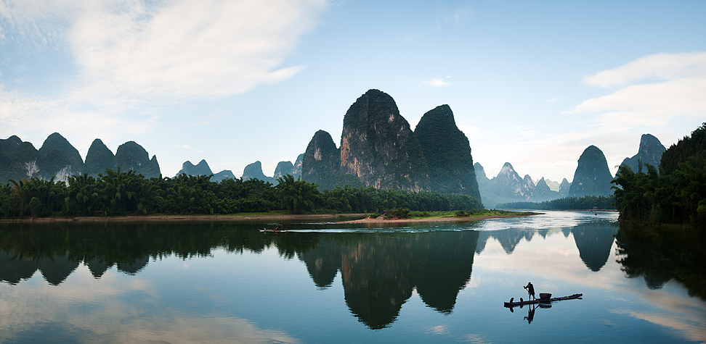
Day 9 Guilin to Chongqing by High Speed Train
Take a morning high-speed train for around 5 hours to Chongqing. The train has a dining carriage where meals are sold at certain times. Also snacks, soft drinks and bottled water can be bought from a cart on the train.
Upon arrival, you will be met and then escorted to board the Century Oasis cruise ship for a three-night stay. After some rest in your private cabin, you will have an exclusive exquisite buffet dinner and be welcomed by a wine party at the invitation of the Captain. The ship sets sail at 22:00. Your relaxing Yangtze cruise journey is about to begin!
★ You will enjoy one of the most luxurious cruises on Yangtze River!
Century Oasis, a member of Century Cruises fleet, is carefully selected after field studies to provide you with luxurious 5-star services during your two-day tour on Yangtze River. As it was newly-built and launched in recent years, it has advanced amenities just as top-rated as any other services. The themed meals on each day, accompanied with free alcoholic drinks and night snacks are what make the ship we select stand out from others.
Meals: Western buffet breakfast and dinner
Cruises: Century Oasis
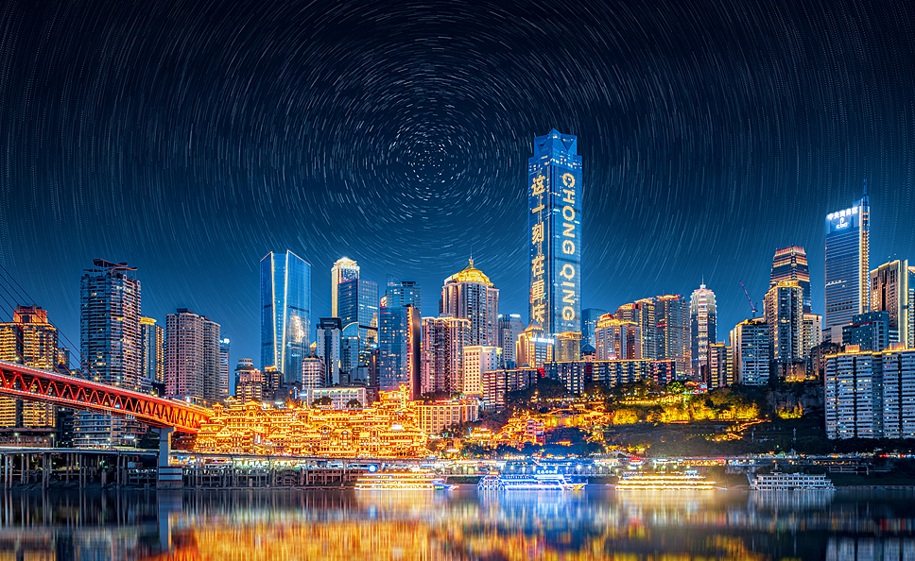
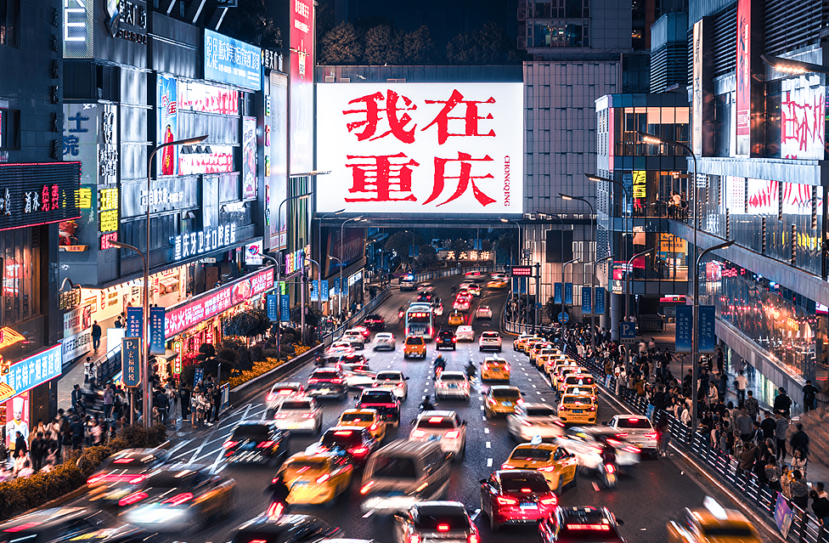
Day 10 Yangtze River Cruise
This morning, before cruising all the way down, we will first come ashore for a visit to the Ghost City in Fengdu County, a palace complex where you get to see what the underworld in Chinese folklores looks like. You get to pass the Guimen Guan, or Gate of Hell, and many attractions ahead to learn about Chinese ghost stories.
You will spend your afternoon onboard participating in activities scheduled by the cruise company. A lecture about the Three Gorges will be given to familiarize you with the site. You can also fly kite, watch cruise staff perform their skills, etc. You will eat buffets for all your meals today and tomorrow, and taste night snacks if you want to.
Meals: Full board served in buffet style
Cruises: Century Oasis
Day 11 Yangtze River Cruise
Today the ship will sail through the splendid Three Gorges. The first is the Qutang Gorge, which is only eight kilometers long but encompasses the most precipitous parts of the gorges. Then the ship will sail into the beautiful Wu Gorge. An excursion between two to three hours long along its tributary, the Shennv Stream, by sampan is arranged for you today. Afterwards, the ship will continue to sail into heavily-shoaled Xiling Gorge.
Take your time to eat a buffet dinner, and end today by enjoying artistic performances that are prepared for you.
Meals: Full board served in buffet style
Cruises: Century Oasis
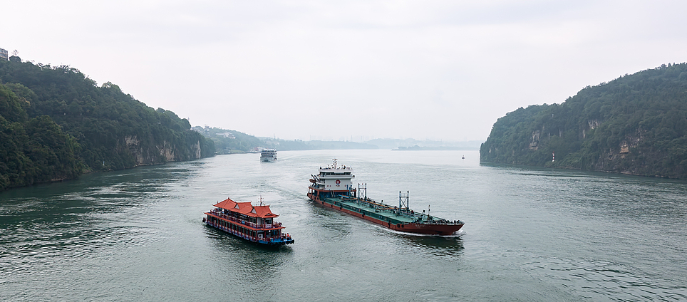
Day 12 Yichang to Shanghai by High Speed Train
This morning, disembark from the ship and we will have an onshore excursion to visit the stunning Three Gorges Dam site, a world-renowned engineering feat built for flood control. Before that, please remember to pack your luggage and check out.
After finishing the excursion, the cruise ship company will drive you to the Three Gorges Tourist Center in Yichang City. Our local guide will meet you there and escort you to the railway station for a high speed train ride to Shanghai. It will be a 7.5-hour ride, so you might want to prepare in advance some snacks, fruits or some books to entertain yourself. Upon your arrival, our guide in Shanghai will greet you and transfer you to your hotel.
Meals: Western buffet breakfast
Accommodation: Radisson Blu Hotel Shanghai New World
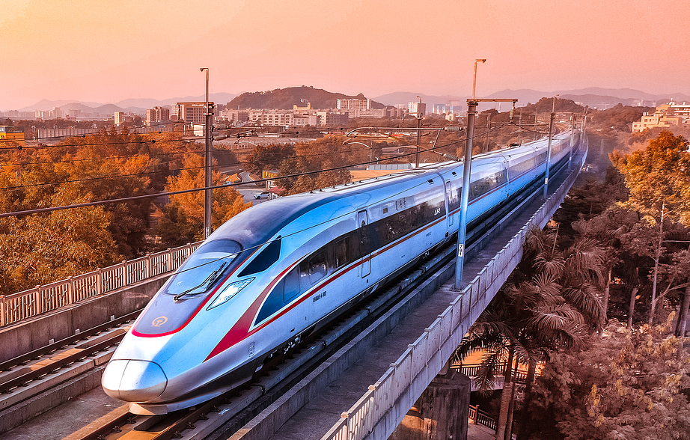
Day 13 Shanghai
Today we will show you around the most important commercial and financial hub in China. The first destination is Shanghai Museum. There are all kinds of collections, with some rarities even commanding world-wide attention. Next, let's turn to Yu Garden, a bright pearl that shines for its typical South China classical garden style. The pavilions, terraces, towers, ponds and rockeries inside the garden are delicately laid out. They show ingenuity in compacting wide views into a confined space. Near the garden is a lively local bazaar. You may wish to enjoy some free time there.
The farewell a la carte lunch (valued at CNY150.00 per person and included in our price) will be served at a well-reputed restaurant featuring delicate Shanghai cuisine.
After lunch, we come to the Bund, where you will enjoy leisure time to take amazing photos of the city’s skyline and then take a one-hour cruise tour along the Huangpu River. On completion of the trip, our guide and driver will transfer you back to the hotel and bid you farewell in the lobby.
Meals: Western buffet breakfast, A la carte farewell lunch
Accommodation: Radisson Blu Hotel Shanghai New World
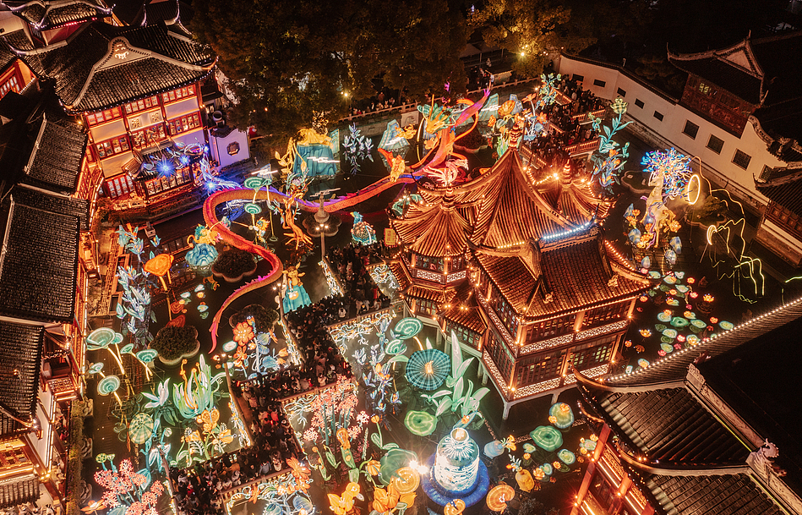
Day 14 Departure from Shanghai
Your 2 weeks guided tour of China draws to a close today. You need to head to the airport for your homeward flight by yourself. As a metro station is just outside your hotel, you can take Metro Line 2 to Shanghai Pudong or Hongqiao International Airport. Or take a taxi to the airports, which costs around CNY200.00 and CNY100.00 respectively.
We wish you a happy flight home and hope we can serve you again in the future.
Meals: Western buffet breakfast

