Packages detail
9 Days Small Group Tour of Beijing - Xi'an - Shanghai - Suzhou – Shanghai

Splendid China with Water Town USD1699
An additional fee of $200 will be charged during China's legal holidays and the summer vacation (July and August).

Overview
Tour Type: Small Group of max 18, guaranteed departures
Guide: Professional English-speaking tour guide in each city
Transportation: Spacious air-conditioned coach with experienced driver
Accommodation: 8 nights at good 5-star hotels

Included & Excluded
Price Includes
• Domestic airfares
• Hotel accommodation with breakfasts
• A la carte lunches as itinerary specifies
• Professional English-speaking guides
• Drivers & air-conditioned vehicles
• Entrance fees to tourist sites
• Tips or gratuities for hotel porters

Price Excludes
• International airfares
• Entry Visa fees
• Personal expenses
• Tips or gratuities for guides and drivers

Itinerary
Day 1 Arrival in Beijing
Welcome to our 9-day small group China tour from Beijing. As your international flight touches down in Beijing, your professional local guide will meet you at the airport after you reclaim your luggage and clear customs. Then your guide and the driver will transfer you to check in at the hotel downtown. Afterward, you will have free time for the rest of the day.
Accommodation: Hotel New Otani Chang Fu Gong
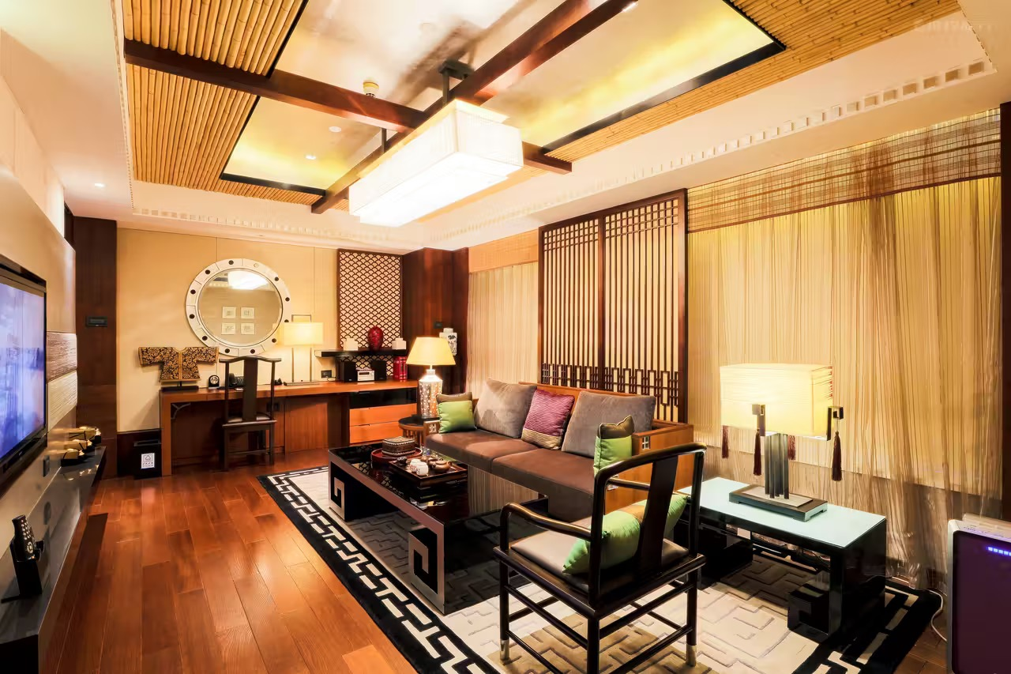
Day 2 Beijing
Before the escorted tour starts, a brief introductory talk will be delivered by your tour guide in the hotel lobby. You will also meet other members of your group at that time. The trip will begin with a visit to Tiananmen Square, China’s most iconic city square, leading to the Forbidden City. Early in the morning and again at sunset, people can watch the majestic national flag-raising and lowering ceremonies. Afterward, you will walk for a few minutes to the Forbidden City, the imperial palace of the Ming and Qing Dynasties (1368-1911). With a history of over 600 years, the UNESCO-listed palace museum not only boasts its magnificent architecture but is also famous as China’s largest ancient culture and art museum, containing a great collection of valuable historical items from porcelain, paintings, timepieces, to instruments, lacquer ware, and textile. Some of the highlights are displayed in the Treasury Gallery, and we just include it on your tour. During the visit, your guide will also relate fun facts about the palace and notable stories about Chinese emperors who resided in the palace. It is hard for you to find any trees in the Forbidden City’s heart, the outer court of Three Halls, though its inner court is rich in lushness. It is said to be due to the following reasons: fire prevention, highlighting the majesty of the emperor, for emperors’ safety, and the ancient Fengshui science. Also, you may hardly discover any bird droppings on the roofs of the giant palace complex. So why? On the one hand, the glazed tiles of the roof are mostly noble yellow colored, and the large bright colors make birds frightened. On the other hand, the glazed tiles feature a slippery surface and the steep pitch of the roof make any birds hard to perch on.
To avoid cheap tourist restaurants that many tours use, we specially arrange for you an a la carte welcome lunch (valued at CNY150.00 per person and included in our price) at a famous and elegant restaurant, where you will be served with signature Chinese food including tasty Peking Roast Duck.
In the afternoon, visit the Temple of Heaven. Four times larger than the Forbidden City in area, the Temple of Heaven has always been a sacred imperial temple for the emperors to make sacrifices to the God of Heaven and pray for a good harvest year. Its outdoor park area is a gathering place for local people to do some recreational activities, such as dancing, singing and drawing. Tonight, you will enjoy a vivid Chinese Acrobatic Show at the Red Theater.
Meals: Western buffet breakfast, A la carte welcome lunch
Accommodation: Hotel New Otani Chang Fu Gong
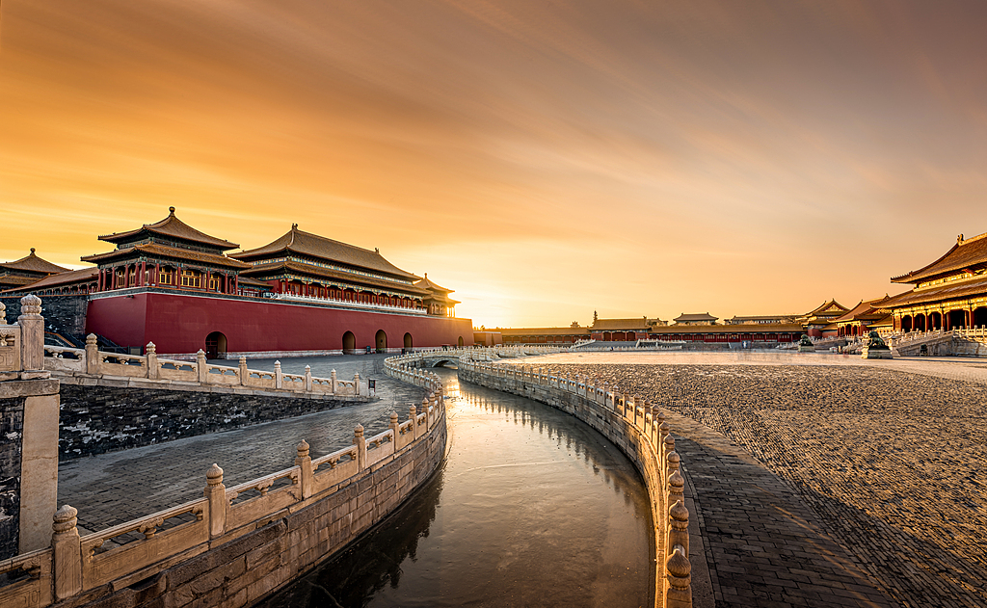
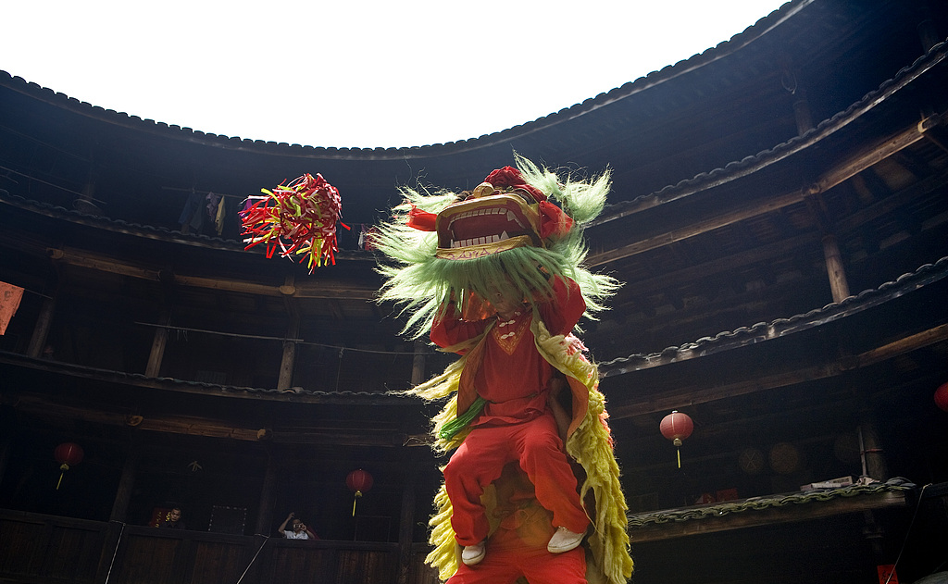
Day 3 Beijing
Today we will go to the highlight of your Beijing trip, the Mutianyu Great Wall. Mutianyu is one of the most popular sections of China's Great Wall. No traveler can help feeling the excitement of witnessing this world wonder. Please wear comfortable walking shoes to prepare for steps and slopes on the Great Wall. To better enjoy the trip, we specially arrange a round-way cable car taking you to the best part of the wall, saving you time and energy. At this time, you may think of drinking a glass of red wine to celebrate the memorable moment. Please rest assured that you will have no regrets, as we have already arranged a red wine toast for our valued guests on the amazing Great Wall. It is suggested that you take some snacks and enjoy a picnic lunch at the ancient marvel. Your guide can also recommend some restaurants nearby for lunch but be prepared that they may be overpriced due to the location.
Afterward, we will escort you back to downtown Beijing. On the way, you will see the Olympic National Stadium (Bird's Nest), which served as the main stadium of the 2008 Beijing Olympic Games. You will have a chance to take photos outside this splendid building.
The afternoon tour takes you to experience the traditional Hutongs on a relaxing rickshaw, where the narrow alleys, old-style courtyards, street peddlers and amiable local people will surely leave you with unique impressions of old Beijing. In addition, paying a visit to a local family’s house will be an added experience to your Hutong visit.
Meals: Western buffet breakfast
Accommodation: Hotel New Otani Chang Fu Gong (5 stars)
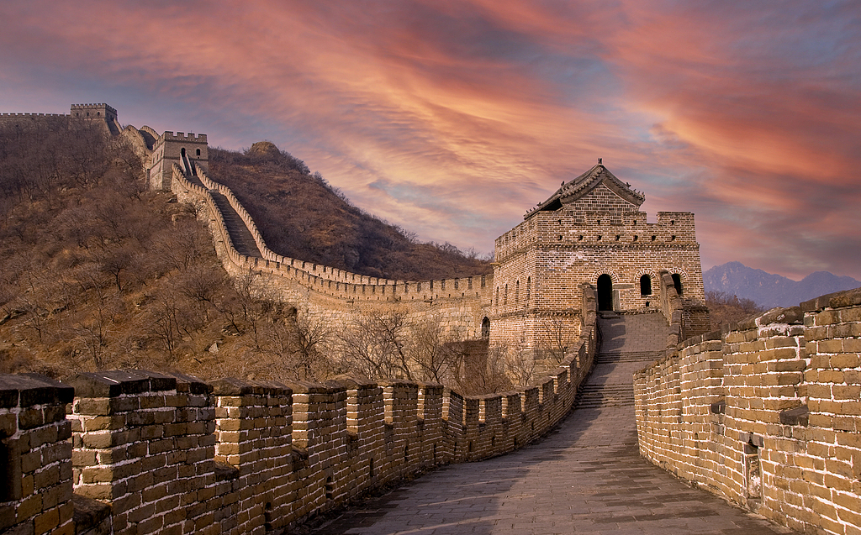
Day 4 Beijing to Xi'an by Flight
After breakfast this morning, you will check out of the hotel. Meet with cute pandas at the Panda House of Beijing Zoo. Then your guide will accompany you to visit the Summer Palace, the largest and best-preserved imperial garden in China. It is mainly composed of Longevity Hill and Kunming Lake which occupies three-quarters of the whole garden. The vast ensemble focusing on the essence of Chinese garden art is dotted with unique pavilions, grand halls, old palaces, and ancient bridges. The 728-meter Long Corridor with its delicate artistic drawings and designs is the most well-known part of the palace.
After lunch, you will be transferred to the airport to fly to Xi'an, located in northwest China, once served as the capital city of 13 ancient Chinese dynasties. Our local guide will meet you outside the baggage claim area of Xi'an Airport, and get you checked in at your hotel.
Meals: Western buffet breakfast, Lunch
Accommodation: Crowne Plaza Xi'an
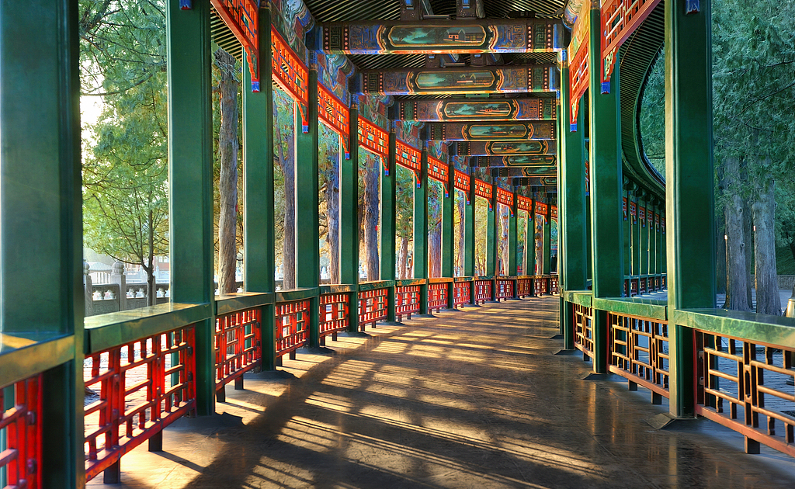
Day 5 Xi'an
There will be a long-awaited trip to the Terracotta Army Museum this morning to explore the world-famous giant underground world. Thousands of life-size pottery soldiers were made to guard the tomb of China’s first emperor Qin Shi Huang (259 BC - 210 BC) after his death. Don't be surprised if you can't find two soldiers that look alike as they were made exactly identical to the real royal army 2,200 years ago. Afterward, we will pay a visit to the home of the first discoverer of the Terracotta Army, who discovered the world wonder in 1974. And then you will be arranged to make a mini clay warrior by yourself with the help of a local artisan.
After experiencing the interesting mini terracotta warrior making, lunch is on your own arrangement. Your guide could give you some advice. In the afternoon, you will be guided to visit the famous World Heritage-listed Giant Wild Goose Pagoda, a monumental Buddhist stupa with more than 1,300 years history. With its beautiful shape, it is regarded as an example of the exquisite Buddhist architectural heritage of the Tang Dynasty. This evening, the Tang Dynasty Music and Dance Show will impress you while enjoying their famous Dumpling Dinner.
► Friendly Tip: Since the theater is usually not open in Jan, Feb, Mar and Dec, we will not arrange the show and dumpling dinner for tours during the periods and the evening time will be left for you to freely explore.
Meals: Western buffet breakfast, Dumpling dinner
Accommodation: Crowne Plaza Xi'an
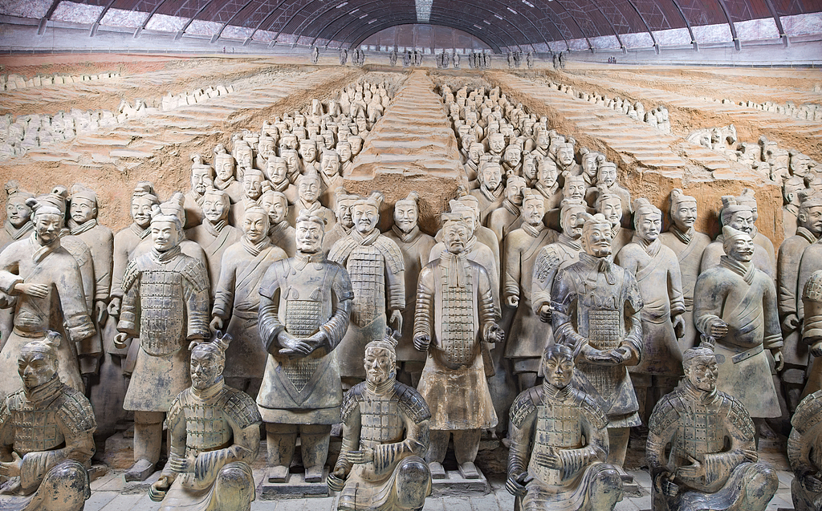
Day 6 Xi'an to Shanghai by Flight
After breakfast, take a leisurely walk in the City Wall Park accompanied by our guide and see how the locals go about their daily lives. Moreover, a Taichi class will be arranged for you to learn and practice in the park. This interesting Chinese Kung Fu featuring soft, slow, relaxing and natural movements is suitable for all people and is good for your health. Next, we will visit the City Wall. Built about 600 years ago, the City Wall is the most well-preserved ancient fortification in China. Travelers can also ride a bicycle or an electric car on the top of the wall, but you need to pay the rental fee on the spot. It should be a fascinating experience to enjoy stunning city views through the old watch towers.
Around noon, you will be accompanied to explore the lively Muslim Quarter. The famous local food bazaar has narrow bustling streets lined with various tasty food stalls and small restaurants. Here offers some of the most representative snacks like Crumbled Flatbread in Mutton Stew, Biangbiang Noodles, Chinese Hamburger, and Cold Noodles. Your guide will give you an introduction to the tasty snacks and just try your favorite dishes for lunch.
In the afternoon, you will board a flight to Shanghai to take in the charm of China’s most modern and vibrant city. The transfer between the hotel and airport will be offered. After check-in, you can rest at the hotel to be ready for the following 3-day Shanghai tour.
Meals: Western buffet breakfast, Lunch
Accommodation: Radisson Blu Hotel Shanghai New World

Day 7 Shanghai
This morning, our first stop will be the famous Shanghai Museum, a large museum of ancient Chinese art built in 1952. Among its huge collections, the displays of bronze vessels of the Shang and Zhou dynasties (1600 - 256 BC), ceramic objects of different historical periods and ancient paintings and calligraphy, grace the museum with their incalculable value. The next stop is Yu Garden, a classical Chinese garden built in 1559, featuring decorative halls, strange rockeries, tranquil pools, zigzag bridges, and exquisite pavilions. Surrounding the garden is a bustling bazaar full of storefronts selling different kinds of local snacks and souvenirs, the best place to feel old Shanghai. Walking along the old street, you will find many red lanterns are hung on the trees, shops and buildings, especially during festival periods, which represent booming life and prosperous business in Chinese culture.
To taste the good Shanghai cuisine, we have arranged an a la carte lunch (valued at CNY150.00 per person and included in our price) for you at a famous local restaurant.
In the afternoon, our guide will escort you to the Bund area, the historical waterfront area in the heart of Shanghai, where you will take a 1-hour Huangpu River cruise. Then take a stroll along the Bund to appreciate a group of Western-style buildings from the colonial period that feature Gothic, Baroque, Romanesque, Classical and Renaissance architectural styles. Your guide will escort you back to your hotel.
Meals: Western buffet breakfast, A la carte lunch
Accommodation: Radisson Blu Hotel Shanghai New World
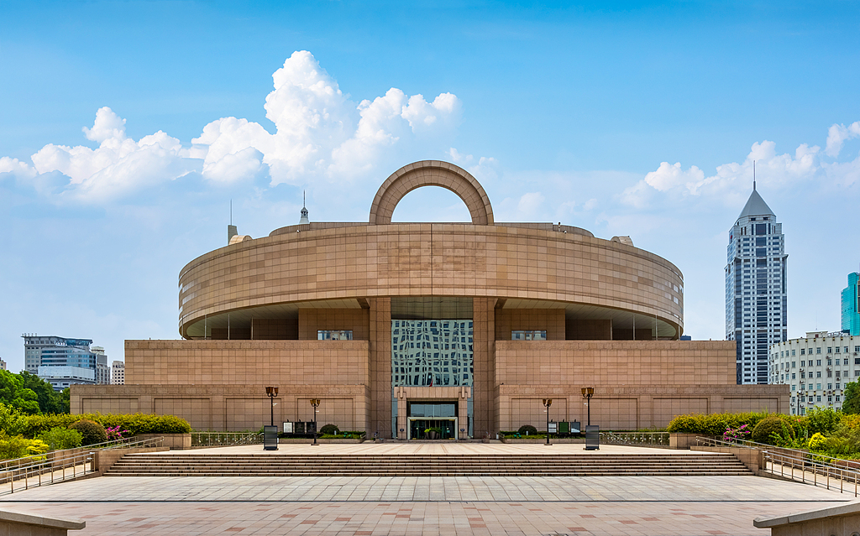
Day 8 Suzhou
In the morning, you will be escorted to Suzhou about 1.5 hours’ drive away. Boasting its beautiful canals, old bridges, and delicately designed gardens, no wonder Suzhou is one of the most attractive cities in China. It was also the favorite destination of Qianlong Emperor (1711 - 1799) in the Qing Dynasty, who had been to Suzhou for 6 times in his Southern Inspection Tours. His court painter had detailed the emperor's lavish arrival scenes in the epic Scroll Six. The emperor had a strong passion for Suzhou and even commissioned to build several gardens and streets in imitation of Suzhou’s typical architecture and classic gardens in his royal garden and summer retreat.
We'll start our Suzhou exploration with a visit to the Humble Administrator's Garden, which is the most famous and largest classical landscape garden in Suzhou. Roaming in the UNESCO World Heritage Listed garden, you will observe the special garden layout, in which the water divides the garden space into smaller parts to form more diversified landscapes with green hills, terraces, cobbled paths, and scenic pavilions. Then, you will take a tricycle to travel around Suzhou’s old town.
The afternoon destination in Suzhou is the Tongli Water Town, where you can appreciate the ancient buildings of the Ming and Qing dynasties and immerse yourself in this peaceful environment by strolling around the old water town. Seeing charming bridges, relaxing in a canal boat, and learning about the local history, are really wonderful breaks from the bustle of Shanghai city. Finally, your amazing journey comes to an end and the guide will transfer you back to Shanghai and say goodbye to you at the hotel lobby.
Meals: Western buffet breakfast
Accommodation: Radisson Blu Hotel Shanghai New World
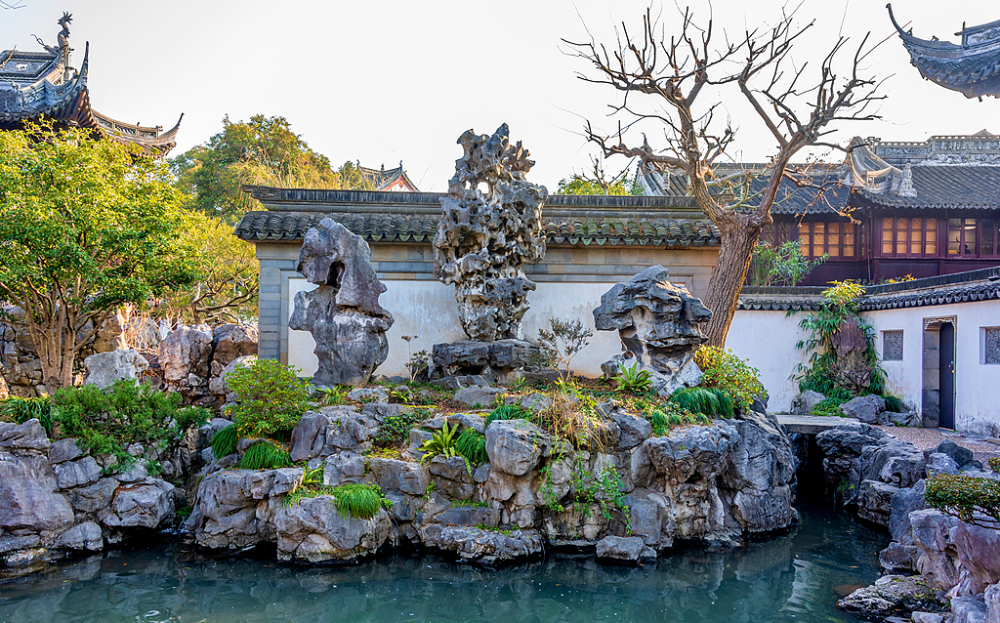
Day 9 Departure from Shanghai
After having breakfast, please check out of the hotel before 12:00 pm and find your own way to the airport. We suggest you book a taxi at the hotel in advance. It takes around 1.5 hours to Pudong Airport and costs around CNY 200 by taxi. By public transport, Metro Line 2 from People’s Square directs to Pudong Airport in about 1.5 hours. The taxi ride to Hongqiao Airport takes about 1 hour and costs around CNY 100. Metro Line 2 is also available to reach the Hongqiao Airport in about 40 minutes. We wish you a happy and smooth trip back home!
Meals: Western buffet breakfast
