Packages detail
9 Days Small Group Tour of Beijing - Xi'an - Guilin - Yangshuo – Guilin

A World of Excellence USD1399
An additional fee of $200 will be charged during China's legal holidays and the summer vacation (July and August).

Overview
Tour Type: Small Group of max 18, guaranteed departures
Guide: Professional English-speaking tour guide in each city
Transportation: Spacious air-conditioned coach with experienced driver
Accommodation: 8 nights at good 5-star hotels
Trip Highlights：
• Must-see sights in China—Mutianyu Great Wall, Forbidden City, Terracotta Army.
• Take a Li River cruise down to Yangshuo and admire the essence of Guilin landscape.
• Walk along or cycle around the 600-year-old City Wall and get stirring views.
• Meet and interact with local people in their homes and get to know their lifestyle.

Included & Excluded
Price Includes
• Domestic airfares
• Hotel accommodation with breakfasts
• A la carte lunches as itinerary specifies
• Professional English-speaking guides
• Drivers & air-conditioned vehicles
• Entrance fees to tourist sites
• Tips or gratuities for hotel porters

Price Excludes
• International airfares
• Entry Visa fees
• Personal expenses
• Tips or gratuities for guides and drivers

Itinerary
Day 1 Arrival in Beijing
Upon your arrival in Beijing today, your local guide will greet you outside the Customs of the airport. Enjoy a comfortable transfer until you arrive at the reserved hotel for a good rest. The remaining time today is left free for you to recover your energy after the long flight.
Accommodation: Hotel New Otani Chang Fu Gong
Day 2 Beijing
After enjoying a hearty breakfast, you will meet other group members at the hotel lobby for the coming trip. The first stop of your 9 days China tour package is the world famous Tiananmen Square, the largest city square in the world. Chairman Mao's Mausoleum, Great Hall of the People, Monument to the People's Heroes are all located there. Chinese people consider it to be the heart of China and a place of pilgrimage.
From the square, we will stroll to today’s biggest highlight - the Forbidden City. Although the political center to house rulers of Ming and Qing Dynasties (1368 - 1911 AD), the City actually occupies an area not that vast. However, it’s not the size, but the countless stories and secrets it contains in every nook and cranny that matter. You will learn that even each brick has its own secret, on which carved the name of its craftsman and the date of birth. And with your knowledgeable guide, you will find out even more, to see beyond the architecture to meet the meaningful histories the City is carrying forward. Today, we will also treat you to an exclusive tour to the Treasure Gallery inside the compound, which exhibits 400-plus most expensive imperial relics.
You will enjoy an a la carte welcome lunch (valued at CNY150.00 per person and included in our price) at a superb local restaurant. You can try the world famous Peking Roast Duck, the aroma of which alone will make your mouth water. We will book the elaborately-made dish in advance, so you can taste it the moment you sit at your table.
After lunch, continue history appreciation at the Temple of Heaven, the world’s largest sacrificial building complex, which has survived hundreds of years intact.In the evening, we will end the day with a lively Chinese Acrobatic Show at the Red Theatre. Afterwards, we will drive you back to your hotel.
Meals: Western buffet breakfast, A la carte welcome lunch
Accommodation: Hotel New Otani Chang Fu Gong
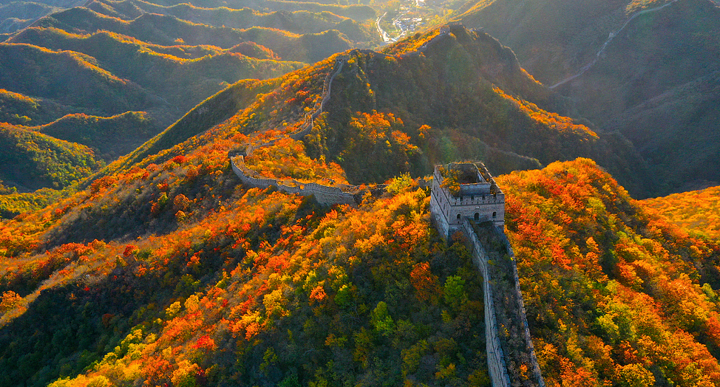
Day 3 Beijing
The highlight of today's trip is a visit to the Great Wall of China. The part we will visit is the Mutianyu section, one of the best-preserved sections of the winding wall. It used to serve as the northern barrier defending the capital and the imperial tombs. To keep your strength up for a bit hiking on the wall, we arrange a round-trip cable car ride for you. Since the food offered in the nearby restaurants is not recommended by the visitors and us, we advise you to take some fast food to provide you with energy around noon time.
In the afternoon, we drive by the Olympic National Stadium (Bird’s Nest), for you to record this moment with pictures of standing before this cradle-like feat of engineering. Then we head to the Hutong area, where a Hutong tour by rickshaw is scheduled. Hutongs are narrow lanes flanked by residential “Siheyuans”, or traditional Chinese courtyard houses. The 700-year-old area is like a long library dedicated to exhibiting traditional lifestyles and cultures of common Beijing people. Besides a Hutong tour, your guide will also take you for a family visit in a Siheyuan. Nothing could give you better insight than directly talking with natives of this place, if you want to learn about authentic local life. As it will be late when the visit finishes, we will drive you back.
Meals: Western buffet breakfast
Accommodation: Hotel New Otani Chang Fu Gong
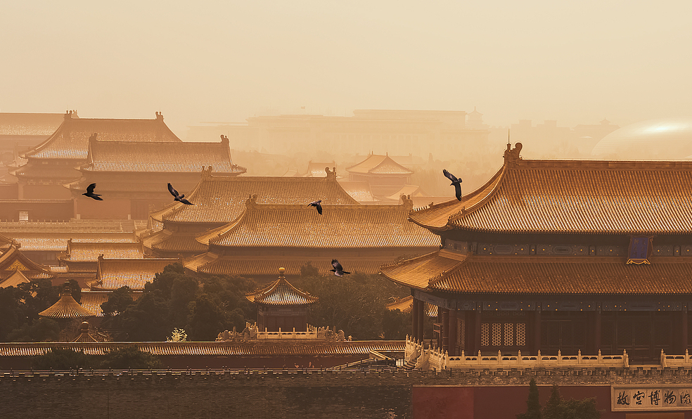
Day 4 Beijing to Xi'an by Flight
This morning's excursion will first cover the Panda Hall, Beijing Zoo, for you to watch Chinese giant pandas eating and playing. But don’t be too deluded by their adorable appearance, because, if threatened, they can bite more forcefully than some wild bears! Then we continue to visit the Summer Palace, the largest existing royal garden in China. Constructed over 200 years ago, it is famous for the magnificent buildings and charming landscape.
Have some local food as your lunch, and an afternoon flight will take you to the second destination, Xi'an. Upon landing, your local guide and driver will meet you at the airport and take you to the hotel.
Meals: Western buffet breakfast, Lunch
Accommodation: Crowne Plaza Xi'an

Day 5 Xi'an
After a lavish breakfast at the hotel, we will take you to the Terracotta Army, an amazing underground project built more than 2,200 years ago. They are none other than the funeral objects of the legendary mausoleum of Emperor Qin Shi Huang (259 - 210 BC), the founder of the first empire in China’s history, who ordered more than 9,000 terracotta warriors and horses to help him rule his underworld.
★ We provide you with an exclusively memorable trip!
► Get first-hand knowledge about the discovery in the discoverer’s home
Today, we offer a chance for you to learn the ins and outs about the discovery of the Terracotta Army, in the home of Mr. Yang Zhifa, the very man who dug out the first warrior in 1974. You will meet and talk with Mr. Yang or his families in person. Also, you get to witness the digging hoe, the wooden cart used to transport it, and an identical copy of the first warrior.
► Bring home the most precious souvenir engraved with your own logo
In addition to the visit, we will also take you to a workshop, where you get to craft your own mini terracotta warrior. An artisan will instruct you in the making process, which takes around 40 minutes with the help of molds. You will refine its facial features and carve your own name on it before you let it dry. After all things are done, marvel at your little masterpiece and take it with you!
Then continue traveling through the city with visiting the Giant Wild Goose Pagoda, part of the Buddhist architectural heritage of the Tang Dynasty (618 - 907 AD). Your evening will find you in a theater watching a the Tang Dynasty Music and Dance Show over dumpling dinner. We can’t miss dumplings because they are more than a dish with a profound story to tell. Going back to winters in ancient times, you will realize they were much colder, to a point that the ears of the poor would suffered from festering. They should thank a renowned doctor, for healing their ears after letting them try a dish - the dumplings - he invented by wrapping shredded ginger and mutton into flour skins. And that’s why dumplings are considered blessings to take, and can be found on the table on important days during the Spring Festival and the Winter Solstice. There are many varieties across China, but none would involve exquisite craftsmanship as Xi’an’s Dumpling Dinner does. After that, we will escort you back to your hotel.
Travel Tip: Guests visiting in Jan, Feb, Mar and Dec need to arrange the dinner and evening activity on their own for this day, since the theater is usually not open during those months.
Meals: Western buffet breakfast, Dumpling dinner
Accommodation: Crowne Plaza Xi'an
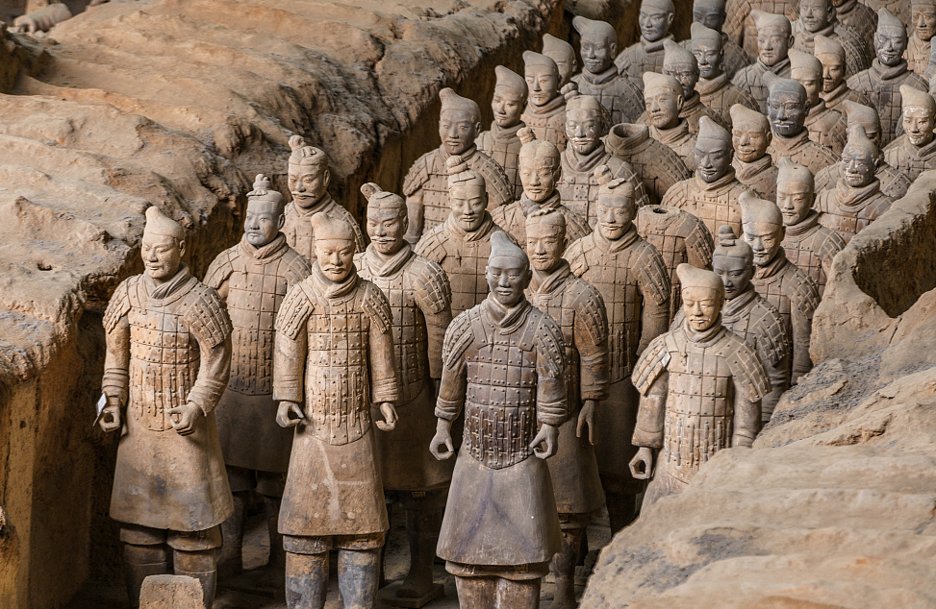
Day 6 Xi'an
The first stop today is the City Wall Park, where you can see locals sing, dance, chat, play chess and instruments, exercise, etc. It is the best place to experience local life. Today, you get to be a part of it. We will invite a Tai Chi Master to teach you some basic moves of Tai Chi, a popular school of Chinese Kung Fu exercise that features slow but flowing movements. Then, you will go on a visit to the well-preserved City Wall. It's very popular among visitors to walk or cycle on its top walkway and have a panoramic view of the old quarter of this city. You may have a try. If you are not skillful in riding a bike, the electric car is also available. Please note that it charges a small fee to rent a bike or take the car.
Your lunch time will be spent at the Muslim Quarter, tasting authentic local food with Muslim flavors. It is a famous snack street in Xi'an. Don't miss it if you are a foodie. The most famous and typical local food is crumbled flatbread in mutton stew (Yangrou Paomo). Cooked with bean thread noodles, slices of marinated mutton, fresh garlic shoots, and various spices, the yummy broth will leave you with endless aftertastes.
Later a visit to the Great Mosque - a mosque unique for its classical Chinese architecture - is scheduled. Then you will be transferred to Shaanxi History Museum, a representative of Chinese museums, featuring collections of relics unearthed locally. If the Shaanxi History Museum is not available, alternatively, the famous Forest of Stone Steles Museum will be arranged instead. After exiting the museum, we will take you back.
Meals: Western buffet breakfast, Local flavor lunch
Accommodation: Crowne Plaza Xi'an

Day 7 Xi'an to Guilin by Flight
Continue your escorted China tour to Guilin today. You will take a morning flight and the local guide will welcome you at Guilin airport and transfer you to check in at the hotel. Later in the day, you will be taken to visit the Reed Flute Cave, a spectacular world of stalagmites, stalactites, stone pillars, and stone flowers formed by carbonate deposits, and the Elephant Trunk Hill, the emblem of Guilin city.
Meals: Western buffet breakfast
Accommodation: Sheraton Guilin Hotel
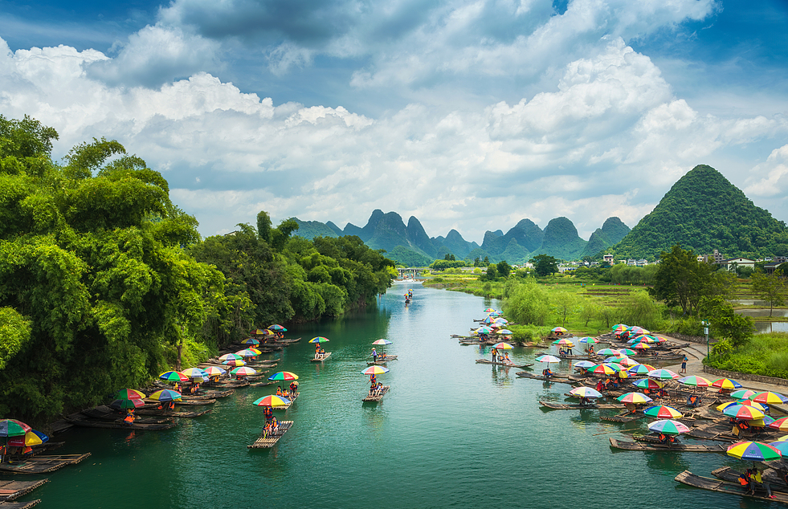
Day 8 Guilin - Yangshuo - Guilin
Today you will have a chance to appreciate China’s most beautiful karst landscape by cruising on the Li River. The cruise will depart from Guilin at 09:00 and arrive at Yangshuo County at about 14:00. The cruise company will provide a box lunch to restore your energy.
An essential representative of Guilin’s charming landscape, Yangshuo is enliven by the West Street, regarded as its beating heart for being the liveliest area of this county. When you arrive at Yangshuo, your guide will take you to West Street for a leisurely stroll. Then you will be driven in the countryside area to enjoy the rural scenery. On the way, you will visit a local peasant's home. After that, get back to Guilin by car.
Meals: Western buffet breakfast, Lunch
Accommodation: Sheraton Guilin Hotel

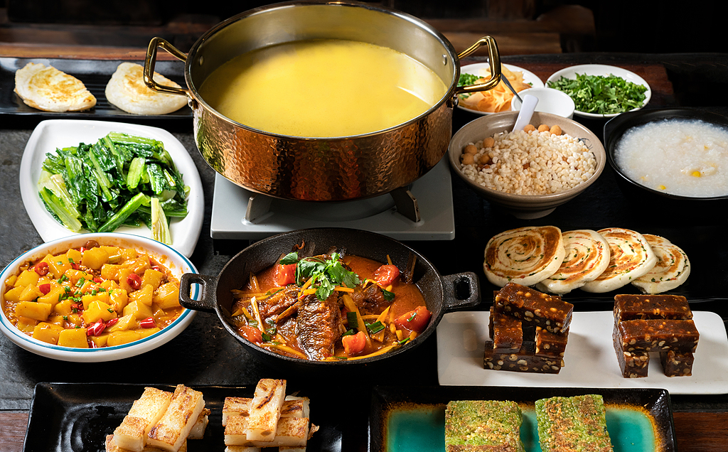
Day 9 Departure from Guilin
Your tour draws to an end. Today you will make your own way from hotel to the airport and board your onward flight. You are recommended to book a taxi from the reception and it will charge around CNY 100 to 150 per cab. We wish you a nice trip home!
From Guilin, you can make travel plans to the Dragon Ridge Terrace in Longsheng, or just stay in Yangshuo for more days to immerse yourself into a relaxing countryside life. Also, taking a bullet train or a flight to Hong Kong is doable. If you need us to arrange the departure air tickets or a subsequent travel, we will be glad to assist you.
Meals: Western buffet breakfast
