Packages detail
10 Days Small Group Tour of Beijing - Xi'an - Shanghai - Mt. Huangshan
Amazing HuangshanUSD1900
An additional fee of $200 will be charged during China's legal holidays and the summer vacation (July and August).

Overview
Tour Type: Small Group of max 18, guaranteed departures
Guide: Professional English-speaking tour guide in each city
Transportation: Spacious air-conditioned coach with experienced driver
Accommodation: 9 nights at good 5-star & 4-star hotels
Trip Highlights：
• Must-see sights in China - Mutianyu Great Wall, Forbidden City, Terracotta Army
• Cruise on the Huangpu River to take in the impressive skylines of Shanghai
• Visit Mt. Huangshan, one of the most scenic mountains in China
• Visit and interact with a Chinese family to know the real local life

Included & Excluded
Price Includes
• Domestic airfares & train fare
• Hotel accommodation with breakfasts
• A la carte lunches as itinerary specifies
• Professional English-speaking guides
• Drivers & air-conditioned vehicles
• Entrance fees to tourist sites
• Tips or gratuities for hotel porters

Price Excludes
• International airfares
• Entry Visa fees
• Personal expenses
• Tips or gratuities for guides and drivers

Itinerary
Day 1 Arrival in Beijing
Your exciting 10 days China group tour begins when your international flight lands at one of the airports in Beijing. Our experienced guide will be waiting for you and will welcome you with a warm greeting. Then our driver will transfer you to the hotel and the rest of the day will be left for you to make your initial contact with this charming city.
As the capital city of China, Beijing must be the first stop of your China tour not only because of its convenient location for international flights, but also because it boasts some of the world’s greatest beats in engineering wonders along with rich traditional Chinese culture. The city offers a feast of eyes by imperial palaces, striking Great Wall, royal gardens, and ancient temples. You can also trace the traditional lifestyles of common people in narrow Hutongs and witness the city’s rapid modernization through streetside skyscrapers, high-end malls and well-equipped hotels.
Accommodation: Hotel New Otani Chang Fu Gong
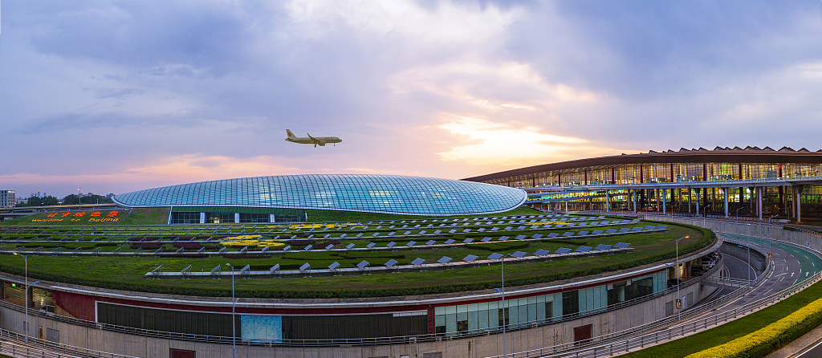
Day 2 Beijing
This morning, you will set off to visit Tiananmen Square. As the symbol of the country, Tiananmen Square occupies an irreplaceable place in the hearts of Chinese people, often serving as the main venue for massive parades and rallies, including the founding ceremony of the People’s Republic of China. Strolling around the vast city square, you can see the Monument to the People's Heroes in the center and other buildings in the surroundings, like the National Museum and Chairman Mao Memorial Hall. A few more steps will bring you to the next destination - the Forbidden City, the former imperial palace complex home to 24 emperors in the Ming and Qing Dynasties (1368 - 1911). The UNESCO-listed palace, occupying an area of 178 acres, features a history of around 600 years and houses over 9,000 rooms, where you can discover the past Chinese royal lives and see the articles they used every day. Especially in Treasury Gallery located in the northeast, you will see a lot of exquisite ancient artifacts made from jade, silver, gold, pearls and precious stones.
Around noon, we will transfer you to a carefully picked restaurant for an a-la-carte welcome lunch (valued at CNY150 per person and included in our price). The famous Peking Roast Duck is also served for lunch.
In the afternoon, you will be guided to explore the Temple of Heaven, the sacrificial altar of emperors to pray for good harvests. It is now a popular park not only for sightseeing but also for the recreational activities of the local residents. Visit the grand sites of praying and performing sacrificial rites, and experience the local’s leisured life by watching them singing, dancing, or practicing Tai Chi in the surrounding garden. A lively Chinese Acrobatic Show at the Red Theatre will give you an impressive Beijing night. After the show, we will take you back to your hotel.
Meals: Western buffet breakfast, A la carte welcome lunch
Accommodation: Hotel New Otani Chang Fu Gong
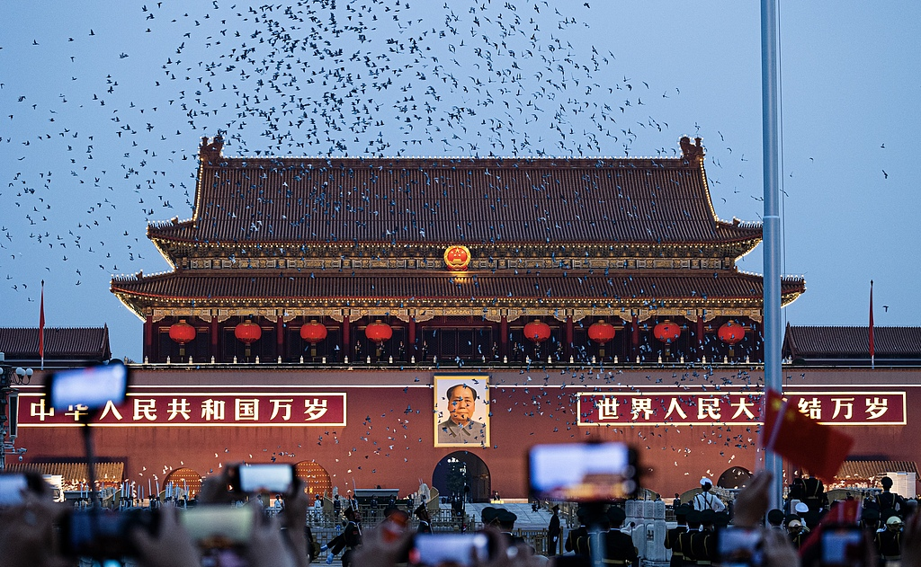
Day 3 Beijing
Climbing the Great Wall is a life-long dream for most travelers. Today, your dream will come true as we will lead you to visit this magnificent human achievement. Get up early in the morning, and please have a substantial breakfast as it will be an energy-consuming day. The Great Wall stretches for thousands of miles from east to west all over the country. We'll visit one of the most famous sections, Mutianyu Great Wall, with a total length of around 5km and there are 20 watch towers in total along the mountain ridges. A round-trip cable car is arranged to save you energy and provide a better experience. After you get to the wall by cable car, enough time will be scheduled for you to walk on it and appreciate the scenic views. In addition, you will have a chance sipping a glass of wine on the Great Wall and have a happy toast. At noon, it is suggested that you have some fast food for lunch by yourself. Our guide could show you some restaurants nearby if needed.
Then we will return to the city, passing by the Bird's Nest stadium, the main venue of the 2008 Olympic Games. We will stop there briefly so you can take pictures. The afternoon arrangement will be a rickshaw journey through Hutongs, which specifically refer to the narrow alleys in Beijing old town area composed of traditional courtyards and residences. Nowadays, the original style and features of these ancient alleys are still well maintained even after hundreds of years. Here you will have a chance to visit a local family to see how Beijing local people live their lives.
Meals: Western buffet breakfast
Accommodation: Hotel New Otani Chang Fu Gong
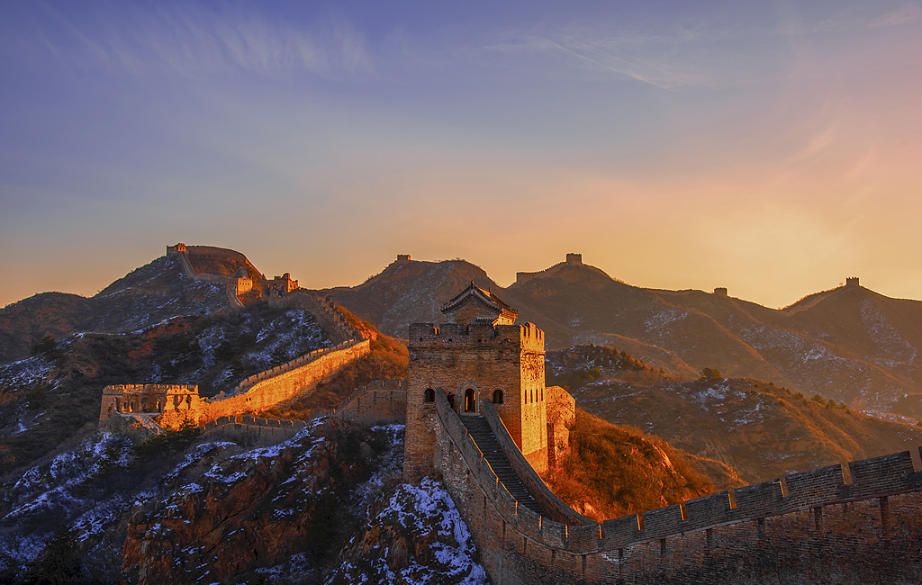
Day 4 Beijing to Xi'an by Flight
Today you are scheduled to see pandas in Beijing Zoo and then visit the Summer Palace after breakfast. There are about 10 cute pandas in Beijing Zoo now and they are generally more active in the morning when you can see them eat and play joyfully. Different from other historical sites, the Summer Palace used to be the summer retreat of royal families, featuring a big, beautiful resort occupying an area of more than two hundred hectares. It is pleasant to walk around the lake and interact with the local people who are doing morning exercises in the park.
After lunch, our guide will see you off at the airport for your flight to Xi'an. There will be another professional guide waiting for you on your arrival and escorting you to the hotel.
Meals: Western buffet breakfast, Lunch
Accommodation: Crowne Plaza Xi'an
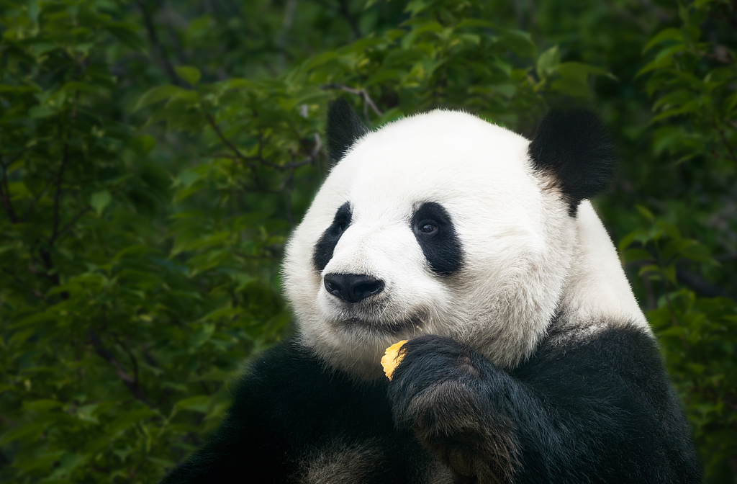
Day 5 Xi'an
After a good night's rest, we'll start our Xi'an journey by visiting the Terracotta Army, often known as the world’s eighth wonder and one of the most important archaeological discoveries of the 20th century. As a part of the unexcavated Mausoleum of the First Qin Emperor, these terracotta soldiers were created to protect Emperor Qin Shi Huang in his afterlife. The astonishing lifelike figures and remarkable army formation in the museum will bring you back to the time of 2,200 years ago. Our guide will give you an introduction to distinguishing normal soldiers and generals. The largest differences are suggested by their clothes, headdresses, and shoes. In most cases, normal soldiers don’t wear any caps while generals have caps with a flat rectangular front consisting two parts. What’s more, the shoes worn by the terracotta warriors are in rectangular shapes, regardless of the left and right feet. The shoe curves upwards at the front, and the higher the level is, the higher the official rank. You can even find names carved on the armor of some soldiers and that is said to be the names of the craftsmen who made them. Thereafter, we will take a family visit to the home of the first discoverer of the Terracotta Army to learn more interesting stories behind the discovery. And then you will try making a mini clay warrior by yourself with the help of a local artisan.
Get useful advice from your guide and have lunch on your own. The itinerary in the afternoon is to visit the Giant Wild Goose Pagoda, a remarkable structure standing in the middle of the Da Ci’en Temple. The famous Buddhist pagoda was built in memory of the eminent monk Zuanzang’s west journey to India and many Buddhist texts and scriptures were preserved and translated here. This evening, a delicious dumpling dinner awaits you, and the brilliant Tang Dynasty Music and Dance Show which recreates China’s golden age of the Tang Dynasty (618 - 907) will make your dinner time more enjoyable.
► Friendly Tip: Since the theater is usually not open in Jan, Feb, Mar and Dec, clients visiting during these periods need to arrange the dinner and evening activities on their own.
Meals: Western buffet breakfast, Dumpling dinner
Accommodation: Crowne Plaza Xi'an
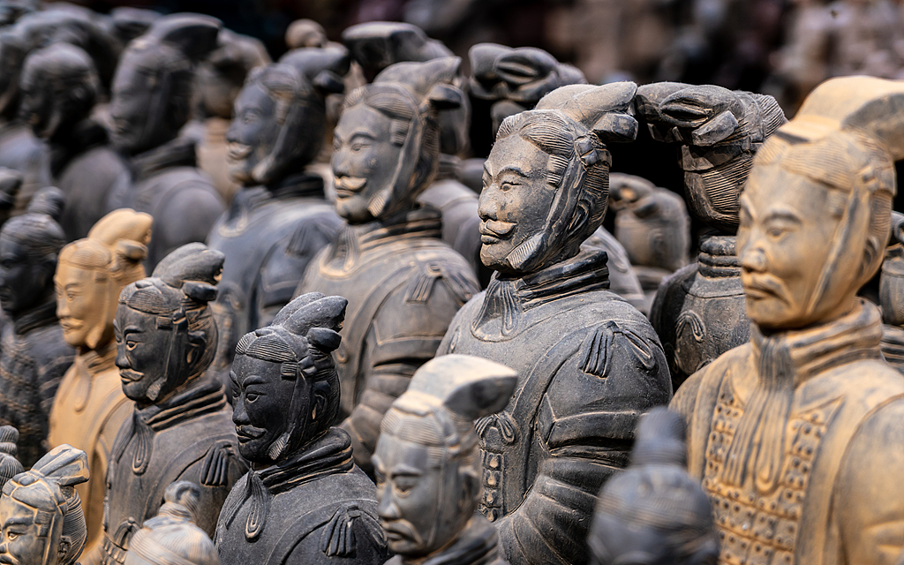
Day 6 Xi'an to Shanghai by Flight
This morning, you will be led to the city’s famous landmark, City Wall, which was built in the early Ming Dynasty of 1374. With a perimeter of 13.8 km, the City Wall was constructed as a military site to protect the city but now the defensive system with its surrounding area has become a popular city playground for local people. A short ride from your hotel will get you to the City Wall Park where you will not only experience the local people's leisured life but also attend a Tai Chi practice and learn the skills from a master. After that, we will proceed to the ancient City Wall, which stands for 600 years, dividing the city into the old town area and modern Xi’an. It’s interesting to stroll around the 14-meter-wide wall on the top to see old and low buildings within the wall while viewing the high-rises outside the wall. If you can cycle, a bike ride on the old wall is strongly recommended. The bike rental fee is at your own expense (CNY 45).
Around noon, let’s explore the lively Muslim Quarter and try the local food there for lunch. Muslim Quarter is known as the most popular food market in Xi’an and it boasts a lot of halal snacks like Lamb Skewers, Soup Dumplings, Cold Noodles (Liangpi), and Chinese Hamburgers (Roujiamo). After lunch, a comfortable transfer will take you to Xi'an airport for a flight to Shanghai. A local guide and a driver are ready to pick you up and escort you to check in at the hotel when you arrive.
Meals: Western buffet breakfast, Lunch
Accommodation: Radisson Blu Hotel Shanghai New World
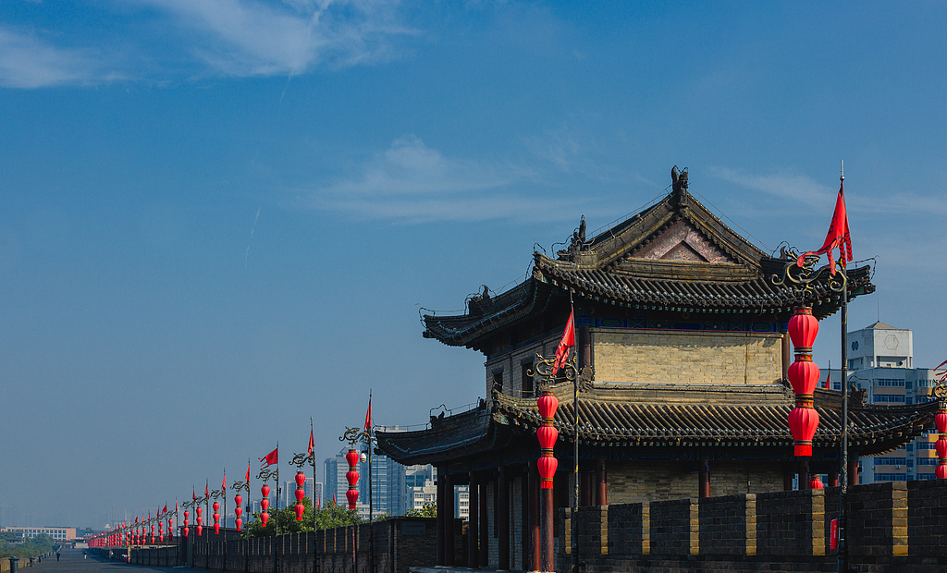
Day 7 Shanghai
As China’s largest commercial and financial center, Shanghai is an attractive city boasting a captivating blend of Eastern and Western cultures, which deserves a complete exploration. We will arrange Shanghai Museum as your first destination. This elegant museum houses fascinating collections from China’s different dynasties and ancient bronze ceramics, calligraphy, and paintings are the most representative exhibits. Then proceed to Yu Garden, which has a history of more than 400 years. The famous classical garden in the city center offers a secret escape from the hustle of city life. Then, enjoy some free time at a traditional bazaar outside the garden, full of shops, food stalls and traditional Chinese architecture.
At midday, we will take you to a nice restaurant offering local cuisine for an a la carte lunch (valued at CNY150 per person and included in our price).
In the afternoon, follow the guide to the Bund area. As the landmark of Shanghai, it gives tourists an excellent introduction to the city. The 1.5-km long stretch of the vibrant waterfront area features 52 buildings of neoclassical, baroque styles. Here, you will have a 1-hour cruise tour along the Huangpu River to admire the skyscrapers across the Bund. Your guide will escort you back to your hotel.
Meals: Western buffet breakfast, A la carte lunch
Accommodation: Radisson Blu Hotel Shanghai New World
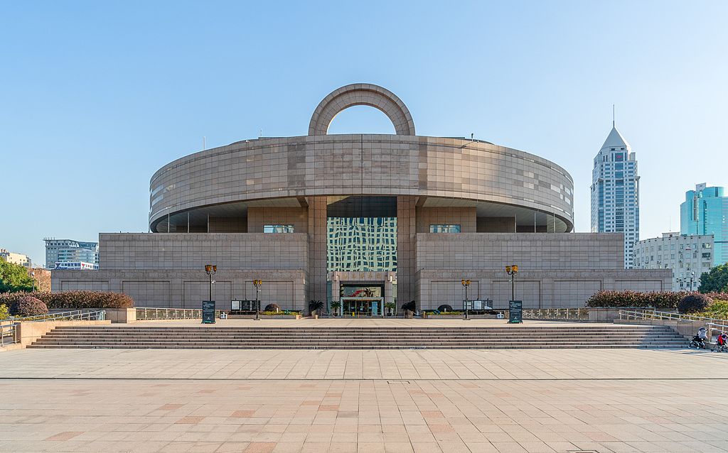
Day 8 Shanghai to Huangshan by High Speed Train
In the morning, our guide will meet you at the hotel lobby and escort you to Shanghai Railway Station to take a 3-hour high-speed train to Huangshan North Station. Upon your arrival in Huangshan, our local guide will greet you and transfer you to Hongcun Ancient Village directly, which is a well-known UNESCO world heritage site. There are, in total, 158 residential houses which can be traced back to the Ming and Qing Dynasties, of which nearly 140 are still in good conditions. The picturesque village with its tranquil setting combining nature and people living harmoniously, earns Hongcun Village the title of 'the Village in a Chinese Painting'. After your visit, we will drive you back to the hotel in downtown for check-in.
Meals: Western buffet breakfast
Accommodation: Huangshan International Hotel
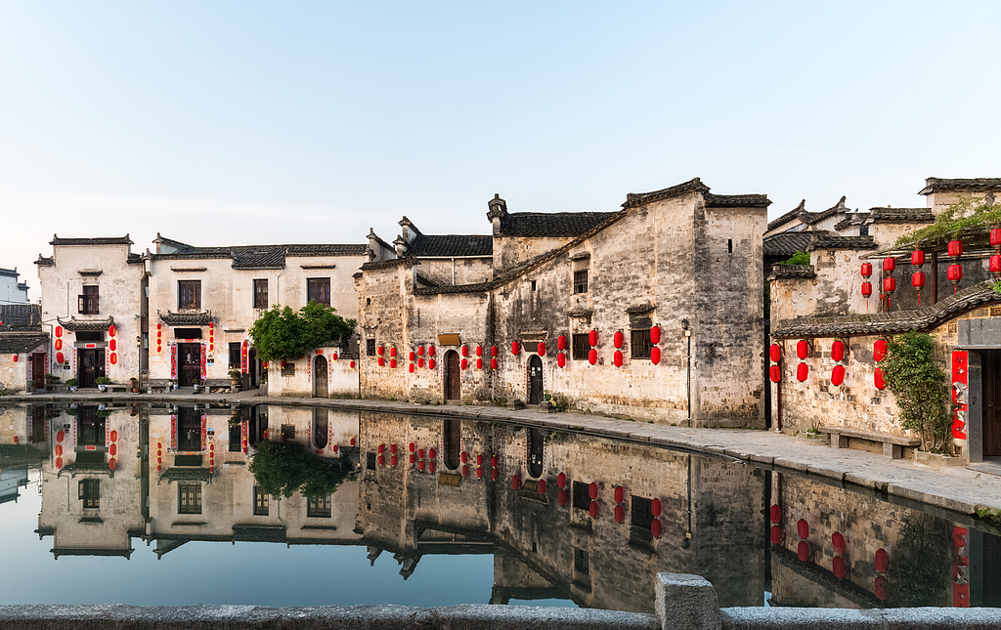
Day 9 Huangshan
Huangshan Mountain (Yellow Mountain) is definitely a must-visit place if you are a nature lover. You are suggested to pack some light luggage along with you and store your main luggage at Huangshan International Hotel. After a one-hour drive to the scenic area, you will ascend the mountain by cable car and the stunning sceneries along the way will never let you down.
Huangshan Mountain offers delightful views in all four seasons. On reaching the end of the cableway, you will walk to enjoy the view of some famous spots, including the Beginning-to-Believe Peak, Peach Blossom Valley, Lion Peak, Flying-over Rock and the Bright Summit. The foot path is quite slippery on rainy days, so please make sure you wear a pair of sturdy shoes. With a height of 1,860 meters, the Bright Summit is one of the 3 main peaks of the mountain, along with the Lotus Peak, and Tiandu Peak. It is so named because the land here is flat and wide with good sunlight. The views from the peaks of the top are amazing beyond expression and will leave you with an everlasting memory. We especially arrange you to the Bright Summit because the other two peaks are open on alternate turns with an interval of 5 years. Huangshan Mountain is the first scenic area in China adopting the alternate turns open practice due to the large fire in 1972. In the fire, more than 4,000 Yellow Mountain pines had been burned and the alternate closure system from 1987 was greatly helpful for the environment recovery. During the period, the pines just grew vigorously. And thus the policy was continued in the following years and imitated by other attractions. After the visit, you will lodge at the 4-star Xihai Hotel on the mountain this evening. Try to get a good sleep in preparation for further exploration tomorrow.
Meals: Western buffet breakfast, Lunch
Accommodation: Xihai Hotel
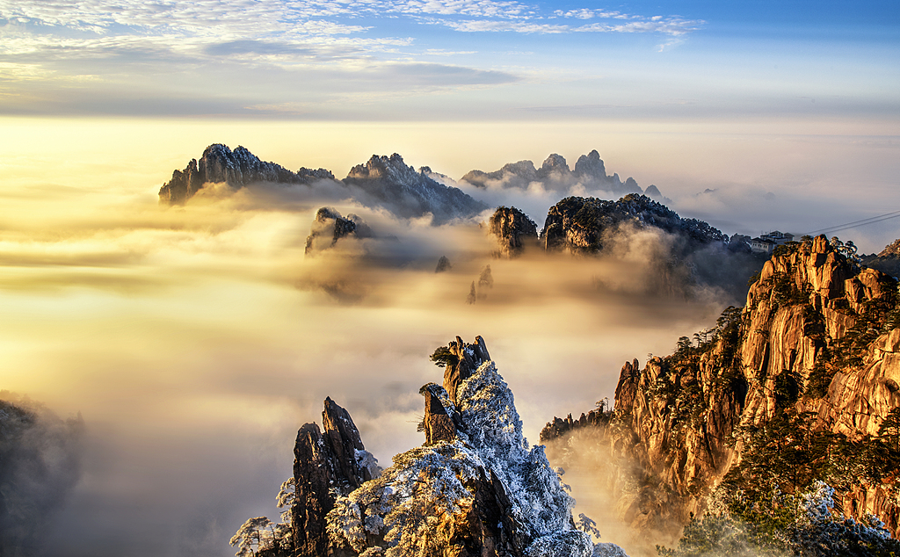
Day 10 Departure from Huangshan
Today begins with an exploration of the Cloud-Dispelling Pavilion. Walking northward for one kilometer from the Flying-Over Rock, you will reach the Cloud-Dispelling Pavilion, which is the best spot to get a fine view of the spectacular scenery. Then our guide will take you to admire Xihai Grand Canyon. Lunch will be served and after that you will descend the mountain by cable car.
Our guide will transfer you back to Huangshan city. Visit the Tunxi Old Street if time permits. With a history of hundreds of years, it is the best-preserved commercial street lined with architecture in Huizhou-style. You may spend the remaining time of the day wandering the street for shopping or photography. Finally our guide and driver will see you off at the airport or the railway station according to your flight or train schedule.
Meals: Western buffet breakfast, Lunch
► For Your Information: Though there are not many flights connecting Huangshan with other cities, the high speed trains are available to reach major cities like Beijing, Shanghai, Hangzhou, Guangzhou, and Hong Kong for your homeward international flights. A direct flight from Huangshan to Beijing can also be expected. Usually, most flights departing from Huangshan are late in the afternoon or in the evening, so you have enough time today. We hope these are helpful to you and our professional travel consultants are glad to assist you in making the best plan at any time.

