Packages detail
Mini Group Beijing City Tour, No ShoppingUSD99（A minimum order of 2 people is required）

Overview
One Day Beijing Trip to Temple of Heaven, Hutong Alleys by Rickshaw, Tibetan Lama Temple, and Summer Palace
Trip Highlights
• Mini group of 3 to 12 guests, escorted by an expert English-speaking guide.
• 100% Lowest Price Guarantee! We beat any price of identical tour service.
• Admire the grand architecture and interact with the locals at the Temple of Heaven.
• Take a Hutong rickshaw tour to explore the courtyard residences of the old Beijing.
• Trace the royal life of ancient China in the time-honored imperial garden Summer Palace.
• Unlimited supplies of free bottled drinking water.
• No optional tours! Optional tour is just a tourist trap and will always cost you more with a high markup on price.

Included & Excluded
Price Includes
• Pick-up & drop-off from the hotel
• Entrance fees as indicated above
• Professional English speaking guide
• Experienced driver & air conditioned vehicle
• Unlimited bottles of drinking water for free
• Baby seat available for free
Price Excludes
• Hotel accommodation
• Meals, advice freely available
• Tips or gratuities to guide and driver

Itinerary
8:00 Hotel Pick-up
Welcome to join in this one day Beijing mini group tour. Your tour guide will fix the meeting time with you one day before and collect you at your hotel this morning. Then, your tour officially starts. The Temple of Haven is today’s first stop.
9:00 - 11:00 Visit Temple of Heaven
The Temple of Heaven, listed as a World Cultural Heritage, was built in 1420 AD in the Ming Dynasty (1368-1644 AD) and rebuilt twice in the Qing Dynasty (1644-1911 AD). It was the imperial place where the emperors of the Ming and Qing dynasties worshipped the Heaven and prayed for harvests. The well-known Altar of Prayer for Good Harvests is the main architecture there. Accompanied by the guide, you will also visit the Circular Mound Altar, the Imperial Vault of Heaven, the Divine Music Administration and the Palace of Abstinence, and learn more about the Heaven worship culture in ancient China.
In addition to appreciating the splendid architecture in the Temple of Heaven, you can also see the local people's leisure life there. They are doing exercises, playing chess, playing musical instruments, practicing singing, dancing or Taichi. It has become a large park for the locals, thus a wonderful place to observe the real life scenes. That's also the reason we arrange this site first in the morning.
Attention: Since the main historical sites of the Temple of Heaven are closed on Mondays, we will arrange for you a visit to the Beihai Park instead if your travel date happens to meet Monday. This park has stunning landscapes and profound cultural significance. It is very nice to walk around in the morning sunshine and see the locals doing exercises and recreational activities as well. The well-known Nine-Dragon Screen inside is the highlight.
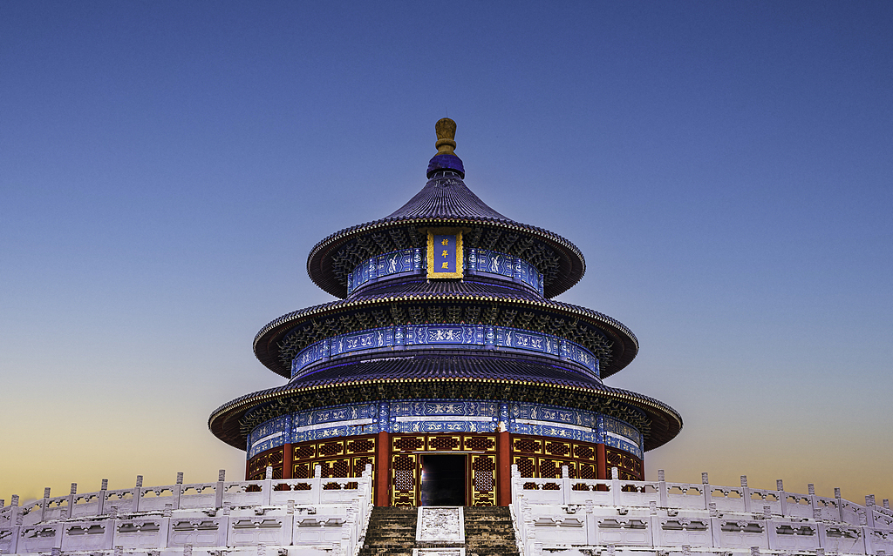
11:00 - 13:30 Hutong Rickshaw Tour & Free Time for Lunch
After visiting the Temple of Heaven, we will leave for Hutong Alleys. There are quite a few ancient Hutongs in Beijing, which are the traditional alleys with old Siheyuan, a kind of folk quadrangle dwellings. There are also some former residences of celebrities hidden in the old Hutongs.
To explore the Hutongs deeply, we will arrange a special rickshaw ride for you. Rickshaw, a popular transportation in cities in the Republic of China era, is a three-wheeled vehicle drawn by man. Experiencing a rickshaw tour may bring you an illusion that you are traveling to the early 20th century of China. Afterwards, you will enjoy some free time there and have lunch on your own. Your guide will recommend you authentic local restaurants and foods according to your taste
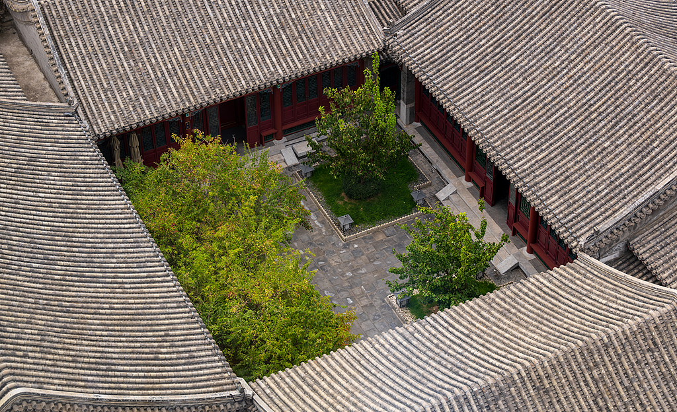.
13:30 - 15:00 Visit Lama Temple
In the afternoon, we will head to visit the Lama Temple, an imperial Tibetan Buddhist temple. It was originally constructed in the late Ming Dynasty. Nowadays, it has become the most welcomed temple for people to pray for peace and goodwill. Walking in the temple, you will not only see the splendid royal buildings, but also learn the mysterious Tibetan religious culture from your guide.
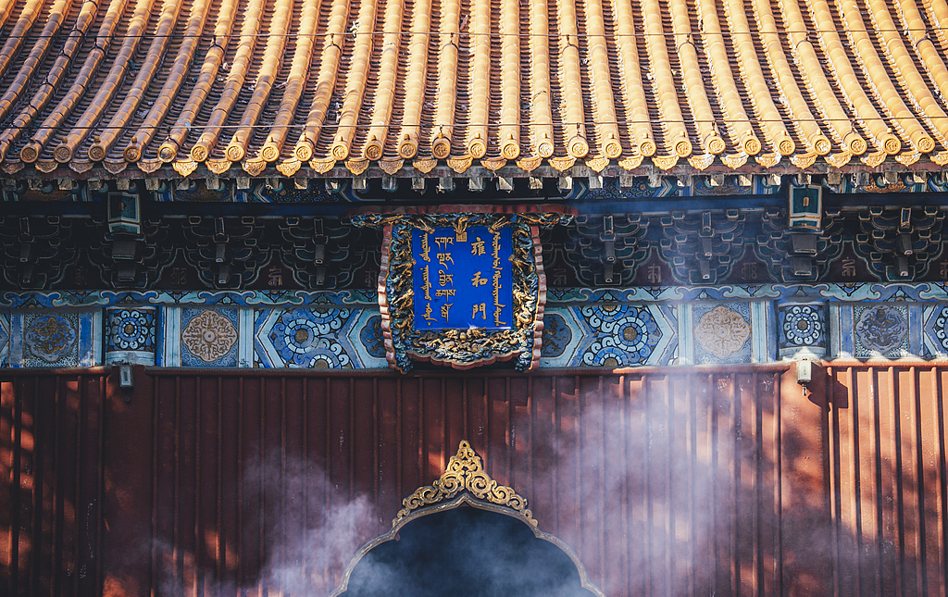
15:00 - 17:30 Visit Summer Palace
Next, we are going to visit the Summer Palace, the best-preserved and largest-scaled imperial garden in China. Built in the Qing Dynasty, the Summer Palace is based on the Kunming Lake, a pretty large natural lake in Beijing, and the Longevity Hill, which lies by the lake. Besides, the Seventeen-Arch Bridge is also worth a visit. It looks like a long rainbow lying on the wave, especially amazing at dusk.
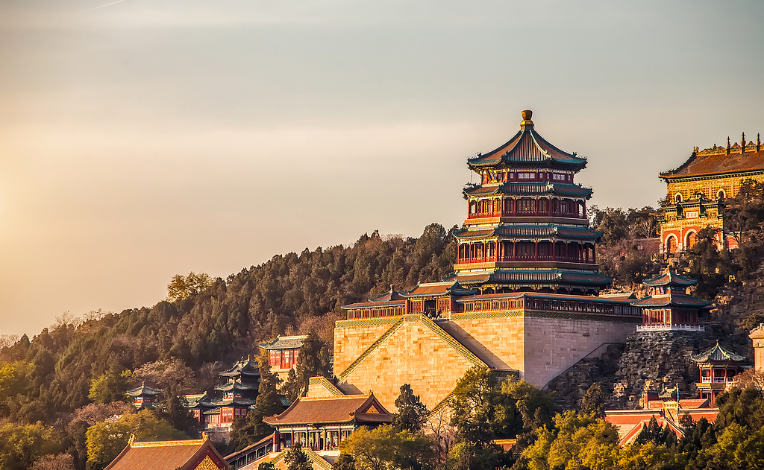
17:30 Hotel Drop-off
After an entire day of sightseeing, your guide and driver will escort you back to the hotel. Then your Beijing city tour brings to a successful end. We wish you have a nice day genuinely.

