Packages detail
One Day Beijing Mini Group Day Tours, No Shopping
USD99（A minimum order of 2 people is required）

Overview
Tiananmen Square-Forbidden City- Mutianyu Great Wall-Hutong

Trip Highlights
• Mini group of about 12 people, with more personal service.
• Price Beat Guarantee: 100% lowest fare is here! We beat any price of identical tour service.
• Visit the 600-year-old imperial Forbidden City and enjoy a cultural feast.
• Smartly avoid the crowds and hike Mutianyu Great Wall on the most beautiful part.
• Unlimited bottles of drinking water and small local refreshments provided for free.
• In-depth commentary and photography inspirations are offered by your professional English-speaking guide.
• No optional tours! Optional tour is just a tourist trap and will always cost you more with a high markup on price.

Included & Excluded
Price Includes
• Pick-up & drop-off from the hotel
• Entrance fees as indicated above
• Professional English speaking guide
• Experienced driver & air conditioned vehicle
• Unlimited bottles of drinking water for free
• Baby seat available for free

Price Excludes
• Hotel accommodation
• Cable car ride on Mutianyu Great Wall
• Meals, advice freely available
• Tips or gratuities to guide and driver

Itinerary

7:00 - 8:00 Hotel Pick-up
Your tour guide will contact you one day in advance to confirm the exact pick-up time. Today at the appointed time, your guide will wait for you in the hotel lobby. Then we set off to start this Beijing day trip.

How to get the pick-up message?
* Your guide will contact you directly if you have a local Chinese number.
* Your guide will contact you through the hotel. If you are out, he/she will leave a message to the hotel reception.
* We will send an email to you with your guide’s contact information and the pick-up time.
* In case you haven't received the pick-up message before 20:00, please contact your guide or travel consultant. We have your back 24 hours.

Note: We usually arrange pick-up from hotels between 7:00 and 8:00. However, to avoid crowds in the peak season and also the heavy traffic on the day, we may advance the pick-up time occasionally. Appreciate your kind understanding!

8:00 - 11:30 Visit Tiananmen Square & Forbidden City
Now let's start this Beijing day tour from the city's core area - the Tiananmen Square. Follow your guide to take a short walk on the largest city square in the world, and you can shoot distant view photos of the brilliant landmark buildings in and around the square, such as the Monument to the People's Heroes, the Great Hall of the People and the Chairman Mao Memorial Hall.

Walking through the Gate of Heavenly Peace, we come to this morning's highlight - the 600-year-old Forbidden City, which is the largest and the most intact imperial palace complex of the Ming and Qing courts (1368-1911 AD).

The majestic Forbidden City has 9,999 rooms! Which are the most essential and interesting parts? Our veteran itinerary designer has carefully selected some top palaces for you, including the major ones on the traditional central axis, and some special chambers on the east and west wings.

Important note: Entrance tickets of the Forbidden City are usually released online 7 days in advance and could be easily sold out. Kindly advise you to book the tour at least 8 days before since the ticket purchase is based on the real name policy.

Attention: Since the Forbidden City is usually not open on Mondays, we will arrange for you a visit to the Summer Palace instead of Tiananmen Square & Forbidden City if your travel date happens to meet Monday. It is the largest and best preserved royal garden in China. The Kunming Lake, Longevity Hill, Seventeen-arch Bridge, Long Gallery, Palaces, and Pavilions in the Summer Palace are all worth your exploration here.
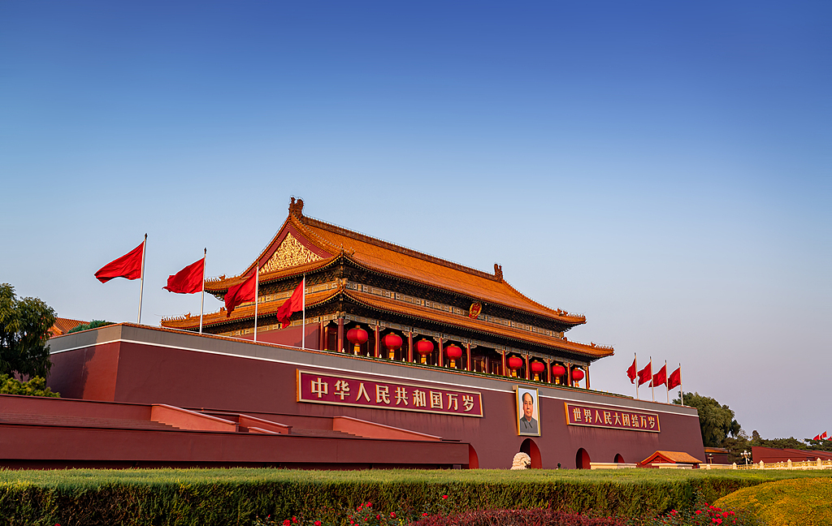
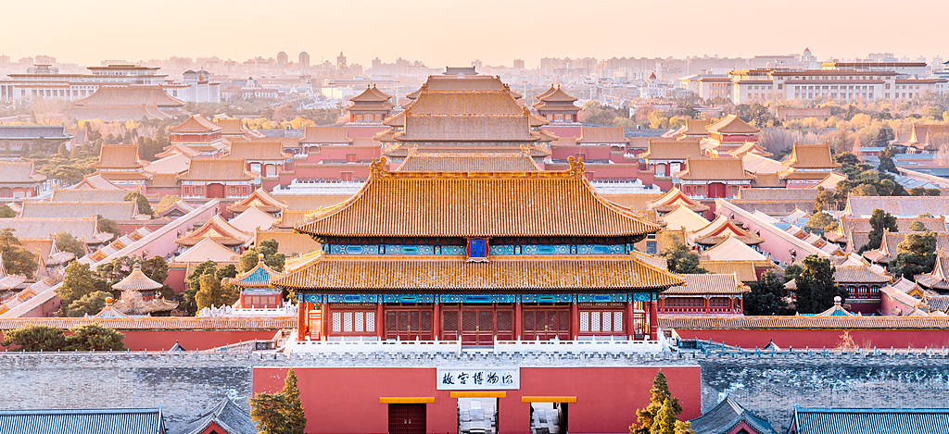
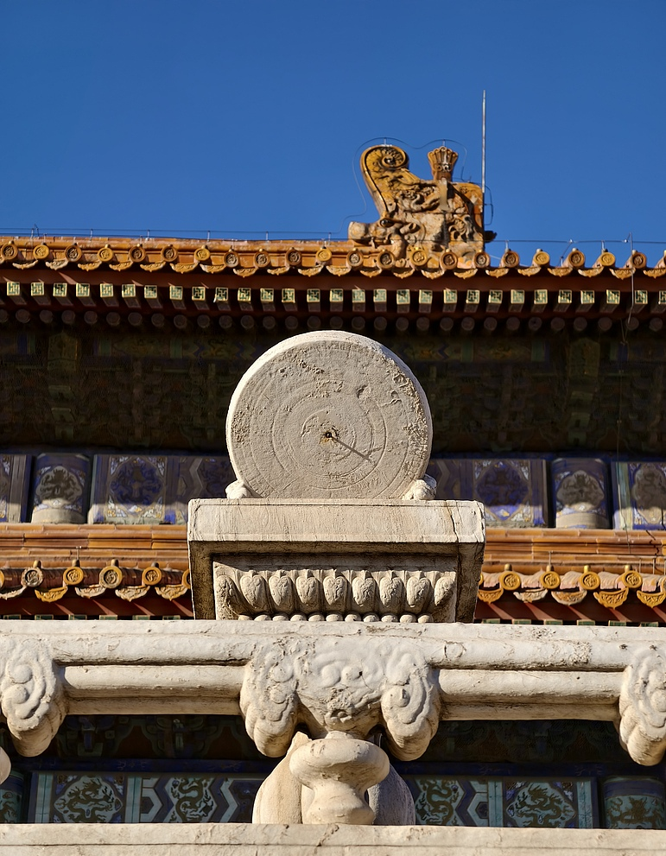

11:30 - 13:30 Drive to Mutianyu Great Wall
It takes around 1.5 hours to drive from the downtown Beijing to the Mutianyu Great Wall. Your guide will share with you some historical facts and less-known titbits on the Great Wall of China. During the drive, we will considerately provide every member with bottles of drinking water and small local refreshments.

Wise lunch suggestion: A variety of food choices like pizzas, hamburgers, and noodles are available at the foot of the Great Wall. Your guide will show you the restaurants and leave you 30 minutes for a quick lunch.

13:30 - 16:30 Visit Mutianyu Great Wall
While Great Wall sights are located outside city center and lack decent dining options, we won’t detour to the restaurants in order to maximize your time exploring the Great Wall. The stories of this world wonder shared by your professional guide will make your Great Wall tour Beijing truly unforgettable.

The Great Wall, once a military defense project, dates back over 2,000 years, from the Warring States Period (476 - 221 BC) to its completion in the Ming Dynasty (1368 - 1644), and Mutianyu is one of the best-preserved sections of the Ming Great Wall. In 1368, Emperor Zhu Yuanzhang ordered General Xu Da to lead a northern expedition to drive Mongolians out and establish the Ming Dynasty. As the retreating Mongol forces posed a continued threat, the construction of the Mutianyu Great Wall began. As you follow the guide to hike the wall, look at its dense beacon towers one after another on every key turn of the ridges. What were these towers for? During the mid-Ming Dynasty, General Qi Jiguang valued the strategic location of Mutianyu and led troops to strengthen the wall, adding countless beacon towers to make it more indestructible. At that time, soldiers lit fires and cannons on the towers to transmit information about enemies: one fire and one cannon signaled less than 100 enemies; three of each meant 1,000 to 5,000 enemies ahead; and five indicated a large army of more than 10,000 attackers was in action. Standing on these towers today, you can feel the echoes of the historical moments and take once-in-a-lifetime photos.

Ways going up and down the Great Wall
Hike the whole way: If you start hiking from the North Entrance, you will reach No. 8 or No. 10 watchtower, while No. 6 or No. 8 watchtower could be accessed if you go through the South Entrance. There are around 500 steps on the mountain way. Usually it takes about half an hour getting to the watchtower whichever route you take.

Round-way cable car: CNY140 per person at your own expense. Another option is to take a chairlift up and a toboggan down at the same price, but the cable car ride is recommended for more security reasons. You can purchase the tickets on spot with your guide's assistance.
Hike up and cable car down: You may hike one way up to the wall to experience the hardship of the laborers to construct the wall in ancient times, and then after the wall visit, get down by cable car from the No. 14 watchtower for CNY100 at your own expense.
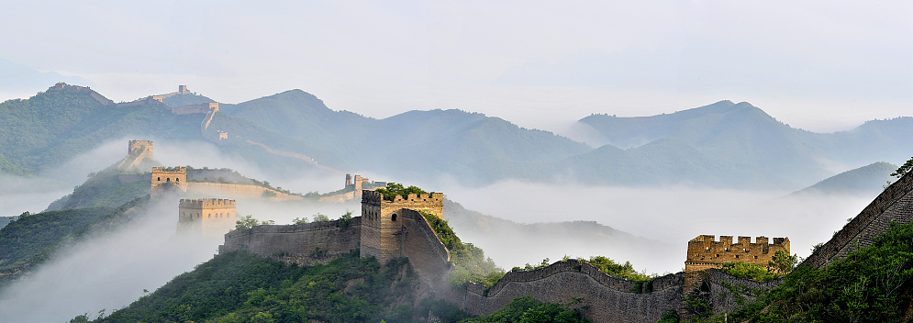

16:30 - 18:00 Drive back to Downtown
We will take another 1.5 hours to drive back to the downtown Beijing. You can massage your legs gently and take a brief rest with your eyes closed in the car to recover from the fatigue of climbing the Great Wall.

18:00 Houhai Bar Street & Tobacco Pipe Lane, or Hotel Drop-off
To let you experience traditional charms and lively nightlife in old alleys, we will have a stopover at the popular area of Houhai Lake and Tobacco Pipe Lane, aka Yandaixie Street, which epitomizes old Beijing. There are various specialty bars, cafes, restaurants, curio shops, as well as the beautiful Houhai Lake nearby. If you are interested, you can get off here to enjoy the rest time free; if not, let’s continue to your hotel.
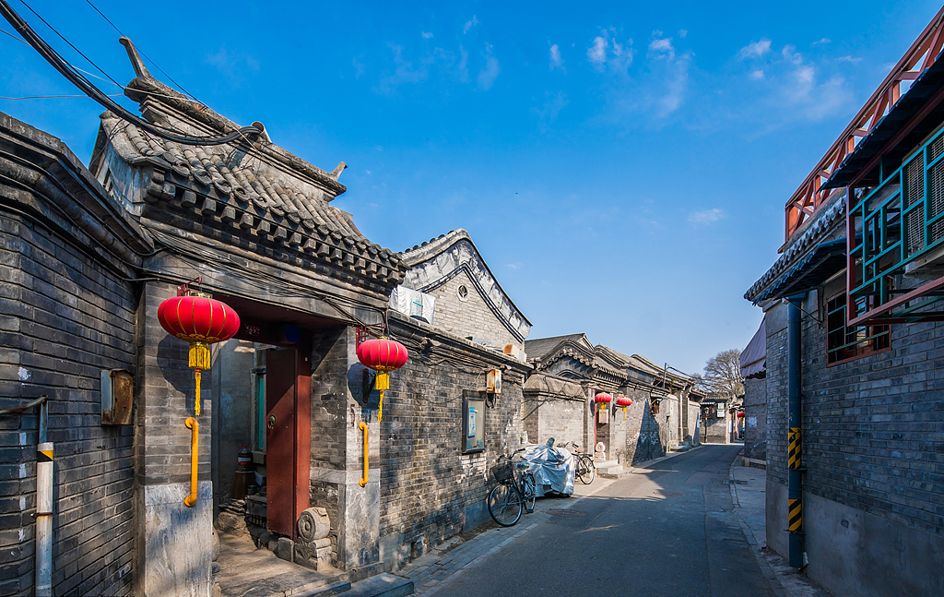
You are encouraged to explore the area on your own. Try the local foods and snacks for dinner, enjoy some boating on the lake, mingle in local life bustling until 9 pm with spectacular night view, and finally drop by a bar for a drink over live music. You may enjoy a cozy moment in a happening little bar interestingly named “Jumping into Houhai Lake”. If you are especially into craft beer and rock music, well, this is your home! Each glass here costs CNY 65 or USD 9 on average. When it’s late, wander to the adjacent street and hail a taxi back. Hope you have enjoyed this day trip from Beijing to the Great Wall. Wish you a nice dream tonight!

