Packages detail
6 Days Small Group Tour of Beijing – Shanghai

Beijing Shanghai Express USD1049
An additional fee of $200 will be charged during China's legal holidays and the summer vacation (July and August).

Overview
Tour Type: Small Group of max 18, guaranteed departures
Guide: Professional English-speaking tour guide in each city
Transportation: Spacious air-conditioned coach with experienced driver
Accommodation: 5 nights at good 5-star hotels
Trip Highlights：
• Must-sees - Mutianyu Great Wall, Forbidden City, Temple of Heaven, the Bund
• Cruise on the Huangpu River to take in the impressive skylines of Shanghai
• Experience China's most developed high speed train from Beijing to Shanghai
• Enjoy a la carte meals & taste authentic Chinese cuisine at superb restaurants

Included & Excluded
Price Includes
• High-speed train fare
• Hotel accommodation with breakfasts
• A la carte lunches as itinerary specifies
• Professional English-speaking guides
• Drivers & air-conditioned vehicles
• Entrance fees to tourist sites
• Tips or gratuities for hotel porters

Price Excludes
• International airfares
• Entry Visa fees
• Personal expenses
• Tips or gratuities for guides and drivers

Itinerary
Day 1 Arrival in Beijing
Your enjoyable escorted China tour starts with our helpful pick-up service. Upon landing at Beijing Airport, your guide will greet you outside the customs area, and then your driver will transfer you to the hotel in a clean and comfortable vehicle. The remainder of the day is free for you to refresh from fatigue after a long journey. You can get the first impression of the city on your own. As the capital city of China for hundreds of years since 1261, the Yuan Dynasty, Beijing leaves so many surprises for visitors, from imperial palaces, summer retreats, old narrow alleys, and ancient temples with giant Buddha statues. Here is also the best place for aliens to experience the traditional culture and folk art of China, like Peking Opera. We have tried to include all those elements in your incredible Beijing trip and just be ready for it!
Accommodation: Hotel New Otani Chang Fu Gong
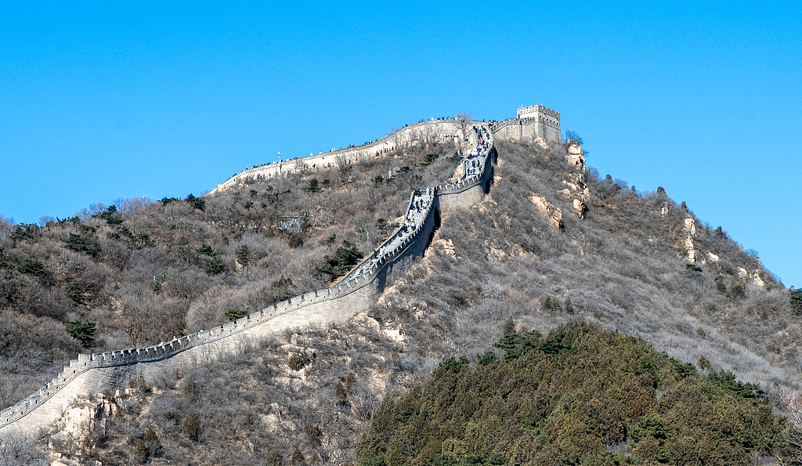
Day 2 Beijing
After breakfast, you will meet with your fellow group members in the hotel lobby and then set off for today's visit. The first destination will be Tiananmen Square, one of the largest city squares in the world, where you can see a lot of monumental buildings like the National Museum, Monument to the People's Heroes, and Great Hall of the People. Then follow your guide, walking across the vast square, to enter the Forbidden City built in 1406. The halls with flying golden roofs and red walls, carved dragons, and lion statues in the palace reveal the past glory of the fallen imperial family. You will also have a special visit to the palace’s Treasure Gallery, where a lot of extant royal accoutrements are exhibited in 6 rooms. The 600-year-old palace complex has more than 9,000 rooms, including the Front Court for emperors dealing with government, the Back Palace for emperors’ and their concubines’ daily lives, as well as a beautiful imperial garden at the northernmost point. During the visit, you may find some water channels in the garden. Though looking like a part of the drainage system, they are actually troughs used by animals. The imperial garden used to be a playground for royals to spend their time and some wild animals were also fed here to entertain them, such as red-crowned cranes and deer.
Finish the visit to the ancient royal palace, and we’ll especially serve you an a la carte welcome lunch (valued at CNY150 per person and included in our price) at a famous restaurant to taste authentic Chinese cuisine. Don't forget to order the yummy Peking Duck.
In the afternoon, continue your visit to the Temple of Heaven, the imperial altar for the emperors of the Ming (1368 - 1644) and Qing (1644 - 1911) Dynasties to worship the God of Heaven. This is the most solemn site for ancient Chinese people, representing their understanding of the relationship between earth and heaven. This evening, you will be entertained by a lively Chinese Acrobatic Show at the Red Theatre.
Meals: Western buffet breakfast, A la carte welcome lunch
Accommodation: Hotel New Otani Chang Fu Gong
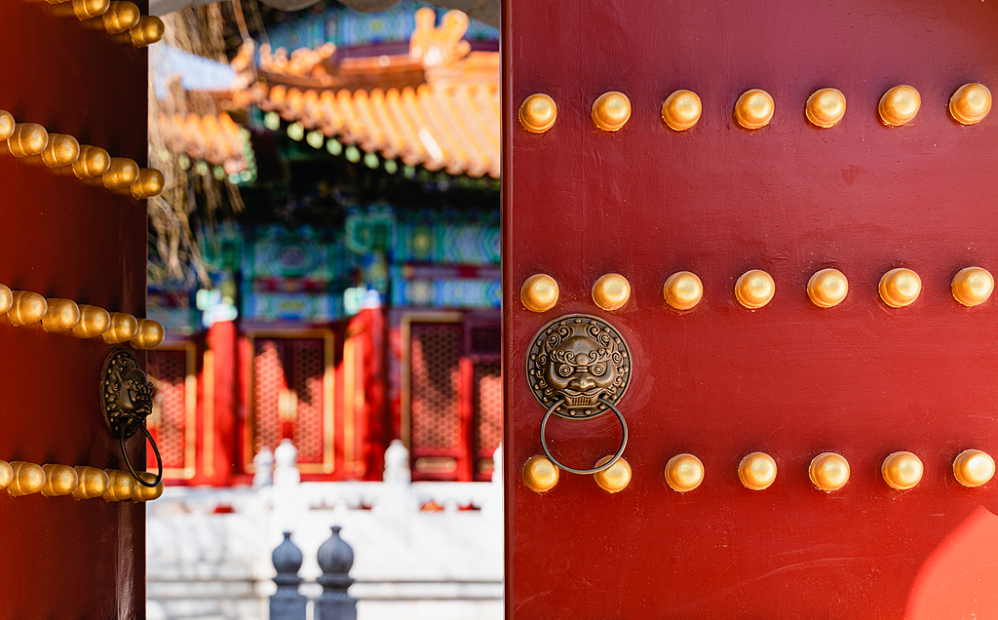
Day 3 Beijing
The morning's excursion takes you to Mutianyu Great Wall, one of the world's wonders. Constructed in the Ming Dynasty, Mutianyu is one of the best preserved sections of the Great Wall, with spectacular surrounding natural scenery. The wall, dotted with beacon towers, stretches along mountain ridges for miles, resembling a huge flying dragon. We arrange for you to take the round-trip cable car to reach and descend the wall to save you energy and time. Free time will be left for you to tour along the Great Wall to explore the watchtowers and appreciate the majestic views. By the way, we also arrange you a good wine toast on the new world wonder.
As the Great Wall is far away from the urban area, without so many lunch options, we suggest that you have a big breakfast and take some fast food for lunch by yourself. Your guide will also be glad to provide you with advice.
We will then escort you back to the city. Have a stopover for nice photo shots at the Olympic National Stadium (Bird's Nest), where the 2008 Olympic Games was held. Then you will have a Hutong tour by rickshaw. Hutong means narrow alleys in Beijing's old blocks. Experiencing the traditional courtyards, local culture and history, all of which make your tour in Beijing more charming and special. There is also a chance to visit a local family to have an insight into the old way of life of Beijing locals.
Meals: Western buffet breakfast
Accommodation: Hotel New Otani Chang Fu Gong
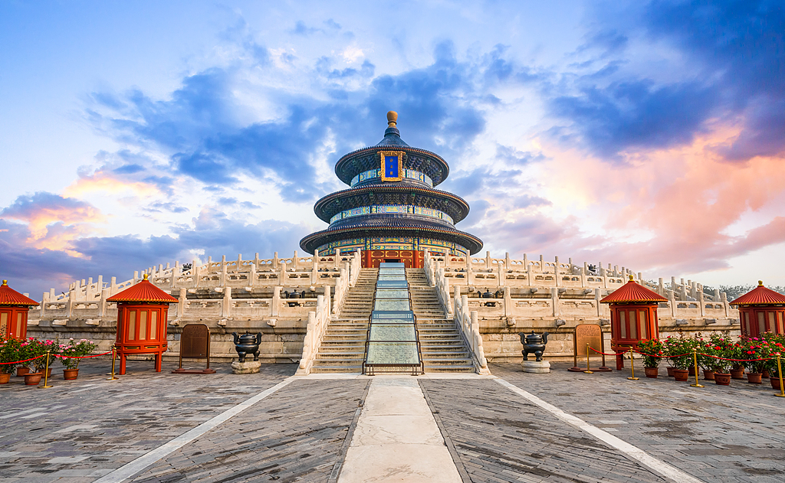
Day 4 Beijing to Shanghai by High-speed Train
Today's visit starts with Beijing Zoo, where you will see lovely pandas. We specially arrange it in the morning because pandas are the most active in the morning. You can view them happily play, eat, and climb trees. Then continue to the Summer Palace, the largest and best preserved imperial garden in China. Constructed on the natural scenery of Kunming Lake and Longevity Hill in the Qing Dynasty, the garden is a perfect combination of landscape and imperial palaces.
After lunch, you will take an afternoon high-speed train for around 4.5 hours to reach Shanghai. Take a nap on the train or view the countryside scenery along the way. Snacks, fruits, music or books are always good company for the train journey, so you may prepare some in advance. Your local guide in Shanghai will meet you at the train station and escort you to the hotel.
Meals: Western buffet breakfast, Lunch
Accommodation: Radisson Blu Hotel Shanghai New World
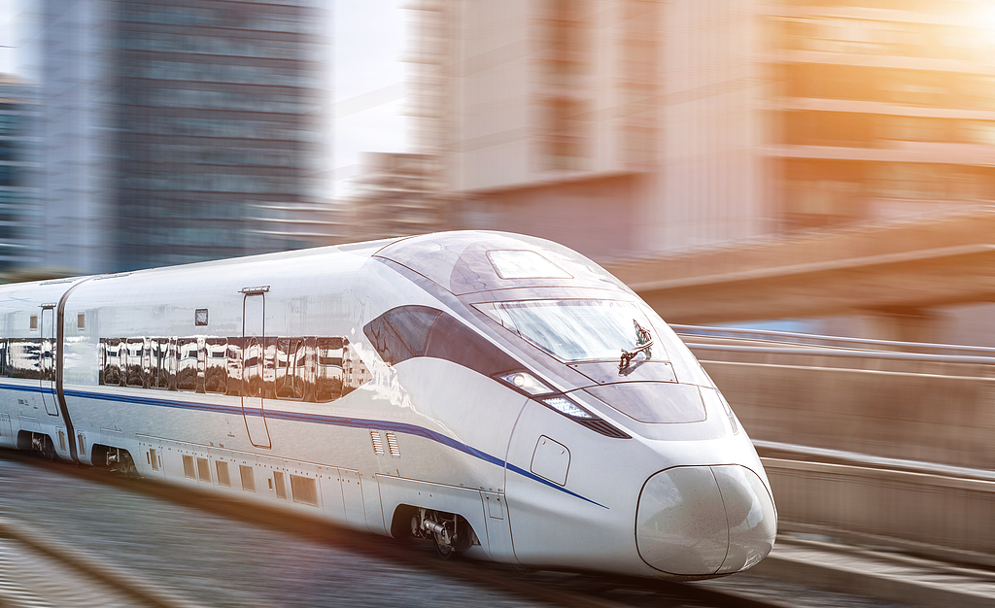
Day 5 Shanghai
Known as the most modern city in China, Shanghai offers more than skyscrapers and gorgeous night views. It also boasts a historical and traditional side, waiting for your exploration. After breakfast at the hotel, we will visit the Shanghai Museum first, which features an ancient Chinese bronze vessel-shaped outer appearance and houses over 120,000 pieces of cultural relics including bronze wares, jades, ceramics, Chinese Calligraphies, and coins. Then we will head to the Yu Garden, a typical Chinese-style garden which can be dated back to 400 years ago. The classic garden boasts its exquisite layout, with landscaped ponds, pavilions, old bridges and strange rockeries. Among a lot of rockeries, the Exquisite Jade Rock (aka Yulinglong Stone) is the most famous one, with a height of 3 meters and weight of 3 tons, featuring elegant edges and interesting shapes. It is said the famous stone once served as a dowry to be sent to the son of the garden’s owner to show the large wealth of the two powerful families. Another iconic sight in the garden is several imposing Dragon Walls, stretching over 20 meters. The black dragon’s body is made of tiles winding on top of the white wall, and there is a feeling of flying out. Chinese dragon with five claws on each foot is always considered the symbol of emperors and normal people who used related objects would be put to death. It is said the garden’s owner cut all the claws of the dragon in the garden into three claws, arguing that they were three-clawed pythons, not dragons. Then the Dragon Walls could be saved from the wrath of emperors. We will continue to explore the Yuyuan Old Street surrounding the garden, where there are many traditional Chinese buildings, which nowadays are used as commercial stores to sell local products, arts and crafts, antiques, snacks and so on. You will enjoy some free time there.
Afterward, we proceed to the Bund area, where you will also take a one-hour cruise tour along the Huangpu River to take in 19th-century colonial buildings on the west bank and high-rise buildings on its east bank. Upon returning to the hotel, your guide will see you into the lobby and bid you bon voyage.
Meals: Western buffet breakfast
Accommodation: Radisson Blu Hotel Shanghai New World
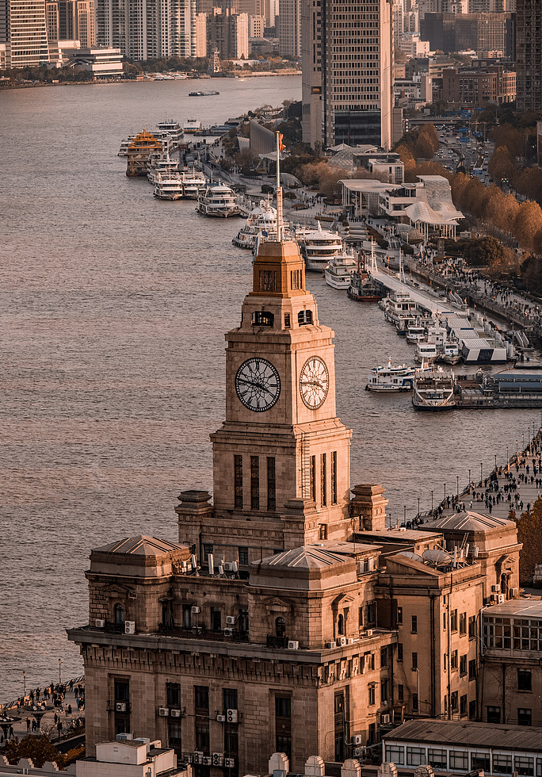
Day 6 Departure from Shanghai
Your 6-day China group tour of Beijing Shanghai ends today and please check out before noon. You need to make your own way to the airport for your homebound flight. We wish you a nice trip home!
► To Shanghai Pudong International Airport (PVG)
You can take Metro Line 2 directly from People’s Square in about 80 minutes, or take Metro Line 2 to Longyang Road metro station and then experience the maglev train, taking only 50 minutes. A direct taxi is also available, taking about 1 hour and costing CNY 200 or so.
► To Shanghai Hongqiao Airport (SHA)
Walk south about 160 meters to take Metro Line 2 from People’s Square to Hongqiao Airport Terminal 2 Station, taking about 40 minutes. If by taxi, it costs around CNY 60-80 at different times but the travel time is nearly the same as that of metro.
Meals: Western buffet breakfast
