Packages detail
9 Days Small Group Tour of Beijing - Xi'an – Chengdu

Follow Pandas' Footprint USD1399
An additional fee of $200 will be charged during China's legal holidays and the summer vacation (July and August).

Overview
Tour Type: Small Group of max 18, guaranteed departures
Guide: Professional English-speaking tour guide in each city
Transportation: Spacious air-conditioned coach with experienced driver
Accommodation: 8 nights at good 5-star & 4-star hotels
Trip Highlights：
• Must-sees - Mutianyu Great Wall, Forbidden City, Terracotta Army, Giant Pandas
• See the giant pandas up close in the Panda Breeding and Research Center
• Ride a bicycle on the Ming Dynasty City Wall of Xi'an, or take an electric car
• Enjoy a la carte meals, Acrobatic Show, Tang Dynasty Music and Dance performance

Included & Excluded
Price Includes
• Domestic airfares & train fares
• Hotel accommodation with breakfasts
• A la carte lunches as itinerary specifies
• Professional English-speaking guides
• Drivers & air-conditioned vehicles
• Entrance fees to tourist sites
• Tips or gratuities for hotel porters

Price Excludes
• International airfares
• Entry Visa fees
• Personal expenses
• Tips or gratuities for guides and drivers

Itinerary
Day 1 Arrival in Beijing
Welcome to choose our 9-day Beijing Chengdu tour with Xi'an! Upon your arrival in Beijing, our guide will be expecting you outside the customs of the airport and then our driver will transfer you to the already reserved hotel in a comfortable and clean car. For the remainder of the day, you can rest well to release the jet lag or explore the surrounding area on your own to get the first impression of the city.
Beijing not only boasts a wealth of Chinese history, ancient palaces and halls, and old wall fortifications, but also is a melting pot of cultures where you can savor Chinese traditions at Hutongs, taste delicious Beijing Duck, and experience the traditional culture by watching an authentic Peking Opera Show.
Accommodation: Hotel New Otani Chang Fu Gong
Day 2 Beijing
Today your itinerary starts from the center of the capital city - Tiananmen Square. The world-famous open square features monumental buildings like the Monument to People's Heroes, the Great Hall of People, and Chairman Mao's Memorial Hall. Walking northward across the square, we will reach the Forbidden City. As the world's largest and best preserved ancient architectural complex of wooden structure, it has over 8,000 rooms and houses tens of thousands of time-honored treasures. Accompanied by the professional guide, you will get an insight into the royal life of China’s last two feudal dynasties and discover more secrets about the 600-year-old giant palace complex. Some are hidden under the ground. In the court of Forbidden City’s largest hall, the Hall of Supreme Harmony, people find that under its floor tiles are still floor tiles. It is said there are a total of 15 layers, which are very impressive. It was mainly for a security purpose as the thick floors couldn’t be dug through by outsiders who wanted to assassinate the emperor. We also include the Treasure Gallery visit in your Forbidden City trip and it exhibits some valuable possessions of emperors, including ritual vessels, decorations, and artifacts.
For today's lunch, you will enjoy our special offer - the a la carte Chinese food with Peking Roast Duck at one of the best local restaurants (valued at CNY150.00 per person and included in our price).
In the afternoon, you will be guided to visit the Temple of Heaven, the royal altar of the Ming and Qing Dynasties (1368 - 1911), where emperors prayed for good harvests. You will be amazed at the awe-inspiring circular building with round roof which has no nails at all. After that, a fantastic Chinese Acrobatic Show will be tonight's highlight and you will be impressed by the excellent performance.
Meals: Western buffet breakfast, A la carte welcome lunch
Accommodation: Hotel New Otani Chang Fu Gong
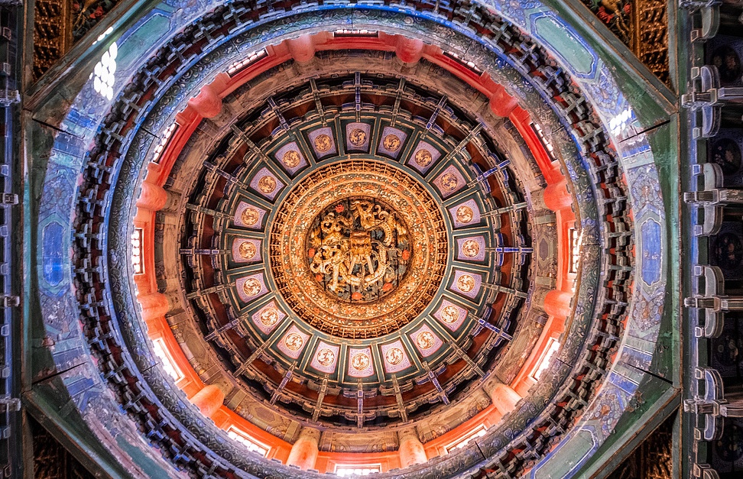
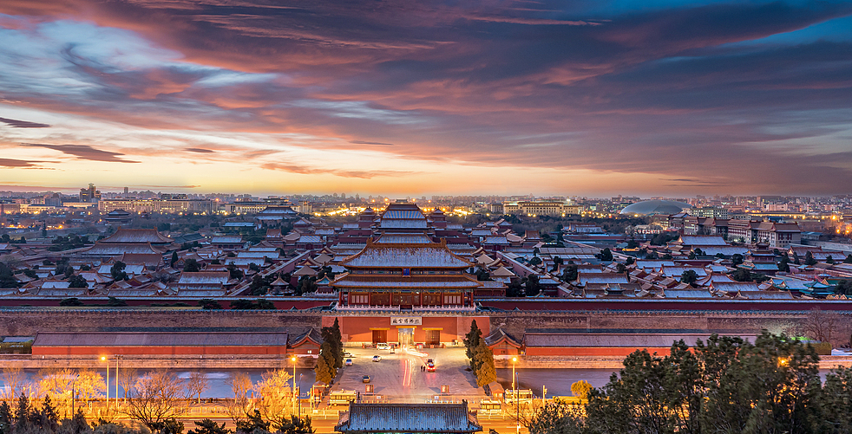
Day 3 Beijing
Your guide will pick you up in the early morning for the trip to Mutianyu Great Wall. It is one of the most splendid and the most representative parts of China Great Wall. The round-trip cable car will take you up and down (included in the price), which offers you more sightseeing time on the Great Wall to cover more watch towers. What’s more, red wine is ready for you. You will enjoy a cup of wine and give a toast on the world wonder. The restaurants near the site may not be so convenient. It is more suggested to have a big breakfast at the hotel and carry some fast food for lunch by yourself.
After that, you will be escorted back to the urban area and pass by the Olympic National Stadium in 2008. You will have a chance to take photos of this large Bird's Nest from a distance. Then follow your guide to trace the old Beijing by riding a rickshaw along the narrow but original Hutong alleys, where you can touch the city’s soul among the groups of traditional courtyards and local residences by observing the local Beijinger’s lifestyle. You will feel excited to visit a local family’s house in the Hutong.
Meals: Western buffet breakfast
Accommodation: Hotel New Otani Chang Fu Gong
、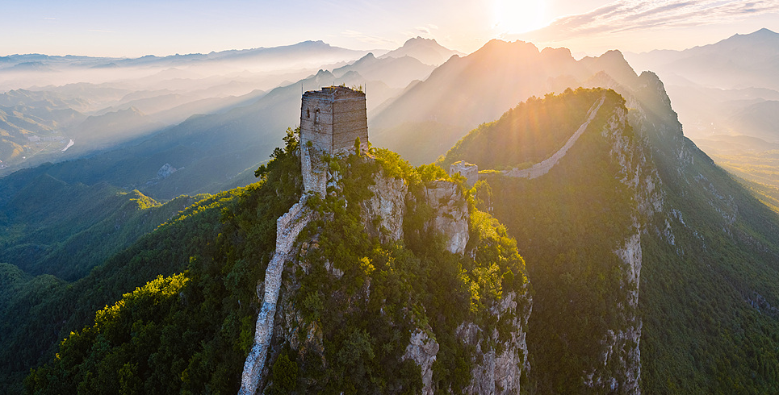
Day 4 Beijing - Xi'an
This morning you will see lovely pandas at Beijing Zoo. Afterward, you will be guided to the Summer Palace, a summer resort for the imperial royalty of the Qing Dynasty. In the vast ensemble of traditional Chinese gardens, artificial waters, pavilions, halls, pagodas and bridges, you can enjoy a leisure stroll to appreciate scenic views and walk the world’s longest corridor, stretching about 728 meters. After lunch, you will fly to the ancient capital city, Xi'an. A local guide will pick you up and help you check into the hotel.
As the oldest one of four ancient capital cities in China, Xi’an (formerly known as Chang’an) unravels a long scroll of Chinese history from the mausoleum site of the first emperor Qin Shi Huang, the eastern departure point of Silk Road, to the important Buddhist cultural center in the grand Tang Dynasty (618 - 907).
Meals: Western buffet breakfast, Lunch
Accommodation: Crowne Plaza Xi'an
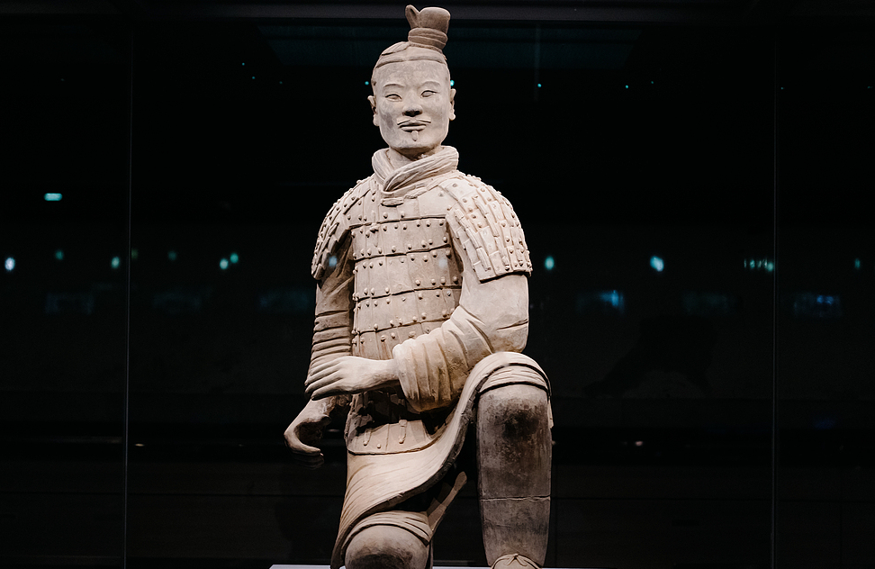
Day 5 Xi'an
To better experience the China’s historical paradise, today you will first be accompanied to the city’s biggest draw, the Terracotta Army. You may not believe that the vast and spectacular Terracotta Army is only a small part of the burial pits of the Mausoleum of Emperor Qin Shi Huang, which has more than 400 pits in total and most of them still remain unexcavated. The grand mausoleum project started as soon as Emperor Qin Shi Huang ascended to the throne in his 13 (247 BC), and it was constructed by 720,000 workers for 39 years. Beyond the magnificent mausoleum, another Chinese engineering wonder was also commissioned by the famous emperor and that is the Great Wall you see in Beijing, which was constructed by over a million people.
The museum not only displays the world-known delicate figures of Qin Terracotta Warriors and Horses, but also shows visitors an array of ancient weapons from 2,200 years ago, like bronze swords, spears, scimitars, crossbows, and shields. Thereafter, we will take a visit to the home of the first discoverer of the Terracotta Army, learning some interesting stories about the first discovery. After that, you will experience making a mini clay warrior by yourself with the help of a local artisan and you can finally take it back home as a meaningful souvenir.
At noon, you will get advice from your local tour guide and have lunch on your own. After that, you will be accompanied to visit the Giant Wild Goose Pagoda. It was built in the Tang Dynasty to store the Buddhist scriptures and statues brought from India by hierarch Xuanzang. The monumental pagoda was also the place where he translated the Buddhist scrolls. As the pagoda is set in a scenic garden area and surrounded by open air squares, it is well worth an evening stroll. At night, we especially arrange a fantastic Tang Dynasty Music and Dance Show for you, offering a chance to glimpse the splendid culture of ancient China’s golden age. Meanwhile, you can savor the unique dumpling dinner.
► Friendly Tip: Since the theater is usually not open in Jan, Feb, Mar and Dec, we will not arrange the show and dumpling dinner for tours during the periods. Clients will enjoy free time tonight.
Meals: Western buffet breakfast, Dumpling dinner
Accommodation: Crowne Plaza Xi'an
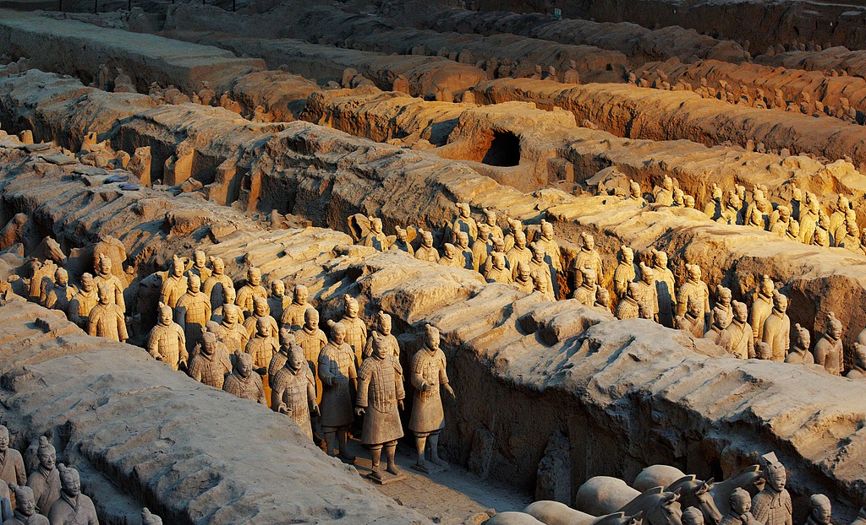
Day 6 Xi'an
Today you will begin your visit to the City Wall Park. Encircling the old City Wall, the park is the most popular place for local people to relax, especially in the morning time. You will see people attending different kinds of activities for fun. It is true that the park has brought the old wall live. Also in this park, you will learn to practice Tai Chi with a master. From the park, we will head to the best-preserved Ming Dynasty City Wall built in 1370. The 12-meter-high walls feature a base width of about 16 meters and the tops are about 12-14 meters wide. It will be a memorable experience to stroll or ride a bicycle on the wall to feel the history and appreciate the city views inside and outside the city wall. If feel interested, you can rent a bike at your own expense (CNY 45 / USD 7).
Around noon, we will continue to explore the lively Muslim Quarter. Follow your guide closely or you may get lost in the maze-like bustling food paradise full of snacks and restaurants. Some famous snacks include Pao Mo (bread in mutton soup), Skewers, Hand-Stretched Noodles, and Beef Roujiamo (Chinese hamburger). Here, you can have a taste of the local snacks you like for lunch (included in the price). In the afternoon, stroll through the Muslim Quarter’s narrow lanes to visit its iconic attraction, the Great Mosque. Though a Muslim mosque, it combines a part of Chinese architectural features. Spend some time here to take in centuries-old historical temple buildings and enjoy the tranquility of its Chinese-style courtyard. Then you will be accompanied to the Small Wild Goose Pagoda, an ancient brick pagoda built in the Tang Dynasty, hidden in a lovely and picturesque park which also houses Xi’an Museum, displaying the city’s deep history through silver works, jade items, pottery figures and Buddhist relics.
Meals: Western buffet breakfast, Lunch
Accommodation: Crowne Plaza Xi'an
Day 7 Xi'an - Chengdu
This morning you will take a high-speed train for about 4 hours to Chengdu, the famous panda capital. Upon your arrival, our guide will pick you up and transfer you to the hotel, and then help you check in for a 2-night stay. The rest of the day is free for you to relax at the hotel or look around the city on your own.
As one of the happiest cities in China for consecutive years, Chengdu located in southwestern China offers more than its most lovely resident, pandas, but also the leisurely and slow-paced lifestyle with China’s largest number of tea houses and third largest number of bars. It is also well known for its local cuisine and designated as a City of Gastronomy by UNESCO.
Meals: Western buffet breakfast
Accommodation: Holiday Inn Chengdu Oriental Plaza

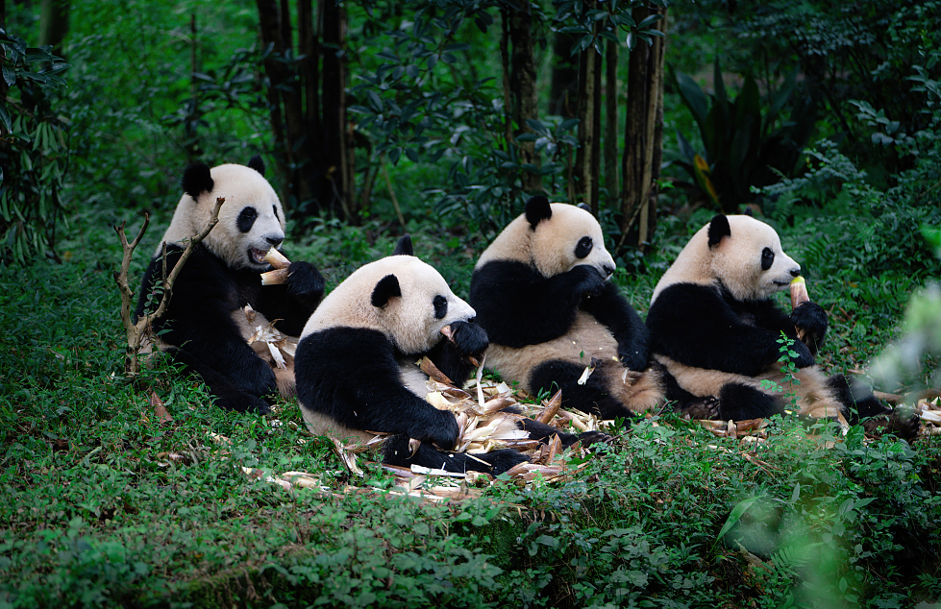
Day 8 Chengdu
Today we will first pay a visit to the lovely giant pandas in Chengdu Research Base of Giant Panda Breeding. Giant pandas only inhabit in China, so it is regarded as the China’s national treasure. They are always more active in the morning so we especially arrange the visit at the time when you can see them eating bamboo, climbing trees, and playing. Then our guide will escort you to explore the Wide and Narrow Alley. Composed of ancient streets from the Qing Dynasty, it is now serves as an iconic community offering fun eateries, boutique shops, and some old Sichuan traditions like tea ceremonies and Sichuan operas. Lunch is arranged on your own and be adventurous to taste some local snacks in the alley or choose a traditional courtyard restaurant to enjoy your lunch.
In the afternoon, we will proceed to visit Jinsha Site Museum. Covering an area of 5 square kilometers, it is the historical remains of the Shang and Zhou Dynasties (1700 - 221 BC) focusing on the cultural relics' exhibit and the sacrificial site. Here you can learn about Chengdu’s early history and have a glimpse of an old civilization that different from China’s mainstream Yellow River civilization, undoubtedly a crucial piece of Chinese history. Then we will head to the last stop of today, People’s Park, to experience the casual lifestyle of Chengdu people. Have a pot of tea and enjoy a relaxing time as most locals do.
Meals: Western buffet breakfast
Accommodation: Holiday Inn Chengdu Oriental Plaza
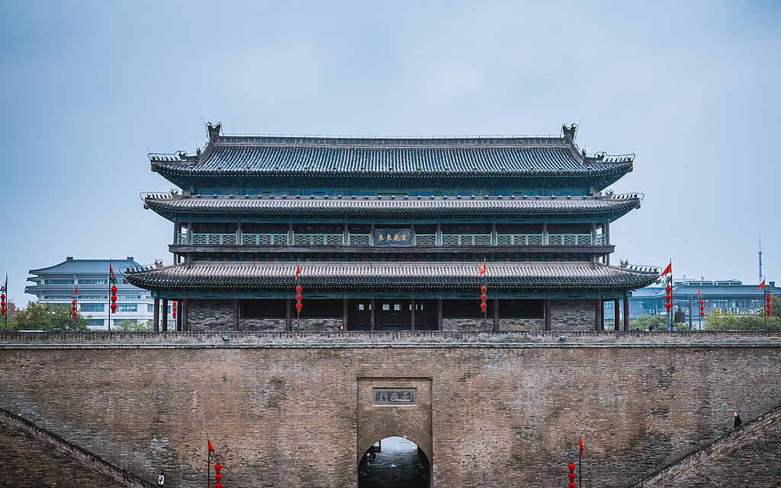
Day 9 Departure from Chengdu
Your 9-day China tour comes to an end today. After breakfast, please check out the hotel before 12:00 and make your own way to the airport for your homeward flight. Wish you a pleasant journey!
From your hotel to Chengdu Tianfu Airport, by metro, you can walk west about 170 meters to take Metro Line 2 from Dongmen Bridge Station to Tianfu Square Station, and then transfer to Metro Line 1 to South Railway Station. Continue to ride the Metro Line 18 to the airport. It takes about 1.5 hours in total. If taking a taxi, it takes about 1 hour and costs around CNY100-150.
► For your reference, we also offer extension private tours after this Beijing Chengdu tour with Xi'an. There are many highlights and famous sites in Sichuan worth your visiting, such as Leshan Giant Buddha and Mt. Emei, Jiuzhaigou Valley and Huanglong. Please drop us an email freely to let us know your preference, and we will be glad to be helpful with your vacation to China.
Meals: Western buffet breakfast
