Packages detail
8 Days Small Group Tour of Beijing - Xi'an – Shanghai

Best of China USD1399
An additional fee of $200 will be charged during China's legal holidays and the summer vacation (July and August).

Overview
Tour Type: Small Group of max 18, guaranteed departures
Guide: Professional English-speaking tour guide in each city
Transportation: Spacious air-conditioned coach with experienced driver
Accommodation: 7 nights at good 5-star hotels
Trip Highlights：
• Must-see sights in China - Mutianyu Great Wall, Forbidden City, Terracotta Army.
• Cruise on the Huangpu River to take in the impressive skyline of Shanghai.
• Family visit to meet local people and experience authentic Chinese culture.
• Enjoy a la carte meals, Acrobatic Show & Tang Dynasty Music and Dance Show.

Included & Excluded
Price Includes
• Domestic airfares
• Hotel accommodation with breakfasts
• A la carte lunches as itinerary specifies
• Professional English-speaking guides
• Drivers & air-conditioned vehicles
• Entrance fees to tourist sites
• Tips or gratuities for hotel porters

Price Excludes
• International airfares
• Entry Visa fees
• Personal expenses
• Tips or gratuities for guides and drivers

Itinerary
Day 1 Arrival in Beijing
The prelude to your 8 days China tour starts when you meet your professional local guide at Beijing Airport after reclaiming your luggage and clearing customs. The driver will convey you in a comfortable vehicle to the hotel and help you with the check-in procedure. The rest of the day is left for you to have a good rest or to become familiar with this capital city on your own.
Accommodation: Hotel New Otani Chang Fu Gong
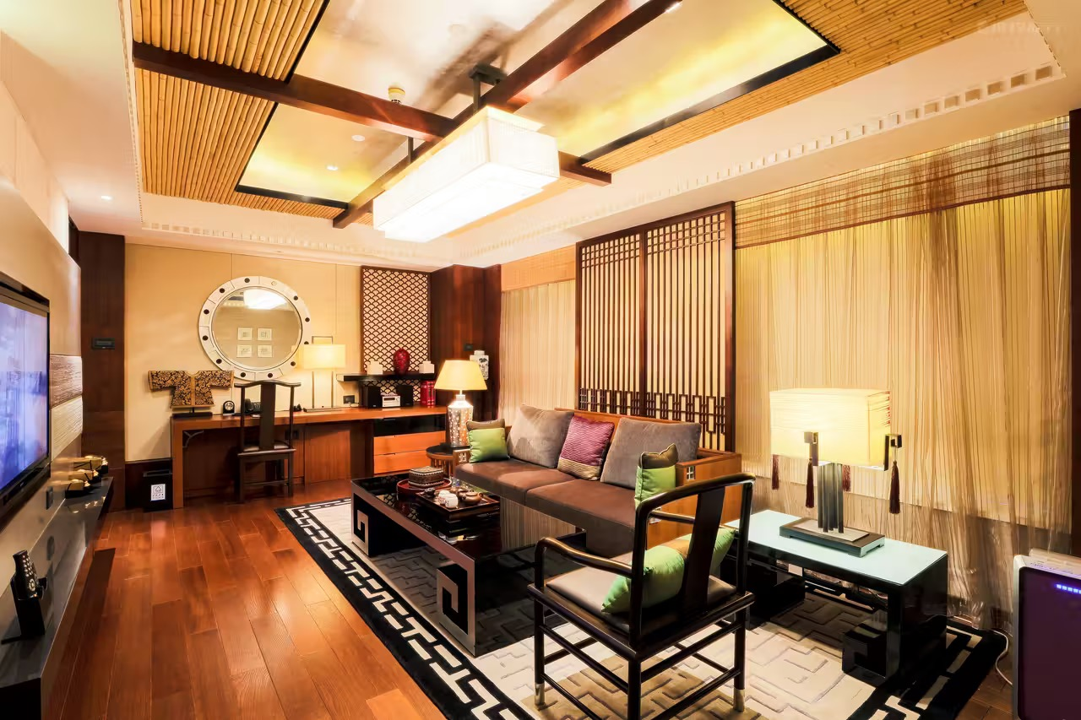

Day 2 Beijing
Today your best China tour officially kicks off! You will meet your group members in the hotel lobby at 08:30 and have a 30-minute pre-trip meeting. Your guide will make a self-introduction, welcome everyone, present a brief introduction to the trip and explain the guidelines that need to be followed during your tour.
Then we will head to the first stop, Tiananmen Square, the biggest urban city square in the world. Many constructions of great historical importance have been built on and around it, and it is an important venue for most national ceremonies. From there you will stroll all the way to the Forbidden City, the office and home of emperors of Ming and Qing dynasties (1368 – 1911 AD). Here, we will take you for a 2 to 3 hours tour covering the most worthwhile sites.
★ We make each minute of your tour in Forbidden City count
Our special ticket-booking service and a knowledgeable expert guide will save you a lot of time and energy, for you to visit as many as significant sites during these hours. With us, you also get to step into the Treasury Gallery, a site you may find missing in tours arranged by other agencies. Just as the name suggests, this is where you can find the most precious treasures left by ancient emperors or empresses, like the 1.29m tall Peal-Inlaid Gold Tower that was crafted with 85 kilo grams of gold and hundreds of pearls and gemstones. Your guide will also embellish your tour with some stories that happened here, like why the water from all those wells you see wasn’t used for drinking. Actually, it once were, but since maids and eunuchs were thrown into the wells due to court intrigue, the water became ominous and no one dared to drink ever after. It’s when they started to fetch drinking water from a nearby mountain more than 20 km away.
At noon, an a la carte welcome lunch (valued at CNY150.00 per person and included in our price) will be served at a superb local restaurant, where you can have a taste of authentic Chinese food and the world-renowned Peking Roast Duck.
In the afternoon, we will head to the Temple of Heaven, the majestic sacrificial building complex where Ming and Qing emperors worshipped the heaven in hope of good harvest. To round out a memorable start to your travel, we will arrange a lively and dramatic Chinese Acrobatic Show at the Red Theater.
Let’s call it a day now. We will take you back to hotel after the performance.
Meals: Western buffet breakfast, A la carte welcome lunch
Accommodation: Hotel New Otani Chang Fu Gong
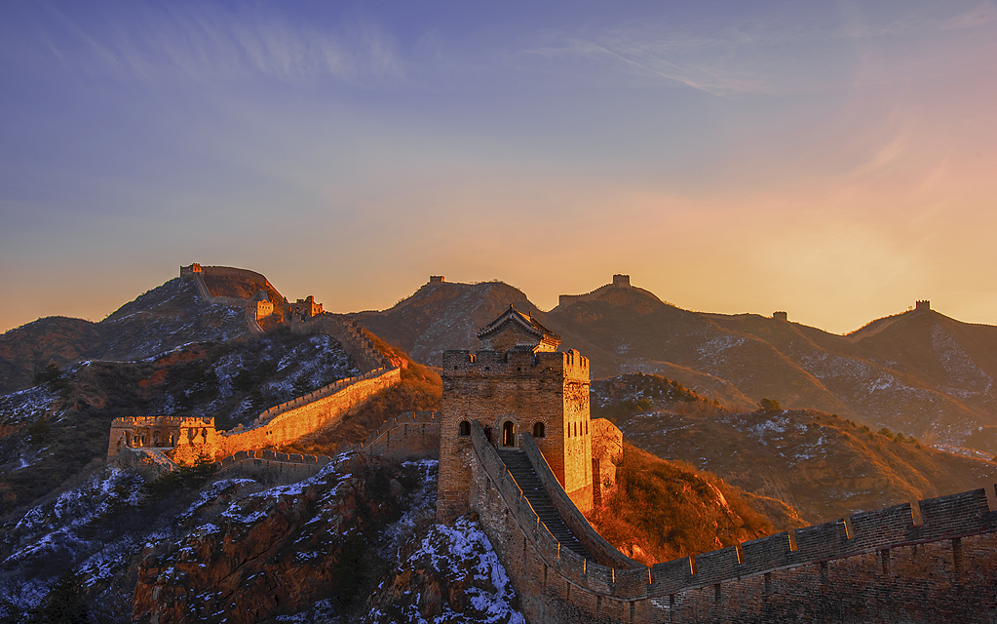
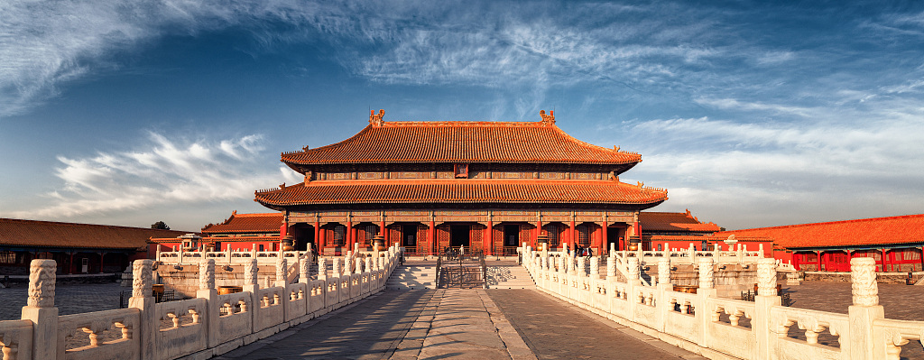

Day 3 Beijing
This morning we will take you to experience at first hand the wonder of the Great Wall of China at its Mutianyu section. A round-trip cable car ride will be arranged. Standing on the wall and looking at it as it winds up and down into the boundless distance is an exciting experience and will leave you with a life-long memory. You will enjoy quite enough time on the wall.
★ Let’s drink to this exciting moment
To celebrate and commemorate your visit to the engineering feat of humanity, we will specially provide red wine for a group-toasting after you finish your hiking on the Wall.
On the way back to Beijing this afternoon, we will drive by the Bird’s Nest, or the National Stadium, for you to take pictures of this award-winningly beautiful steel construction, originally built for Beijing 2008 Olympic Games, from close by.
Then we will take you for a rickshaw ride through Hutongs to experience Beijing’s local life. Hutongs are alleys that are lined with Chinese traditional courtyard houses, or “Siheyuan”, a quadrangular compound with houses on four sides. The rickshaw, a main vehicle for transportation in Beijing’s past, will take you for a Hutong tour for around 40 minutes, until you stop to step into a Siheyuan to visit a local family.
Then it’s time for us to drive you back to hotel. Have a good rest and prepare for tomorrow’s trip.
Meals: Western buffet breakfast
Accommodation: Hotel New Otani Chang Fu Gong
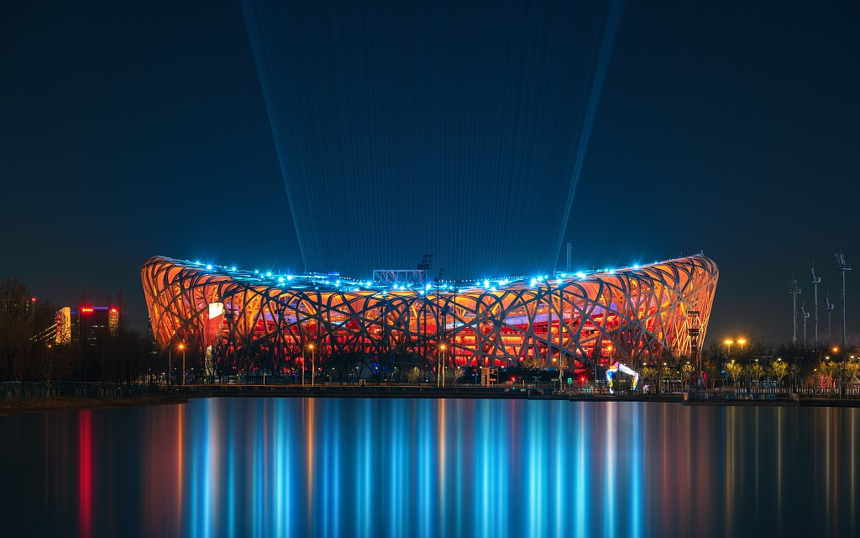

Day 4 Beijing to Xi'an by Flight
The first stop of today's itinerary is the Panda Hall, Beijing Zoo, a rare chance for you to get close to the precious giant pandas. We will leave early in the morning because it’s when pandas get most active. You will watch them endlessly foraging or eating bamboo, of which a typical adult has to digest 23 - 40kg per day - that’s 10 times the amount of humans’ daily food intake - to meet their nutrient needs.
Then we will head to the Summer Palace, the largest existing imperial garden with graceful landscape and magnificent historical constructions. If you travel in early July, summertime, lovely lotus scenery will be a delight.
After a lunch of local flavors to conclude your memorable tour in Beijing, your guide will see you off at the airport for the flight to Xi'an. On your arrival, your Xi'an local guide will meet you outside the baggage claim area and transfer you to the downtown area to check in at your hotel for a two-night stay.
Meals: Western buffet breakfast, Lunch
Accommodation: Crowne Plaza Xi'an
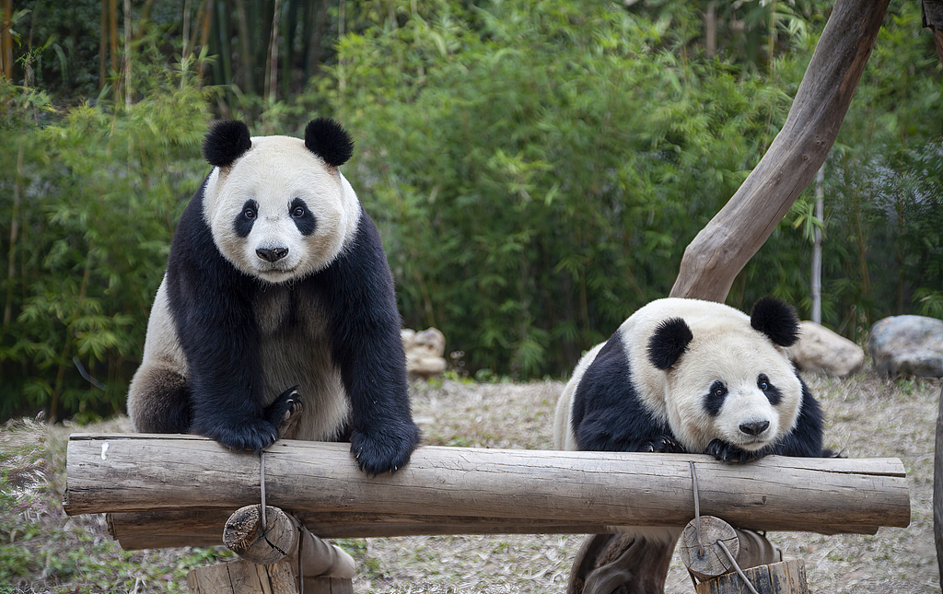
Day 5 Xi'an
Kick off your today’s tour with a visit to the man-made miracle Terracotta Army! Discovered decades ago, the army turned out to be the funeral objects for the mausoleum of Emperor Qin Shi Huang (259 – 210 BC), founder of the Qin Empire (211 – 206 BC) and China’s imperial history. The reappearance of the hidden wonder once shocked the world. But just as the earth caged it, the long history has drowned numerous facts about the empire or even the emperor himself (for example, as a figure full of masculinity and charm, why he seemed to be in lack of an empress remains a mystery!). Aside from having panoramas of countless warriors in pits forming a battle array, we will also take you to a newly-set hall where the essence of all the archaeological discoveries is exhibited in glass, meaning you can observe the real deal up close and in details! Through 230 collections, many of which are their first time to show up, your guide will take you to delve deep into the heyday of the fearsome empire. Marvel at meticulously sculptured animals like Chinese cane and camel, as well as the coloring on pottery or bronze!
★ Privileges of Our Guests:
1. Take a Family Visit to Home of the First Discoverer of the Terracotta Army
Not only the Terracotta Army but its discovery has been an intriguing mystery to most people, even to the former US president Bill Clinton, who, during his visit to the museum in 1998, invited the discoverer to recount how he unearthed the first terracotta warrior in 1974. After visiting the museum, we will take you to visit the home of the discoverer, whose name is Yang Zhifa, to hear what President Clinton once heard and interact with his family. Inside the house, you can see the hoe he used to dig out the first warrior, the wooden cart used to transport it, and its 1:1 replica. Also, you may take photos with Mr. Yang personally if he's there.
2. Try to Make a Mini Terracotta Warrior by Yourself
Then a visit is followed to a terracotta warrior making workshop. An artisan will explain the procedure and show you how to craft it step by step with the help of molds. You will spend around 40 minutes to make your own mini warrior, which, of course, you can take home as a memento.
Put your little warrior in a safe place, and continue to visit the Giant Wild Goose Pagoda, which was built in the Tang Dynasty (618–907 AD) to store the Buddhist scriptures brought from ancient India. In addition to the strong Buddhist atmosphere, the fascinating royal stories of Da Ci’en Temple where the pagoda sits, are also waiting for you to explore. It is said that Tang Emperor Li Zhi, who built the temple in order to thank his father for electing him as the crown prince and to express his deep missing to his late mother. Then a splendid evening is in store, as you will be entertained by the famous Dumpling Dinner and Tang Dynasty Music and Dance Show. After the show, we will drive you to your hotel.
Travel Tip: Since the theater is usually not open in Jan, Feb, Mar and Dec, we will not arrange the show and dumpling dinner for tours starting during those periods.
Meals: Western buffet breakfast, Dumpling Dinner
Accommodation: Crowne Plaza Xi'an
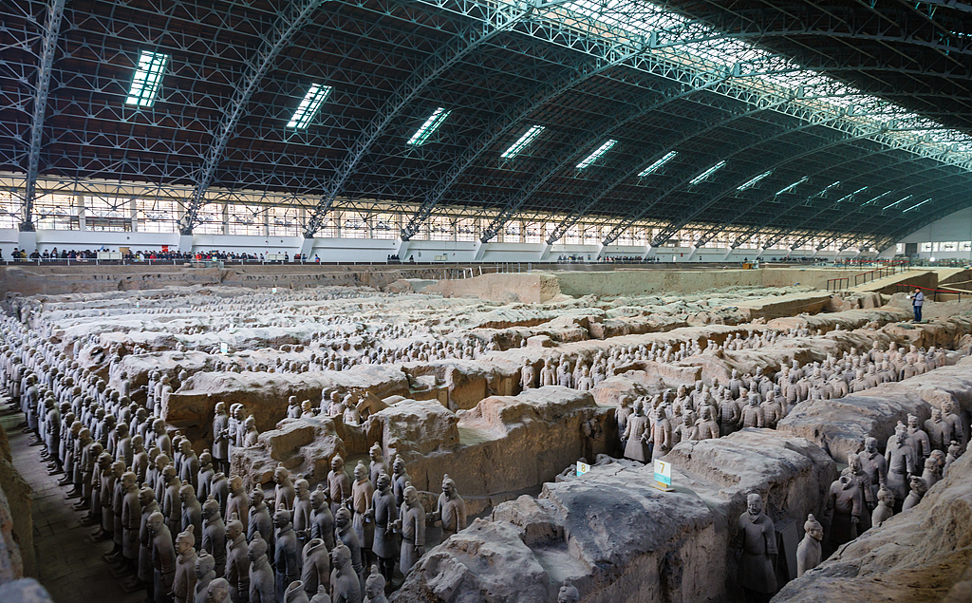
Day 6 Xi'an to Shanghai by Flight
The day begins with a refreshing visit to the City Wall Park, where you can observe the day-to-day life of locals in the morning. You may see them singing, dancing, playing musical instruments, and playing chess. Join them if you want! A traditional Tai Chi class will also be arranged for you here. Tai Chi, a form of traditional Chinese martial arts that strengthens both body and mind through slow gentle moves, is considered a quintessential Chinese culture, which you might want to experience yourself.
After that, you will pay a visit to the City Wall. It is the most complete existing urban fortification in China that dates back to 1300s. Cycling on the ancient wall is a recommended experience that many people find it unforgettable. Please note that bike rental fee is at your own expense.
Today we provide you with a special lunch at the Muslim Quarter, to taste local foods, like Rougamo (Chinese Burger), Biang Biang Mian (Belt-shaped Noodles), Fried Beef Dumplings, and Cold Noodle with Sesame Paste, all dating from Qin Dynasty. You are going to eat what Qin warriors ate! We particularly recommend you to try Rougamo. The succulent shredded beef sandwiched into two halves of flatbread will make your day.
It’s time for you to say goodbye to Xi’an now, as we will transfer you to the airport to board the flight to Shanghai. Your local guide will pick you up at the airport and escort you to the hotel.
Meals: Western buffet breakfast, Local flavor lunch
Accommodation: Radisson Blu Hotel Shanghai New World
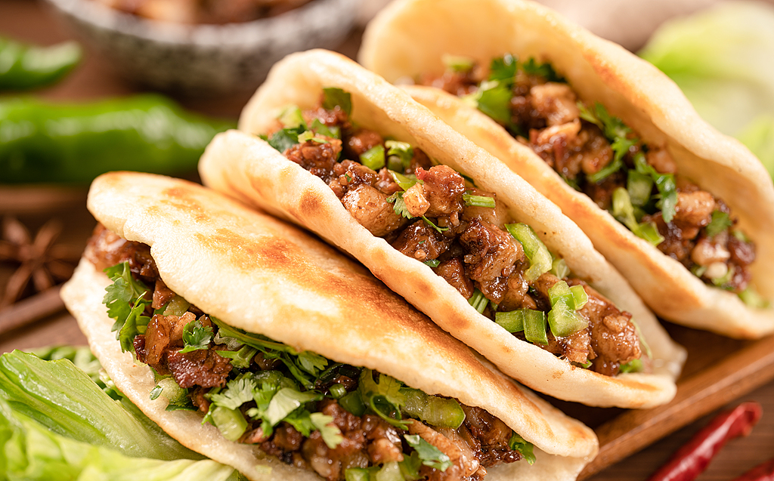
Day 7 Shanghai
A day trip will show you the essence of Shanghai. This morning, you will visit one of the four largest museums in China, Shanghai Museum, which specializes in exhibiting art works from ancient times. After that, explore Yu Garden. Symbols of the Garden - the Nine Zigzag Bridge, built of granite and grass-white jade, and the mid-lake pavilion - will mesmerize you with their quaint elegancy. Search for some souvenirs at its nearby historical bazaar if you like.
Around noon, an a la carte farewell lunch (valued at CNY150.00 per person and included in our price) will be served to you at a very nice restaurant.
In the afternoon, you will first wander in the prosperous Bund area and then take a one-hour cruise tour along the Huangpu River, where you will appreciate the city's historical buildings on one side and modern skyscrapers on the other side, such as Oriental Pearl Tower and Jinmao Tower – two landmarks of Shanghai. Finally, upon returning to the hotel your guide will see you into the lobby to say bon voyage.
Meals: Western buffet breakfast, A la carte farewell lunch
Accommodation: Radisson Blu Hotel Shanghai New World
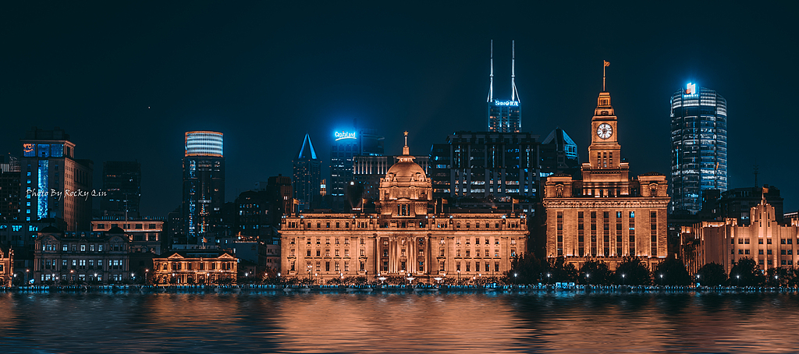
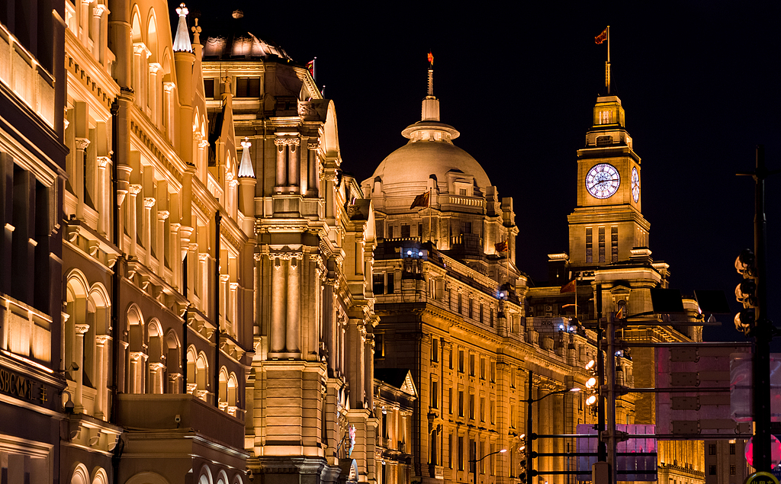
Day 8 Departure from Shanghai
Check out from the hotel any time before 12:00 pm, and then head to the airport for your homeward flight. Your 8 days China tour package is waning to its close with wonderful memories. We suggest you reserve a taxi at the hotel reception beforehand to avoid having to wait for a taxi outside. The trip to Pudong Airport (PVG) will take about 1.5 hours and cost around CNY200. Ensure you have at least an hour drive if your flight leaves from Hongqiao Airport (SHA). The cost for the taxi there is about CNY100. You can also take Metro Line 2 at the metro station just outside your hotel to reach both airports. Please check carefully from which airport your flight will depart. We wish you a smooth journey home.
Alternatively, should you wish to stay on rather than return home right away, we would be glad to assist you for an extension trip!
Meals: Western buffet breakfast
