Packages detail
One Day Mt. Huashan Mini Group Tour USD129（A minimum order of 2 people is required）

Overview
One Day Mini Group Tour to Mt. Huashan from Xi’an

Trip Highlights
• Mini group of about 6 people, with more personal service.
• Professional English-speaking guide and comfortable vehicle with air-conditioner.
• Pure sightseeing tour: Focus solely on attractions with NO shopping stops, NO shopping site eateries, and NO tea ceremonies!
• No optional tours, which are just a tourist trap that always leads to high mark-ups.

Included & Excluded
Price Includes
• Entrance fees to the sights visited
• Pick-up & drop-off from your hotel
• Professional English speaking guide
• Experienced driver & air conditioned vehicle
• Unlimited bottles of drinking water for free
• Baby seat available for free
Price Excludes
• Hotel accommodation
• Round trip cable car to West Peak: CNY280 per person, pay on spot
• Gratuities to guide and driver
• Meals

Itinerary
07:30 - 08:30 Morning Pick-up from Hotel in Downtown Xi’an
In the early morning, your guide and driver will warmly greet you in the lobby of your self-reserved hotel at the appointed time. The day before departure, the guide will contact you to confirm the exact pick-up time and other details. Find us online to help you whenever and whatever you need.
► Kind Note:
Touring on the mountain requires a lot of hiking, so it’s better to wear your most comfortable sports shoes today. And to cope with the relatively lower temperature and strong wind, a thick jacket should also be prepared. In clear weather, wearing a visor and sunglasses is also very necessary.
08:30 - 10:00 Drive from Xi’an to Mt. Huashan
At around 8:30, start to travel with other fellows about 1.5 hours by our comfortable vehicle to Mt. Huashan. Facing the Yellow River to the north, Qinling Mountains to the south, and Xi’an city to the west, it is known both domestically and internationally as the “the most dangerous mountain in the world”. On the way, get acquainted with what the Mountain is like and how we will tour around it with the guide’s elaborate explanation. Rest assured you will enjoy a pure tour without any stops to the tourist shops.
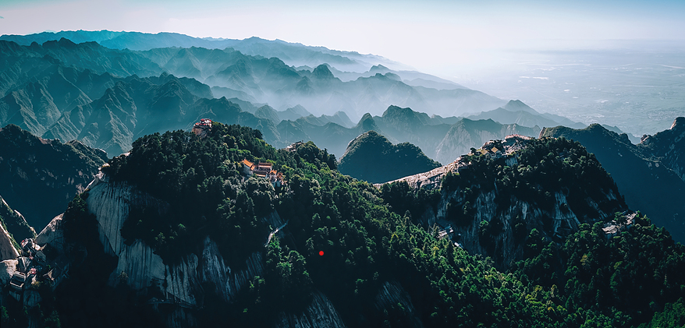
10:00 - 16:30 Adventure on Mt. Huashan
Upon arrival, the guide will help you whisk through the entrance, and then let’s hop in an eco-bus to the lower station of the West Peak to take the cable car up the mountain. With a W-shaped undulating trend, the cableway is both a scenic sightseeing line and an exciting but safe experience line. During the 20-minute ride, experience the thrill of speeding over the steep cliffs, which is like traveling in an air corridor. Off the carriage, your thrilling hike begins. Some of the trails you will pass through are as steep as 80 degrees, and you have to hold on chains on either side to climb up. Walk a little further, and you will reach the top of the West Peak. Formed by a whole natural monolith, it is hailed as the most beautiful and precipitous peak of Mt. Huashan. The first thing that comes into sight will be a Taoist temple, the Emerald Cloud Palace, in front of which there is a boulder shaped like a lotus, so the peak is also called Lotus Peak. Next to the temple you will see another huge rock split in the middle, as if it had been hacked by the long axe beside it, and that is the famous Axe-splitting Rock, which was said to be created by Liu Chenxiang in ancient Chinese mythology when he saved his mother here. Curious about this story? Your guide will definitely explain more details to you on the spot. Also the Peak’s west and north sides are especially upright like being cut by a knife, giving visitors a strong visual shock and psychological stimulation.
Next, continue our sightseeing to the East Peak, which also has the reputation of Facing Sun Peak as it is the best place to enjoy the sunrise on Mt. Huashan. The abyss on the eastern side is even more daunting, while the gentle slope on the west side is covered with towering pines and junipers, which is a good place for you to enjoy the cool and rest. Shuttling through the forest, the sun is blocked by umbrella-like shades, and the soughing of the wind will make you feel a rare relaxation in such a parlous place. On a cliff, you will easily find the natural rock veins looking like a giant palm print, and this is the famous Immortal’s Palm Peak, which is listed as the No.1 of the Eight Scenic Wonders of Xi'an. This is also where the noted Long Skywalk Plank Road and Hawk's Turn Road are located. To get through here, one needs to tie a safety rope on the body, face the cliff and use just tiptoes to find the footholds, which will make people feel like hanging over the abyss. While incredibly exciting, it's not recommended for those with a fear of heights or heart conditions. If you're up for the challenge, you can pay to experience it on-site.
After that, your guide will accompany you on about an hour’s hike to the South Peak. Legend has it that wild geese returning to the north often stop here to rest, thus it is also called Landing Wild Geese Peak. As the highest peak of Mt. Huashan and even of the world-known Five Sacred Mountains in China, climbing to its summit can certainly be a great honor. At the top of it, you will be welcomed by Black Dragon Pool. It is interesting to know that the water inside has never dried up during droughts or overflowed during floods, making it a great wonder. Standing high looking around, the surrounding undulating mountains are totally covered with green woods and the Yellow River flows far below like a strip of silk, giving you a real taste of the grandeur of Mt. Huashan. Afterwards, get back to the West Peak via a 300-meter-long (984-foot-long) ridge, which winds like a dragon and is one of the perilous sections for you climbers to challenge yourselves. At last, let’s descend the mountain by cable car and take the eco-bus to the exit.
► Kind Note:
We would be remiss if we didn’t remind you that there are no restaurants on the mountain, and that is also why we don’t include lunch in the tour. It is recommended that you have a substantial breakfast at the hotel and pack some quick energy booster food like chocolates and bread or hamburgers to fuel yourself during the visit. Or you can buy some drinks and instant noodles at rest stops on the mountain, but note that these foods are carried manually by local laborers from the foot of the mountain, so the prices are understandably higher than usual.
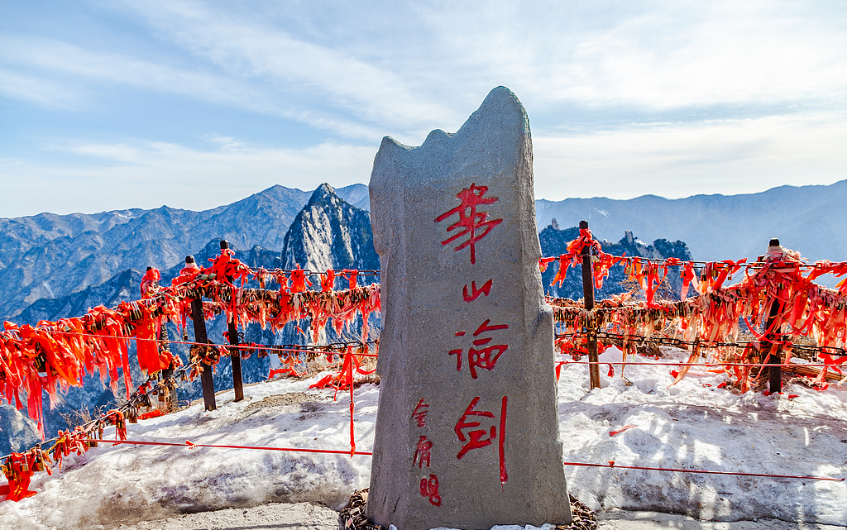
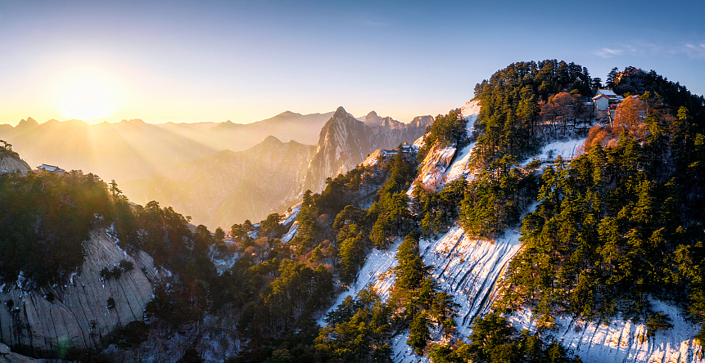
16:30 - 18:00 Drive Back to Xi’an
So far, your Xi’an to Mt. Huanshan day tour comes to an end, and we will drive you back to downtown Xi’an. On the way, you can shut your eyes for a while to restore energy. Hope you had a good time with us! Want to visit more attractions in and around Xi’an? Then feel free to contact us, and our travel consultant will customize a tour to your satisfaction.
Nighttime Activities Recommendation (at your own expense):
After a laborious day on the mountain, you might want to replenish your energy with some local snacks like Chinese Hamburgers, Biang Biang Noodles and Crumbled Flatbread in Mutton Soup, then we recommend you to check out the Muslim Quarter, the most popular food paradise in Xi’an. Then take a leisurely stroll to admire the nearby Bell and Drum Towers, Xi’an’s well-known landmarks, which are especially charming under the light at night. Maybe pose for a picture in front of the ancient towers like many visitors do. 