Packages detail
5 Days to Zhangjiajie, Furong & FenghuangUSD999（A minimum order of 2 people is required）

Overview
Trip Highlights
• Personalized private tour tailored to your own schedule and interests.
• English-speaking private guide, air-conditioned private car with experienced driver.
• Climb up to witness Hallelujah Mountain by World’s highest Bailong Elevator.
• Challenge yourself on the world’s highest and longest Zhangjiajie Glass Bridge.
• Feast your eyes on the jaw-dropping natural wonders of Tianmen Mountain.
• Discover mysterious Tujia culture in Furong Town, a picturesque town clinging to a cliffside waterfall.
• Cruise along Tuojiang River flanked by Tujia stilted houses in Fenghuang Town.

Included & Excluded
Price Includes
• Private English-speaking guide
• Private driver & air-conditioned vehicle
• Hotel accommodation with breakfasts
• Four lunches
• Entrance fees to the sites visited
• Bailong Elevator, Tianzi Mountain Cable Car, Glass Bridge, and round-trip cableway in Tianmen Mountain.
Price Excludes
• Arrival and departure trains or flights
• Entry visa fees
• Personal expenses
• Tips to guide and driver

Itinerary
Day 1 Arrival in Zhangjiajie; Pick-up
Welcome to choose us to plan your Zhangjiajie and Fenghuang tour, all tailored to your needs.
What to Expect:
1. 24-hour Pick-up Service: When you arrive at Zhangjiajie’s airport or railway Station, your private guide will show up on time and warmly greet you, and then transfer you to the hotel in our comfortable private car.
2. Selected Accommodation: We are most concerned about your sleep comfort, so we have selected the hotels with the cleanest and most comfortable beds, based on the field investigation of our professional hotel test sleepers. The hotels handpicked for you are very close to the main scenic area, and particularly convenient for dining and other enjoyments.
► Dinner Suggestion (at your own expense):
Hotels’ front desk or our guide will be glad to help you locate the nearby popular restaurants for dinner. The restaurant Committee in Old Fishing Village within walking distance from your hotel won’t fail you tonight. The cook team of the restaurant is led by a master local chef, who draw on their profound insights of Hunan Cuisine and handpick fresh ingredients to create dishes rich in forms and flavors. The staff have even been featured on TV before. Try its Stir-Fried Beef with Chili, a classic popular among locals as well as international visitors. Zhangjiajie’s Cured Pork, Sanxiaguo Mixed Stew, Sour Fried Fish, Sour Radish, Soy Bean Rice Noodles are also worth trying. The local cuisine tastes very spicy, and if you can’t handle it, please tell the chef to use less chili to avoid tongue or stomach discomfort. The courtyard is arranged in a nostalgic, artistic style, with a singing stage in the middle, allowing you to join a dance party around a bonfire. The joyous and carefree ambiance will make for a unique dining experience.
Average cost per person: CNY 100 / USD 14
Address: Across from Yunxi Estate, Xiangzhang Road, Wulingyuan District, Zhangjiajie
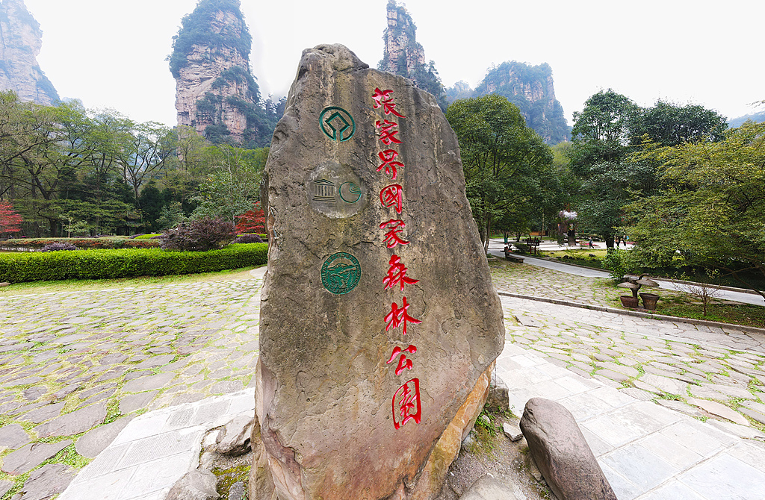
Day 2 Zhangjiajie National Forest Park
Today, our guide will lead you on the most efficient and classic route to deeply explore highlights of Zhangjiajie National Forest Park. After breakfast, our guide will pick you up from your hotel, enjoy fast entry into the park, and head straight to the Bailong Elevator. The Park is very large, and the whole hike is not only physically demanding, but also doesn’t allow enough time to see the scenic spots. Your enjoyment always comes first and we never hesitate to spend more to enhance your experience, so we have arranged the elevator ride for you. Your heart will beat faster and faster as you look out of the transparent glass cab rising quickly on this world’s tallest outdoor sightseeing elevator. We will reach the most spectacular Yuanjiajie Scenic Area at the top of the mountain in 88 seconds, and start a guided tour taking in stunning views of dozens of freestanding stone peaks soaring into the sky, including the world-renowned Hallelujah Mountain where 'Avatar' was filmed. Also admire the No.1 Bridge under Heaven and the Enchanting Platform…
After lunch, take an eco-bus of the scenic area for about 15 minutes to Yangjiajie Scenic Area. Standing on one of the spacious viewing platforms, the valleys below are daunting, and the mountains winding and rolling in the distance are shrouded in clouds. The most striking will be the Natural Great Wall. Several impressive stone walls formed about 380 million years ago, of varying heights, broke through the valleys covered with dense greenery, which are older than the real Great Wall in China. Next, the guide will accompany you to the Tianzi Mountain to enjoy the vast sea of clouds and peak forests. According to the longtime residents of Tianzi Town, Xiang Dakun, the Tujia ruler, led about 30,000 soldiers to revolt here, and then he and his subordinates transformed into strange peaks after being suppressed. You will be awestruck by the most famous Imperial Brush Peaks, which are said to be the brushes that Xiang once used. Moreover, Tianzi Mountain is the only site in the park where the sunset can be photographed, attracting many well-known photographers at home and abroad. Just enjoy it and see if you can get a life shot too. Then, descend the mountain by cable car and get back to the hotel for rest.
Meals: Breakfast, Lunch
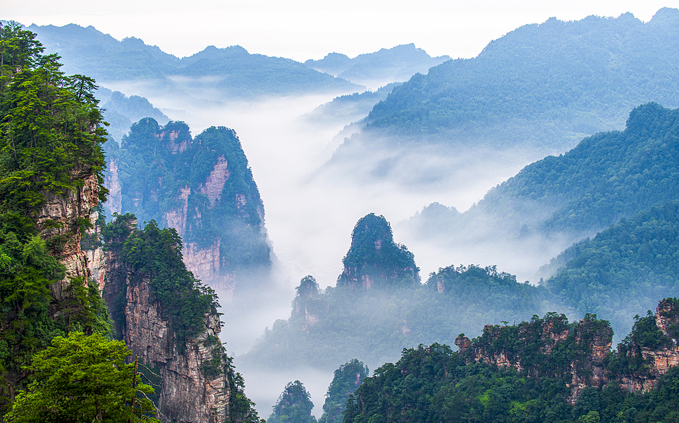
Day 3 Zhangjiajie Grand Canyon and Golden Whip Stream
In the morning, our guide will escort you to the unmissable Zhangjiajie Grand Canyon, which is famous for the scary but exciting Yuntiandu Glass Bridge. Upon arrival, go straight to challenge yourself on this transparent glass-bottomed bridge, the world’s tallest and longest of its kind, which is 536 meters (1,759 feet) long and 300 meters (984 feet) high, suspended over the deep canyon. Walk carefully across it, and you won’t help but hold your breath and can certainly hear your heart beat.
If you are an adrenaline junkie, you can also experience bungee jumping here at your expense. Note that advance booking is required and we are happy to help you. Afterwards, we will retrace our steps back to the neighborhood of the Zhangjiajie National Forest Park for lunch.
Later, you will be led to hike along the Golden Whip Stream. Enter from the East Gate of the park, take the eco-bus first to the starting point - Shuirao Simen, and then stroll along the section containing almost all the highlights here. You won't feel too tired because the whole path here is level. Along the way, at your feet is a stream winding its way through the valley, while above you are the thick canopies and high cliffs flanking the path. Spotting wild monkeys on the treetops is the most interesting thing.
Finally, our guide will escort you back to your hotel. Have a good rest to dissipate the fatigue of the day.
► Tip: A ticket of Zhangjiajie National Forest Park is valid for 4 days. If you want to extend your trip, feel free to contact us to customize the itinerary for you.
Meals: Breakfast, Lunch
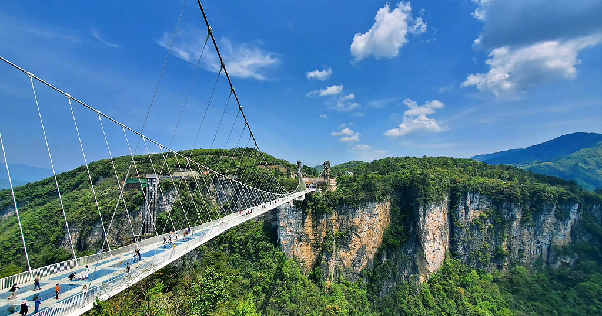
Day 4 Zhangjiajie - Furong - Fenghuang
This morning, we will visit the Tianmen Mountain (Heaven's Gate Mountain) by round-trip cableway. An aerobatic master once flew through its iconic Tianmen Cave, which makes it famous at home and abroad. Let’s take one of the world’s longest sightseeing cableways from downtown directly to the top of the mountain. The mountain cannot be climbed on foot for several reasons. The first and foremost would be that the mountain slope is just too steep to carve a trail all the way up. It’s also because of the need to avoid man-made forest fires, protect the local ecological environment, and ensure the safety of visitors. Follow our guide to enjoy the primitive scenery above, walk on the thrilling cliffside Glass Skywalk, and then take the 7-level downhill escalator to Tianmen Cave. Standing under the huge opening, you will feel the smallness of human. Appreciate the surrounding clouds and fog, sometimes with a gorgeous glow passing through the cave. Then go down the 999-step Heavenly Stairway or take another escalator down to Tianmen Square, where our guide will accompany you on the returning cableway.
In the afternoon, hop on your private car to travel further south, and stop by the Furong Ancient Town, which has a history of 2,000 years, offering you a glimpse into ancient Tujia ethnic culture. Formerly known as Wang Village, it was renamed after the film adaptation of the Chinese novel ‘Furong Town’ was filmed here. Marvel at the Furong Waterfall, the largest and most spectacular waterfall in western Hunan, plunging down the cliff in two stages. Because of it, the town is honored as "Millennium Town hanging on the Waterfall". Then we will arrive at the hotel in Fenghuang Ancient Town, nestled deep in a mountain and near a river, populated by minorities of Tujia and Miao, and filled with mysteries and cultural fun.
★ Handpicked Hotel in Fenghuang Ancient Town
Our carefully selected hotels are located just outside the town. Why outside? Here are three reasons:
1. Hotels inside the ancient town require quite a long walk with your luggage, unfriendly to travelers with large bags.
2. It is noisy inside for there are many shops, bars and entertainment places, while living outside is quiet and suitable for sleeping. Don’t worry about the distance, as there are shuttle bus available.
3. Most hotels inside are old, with limited space and facilities, while hotels outside are relatively new with better facilities.
► Our 4 Stars Hotel: Very convenient to the town. The rooms on the upper floors have excellent views of the town.
► Our 5 Stars Hotel: Definitely the best hotel in Fenghuang, with spacious rooms. It is a mountain resort, with a private path surrounded by green trees that leads directly to the town, about 5 to 6 minutes on foot.
★ Once-in-a-Lifetime Romantic Night View of Fenghuang
After check-in, perhaps make your own way to the old town for dinner and night views, and our guide will be glad to offer recommendations. As night falls, the banks of the Tuojiang River gradually light up. The exotic riverside stilt houses built by local ethnic people and the multi-eave gate towers decorated with red lanterns are reflected in the sparkling river, like a super-long panoramic painting. Nanhua Gate Bridge and Rainbow Bridge are the best places for superb night views.
Meals: Breakfast, Lunch
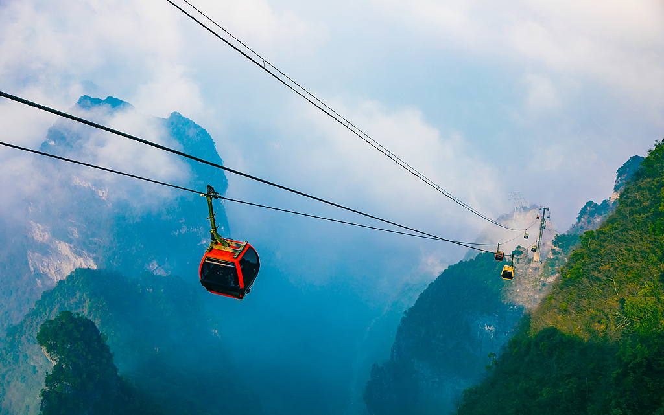
Day 5 Sightseeing in Fenghuang; Departure from Zhangjiajie
Today we will have a full exploration of the Fenghuang Ancient Town. After breakfast, our guide will accompany you on a boat tour along the Tuojiang River, the mother river of the town, flowing slowly along the old city walls. The water plants sway in the gentle waves and the morning mist rises from the calm river, making this place like a fairyland. Inhabited by various ethnic minorities, such as Tujia, Miao, and Bai, the town features traditional wooden stilt houses, amazingly clustered along the river.
After disembarking, the guide will take you to discover some of the most iconic sights of the town. Walk on the Jumping Rock Bridge, a row of rocks across the Tuojiang River, to take beautiful photos. Climb up the thousand-year-old Rainbow Bridge and enjoy views of the entire old town from the second floor. Check out the Palace of Longevity with exquisite traditional Chinese architecture. Under the 7-story ancient Wanming Pagoda, you can listen to the crisp sound of copper wind chimes hanging on its hexagonal eaves…
If you’re lucky to encounter a grand festival, it would be great to see people wearing colorful ethnic costumes – Tujia people wearing round hats made of twined cloth, while Miao girls with huge and intricate silver headwear, singing and dancing in a lively atmosphere. If time permits, explore more attractions according to your own interests, including former residences of local celebrities and ancestral halls of ancient notable families.
Late in the afternoon, our guide will accompany you on a private drive back to Zhangjiajie and see you off at the airport or train station. This is the end of your private guided Zhangjiajie tour with Fenghuang and Furong. Hope you enjoyed it! If you want to stay extra days in Zhangjiajie, feel free to contact our travel consultants.
Meals: Breakfast, Lunch
