Packages detail
Zhangjiajie Mini Group Day Tour, No Shopping USD59（A minimum order of 2 people is required）

Overview
One Day Zhangjiajie Highlights Tour to Forest Park, Bailong Elevator, Yuanjiajie, Hallelujah Mountain, Yangjiajie, Tianzi Mountain
Trip Highlights
• Mini group of about 9 people, with more personal service.
• Take the tallest elevator in the world to see Avatar's Hallelujah Mountain.
• Marvel at Natural Great Wall formed by rolling stone peaks in Yangjiajie.
• Enjoy stunning sunset and vivid odd-shaped formations in Tianzi Mountain.
• Pure sightseeing tour: Focus solely on attractions with NO shopping stops.
• No optional tours, which are just a tourist trap that always leads to high mark-ups.

Included & Excluded
Price Includes
•Pick-up & drop-off from hotels in Wulingyuan near East Gate of the Forest Park, or downtown Zhangjiajie City
•Professional English-speaking guide
•Experienced driver & air-conditioned vehicle

Price Excludes
•Entrance fees: We will reserve entrance tickets in advance and guarantee the availabilities, and you just need to pay when meeting your guide. The total entrance fees are CNY364 per person. See details：
- Zhangjiajie National Forest Park: CNY227
- Bailong Elevator: CNY65
- Tianzi Mountain Cable Car: CNY72
•Hotel accommodation & meals
•Tips to guide and driver

Itinerary

7:00 to 8:00am Pick-up from Hotel
Our pick-up service is offered from hotels both in Wulingyuan district that is near the East Gate of the park and also in downtown Zhangjiajie. In the morning, meet our guide in your hotel lobby at the appointed time, and then set out to seek travel delights in Zhangjiajie National Forest Park. Still remember the dreamy floating Mountains in the sci-fi moive Avatar? This is where you will have a chance to witness the real looks of these epic karst formations.
► Hotel Suggestion:
East Gate serves as the main gate of the Zhangjiajie Forest Park we will visit, and around it there are plenty of well-conditioned hotels and restaurants. For your convenient access to the Park, we suggest you book a hotel nearby, and the 4-star Expert Village Courtyard Hotel or 5-star Pullman Zhangjiajie Hotel can be a reference.

Stop 1: Bailong Elevator
After entering the East Gate, let’s ride in an eco-bus of the scenic area for about 20 minutes to the lower station of the world-renowned Bailong Elevator. Holiday crowds may limit seating. Don't worry! Our guide will assist you while waiting, as the bus runs fast and standing can be unsafe. As the highest, fastest and largest-loaded cliffside outdoor sightseeing elevator in the world, it takes only 88 seconds to finish a length of 335 meters (1,099 feet) to reach the cliff top. And during rising up, a grand scene of the vertical karst pillars will unfold before you, making you feel like entering a fairyland.
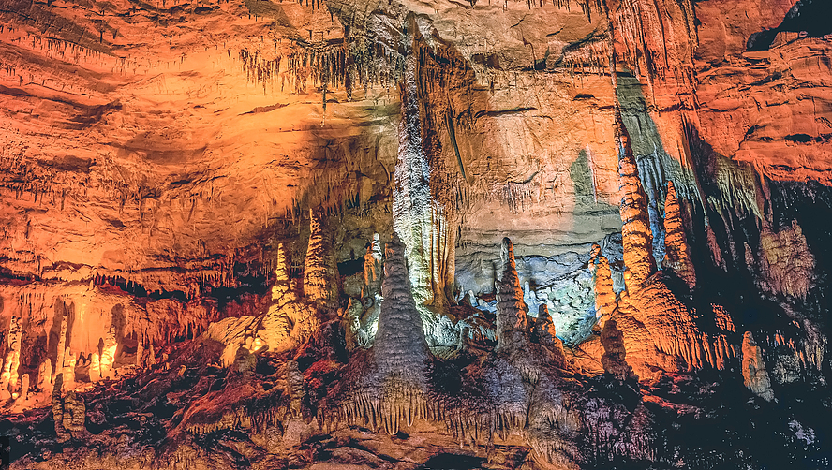

Stop 2: Yuanjiajie Scenic Area with Hallelujah Mountain
When getting out of the elevator, you will be accompanied to sightsee in the Yuanjiajie Scenic Area. It is right the place where you will find the Qiankun Pillar, which name was changed to the namesake Hallelujah Mountain after the movie Avatar became a hit. Having appeared numerous times on TV, this towering 1,000-meter-plus-high (3,280-feet-plus-high) peak has been known by every Chinese household and is now enjoying a global fame. Also follow the guide to admire other extraordinary pillar sights here like the Back Garden, Enchanting Platform, and No.1 Bridge under Heaven - a naturally formed stone bridge connecting two peaks.
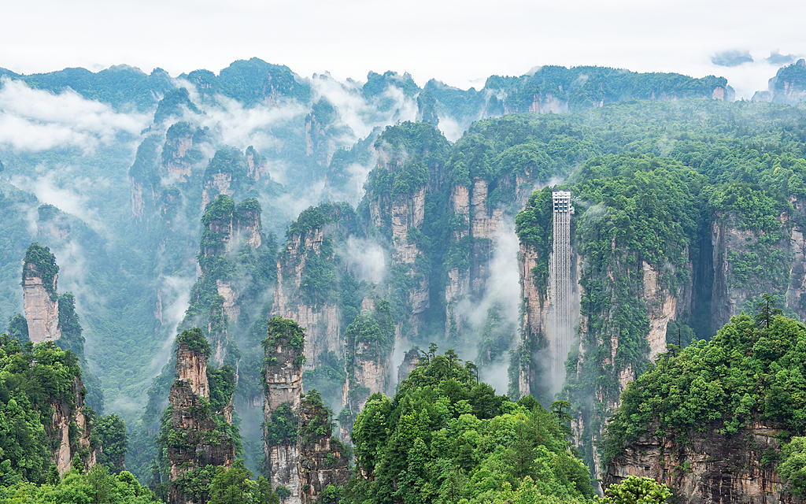

Lunch Break
Lunch today is not included. Food options are available on the mountain and our guide will offer suggestions and assistance. However, you are advised to have a hearty breakfast at the hotel this morning and take some snacks to replenish energy anytime.

Stop 3: Yangjiajie Scenic Area with Natural Great Wall
After lunch, take the eco-bus to Yangjiajie Scenic Area, the last area developed among the four scenic areas of the Park. This place is right in the infancy stage of peak forest evolution, with continuous peaks unlike Yuanjiajie’s isolated ones. Here, you will be surprised by an out-of-print wonder on Earth, the Natural Great Wall. Every stone peak is uncarved but perfectly arranged together, and from a distance there is quite a bit of the majestic momentum of the Great Wall, which will definitely make you amaze at the magical creativity of nature. Plus thick forests that grow and thrive here and gurgling streams that meander through valleys, it is an attraction not to be missed.
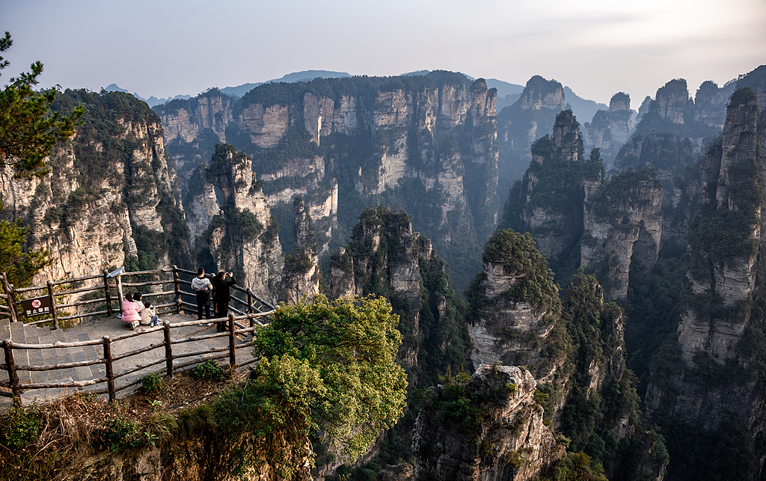

Stop 4: Tianzi Mountain
Next, let’s hop on an eco-bus to reach Tianzi Mountain in 30 minutes. Here, thousands of stone pillars rise to the sky, forming a grand peak forest kingdom for you to marvel at. The view here is said to be at its best at sunset, attracting numerous great photographers from all over the world, especially when there is a sea of clouds. During the visit here, our guide will show you the most significant spots including the Helong Park, where five viewing platforms offer all-round views of the Imperial Brush Peaks, named for resembling writing brushes. Admire other stunning sights like Flower Fairy Peaks and Dianjiang Terrace if time and weather allow. Afterwards, the guide will take you down the mountain by cable car.
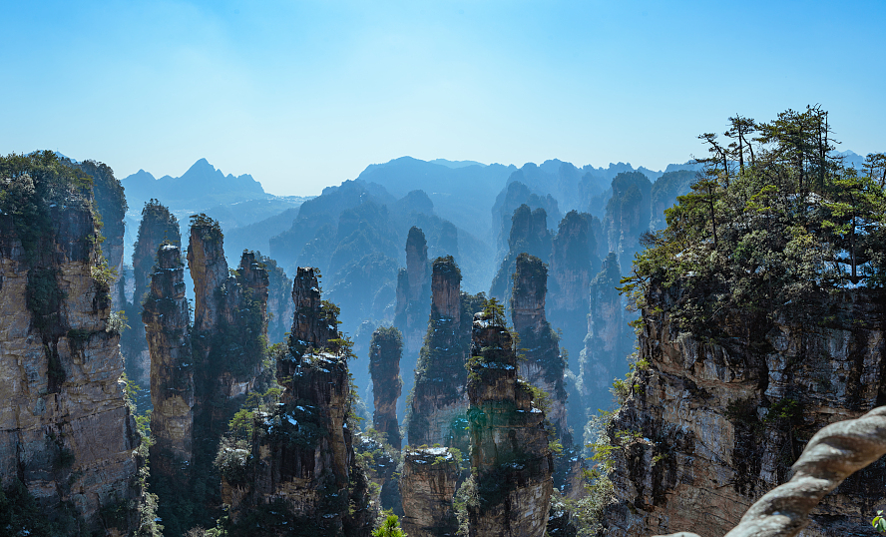

Send Back to the Hotel
Your memorable mini group Zhangjiajie day tour ends now, and our guide will escort you back to your hotel. If you are interested in beholding more of Zhangjiajie’s beauties, such as Golden Whip Stream, Ten-Mile Gallery, Tianmen Mountain (Heaven's Gate), and Grand Canyon with the famous Glass Bridge, check out more of our Zhangjiajie routes or contact us for a customized private tour.
► Free Time Suggestions at Night:
If you stay overnight at hotel near the East Gate in Wulingyuan District, you can try barbecue and local beer on the food street like locals do. If you transfer to downtown Zhangjiajie on your own for the night, don’t miss the magical 72 Tujia Stilted Buildings, a new landmark in Zhangjiajie that serves as a great nightlife hangout place, bustling with traditional crafts workshops, lively bars, and a variety of food. For local cuisine explorers, do drop by the chain restaurant Impression Old Stove, which can be found in both regions. Try its Water-Boiled Fish cooked in the traditional method, which retains a special tenderness and flavor that is hard to find elsewhere. The restaurant is also attractive for carrying forward the Zao Tai culture. If interested, you can even ask to cook by yourself for fun and some unique memories.
Average cost per person: CNY 70 / USD 9
Address: No.295, Jundi Road, Wulingyuan District, or opposite to back exit of Tianmen Mountain Cableway Company, Dayong Road, Yongding District, Zhangjaijie
