Packages detail
One Day Zhangjiajie Mini Group Tour, No Shopping
USD79（A minimum order of 2 people is required）

Overview
Grand Canyon-Glass Bridge-Tianmen Mountain

Included & Excluded
Price Includes
•Pick-up & drop-off from hotels in Wulingyuan near East Gate of the Forest Park, or downtown Zhangjiajie City
•Professional English-speaking guide
•Experienced driver & air-conditioned vehicle

Price Excludes
•Entrance fees: We will reserve entrance tickets in advance and guarantee the availabilities, and you just need to pay when meeting your guide. The total entrance fees are CNY466 per person. See details：
- Grand Canyon & Glass Bridge: CNY188
- Tianmen Mountain & Cable Car: CNY278
•Hotel accommodation & meals
•Tips to guide and driver

Itinerary
- 7:30 to 8:30am Hotel Pick-up
In the morning, our guide will meet you at your self-booked hotel near the East Gate of the Zhangjiajie National Forest Park in Wulingyuan District or in downtown Zhangjiajie. For more specific pick-up time and other details, the guide will confirm with you the day before departure. If you don’t want to spend too much time on the way over, it is recommended that you prioritize the hotel near our first stop today, such as the 4-star Expert Village Courtyard Hotel or 5-star Pullman Zhangjiajie Hotel. After gathering all the fellow members, let’s set off for Zhangjiajie Grand Canyon, enjoying the reputation of the “museum of Zhangjiajie landform”.
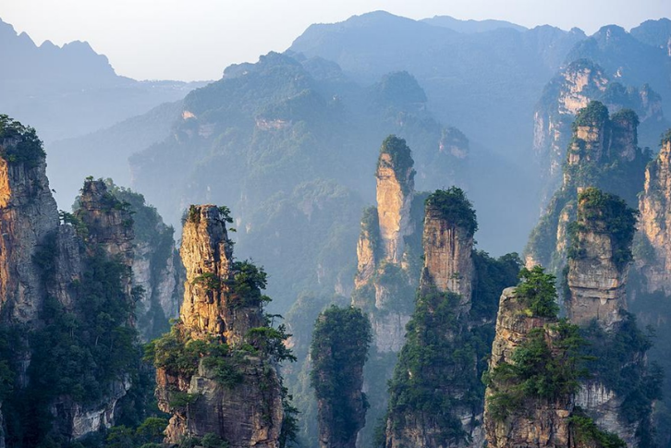
- Zhangjiajie Grand Canyon with Glass Bridge
In Zhangjiajie Grand Canyon, waterfalls, streams and springs can be seen everywhere in the deep valleys covered with dense vegetation, which is why it was also called Massive Springs Gorge in the past. Once through the entrance, head straight for the most celebrated Glass Bridge. In terms of length and height, the bridge ranks first in the world. It is all laid with 99 pieces of transparent glass, and walking on it seems to be suspended between heaven and earth. Standing on it not only allows you to admire the depth and vastness of the Canyon and the rolling mountains in the distance, but also a great test of your courage. If you really can’t overcome severe leg tremors and crazy heartbeats, just try stepping on either side of the opaque area for a photo with stunning panoramic canyon views. After that, leave the Canyon for your lunch.
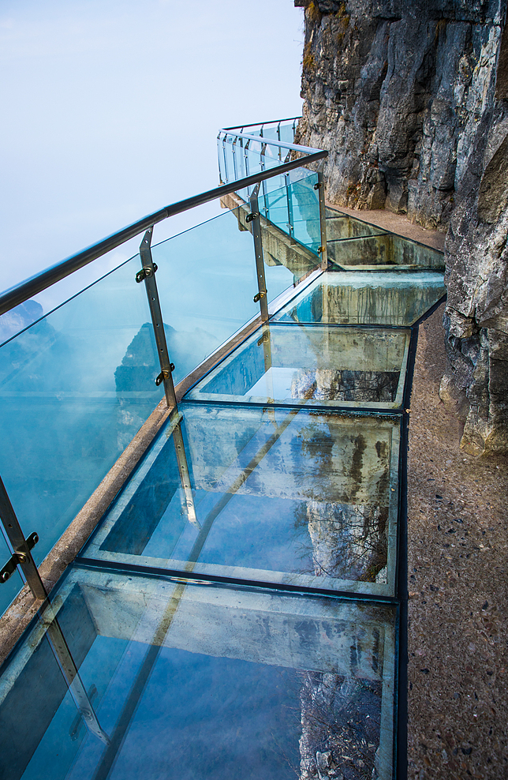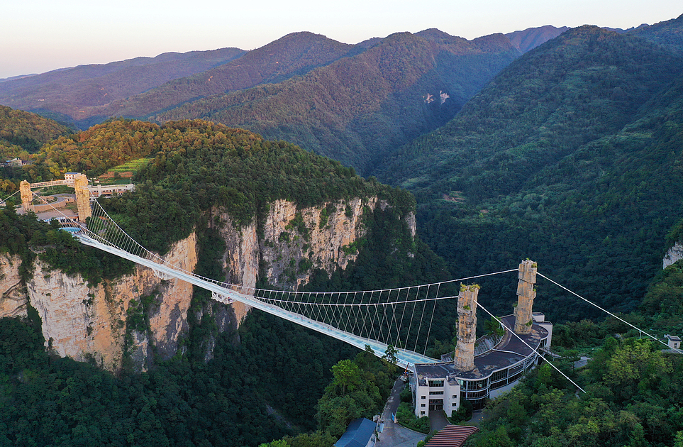
3.Lunch Break
Today’s lunch is not included. If you have trouble choosing a restaurant, ask our guide to recommend some with authentic taste, reasonable prices and a clean environment. You can also enjoy a hearty breakfast in the morning and then pack some quick refresher snacks with you.

4.Tianmen Mountain (Heaven's Gate)
After a short break at noon, you will be escorted downtown to the lower cableway station of Tianmen Mountain (Heaven's Gate Mountain), where the world’s longest sightseeing ropeway will transfer you to the mountaintop in about 28 minutes. Looking back from the cable car, the roofs of the attached buildings on both sides of the station are surprisingly like a pair of wings facing the sky, and the station rooms with white and green as the dominate hue look like clouds and nature, making you marvel at Zhangjiajie’s charm from the beginning. A little bit further on, what comes into view will be the vast expanses of rice fields and farmhouses with curling smokes, and then the lush virgin forests. Start your sightseeing at the top with a thrilling walk on the cliffside Glass Skywalk. Sometimes the reflection of the sky on the glass will give you a feeling of walking on clouds. Can’t wait to witness the iconic Tianmen Cave (Heaven's Gate)? Then ride the 7-level escalator down. With our guide, get to know how this natural karst cave was conquered by six pilots from different countries in 1999 and more famous extreme sports challengers have taken place here. At last, take the express cable car down the mountain to leave.
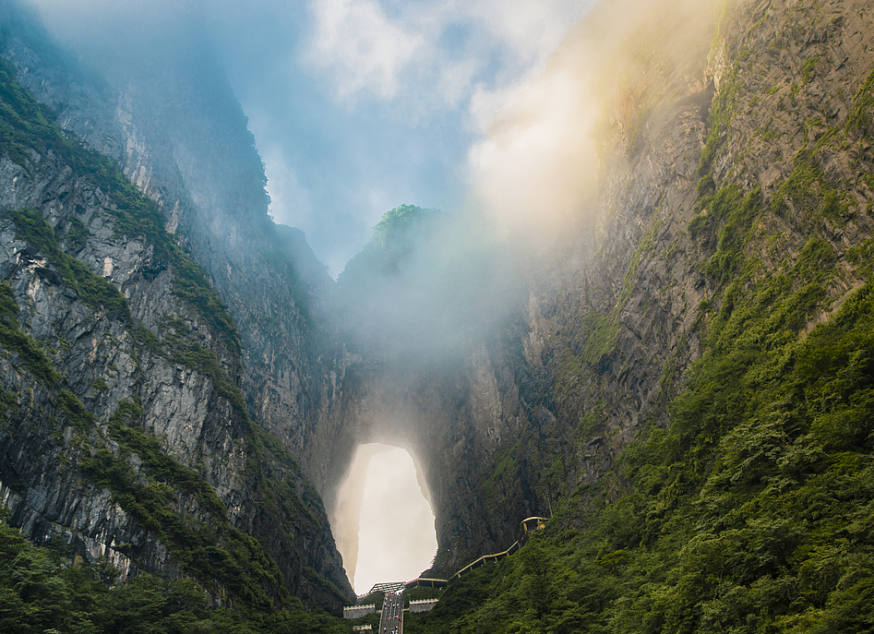
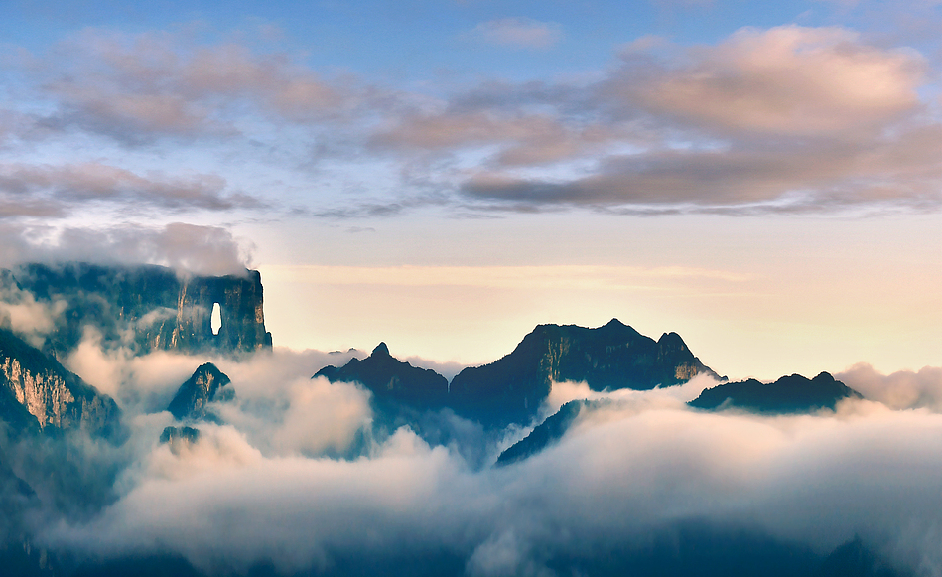
5. Hotel Drop-off
Your fascinating Zhangjiajie group tour to the Glass Bridge and Tianmen Mountain comes to an end now, and our guide will send you back to your hotel. If you are enamored of the beautiful sights in Zhangjiajie National Forest Park as well, why not check out our other Zhangjiajie mini group tours? If you have no travel plan in Zhangjiajie National Forest Park in Wulingyuan District, you are recommended to book your hotel in downtown Zhangjiajie tonight. For more unmissable sights around Zhangjiajie like Fenghuang Ancient Town and Furong Ancient Town, feel free to contact our travel consultants to tailor an exclusive tour for you.

Dinner Suggestion (at your own expense):
In addition to natural beauties, you may expect to know about Zhangjiajie from its food culture, so we recommend you try out the CCTV-interviewed Village Wife Household Restaurant, which is located right opposite the postern of Tianmen Lower Cableway Station. It is decorated in an antique style, with wooden table wares and ethnic murals, making you feel that you have space travel to a lodge deep in the mountains. Its signature dish is the Tujia Stewpot, cooked with a variety of meat and vegetables, which is now a must-have for treating guests and celebrating festivals. After the meal, you may be lucky to get some small bags of berry tea, Zhangjiajie’s specialty, and just take them home to yourself or friends and relatives to taste.
Average cost per person: CNY 50 / USD 7
Address: S06, Building S2, Xingmin Road, Yongding District, Zhangjiaji

