Packages detail
2 Days Mini Group Zhangjiajie Tour, No Shopping USD119（A minimum order of 2 people is required）

Overview
2 Days to Zhangjiajie Forest Park, Bailong Elevator, Hallelujah Mountain, Tianzi Mountain, Grand Canyon, Glass Bridge, and Tianmen Mountain

Trip Highlights
• Mini group of about 9 people with more personal care from your guide.
• Ride the world’s highest cliffside Bailong Elevator to see Zhangjiajie’s karst peaks.
• Step into Pandora planet to witness imposing Hallelujah Mountain in the film Avatar.
• Stroll on thrilling Glass Bridge and overlook the panorama of Zhangjiajie Grand Canyon.
• Ascend Zhangjiajie’s highest Tianmen Mountain to admire world-famous Heaven's Gate.
• Pure sightseeing tour: Focus solely on attractions with NO shopping stops!
• No optional tours, which are just a tourist trap that always leads to high mark-ups.

Included & Excluded
Price Includes
• Pick-up & drop-off from hotels in Wulingyuan near East Gate of the Forest Park, or downtown Zhangjiajie City
• Professional English-speaking guide
• Experienced driver & air-conditioned vehicle

Price Excludes
• Entrance fees: We will reserve entrance tickets in advance and guarantee the availabilities, and you just need to pay when meeting your guide. The total entrance fees are CNY830 per person. See details:
- Zhangjiajie National Forest Park: CNY227
- Bailong Elevator: CNY65
- Tianzi Mountain Cable Car: CNY72
- Grand Canyon & Glass Bridge: CNY188
- Tianmen Mountain & Cable Car: CNY278
• Hotel accommodation & meals
• Tips to guide and driver

Itinerary
Day 1 Zhangjiajie Forest Park: Bailong Elevator, Yuanjiajie, Hallelujah Mountain, Yangjiajie, Tianzi Mountain
In the morning, our guide will pick you up from your own booked hotel at the time previously agreed with you, around 07:00 to 08:00 am, and then embark on a full-day journey to the Zhangjiajie National Forest Park. We provide pick-up service from hotels near the East Gate of the park in Wulingyuan District and also in downtown Zhangjiajie. While, for your easy access to the scenic spots and to avoid getting up too early, it is recommended that you book a hotel near the East Gate, where there are quite a few restaurants and hotels, as bustling as the downtown area.
Have you ever watched the fantasy movie Avatar? And do you want to enter that Pandora Planet, Yuanjiajie Scenic Area, as fast as possible? Then follow us for a ride on the Bailong Elevator, the world’s tallest outdoor lift built on the edge of a cliff, which will get you there in mere 88 seconds. In 2013, it was listed among the other creative elevators in the world, and in 2015, it entered the Guinness World Records, becoming the pride of China. The ingenious part is that it is not only an engineering marvel, but also offers an unusual opportunity to “converse” with nature. During the ascending, the strange peaks loom before your eyes, making you feel shuttling through the clouds. As you step out of the carriage, you will be amazed by countless quartz-sandstone pillars that date back hundreds of millions of years ago. Among them, the most famous is the Hallelujah Mountain, formerly known as the Qiankun Pillar, which was the inspiration for the floating mountain in the sci-fi movie Avatar. It is more than 200 meters (656 feet) high, like being well-whittled by axes, towering in this peak forest. What’s more, you will be led to visit No. 1 Natural Bridge under Heaven and Enchanting Platform…
Lunch will be on your own, and you can taste local cuisine at one of pleasant restaurants in Yuanjiajie. If needed, our guide will be pleased to make some recommendations. After that, our guide will accompany you on an eco-friendly shuttle bus to the Yangjiajie Scenic Area, famous for its beautiful streams, lush virgin forests and peak walls. It is said that in the Northern Song Dynasty (960 - 1127), the military Yang family once camped here to surround and suppress Xiang Dakun, a Tujia king, and later lived and multiplied, making this place the Yangjiajie, literally meaning Yang family’s land. With us, you will get a glimpse of the well-known Natural Great Wall. Once it was introduced to the world, it was hailed as a “major new discovery of Zhangjiajie geomorphology”. Dozens of rolling peaks capped with Wuling pines stand parallel and resemble a row of stone walls. Take the eco-bus again, and you will come to Tianzi Mountain. At this time almost reached the sunset, and the towering peaks will reflect the red glow in the misty cloud sea, which is pleasing to your eyes. Be taken to stand on an observation deck of Helong Park at a high altitude, the surrounding stunning views of Imperial Brush Peak and Fairy Dispersing Flowers, which are believed to be the incarnations of Xiang Dakun’s brush and lover, will probably make your jaw drop. Next, top your day off by taking the cable car down the mountain. You will then be taken back to the hotel.
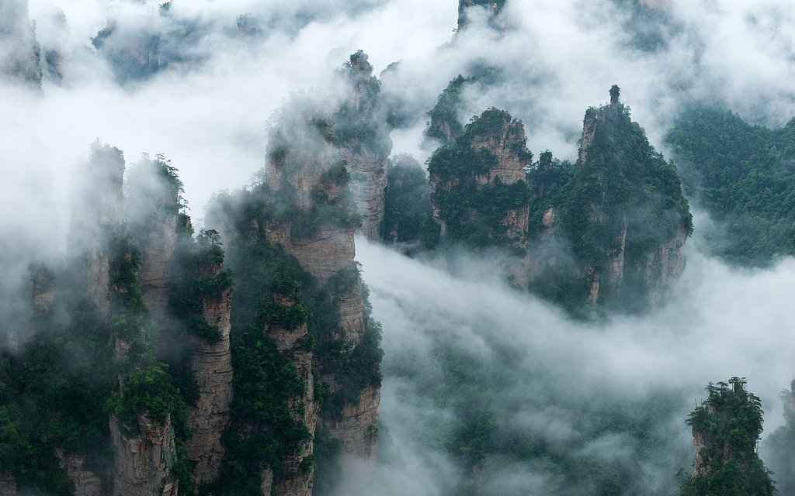
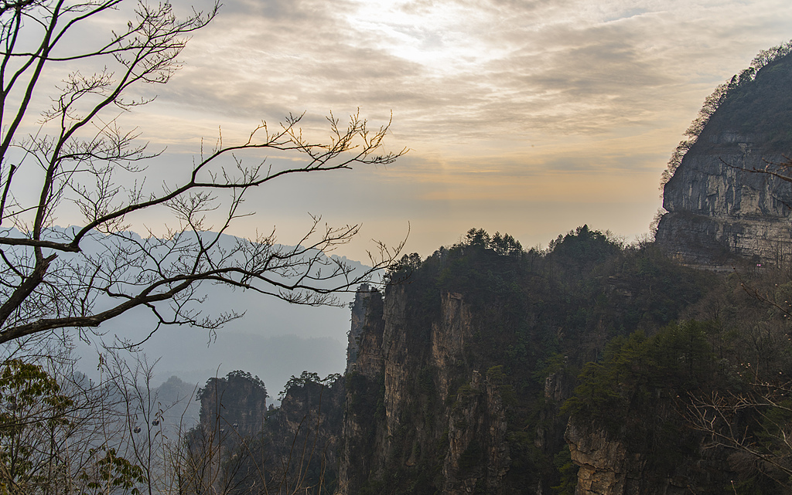
Day 2 Experience Glass Bridge of Zhangjiajie Grand Canyon, Visit Tianmen Mountain (Heaven's Gate)
Today we will pick you up and then drive you along the winding mountain road to Zhangjiajie Grand Canyon for around 40 minutes. The most thrilling thing that will welcome you is the high-rising Glass Bridge that spans the canyon. Dare you to walk across this world’s highest and longest transparent bridge? Give it a try, and you will feel as if you are wandering in the air! If you are afraid of heights, you can also follow the opaque sections on either side. Being actually on it, you could not help but let out a wow when beholding the panoramic view of the canyon and the abyss beneath your feet. Afterwards, go back the way we came and leave for the next destination.
In the afternoon, we will reach the downtown cableway station of Tianmen Mountain and take a 28-minute ride up this Zhangjiajie’s highest mountain. As the world’s longest passenger cableway, it will bring you the double enjoyment of excitement and beauty. Along the way, Zhangjiajie’s city sights, countryside scenes, and mountain scenery will unfold before your eyes one by one. At the summit, pluck up courage again to stroll through the transparent Glass Skywalk hanging onto a cliff. Then the 7-level escalator will take you down to the Tianmen Cave (Heaven's Gate), a giant natural hole that not only boasts many ancient Chinese myths, but also is fanatic for extreme sports enthusiasts. Continue your descent with our guide to Tianmen Square, where the juxtaposition of the 999-step Heavenly Stairway and the Cave will make you feel that heaven is within reach. After the sightseeing, let’s descend the mountain by express cable car.
At the end of this small group Zhangjiajie tour, you will be escorted to your hotel. Since Tianmen Mountain is right in urban areas, you may consider booking your hotel tonight in downtown Zhangjiajie. Hope you had 2 pleasant days with us. Want to extend your tour? Do not hesitate to call our hotline, and our travel consultant is always ready to customize an exclusive tour for you.
► Dinner Recommendation (at your own expense):
In the evening, we recommend you dine at the time-honored Mr. Tang · Famous Western Hunan Cuisine Restaurant in hotels area of Wulingyuan District. For three decades, it has stuck to the principle of inventing new recipes on its own, bringing new joys for the palate while assuming the mission of promoting Hunan cuisine. The décor is in a traditional wooden style and looks inviting and clean.
Average cost per person: CNY 80 / USD 11
Address: No.463, Wuling Road, Wulingyuan District, Zhangjiajie
