Packages detail
6 Days Private Tour of Chengdu - Leshan - Mt. Emei - Chengdu - Huanglong - Jiuzhaigou
Jiuzhaigou & Giant PandasUSD1699（A minimum order of 2 people is required）

Overview
Tour Type: Private tour with an English-speaking guide, flexible and customizable
Transportation: Air-conditioned private car with an experienced driver
Hotels: 5-star luxury or 4-star comfortable hotels, open to your choice
Meals: 5 breakfasts, 1 dinner
Trip Highlights：
• Get close to observe how giant pandas of various ages eat bamboo and entertain themselves.
• Take a cruise to admire the Leshan Giant Buddha, the largest stone-carved Buddha in the world.
• Ride a cable car to see temples on Mt. Emei, one of China’s sacred Buddhist mountains.
• Discover the enchanting fairyland of Jiuzhaigou and Huanglong, featuring vibrant ponds and majestic waterfalls.

Included & Excluded
Price Includes
• Second-class high speed train of Chengdu/Jiuzhaigou
• Hotel accommodation with breakfasts
• Private English-speaking guides
• Lunches and dinners as itinerary specifies
• Private drivers & air-conditioned vehicles
• Entrance fees to tourist sites
Price Excludes
• International airfares
• Entry Visa fees
• Personal expenses
• Tips or gratuities for guides and drivers

Itinerary
Day 1 Arrive in Chengdu
Welcome to Chengdu! Your 6-day Sichuan tour itinerary starts when your private guide and driver greet you at the airport or the high-speed train station. Then, a comfortable private car ride will take you to the conveniently located hotel for check-in.
For the rest of the day, you can relax at the hotel or explore the downtown attractions on your own. The nearby vibrant Chunxi Road and Taikoo Li district offer a shopping paradise for finding souvenirs and tasting local cuisine, immersing yourself in a refined atmosphere surrounded by traditional and modern architecture.
► Suggested Restaurant for Dinner (at your own expense)
If you’ve always wanted to try Sichuan cuisine but can only handle mild spice, don’t miss Tao Lin Restaurant, which offers modified Sichuan dishes suitable for foreigners. Its signature bass is prepared from live fish, freshly killed, and cooked with pickled peppers, pickled ginger, and various seasonings, resulting in tender, flavorful, sour, spicy, and aromatic fish. Additionally, Black Tofu comes highly recommended by diners for its premium ingredients and creative flavor profile. Topped with Sichuan chili sauce, the hand-ground black tofu is sizzling, crispy on the outside, and tender inside, and goes well with rice.
Average Cost per Person: CNY 70 (USD 10)
Address: 1F, Zhongdian Mansion, No. 81 Xuedao Street, Jinjiang District, Chengdu
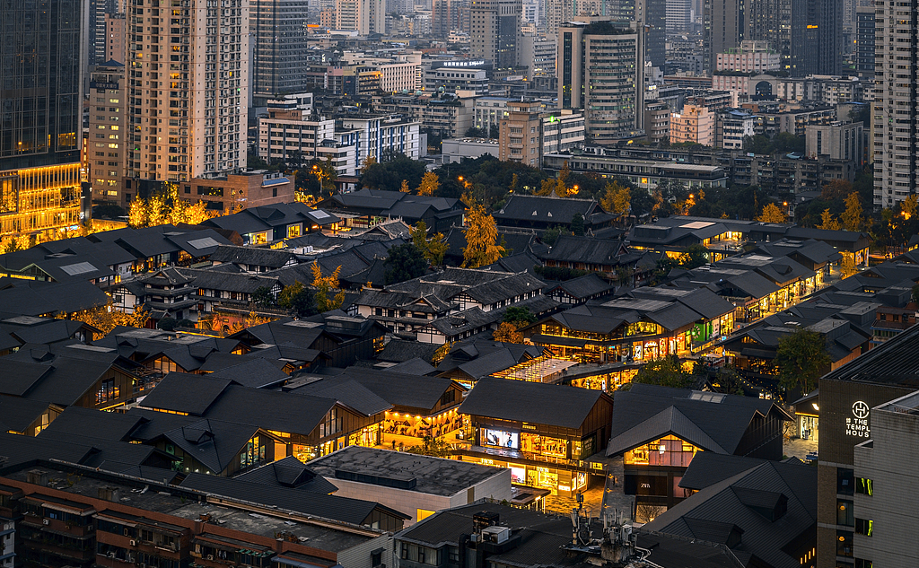
Accommodation: Holiday Inn Chengdu Oriental Plaza (4 stars) or Grand Hyatt Chengdu (5 stars)
Day 2 Chengdu – Leshan – Mt.Emei
Observing adorable giant pandas is a bucket list highlight of any Chengdu tour. Therefore, after breakfast, we will set off as early as possible to meet these fluffy creatures during their most active hours at the Chengdu Research Base of Giant Panda Breeding. Beyond local pandas, you can visit a unique living area for pandas returning from overseas, such as Mei Lun and Mei Huan, who came back from the United States, and Yuan Xin, the father of Fu Bao from South Korea, demonstrating how they adapt to life in their hometown. Interestingly, returning pandas need to relearn commands in the Sichuan dialect, and your guide will explain the meaning of Sichuan dialect commands to you.
In the afternoon, let’s embark on a two-hour drive to the UNESCO-honored Leshan Giant Buddha, the world’s tallest Maitreya statue at 71 meters (233 feet). Upon arrival, follow your guide to hop on a cruise offering a complete view of the Buddha. The Giant Buddha was initially constructed during the Tang Dynasty (618-907) to bless passing ships. However, in modern times, the Giant Buddha has shed tears during four significant disasters in China: the Great Famine in 1962, the Tangshan Earthquake in 1976, acid rain in 1994, and the devastating flood in 2020. Although scientific explanations can account for these occurrences, people prefer to believe that they serve as warnings from the Buddha, giving this millennium-old statue a new allegory relevant to our times.
At the end of today, the guide and driver will transport you for one hour to Mt.Emei and assist you with checking into a local hotel.
Meals: Western buffet breakfast, Dinner
Accommodation: Building No. 5 of Hongzhu Shan Hotel (5 stars), Mountain-view Room
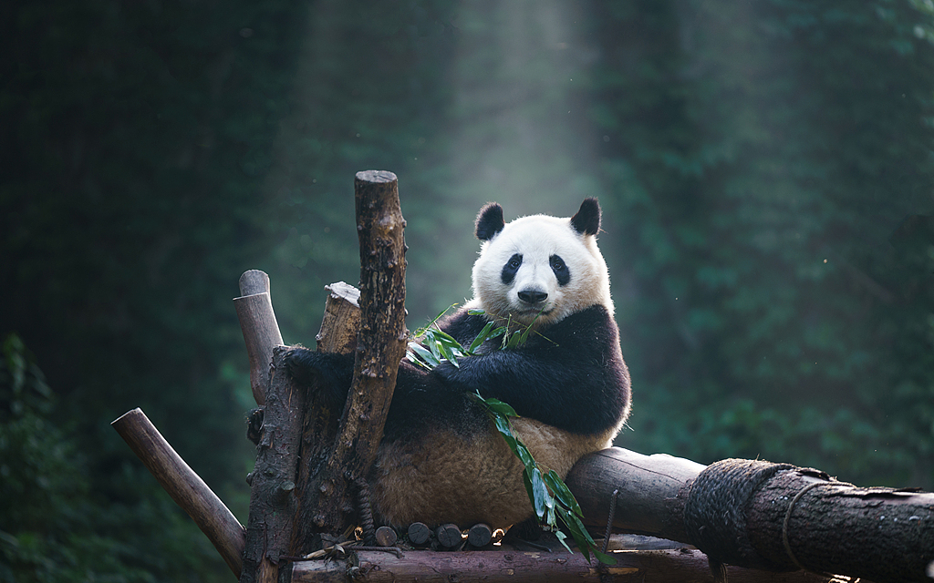
Day 3 Mt. Emei Exploration – Chengdu
Today, your guide will accompany you to explore Mt. Emei, one of China’s four most famous Buddhist mountains. After a cable car ride from the parking lot, followed by a 10 - 20-minute walk, you’ll breathe in the natural fragrance exuded by the thousand-year-old nanmu forest, encounter curious monkeys, and finally reach the 1,600-year-old Wannian Temple. As one of the oldest temples on Mt. Emei, the Wannian Temple not only embodies profound Buddhist culture but also boasts natural wonders and architectural wisdom. Three echoes resonate when you clap your hands in its Beamless Brick Hall, earning it “the Roman Pantheon of the East.” Additionally, don’t miss the temple’s must-see: the 62-ton bronze statue of the Bodhisattva of Universal Benevolence from the Song Dynasty (960-1279), whose intricate details of a lotus wrapped in the elephant’s trunk will amaze you with the ancient Chinese lost-wax casting technique.
Next, we’ll head downhill the same route and take a 20-minute drive to Baoguo Temple, the Temple of Loyalty to the Nation. Nestled among ancient pines and cypresses, the temple honors the Buddhist Samantabhadra Bodhisattva, the Taoist Zhenwu Emperor, and Confucian saints, embodying the unity of China’s three religions. By showcasing numerous rare treasures, it exudes a unique appeal for enthusiasts of Eastern culture. Ultimately, the guide and driver will return you to the hotel in downtown Chengdu.
Meals: Western buffet breakfast
Accommodation: Holiday Inn Chengdu Oriental Plaza (4 stars) or Grand Hyatt Chengdu (5 stars)
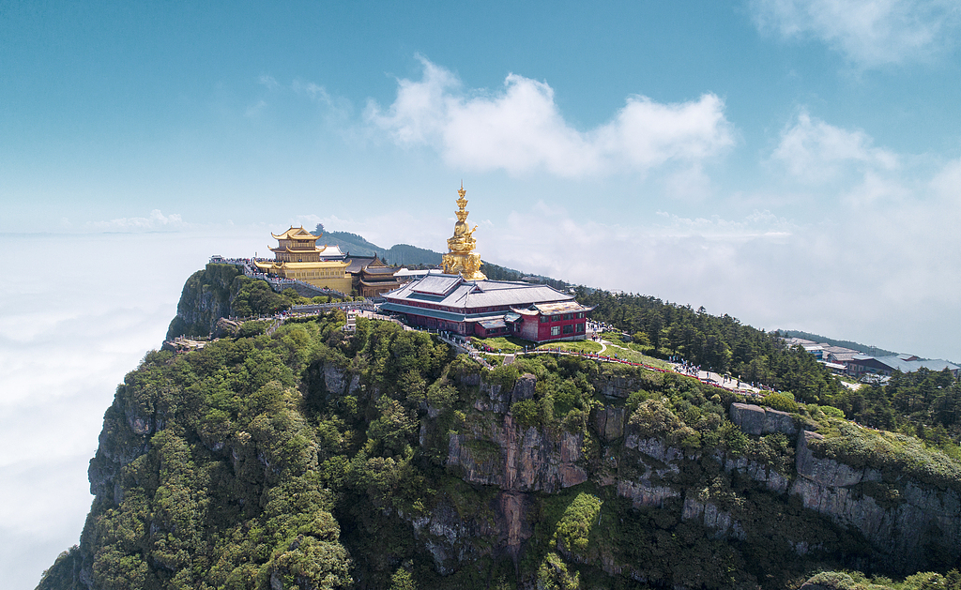
Day 4 Chengdu – Huanglong – Jiuzhaigou
This morning, the guide will see you off for a high-speed train ride to Huanglong Jiuzhai Station, where the local guide and driver will pick you up and transfer you to explore Huanglong National Scenic Reserve for the rest of the day. As a UNESCO World Heritage Site, Huanglong is renowned for hosting the world’s largest and most complete travertine terrace pool, which features thousands of multi-colored ponds stretching 3.6 kilometers (2.2 miles), resembling a Chinese dragon winding through the forests, and is thus named Yellow Dragon Gully (Huanglong).
During our hike, you will witness glacial relics and untouched forests intertwining to create a magnificent alpine canyon landscape, home to unique vegetation such as the alpine rhododendron and fir, alongside endangered species like the Sichuan golden monkey and the green-tailed pheasant. As the otherworldly scenery continues to captivate your imagination of the secret land of the East, we’ll arrive at the highest point of the “abode of immortals” on earth, Huanglong Temple, which combines Han and Tibetan architectural styles, exudes an intense religious atmosphere, and enhances the cultural heritage. Ultimately, the guide will lead you downhill, and we will drive you to our hand-picked hotel in Jiuzhaigou.
► Attention for Your Jiuzhaigou-Huanglong Tour
Since Huanglong lies at an altitude of 1,700 to 5,588 meters (5,577 to 18,333 feet) and Jiuzhaigou Valley is situated between 1,900 and 3,500 meters (6,233 and 11,482 feet), altitude sickness is likely to occur, and weather changes are difficult to predict. We recommend the following:
1. Avoid heavy exercise and alcohol; instead, eat plenty of vitamin-rich fruits and vegetables for these two days’ meals.
2. Bring sunblock, a sun hat, and sunglasses to protect against the sun’s UV rays.
3. Take an umbrella or raincoat and a warm overcoat in case of rain or low mountain temperatures.
4. Pack snacks like chocolate to replenish your energy, and always watch your steps during the trek.
Meals: Western buffet breakfast
Accommodation: Qianhe Rezen Hotel Jiuzhaigou (4 stars) or Wyndham Grand Plaza Royale Jiuzhaigou (5 stars)
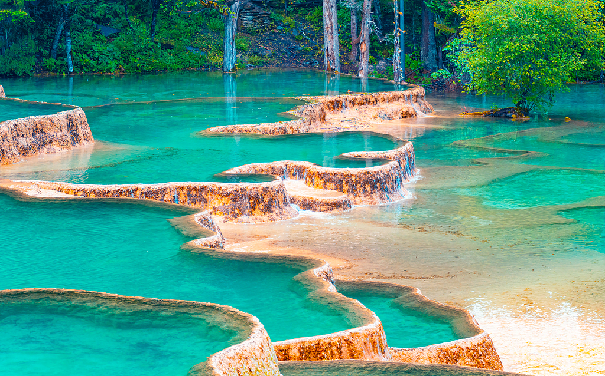
Day 5 Jiuzhaigou Valley National Park
Today, come with your guide to enjoy a full-day trip touring the other UNESCO-honored natural wonder, Jiuzhaigou Valley National Park. Known as a “fairyland on earth,” Jiuzhaigou features 108 stunning ponds, notably the Multi-Colored Lake and the Long Lake, which present dreamy colors such as blue, green, and emerald, called the “God’s overturned palette.”
Also, don’t miss out on take incredible photos at a famous shooting location of the Chinese TV series “Journey to the West” and Zhang Yimou’s film “Hero,” where the two roaring travertine waterfalls, Nuorilang Waterfall and Pearl Shoal Waterfall, feed into placid ponds, creating a visual spectacle that combines movement and stillness. Beyond the breathtaking waterscape, traditional Tibetan villages emerge from the dense forest, exuding an ancient character, allowing you to find not only crystal-clear ponds but also a preserved segment of Tibetan life. At the end, the guide and driver will take you back to the hotel.
► Lunch Tip
Since there is only one buffet restaurant in the park, if you are concerned about a long queue or if the offerings do not suit your taste, we suggest enjoying a hearty hotel breakfast this morning and packing some fast food for lunch today. But don’t worry, you will have many delicious choices for dinner in Jiuzhaigou County, and feel free to ask your guide for advice after all the visits.
► Where to Try Tibetan Cuisine in Jiuzhaigou (at your own expense)
On a relaxing evening, the Tibetan Accord Restaurant, with exquisite ornaments and river-view seats, is the perfect setting for a mouth-watering yak meat feast. Yak meat can be enjoyed either in a hot pot or grilled, and the portions are quite generous. The highlight is the restaurant’s special secret sauce, which is fragrant and not greasy. You can pair the hotpot meat with the secret sauce and the grilled meat with dried chili peppers, each having its unique characteristics.
Average Cost per Person: CNY 100 (USD 14)
Address: No. 68, Huodiba Bianbian Street, Zhangza Town, Jiuzhaigou County
Meals: Chinese breakfast
Accommodation: Qianhe Rezen Hotel Jiuzhaigou (4 stars) or Wyndham Grand Plaza Royale Jiuzhaigou (5 stars)
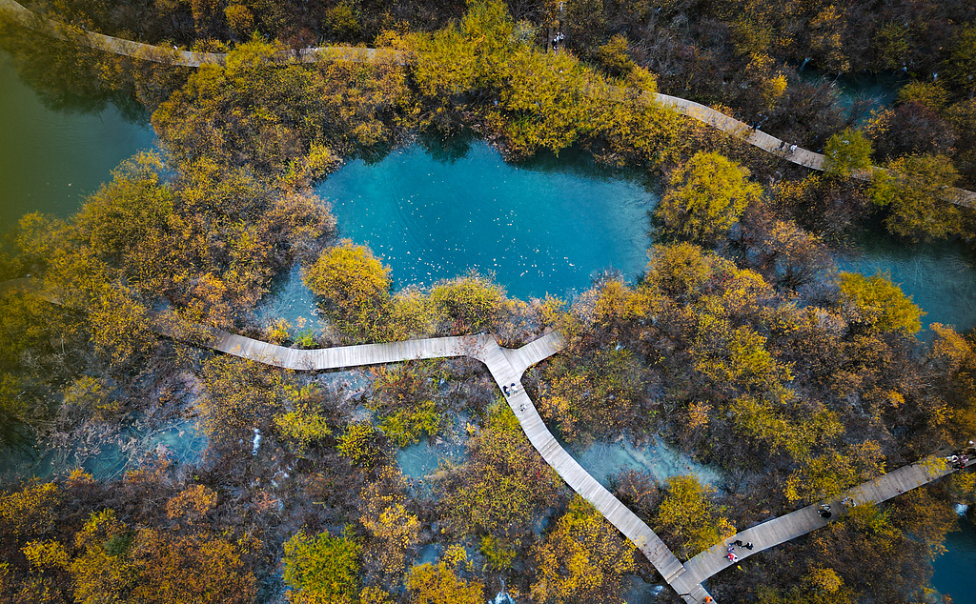
Day 6 Depart from Jiuzhaigou
On the final day of your private Sichuan tour package, your guide and driver will escort you to Jiuzhai Huanglong Airport or Huanglong Jiuzhai Railway Station, depending on your onward flight or train schedule. Kindly note that the airport only offers direct flights to a limited number of cities, such as Chengdu, Beijing, and Hangzhou, so please arrange two journeys from Jiuzhaigou to one of these cities and then back to your country. Alternatively, you can request our assistance with booking the tickets (at your own expense). Wish you a pleasant journey!

