Packages detail
1 Day Chengdu Highlights with Panda, No Shopping
USD229（A minimum order of 2 people is required）

Overview
Panda- Wide and Narrow Alley- The Jinsha Site Museum

Included & Excluded
Price Includes
• Private English-speaking guide
• Private driver & air-conditioned vehicle
• Entrance fees to tourist sites

Price Excludes
• Hotel accommodation with breakfast
• Lunch and dinner
• Tips or gratuities for guide and driver

Itinerary
Welcome to our full-day exploration of Chengdu!

1.Panda
As giant pandas are most active in the morning, let’s start with a visit to the Chengdu Research Base of Giant Panda Breeding. After picking you up from your hotel at 8:00 a.m., the driver and guide will transfer you there, briefly introducing today’s itinerary and an overview of Chengdu’s history and culture along the way. Upon arrival, the guide will escort you to separate enclosures featuring giant pandas at various life stages, especially a close-up viewing area where baby pandas are open to the public from August to October. If you don’t see it with your own eyes, it’s hard to imagine that a black and white adult panda weighing more than 100 kilograms (about 220 pounds) grew from a pink, mouse-sized cub. Beyond, the must-see is the “villa” of the star female giant panda, Hua Hua. With a rounder appearance than other pandas of the same age and puffy hair, Hua Hua often sits on the ground like a fluffy triangular rice ball, which has become her iconic image, making her go viral on the internet. She was even appointed “Honorary Director of Chengdu Culture and Tourism Bureau”, earning her the nickname Director Hua.
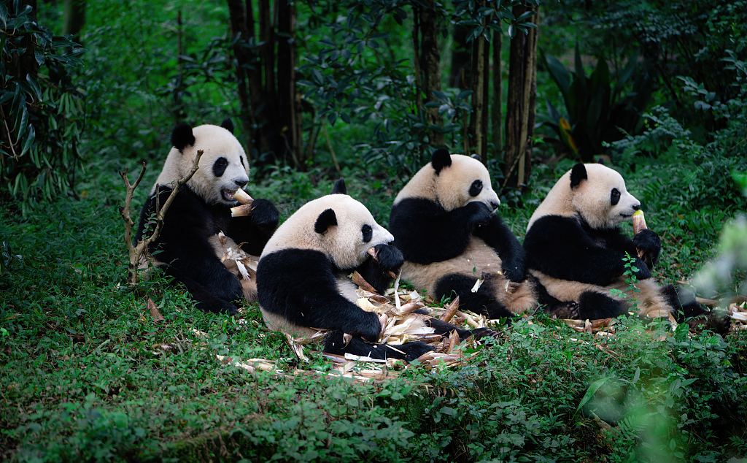
2.Wide and Narrow Alley
Around noon, we’ll arrive at Wide and Narrow Alley. Once a residential area during the Qing Dynasty (1644-1911), it is now a cultural hub where traditional Chinese architecture is being revitalized by being transformed into restaurants, craft stores, bars, art galleries, and teahouses. Despite the synergy between the old and new throughout changing times, you’ll find that one constant is the locals’ ever-laid-back lifestyle of playing Mahjong and drinking tea in their spare time.

Tip: You may notice many locals receiving ear cleaning right on the street, a unique tradition that brings people comfort and refreshment. However, we do not recommend trying it, as excessive ear canal cleaning may be detrimental to your health. Does the heady scent of enticing street snacks pique your appetite as you pass by countless stalls selling mung bean jelly, Three Artillery made from sweet glutinous rice, or crispy sautéed potatoes? Just in time for lunch, your guide will give you restaurant recommendations to feast on authentic Sichuan cuisine.

Unmissable Restaurant near Wide and Narrow Alley (at your own expense)
You might try the Chicken Feather Restaurant, which has attracted a flux of gastronomes. Its signature dish is spicy diced chicken, which is made by deep-frying crispy chicken cubes with dried chilies and Sichuan peppers. Grabbing a bite, your taste buds will tangle with punches of charred aroma and a numbing tingle, but not choking. You may even find a hint of sweetness in the aftertaste.
Average Cost per Person: CNY 70 (USD 10)
Address: No. 2, 1st Floor, 69 Tonghuimen Road, Jinniu District, Chengdu
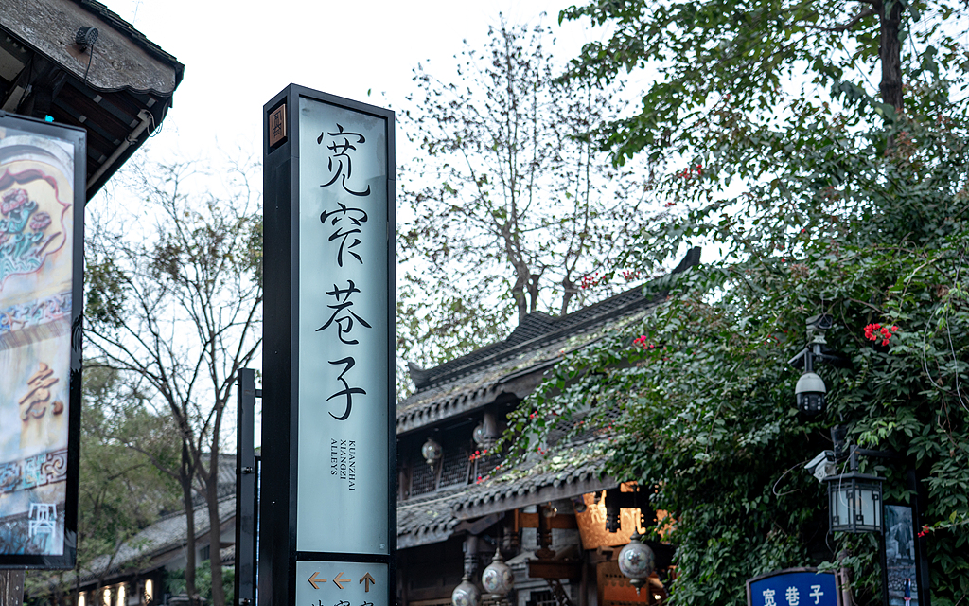
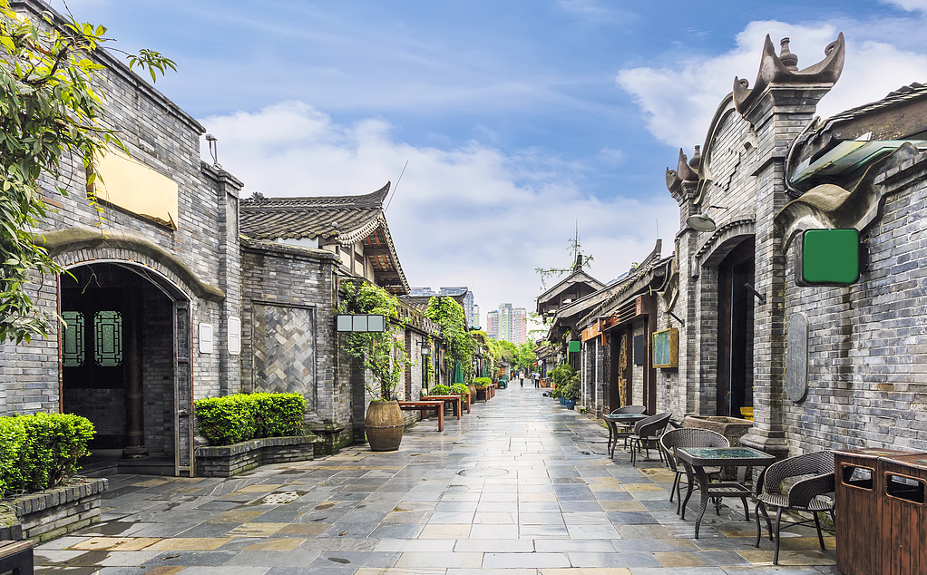
3.The Jinsha Site Museum
In the afternoon, drive for only 15 minutes to the Jinsha Site Museum, situated on the archaeological site of the ancient Shu Kingdom (12th-7th century BC), which reveals a mysterious civilization through numerous treasured artifacts made of ivory, jade, and gold. Follow your guide to the Relics Hall, where you will witness the original appearance of several sacrificial pits and experience the unearthed scenes. Marveling at the crowning touch of all collections – the Sun and Immortal Birds Gold Ornament, hollowed out with uniform patterns to a thickness of only 20μm – you can’t help but exclaim over the exquisite craftsmanship of the ancient Shu people 3,000 years ago. Besides, you can find numerous everyday products made of stone, pottery, bronze, or ivory, offering valuable insights into daily life at that time.
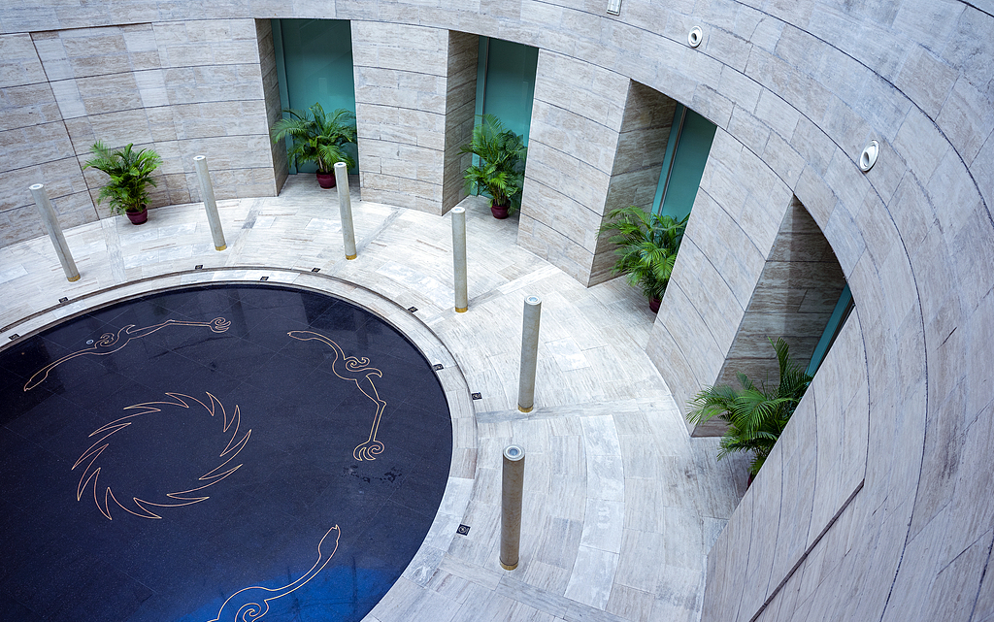
As our Chengdu day trip comes to an end, the guide and driver will escort you back to your hotel. You may ask your guide for recommendations on dinner or other tourist attractions. We hope you’ve had a pleasant time with us and look forward to serving you again shortly!
Free Time Recommendation: Watch Sichuan Opera (at your own expense)
To enrich your trip to Chengdu, consider enjoying the Sichuan Opera, an art form that combines traditional Chinese drama with local culture, at the Shufeng Yayun Theater. As a UNESCO Intangible Cultural Heritage, the Sichuan Opera will amaze you with its eye-popping artistic expressions, such as face-changing and fire-spitting performances, accompanied by engaging live background music. The daily show lasts from 8:00 p.m. to around 9:30 p.m. Order a cup of tea and get ready to glut your eyes!
Contact us in advance to book your tickets if you are interested in the show.

