Packages detail
5 Days Private Tour of Chengdu - Huanglong – Jiuzhaigou
Side Trip to Fairy Jiuzhaigou USD1399（A minimum order of 2 people is required）

Overview
Trip Highlights
• Personalized private tour tailored to your schedule and preferences.
• English-speaking private guide, air-conditioned private car with an experienced driver.
• Marvel at Jiuzhaigou Valley and Huanglong’s pristine, colorful ponds, and spectacular waterfalls.
• Have a special date with cuddly giant pandas in their hometown.
• Take in century-old buildings and feel Sichuan folk culture at Wide and Narrow Alley.
• Experience Chinese marriage culture and enjoy local tea at People’s Park.

Included & Excluded
Price Includes
• Private English-speaking guides
• Private drivers & air-conditioned vehicles
• Second-class high speed train of Chengdu – Jiuzhaigou
• Hotel accommodation with breakfasts
• Lunches as itinerary specifies
• Entrance fees to tourist sites

Price Excludes
• Airfares of arrival and departure
• Entry visa fees
• Personal expenses
• Tips or gratuities for guides and drivers

Itinerary
Day 1 Arrival in Chengdu
Welcome to Chengdu! In the next 5 days, you’ll explore the famous hometown of giant pandas and immerse yourself in the otherworldly natural beauty of Jiuzhaigou Valley. Upon your arrival in Chengdu, your guide will meet you outside the airport’s baggage claim area and transfer you to the hotel in a private car. The remainder of the day is yours to enjoy freely. Get some rest to prepare for your Chengdu Jiuzhaigou Huanglong tour.
If you are still energetic, exploring the surrounding neighborhood on your own is possible. We selected the hotel in the city center, next to Chengdu’s most prosperous business street, Chunxi Road, flanked by various high-end shopping malls, luxurious stores, and fancy restaurants. You can also find some local snacks and street food here. Stroll around and take in the city’s modern development. At the luxurious shopping mall IFS, you can witness a huge urban landmark, the “Climbing Giant Panda” sculpture, which is pretty interesting and impressive!
► Recommended Diner Site (at your own expense)
If the snacks at Chunxi Road haven’t filled your stomach, we recommend the century-old Chen Mapo Tofu Restaurant, to experience the local flavor of the signature Sichuan dish. Dating back to 1862, it is recognized as the birthplace of the famous dish Mapo Tofu. Its delicious flavors have also earned high praise from the Michelin Guide. You can enjoy the spicy, silky tofu with ground beef and other representative dishes like Zhong Dumplings and Dan Dan Noodles. There may be a long queue during meal times, but the wait is worth it!
Average Cost per Person: CNY 70 (USD 10)
Address: No. 10, Qinghua Road, Qingyang District, Chengdu
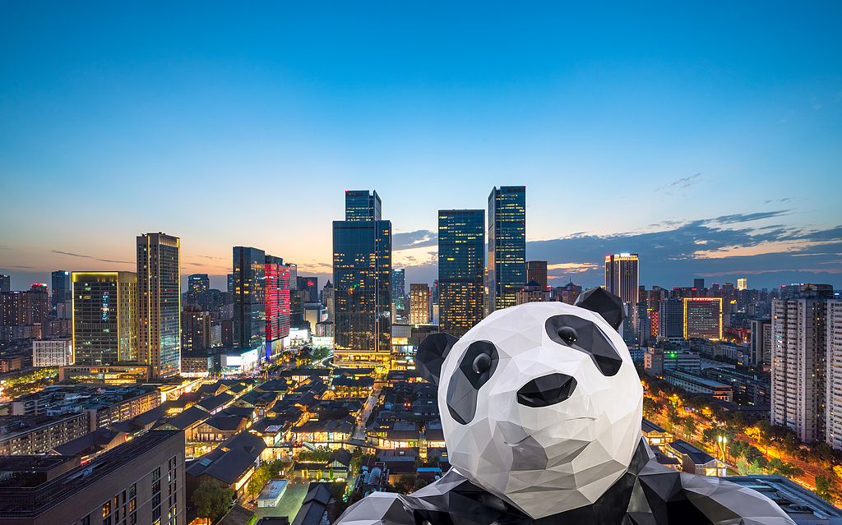
Day 2 Chengdu City Tour
In the morning, we will enjoy a special date with adorable giant pandas at the Chengdu Research Base of Giant Panda Breeding, which houses over 200 pandas. It is astonishing to see so many giant pandas in one place, something you can do only in their hometown, Chengdu. The panda visit is fascinating from June to September, when many lovely panda cubs are born. We’ll arrange your panda visit for early morning to avoid large crowds and when the pandas are most active. With your guide’s assistance, you can observe them playing, climbing trees, eating bamboo, and even pooping, gaining valuable insight into the lives and habits of these treasures.
Next, let’s head to the historic Wide and Narrow Alley. This traditional community consists of three alleys, filled with ancient buildings dating back 300 years. Nowadays, these old houses have been restored and transformed into shops selling local souvenirs and handicrafts, as well as workshops with exquisite embroidery and other Chinese-style goods. It is somewhat touristy and features bars, tea houses, and local food stalls. Moreover, you may encounter live Sichuan operas and engaging ‘face-changing’ performances.
In the afternoon, follow your guide to the Jinsha Site Museum to see relics from the ancient Shu Kingdom, based in Sichuan, over 3,000 years ago. You’ll be amazed by the extensive collection of ivory and exquisite gold artifacts unearthed from this UNESCO-listed site. The most famous exhibits include the gold sun bird ornament, a symbol of China’s cultural heritage, and a mysterious smiling golden mask.
Afterward, we’ll head to People’s Park, an ideal place to experience the laid-back lifestyle of locals. You’ll find people playing Mahjong, practicing Tai Chi martial arts, singing, dancing, or writing calligraphy with super-large brushes on the ground. These friendly people will welcome you if you wish to join them. This is also where you can experience China’s unique marriage culture. Parents search for candidates to marry off their sons or daughters in the matchmaking corner by displaying their detailed profiles. If you like, just sip a cup of tea like a local in a lakeside teahouse.
Meal: Western buffet breakfast
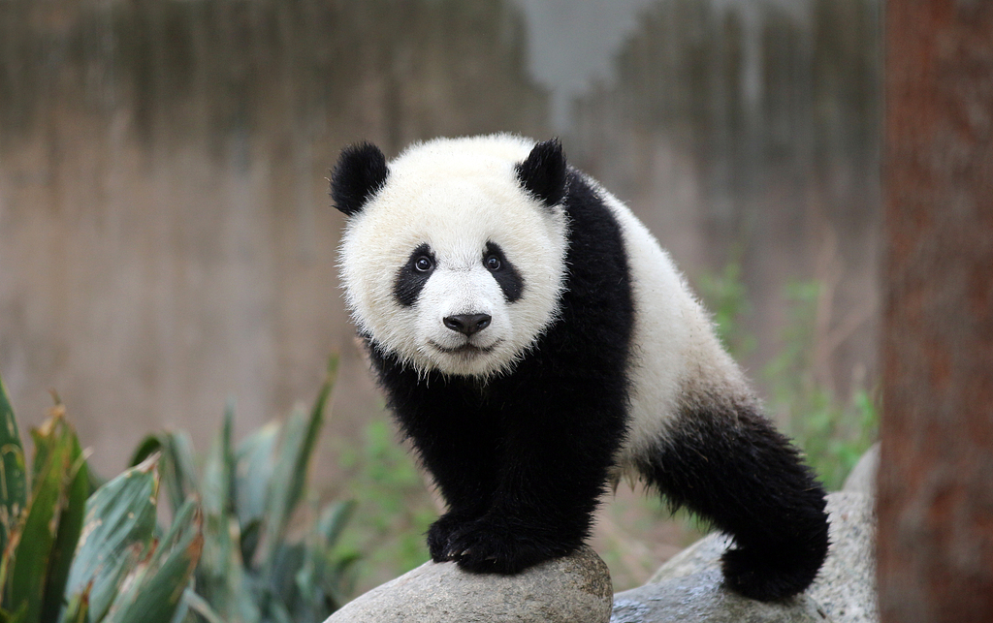
Day 3 Chengdu - Huanglong - Jiuzhaigou
On this day, we’ll leave Chengdu for the fairytale-like Jiuzhaigou Valley. After breakfast, you’ll be escorted to the Chengdu railway station for a 2-hour high-speed train journey to Huanglong Jiuzhai Railway Station. Our local guide will meet you at the railway station and transfer you to the Huanglong National Scenic Reserve, a gem on every nature lover’s itinerary. The drive takes about 30 to 40 minutes. In the northwest of Sichuan, Huanglong attracts visitors with its colorful lakes, snow-capped peaks, glaciers, mountain landscapes, diverse forest ecosystems, waterfalls, and hot springs. At the highest point, you’ll find the iconic Multi-Colored Ponds on a tract of terraced ivory travertine, showcasing varied shapes and dreamlike colors of yellow, blue, green, and brown. We have arranged cable cars to conserve your energy, giving you more time to immerse yourself in the stunning natural beauty of the amazing Multi-Colored Pond. An ancient temple, Huanglong Monastery, built in the Ming Dynasty (1368 - 1644), is where you can rest briefly. Afterward, proceed to Jiuzhaigou for a two-night stay.
Meal: Western buffet breakfast
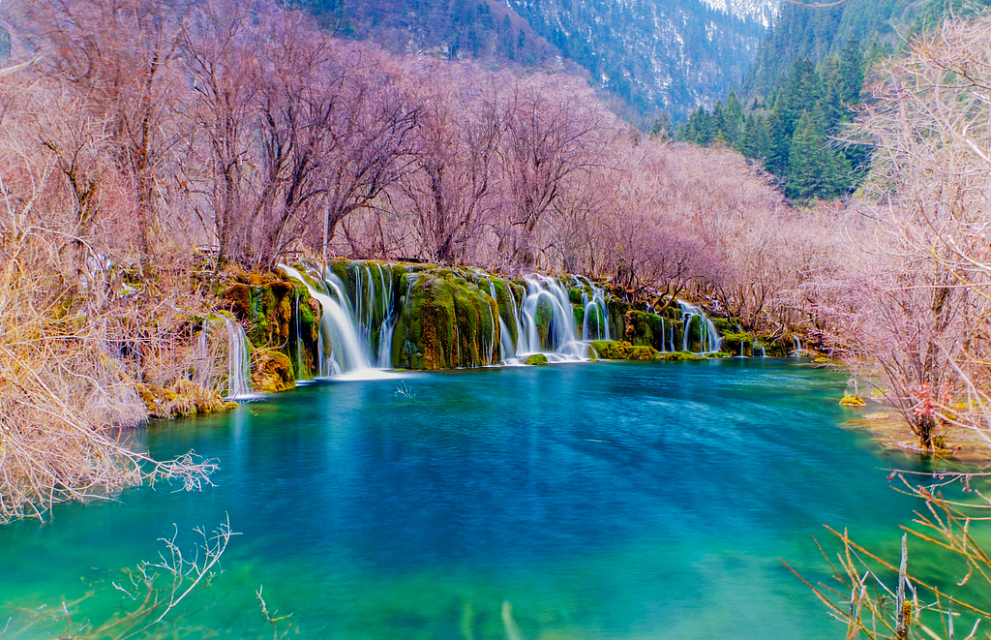
Day 4 Full-day Exploration in Jiuzhaigou Valley
Today, you’ll spend a whole day sightseeing in the Jiuzhaigou Valley, the biggest highlight during your private Jiuzhaigou tour from Chengdu. The world-famous valley is 35 kilometers (22 miles) long, consisting of three parts with diverse natural beauty, at 2,500 meters (8,200 feet) above sea level. The fairyland includes virgin forests, over a hundred limpid lakes, verdant mountains, and awe-inspiring waterfalls. But speaking of the most beautiful, we can’t miss its Multi-Colored Pond, the Nuorilang Falls, Long Lake, and the Pearl Shoal.
Unlike the large-scale one in Huanglong, Jiuzhaigou Valley’s Multi-Colored Pond is the smallest among the valley’s many lakes and ponds. However, it is the most captivating, featuring transparent water blending azure, light green, and orange, especially beautiful under sunshine. The Nuorilang Falls, whose name means “majestic and grand” in Tibetan, are among the most stunning waterfalls here. From above, you can see rows of dense forests stretching across its upper region, through which currents rush to the edge and cascade down. In the cooler morning, rainbows hang around, adding to the magic of the landscape. While at Long Lake, you’ll see a meandering S-shaped body of water reflecting snow-capped peaks, lush forests, blue sky, and white clouds. The Pearl Shoal comprises falls tumbling down across a vast expanse of jagged outcrop. It’s named for beads of water that scatter where the torrents splash onto rocks, resembling pearls gleaming in the sunlight.
Meal: Chinese breakfast.
► Friendly Tips:
1.Jiuzhaigou Valley, with its stunning sights, is always popular and filled with numerous visitors. Your private guide will arrange the visit order effectively based on the circumstances, saving you time and providing a better travel experience.
2.There is only one buffet restaurant in the Jiuzhaigou scenic area, and people always queue up. Based on our experience, many Western tourists find it difficult to adjust to its flavors. Therefore, we recommend having a hearty breakfast at the hotel and bringing snacks to regain your physical energy around noon.
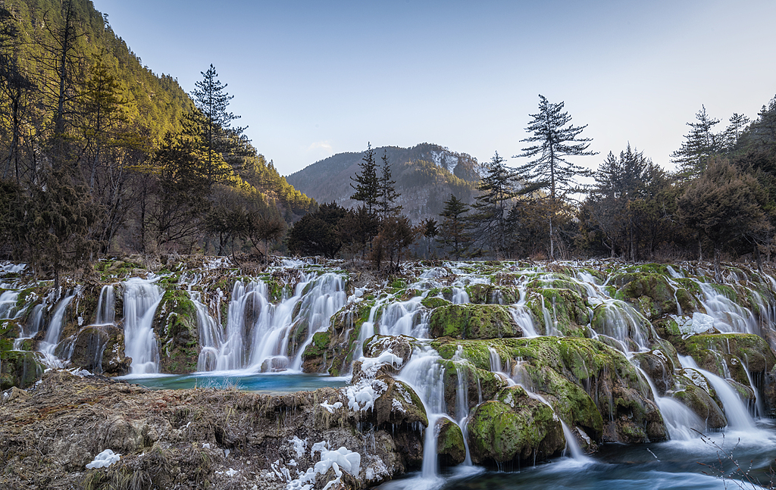
Day 5 Departure from Jiuzhaigou
As our 5 days Chengdu Jiuzhaigou tour concludes today, we’ll arrange a comfortable transfer from the hotel to the Jiuzhaigou airport or railway station for your onward journey. It is necessary to remind you that Jiuzhai Huanglong Airport only offers direct flights to a few cities like Chengdu, Beijing, and Hangzhou. Please arrange two journeys from Jiuzhaigou to one of these cities and then back to your country, or you can also ask us to help book the tickets (at your own expense). We hope our service leaves you with a pleasant memory!
Meal: Chinese breakfast
