Packages detail
Yunnan Minority Discovery USD1399
8 Days Private Tour of Kunming - Dali - Lijiang - Shangri-La
An additional fee of $200 will be charged during China's legal holidays and the summer vacation (July and August).

Overview
Tour Type: Private tour, any part of the itinerary can be customized
Guide: Private & professional English-speaking guide
Transport: Spacious and air-conditioned car with private driver
Accommodation: 5-star luxury and 4-star comfort hotels at your choice
Trip Highlights：
• Marvel at karst landscape of the Stone Forest & experience a local market.
• Immerse yourself in the beauty of Erhai Lake & visit the Bai people’s traditional houses.
• Explore the nearly 1000-year-old town Lijiang - a UNESCO World Heritage site.
• Admire the sheer natural beauty in the Lost Horizon of Shangri-La.

Included & Excluded
Price Includes
• Domestic airfares & train fares
• Hotel accommodation with breakfasts
• Lunches as itinerary specifies
• Private English-speaking guides
• Private drivers & air-conditioned vehicles
• Entrance fees to tourist sites

Price Excludes
• International airfares
• Entry visa fees
• Tips or gratuities for guides and drivers
• Peak season surcharge (public holiday, July & August, etc.)

Itinerary
Day 1 Arrival in Kunming, Airport Pick-up
Upon your arrival in Kunming, the capital city of Yunnan today, our professional guide will pick you up in the arrival hall of the airport on time and then transfer you to the hotel in downtown area by an air-conditioned car.
After a short break, start the exploration in Yunnan from the Golden Temple, a well-known Taoist temple on Mingfeng Hill. It is actually not built of gold, but bronze. As shining as gold under the sunshine, it is hence named Golden Temple. After that, take a leisurely wander in the Green Lake Park to appreciate the beauty of the waterscape, which enjoys the reputation of “jade of the city”.
► Restaurant Recommendation for Dinner (at your own expense):
If you want to sample Yunnan cuisine, do it at the time-honored Emerald Cloud Restaurant besides Green Lake Park. The restaurant is 10 minutes' walk from Green Lake Hotel and 20 minutes' taxi ride from Jinjiang Hotel. Dating from the Ming Dynasty (1368 - 1644), the restaurant building has become a historical landmark. It allows you to eat while appreciating the beautiful scenery of the entire park.
Average cost per person: CNY 70 / USD 10
Address: No.82 Qingyun Street, Wuhua District
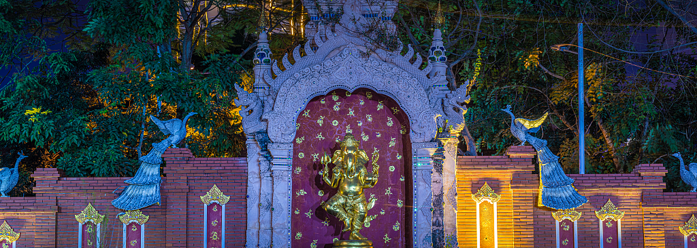
Day 2 Kunming to Dali by High Speed Train
This morning, you will have a chance to experience locals’ life at Zhuanxin Farmers' Market, which is the largest of its kind in Kunming, even the whole Yunnan. Every day, thousands of people come here to buy ingredients for cooking meals, including vegetable, meat, seafood, and fruit. Blessed with complex landforms and diverse climate, Yunnan always cultivates something different from others, so it’s not surprising to see strange wild mushrooms and vegetable in the market.
Then, continue to visit the Stone Forest, a typical model of China's Karst landforms. Walking through the Stone Forest, you will be astonished by the extraordinary workmanship of the nature. Stones in the shapes of plants, animals and even humans can all be found here, some elegant, some rugged.
After, your guide will transfer you to the railway station and instruct you to board the high speed train to Dali, which takes around 2 hours on the way. Our guide based in Dali will pick you up on your arrival and escort you to the hotel in the primitive Dali Ancient City.
Meals: Western buffet breakfast
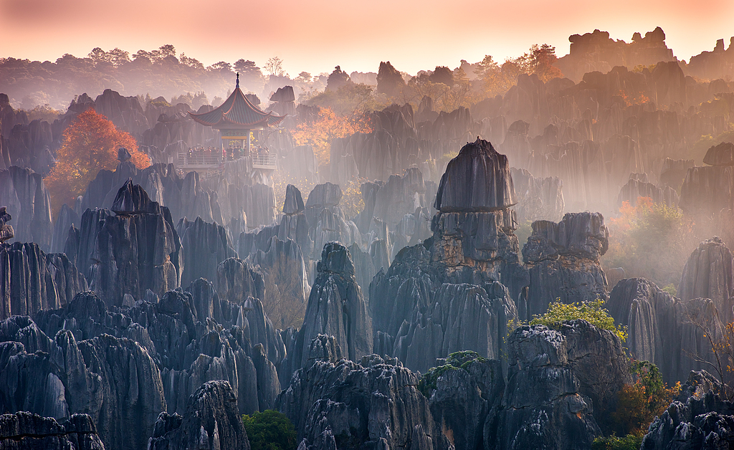
Day 3 Dali
This will be an impressive day in Dali, a habitation for Bai minority group! Firstly, stroll around in the ancient city along stone-paved road, seeing traditional Bai ethnic minority folk houses, unique city gate towers with overhanging eaves, local people in their ethnic costumes and more. The street that goes from the South City Gate to the North City Gate is now a prosperous market street lined with distinctive stores.
Afterwards, go out of the ancient city to visit the Three Pagodas which faces the beautiful Erhai Lake. As its name implies, there are three ancient pagodas there, standing in a symmetrical triangle. With a history of more than 1,800 years, the three pagodas have been the symbolic constructions of Dali.
Later, enjoy some walking in the ecological corridor of the Erhai Lake accompanied by your guide.
★ Privileges of Our Guests
We have chosen the area around Longkan Pier for the walking, which is the most scenic part of Erhai Ecological Corridor. If interested, the guide will leave you with some free time to enjoy the fun of cycling along the Corridor. He or she will assist you to rent a bicycle at your own cost and inform you the best biking route. There are both single bikes and double bikes for you to choose from.
Meals: Western buffet breakfast

Day 4 Dali to Lijiang by Private Car
This morning, move on to Lijiang by a private car, which is about three to four hours' drive away. On the way, we will arrange a visit in Xizhou Bai’s Compound. It is in traditional Bai Minority style, distinctive with delicate wood and stone carvings, inky paintings on the lime powdered walls and overhanging eaves.
★ Interesting Experience of Bai Minority Tie-Dyeing
Later, the guide will lead you to a nearby dyehouse to try the traditional Bai minority tie-dyeing. It will be exciting to dye a piece of cloth with various patterns with the help of a local craftsman.
Upon arrival in Lijiang, the guide will firstly escort you to check into the hotel we have reserved for you in advance. After a short rest, start exploring Lijiang Old Town, which is centered on Square Street paved with bluestones and lined with numerous souvenir shops, unique bars and restaurants. A majority of dwellers here are Naxi people. So if looking carefully, you will find the folk houses, locals’ costumes and more different from those in Dali. After that, your guide will accompany you to the hotel.
Travel Tip: The town is even more charming at night when all red lanterns along the street are lit. It is strongly advised you stay longer to appreciate the night pieces. Just inform the guide and he or she will point you the way to return.
► Restaurant Recommendation for Dinner (at your own expense):
Why not idle away your time at Lijiang Old Town and tackle your dinner here? Visit the restaurant No.88 Snack. Standing here for over three decades, it is a locally widely-known old brand. The façade is unimpressive but you will find a world of its own on stepping in. With several courtyards, it would remind you of ethnic-style local houses. Anyway, this is a restaurant even locals speak highly of and would strongly recommend. Later, perhaps stroll some 20 minutes through local life back to your hotel.
Average cost per person: CNY 50 / USD 7
Address: No. 88, Xingren Section, Wuyi Street, Dayan Street, Gucheng District
Meals: Western buffet breakfast

Day 5 Lijiang
Today’s first stop will be the Baisha Village, the ancient capital of Naxi Minority Group, and once the political, economic and religious center of Lijiang.
★ Learn Naxi Minority Customs at a Local’s Home
In addition to sightseeing, we always try to unveil more aspects of China to our guests. In Baisha Village, we will specially arrange a visit to a local Naxi family, helping you know more about Naxi people's culture, customs and daily life. A visit to a Tibetan family will also be planned in the upcoming itinerary.
Baisha Village is now best known for well-preserved murals. These murals, combining the Naxi, Han, and Tibetan features together, are a wonderful art form, and vividly unfold the life of the minority people in the past to us. Our knowledge guide will help you learn more stories and history behind the murals.
The next stop will be the Jade Lake Village, where your tour guide will escort you to further explore the local people's life. After, head to the Black Dragon Pool Park, aka Jade Spring Park, a large park with beautiful landscape and some ancient monuments, and then visit the Dongba Culture Museum. As the name indicates, it mainly displays Dongba culture preserved by Naxi People. The exhibitions include Dongba hieroglyphs, architecture, religious tools and more…
Meals: Western buffet breakfast
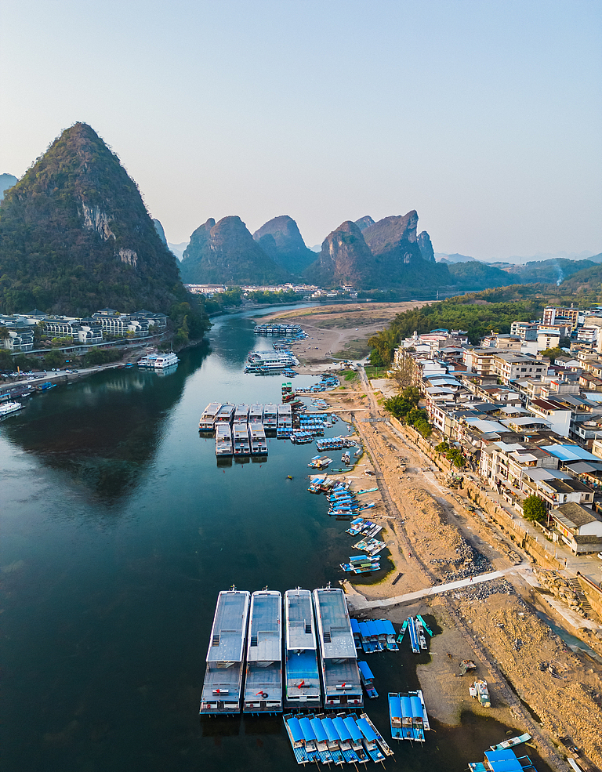
Day 6 Lijiang to Shangri-La by Private Car
Today you will be transferred to Shangri-La. On the way to Shangri-La, visit the First Bend of the Yangtze River and the Stone Drum Town. After that, your Lijiang guide will say goodbye to you, and the driver will escort you to the Tiger Leaping Gorge, where your Shangri-la guide will greet you and escort you to continue the visit. Later your Shangri-la guide will take you to check in at the hotel.
Meals: Western buffet breakfast
Day 7 Shangri-La
Shangri-La features Tibetan culture. Today's tour will begin with a visit to the biggest Tibetan Buddhist Temple in Yunnan, Songzanlin Monastery, to learn Tibetan religious culture and appreciate splendid Tibetan style architecture. Because of its similar appearance and layout to Potala Palace in Lhasa, it is also reputed as the “Little Potala Palace”.
After that, immerse yourself in the breathtaking scenery in Potatso National Park. The dense woods, vast grassland, clear lake, blue sky, fresh air and cute animals form a fairly land meeting all your imaginations. The Shudu Lake inside is one of the largest plateau lakes in Shangri-La with an altitude of over 3,700 meters (12,140 feet) and it’s the most beautiful part of Potasto.
Finally, visit a local Tibetan family, having a talk with the host and tasting local butter tea to get involved into the Tibetan people's lifestyle.
Meals: Western buffet breakfast
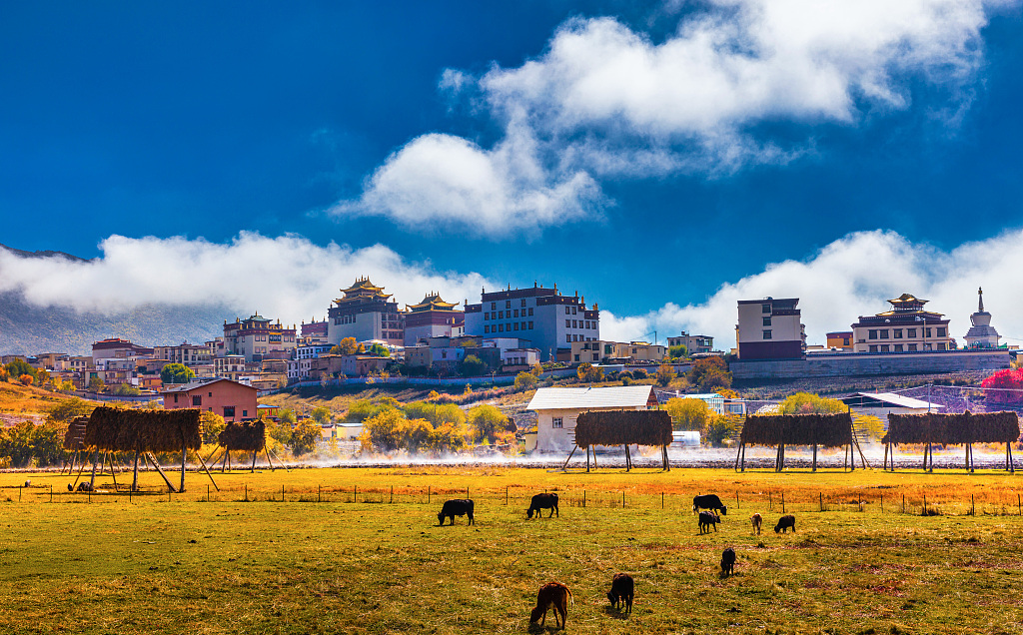
Day 8 Departure from Shangri-La
Your private Yunnan minority trip will end here as we transfer you to the airport today. Wish you a nice onward journey!
There are direct flights to Kunming, Chengdu, Guangzhou and Lhasa from Shangri-La. If you want to extend your China tour to other cities, we will be glad to customize an itinerary for you.
Meals: Western buffet breakfast


