Packages detail
5 Days Guilin - Longsheng - Yangshuo – Guilin
Private Guilin Photography TourUSD699（A minimum order of 2 people is required）

Overview
Trip Highlights
• Personalized private tour tailored to your own schedule and interests.
• English-speaking private guide, air-conditioned private car with experienced driver.
• Enjoy 3 sunrise and sunset trips at Dragon Bone Rice Terraces, Xianggong Mountain, and Five Fingers Mountain.
• Bamboo raft on the Yulong River with an expert raftman steering with a pole, taking in the most beautiful idyllic scenery.
• Visit Yao and Zhuang ethnic villages to dive deep into indigenous cultures.
• Explore Xingping Ancient Town and soak up timeless streetscape.

Included & Excluded
Price Includes
• Private English-speaking guide
• Private driver & air-conditioned vehicle
• Hotel accommodation with breakfasts
• Entrance fees to tourist sites
Price Excludes
• Airfares of arrival and departure
• Entry visa fee
• Personal expenses
• Tips or gratuities for guide and driver

Itinerary
Day 1 Guilin Airport or Train Station Pick-up, Transfer to Longji Rice Terraces
Welcome to choose this 5 days Guilin tour to Yangshuo and Longsheng, full of surprises and jaw-dropping views! You will have a chance to take in the enchanting idyllic vistas, farm engineering rice terraces, and stunning Li River natural views, which are all the best sceneries in Guilin recommended by experienced shutterbugs.
Upon arrival in Guilin, your private guide will wait for you at the airport or train station with a paging board of your name. After that, we will directly drive to Longsheng County by a private drive, about 90 km (56 mi) away from Guilin, where the world-famous Longji Rice Terraces, aka Dragon's Backbone Rice Terraces, is located. If arriving early, you will be guided to get a first impression of the jade green rice paddies cascading down the slopes of hills, which are full of sparkling water and surrounded by lush mountains from May to September. However, if your schedule is comparatively late, then your guide will help with the hotel check-in and you could have a good rest tonight and be ready for tomorrow’s amazing sunrise trip!
★ Our Accommodation Strength: Enjoy a Terrific Rice Terraces View in Your Own Room
In Longji Rice Terraces Scenic Area, without many luxury hotel options or famous chain brands, there are only some good local hostels and homestays available. We have especially chosen a high-quality hotel, with a nice environment and good facilities for your comfortable stay. The most important thing is that you can enjoy a fantastic view of the spectacular rice paddies in your hotel room. Generally, a northern room offers the view of the No. 1 viewing spot - ‘Nine Dragons & Five Tigers’, while a southern room can let you enjoy the view of the No. 2 viewing spot - ‘Seven Stars Chase the Moon’. If you have any preference, please contact your travel consultant to book in advance.
Accommodation: Ping An Hotel in Longsheng
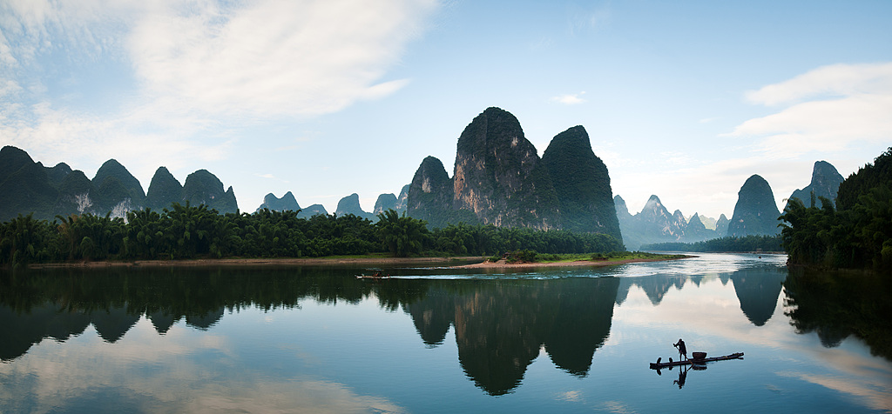
Day 2 Capture Longji Rice Terraces Sunrise, Visit Yao & Zhuang Ethnic Villages, Xianggong Mountain
★ Witness a Fabulous Sunrise over Longji Rice Terraces
Today we will get up early and reach the nearby Seven Stars Chase the Moon Viewing Point to wait for the beautiful sunrise as the sun generally comes out before 7 am. A stunning vista begins to appear about ten minutes before the sun rises when the clouds are gradually painted in rosy colors and the sky is soft orange lighted on the horizon. When the first ray of sunlight comes out, penetrating through the mist and shining on the rice terraces, the whole world wakes up, and you will be fascinated by the sculpted terraces filled with water. Stacked layer upon layer, the swirled terraces are just like the fingerprint of the earth, recording the hard work and wisdom of generations of Chinese farmers.
After capturing great photos, we will go back to the hotel for breakfast and then depart to visit two Chinese ethnic villages in the surroundings. The first is Huangluo Yao Village, which is famous as the world’s longest hair village. The local women here feature an old custom of keeping super long hair, the longest of which can reach about 2.6 meters (8.5 ft.). It is said they only cut their hair once in a life, on their 18th birthday. Belonging to the Yao Nationality, people inhibited here are called Red Yao, as red is their exclusive color. You can easily see that from their traditional costumes. After that, we will make our way to Golden Bamboo Zhuang Village, which has a history of more than 400 years. As the first village of the 13 villages in Longji, this is a typical Zhuang village where you may have a glimpse of some old customs like rice wine making and traditional way of Tofu making, to see how they steam the rice and ferment it, and grind beans for making tofu. You will also be guided to admire their well-preserved stilt wooden architecture which have been stood for centuries. Finish the visit, and then you will be escorted to Xianggong Mountain, staying overnight at the foot of the mountain, which can save you a lot of time for tomorrow’s early sunrise.
Meals: Breakfast
Accommodation: Cloud Mountain Lodge

Day 3 Xianggong Mountain Sunrise, Mural Hill, Five Fingers Mountain Sunset
★ Catch a Photogenic Sunrise at Xianggong Mountain
Today starts with the amazing sunrise of Xianggong Mountain, which requires to get up very early as we need to arrive at the hill top at around 5 am. Don’t worry, the mountain is not so difficult to climb. Its stairs are moderately challenging, which need only about 15-20 minutes. There is an observation deck with 6 layers on the top, and generally arriving early is beneficial to acquiring a good spot. Before the sun rises, you can even enjoy a beautiful starry sky on the hill top. Gradually, the sky starts to warm up with purple and pale blue colors. Sometimes a sea of clouds may block the sun, which makes the horizon even more beautiful. Waiting for a while patiently, you will see the first ray of sunlight penetrate through the mist, the surrounding karst mountains glow above the clouds, and the Li River winds through the green hills.
Stop for a while to take photos and then we will go back to the hotel for breakfast and rest. At noon, check out the hotel and drive to nearby Cold Water Ferry, where you can enjoy one of the most famed sights of the Li River, Mural Hill, aka Nine Horses Fresco Hill. Featuring a giant cliff standing along the Li River, it is composed of nine peaks, which resemble nine horses from the distance. Use your imagination and see how many horses you can identify. Your guide will also help you with that and tell you the legendary stories behind the scenery.
Later, we will drive about 30 minutes to Five Fingers Mountain, another great photo spot for shutterbugs. Compared to Xianggong Mountain, it is a little higher but the slope is relatively gentle. What’s more important, it is far less visited, with fewer people around, allowing you to enjoy a picturesque panoramic view leisurely and quietly. As the horizon turns into a sea of red and pink, you will not only get stunned at the gorgeous sunset view but also overlook the tranquil countryside crisscrossed by meandering and gurgling rivers and scenic village paths. Immerse yourself in the compelling natural beauty with the sun slowly sinking behind the mountains. Descend from the mountain, and then we will depart to Yangshuo County. Upon arrival, you will be assisted with hotel check-in. Your handpicked hotel is just located near Yangshuo West Street, a historical street lined with shops, bars, and restaurants. You can choose to rest at the hotel or wander along the street to feel the local charm.
► Restaurant Recommendation for Dinner (at your own expense):
From your hotel, walking northeast about 900 meters, you can reach the Percent Cuisine Restaurant, located near the Li River. With a simple and natural log style decoration, the restaurant boasts a quiet and warm atmosphere, and offers tasty local dishes like Beer Braised Fish, Stir-fried Beef with Sour Bamboo Shoots, Taro Paste Cubes, Li River Shrimps, and Steam Tofu with Minced Meat. After dinner, you can take a stroll along the Li River or enjoy the vibrant night life at West Street.
Average cost per person: CNY 80 (USD 11)
Address: 1st floor, Percent Hotel, Yangshuo County
Meals: Breakfast
Accommodation: Amari Yangshuo Hotel

Day 4 Yulong River Bamboo Rafting, Explore the Xingping Ancient Town
★ Impressive Bamboo Rafting along Yulong River
After breakfast, you will be transferred to float on a unique bamboo boat accompanied by a local boatman who steers with a long pole along the Yulong River. This is the longest branch of the Li River, stretching about 43.5 km (27 mi) long and flowing through over 20 villages. Nicknamed ‘Little Li River’, Yulong River creates a beautiful natural display no less than the Li River. And drifting by bamboo raft is definitely the best way to explore it. There are several sections offering drifting services and our travel experts have carefully chosen the best two options for you: Xiatang Dock - Jima Dock; or Shui’edi Dock - Gongnong Bridge Dock. Both of the two sections’ rafts offer a 40 to 50 minutes’ drift along the 3-km-long river section, and cross over 4 water dams, experiencing the exciting moment of going down chutes. Referring to the difference between the two routes, the former one is newly opened, with fewer tourists while the latter one features the most essential scenery of the Yulong River. You can choose it according to your own interests.
► Warm Tips:
1. When the bamboo raft rushes down the dam, the water may wet your shoes and pants. You can prepare shoe and leg covers in advance or just wear flip-flops.
2. Prepare a waterproof cell phone arm bag or waist bag in case you drop the phone into the river.
Finishing the drifting, your guide and the driver will wait for you at the terminal dock. Then we will drive for about 1 hour to Xingping Ancient Town, about 25 km (16 mi) upstream from Yangshuo. Situated on the east bank of the Li River, this is considered the most beautiful ancient town near Guilin. You will be led to poke around old architecture and feel the local way of living along the 1-km-long cobbled main street, which is lined with local shops, boutiques, restaurants, and old brick-tile structures including guild halls and old theaters preserved from hundreds of years ago. This is also a good place to taste some local snacks like Guilin Rice Noodles, Mugwort Rice Cake, Deep-Fried Shrimp Cake, Deep-Fried Sweet Potato Cake, Bamboo-Tube-Cooked Rice and Glutinous Rice Cake.
After spending some time in the small town, if time permits, you can also wander along the Li River for around 20 minutes to capture another highlight here, the famous sight that appears on the CNY 20 note. Prepare a CNY 20 note ahead of time, and you will surprisingly discover the same scenery depicted on the note: a local fisherman on a bamboo raft casting a net on the Li River surrounded by emerald karst mountains, with their beautiful reflections in the clear water, making for an impressive picture at sunset.
Meals: Breakfast
Accommodation: Rosewood Hotel in Xingping
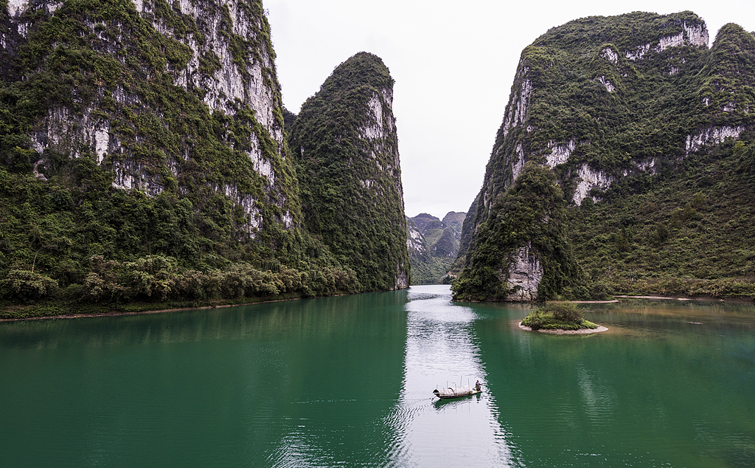
Day 5 Return to Guilin, Airport or Train Station See-off
This is the last day of your Guilin photography tour! After breakfast, we will help you with the hotel check-out and escort you to Guilin airport or train station, taking about 2 hours on the way. Hope you enjoy the trip with us!
Anyway, if you want to continue to take in Guilin city highlights like Elephant Trunk Hill or explore karst caves, please feel free to contact us.
► Restaurant Recommendation for Dinner (at your own expense):
People always say that you are never more than 6ft away from a rat in London, the same could be said for Rice Noodles stalls in Guilin. Before leaving Guilin, you cannot miss trying a bowl of authentic Guilin Rice Noodles. Old East River Restaurant is such a popular rice noodles restaurant locals often head to, without any frills. It specializes in more chewy and thicker rice noodles than usual thin ones, topped with various side dishes like braised eggs, deep fried pork slices, beef, and roast pork. Locals always slurp a bowl of ‘dry rice noodles’ mixed with chili sauce, without too much soup. However, if it is too spicy for you, add some soup to neutralize the spicy flavor. Due to its popularity, queueing up is necessary most of the time.
Average cost per person: CNY 12-20 (USD 2-3)
Address: No. 23, Lane 4, Lanhua Road, No.7 Dacunmen Development District, Yangshuo Town
Meals: Breakfast
