Packages detail
3 Days Best Guilin, Li River Cruise and Yangshuo Private Tour
Private Essence Tour of Guilin & Li RiverUSD599（A minimum order of 2 people is required）

Overview
Trip Highlights
• Personalized private tour tailored to your own schedule and interests.
• English-speaking private guide, air-conditioned private car with experienced driver.
• Be enchanted by Guilin’s iconic Reed Flute Cave & Elephant Trunk Hill.
• Hold your breath before the poetic landscape as you cruise down the Li River.
• Immerse yourself in countryside of Yangshuo by bike and paying a family visit.
• Savor breathtaking panorama of the Li River from the top of Xianggong Hill.

Included & Excluded
Price Includes
• Private English-speaking guide
• Private driver & air-conditioned vehicle
• Hotel accommodation with western buffet breakfasts
• Lunch on the cruise
• Entrance fees to tourist sites
Price Excludes
• Airfares of arrival and departure
• Lunches and dinners not specified
• Entry visa fees
• Tips or gratuities for guide and driver

Itinerary
Day 1 Arrival in Guilin; Visit Reed Flute Cave & Elephant Trunk Hill
Welcome to Guilin! After retrieving your luggage, you will find your local private guide waiting for you with a welcome sign bearing your name in the Arrival Hall of the airport; if you leave for Guilin by high speed train, you will see your private guide at the exit of the train station. After a warm greeting, you will be taken to the hotel by a comfortable and air-conditioned vehicle and your guide will help you with check-in.
Today's private sightseeing trip covers two of the most famous attractions in Guilin city. The first stop is the Reed Flute Cave. As the Palace of Nature's Art, it is renowned for its marvelous karst landscape containing stalagmites, stalactites, stone columns, stone curtains and stone flowers. Highlighted by eco-friendly neon lights, the beauty of each of those elements now can be fully perceived. Over there, you can also see many ancient murals and inscriptions left from the Tang Dynasty, about 1,300 years ago.
Then visit the city's emblem - the Elephant Trunk Hill. You will know why the hill gets such a name the moment you see it - yes, it’s like an elephant! Actually, this enchanting site earns its fame not only for such resemblance, but for many other wonders and even a folklore. A famous example is the Water Moon Cave, a natural circular hole between the trunk and front legs whose reflection on water is sometimes like a moon, which adds a heavenly charm to the site. Don't forget to take photos in front of the giant 'elephant'. You will get a nice shot. Stay here until sunset, then we will drive you back to hotel.
► Restaurant Recommendation for Dinner (at your own expense):
Perhaps after sightseeing at the Elephant Trunk Hill, walk 10 minutes to Chunji Roast Goose Restaurant, a locally well-known chain restaurant, to relish authentic Guilin food. The restaurant has a catering history of more than 20 years and receives more than 5 billion guests per year with classy taste and reasonable prices. The signature Roast Goose is your must-try, and you may also want to order their well-liked Beer Fish and Braised Pork. By the way, almost all dishes come in regular or small portions for you to try many at a time without making waste.
Average cost per person: CNY 60 (USD 9)
Address: No. 2 Zhongshan Middle Road, Xiangshan District
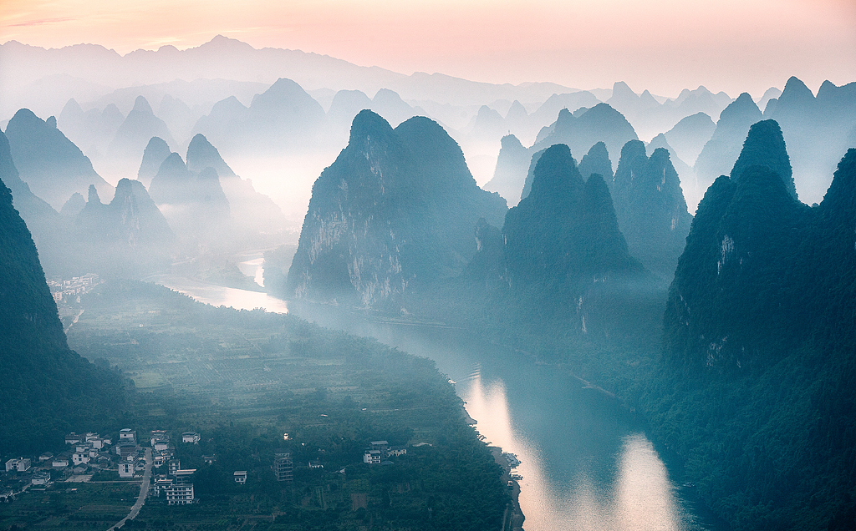
Day 2 Guilin to Yangshuo by Li River Cruise; Go Cycling in the Countryside and Visit a Farmer’s Home
The most unforgettable highlight of your Guilin private tour comes today as you take a cruise down the Li River to Yangshuo County. By the end of the cruise, you will know what a splendid Chinese landscape painting is. You get to cruise along an 83-kilometer (about 52-mile) emerald ribbon winding amid numerous verdant hills, passing reflections of the grotesque peaks in the crystal-clear water, rice fields, and orchards strewing on the banks. You will have today’s lunch on the cruise ship, as it will be 2 pm when you disembark.
On arriving in Yangshuo, go on a countryside tour to see the breathtaking rural views of the county. You can bike all the way to and in the countryside to enjoy them to the fullest. Of course, if you don’t feel like biking, we can give you a private car ride. Biking takes around two hours and rewards you with a unique personal memory, as you can choose from many routes to explore. Take time to immerse yourself in the idyllic scenery of those hills, cropland, and serene water. Have breaks and take photos from time to time with the help of your guide. After some time, you will stop by a local house and be guided to pay a visit. You will see what a typical house of local farmers is like and how they make their living. Late into the afternoon, pedal again, or get on our car, to return to downtown Yangshuo.
Since you are going to spend tonight in Yangshuo, as for dinner, you can take a stroll along its West Street to taste some local food. Although it is a 1,400-year-old Chinese street, you see faces from different countries everywhere. It’s true that the street has become globally famous for its ancient ambience mixed into modernity.
Restaurant Recommendation for Dinner (at your own expense):
While in Guilin, trying Rice Noodles should be included in your schedule. Rice Noodles, which can be traced back to the Qin Dynasty (221 BC - 207 BC), have long been a favorite food in Guilin or even across China. There are countless Rice Noodles eateries in the streets of Guilin and Yangshuo, and statistics show that Guilin sells more than 600 million servings of Rice Noodles every year. Rice Noodles on Tongue Tip Restaurant cannot be missed when you visit West Street as it offers the most authentic and best-rated Rice Noodles. For about CNY 15 (USD 2), you can get a bowl of Rice Noodles topped with chopped pickled long beans, peanuts, bamboo shoots and spring onions. Locals also love to add beef slices, spiced duck claws and other ingredients, and you can just do the same.
Address: No. 26, Chengzhong Road, Yangshuo Town
► Activity Suggestion for Evening
For your evening time, you can watch a splendid night show called Impression Sanjie Liu in Lijiang Landscape Theater, just one mile away from the West Street. It is an award-winning live art performance inspired by a local folk tale and directed by Zhang Yimou, a legendary film director in China’s moviedom. Instead of being staged in a concrete theater, the show unfolds amid the wild natural landscape along the Li River. If you are interested, the guide will be glad to help you purchase ticket.
Meals: Western buffet breakfast, Lunch
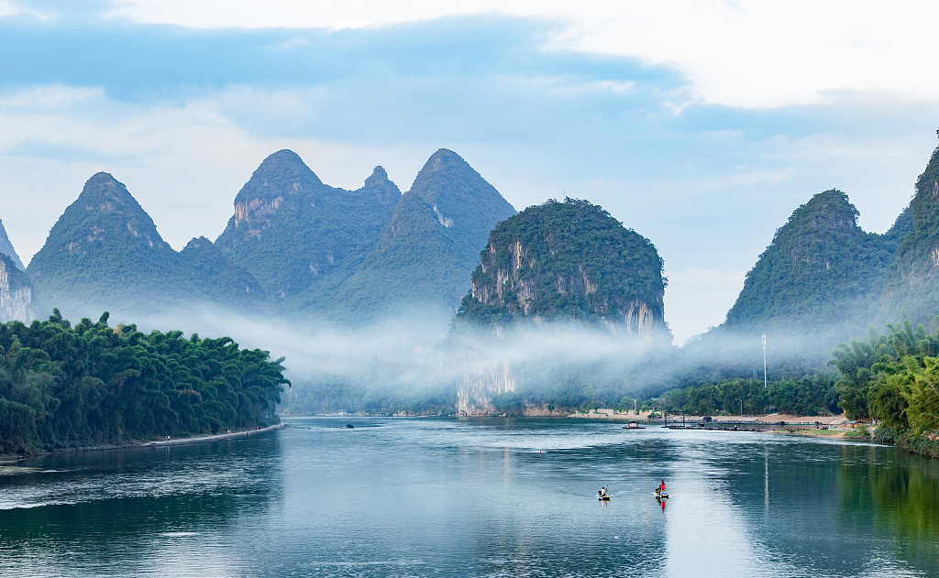

Day 3 View Panorama of Li River from Xianggong Hill; See Off at Guilin Airport
This morning, 28 miles down the road to Guilin, we will turn to Xianggong Hill, a karst work on the west bank of the Li River, atop which you will savor a panoramic view of the Li River. The sea of clouds in cool early morning above, along with the green waterscape below, is what makes it a place of pilgrimage for travelers. It will be a 15-20 minutes’ moderate hike up to the top, as the hill is relatively short with an overall easy slope and stairway. There are four lookouts for visitors to command the river, all of which can provide you with views of a fairyland.
At the end of your 3 days Guilin tour, your private guide and driver will drive you to the airport or high speed train station for your return or onward journey to the next destination. If you need us to book tickets, please let us know and we will be very glad to do it for you.
Meals: Western buffet breakfast
