Packages detail
6 Days Guilin - Longsheng - Sanjiang Ethnic Villages – Yangshuo
Private Journey to Ethnic VillagesUSD1199（A minimum order of 2 people is required）

Overview
Trip Highlights
• Personalized private tour tailored to your own schedule and interests.
• English-speaking private guide, air-conditioned private car with experienced driver.
• Cruise in Chinese ink painting along Li River, followed by a countryside biking tour.
• Appreciate Elephant Trunk Hill, a wonder that goes beyond nature.
• Experience ethnic cultures up close in villages of Zhuang & Dong ethnic groups.
• Raft on serene Yulong River and appreciate the most stunning karst beauties.
• Travel through Guilin’s ancient history at Daxu Ancient Town.

Included & Excluded
Price Includes
• Hotel accommodation with breakfasts
• Lunches as itinerary specifies
• Private English-speaking guide
• Private driver & air-conditioned vehicle
• Entrance fees to tourist sites
Price Excludes
• Airfares of arrival and departure
• Entry visa fees
• Personal expenses
• Tips or gratuities for guide and driver

Itinerary
Day 1 Arrival in Guilin; Drive to Longsheng
Once you arrive at Guilin Airport, you will find your local private guide waiting for you outside the baggage claim area with a welcome sign bearing your name. If you arrive in Guilin by high speed train, you will see your guide at the exit of the high speed railway station. Then your private guide and driver will escort you to Longsheng with around a 2-hour private transfer. If you arrive in Guilin after 18:00, we suggest you stay overnight in downtown Guilin and depart for Longsheng on the next day. Our professional travel consultant will be very glad to customize this private tour to your needs.
Accommodation: Ping An Hotel in Longsheng
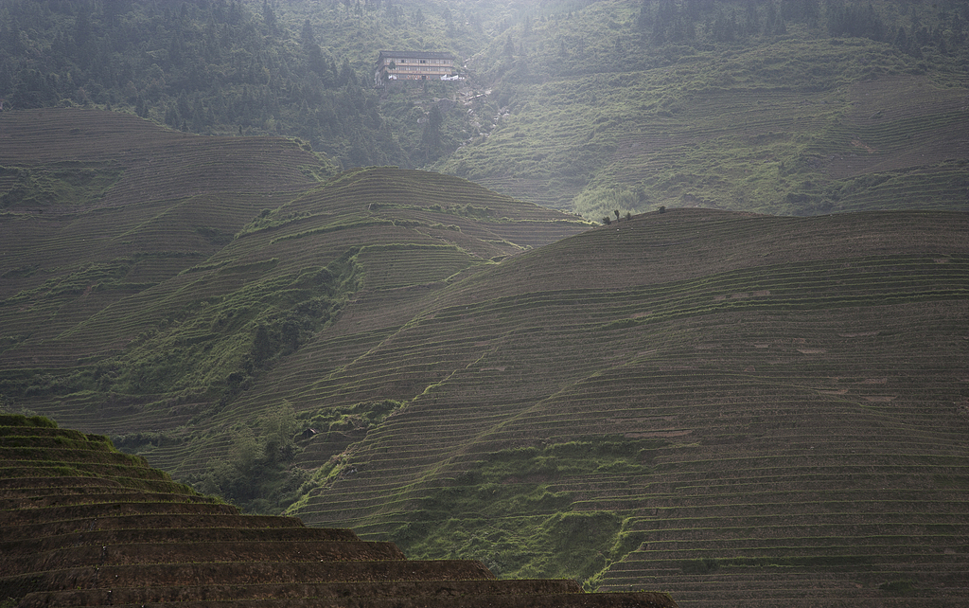
Day 2 Visit Rice Terraces and Zhuang Minority Villages; Drive to Sanjiang
After breakfast, your guide and driver will pick you up and transfer you to visit the Longji Rice Terraces, aka Dragon's Backbone Rice Terraces, and villages of Zhuang ethic group. You will have lunch in the middle of your tour.
Stretching layer upon layer from foot to top of rolling hills, the terraces were constructed and cultivated from the 13th century by local ethnic Zhuang people. Now they cover an area of 66 square kilometers (about 16,308 acres) and span an altitude between 300 meters (984 feet) and 1,100 meters (3,608 feet). Follow your guide through a maze of hiking trails to stand on the top, where you will get a 360-degree view of cascading rice terraces, whose wavy stone walls fitting the contours of hillsides combine to make a spectacular line art.
Soak up the terraced spectacle for some time, and then pay a visit to the villages of Zhuang people nestling among the hills to experience their unique Chinese ethnic culture. What might interest you is their iconic traditional clothing for women, dubbed “the Three-Storey Building”. You will know why it’s called so when you see their multi-layered outfit, which consists of a short jacket, a knee-length skirt, and a pair of ankle pants.
Afterwards, continue the private trip to Sanjiang County, another typical minority region, which is home to ethnic Dong people. In 1.5 to 2 hours, you will arrive and check in at the hotel for a good rest.
Meals: Western buffet breakfast, Lunch
Accommodation: Jingxiang Hotel
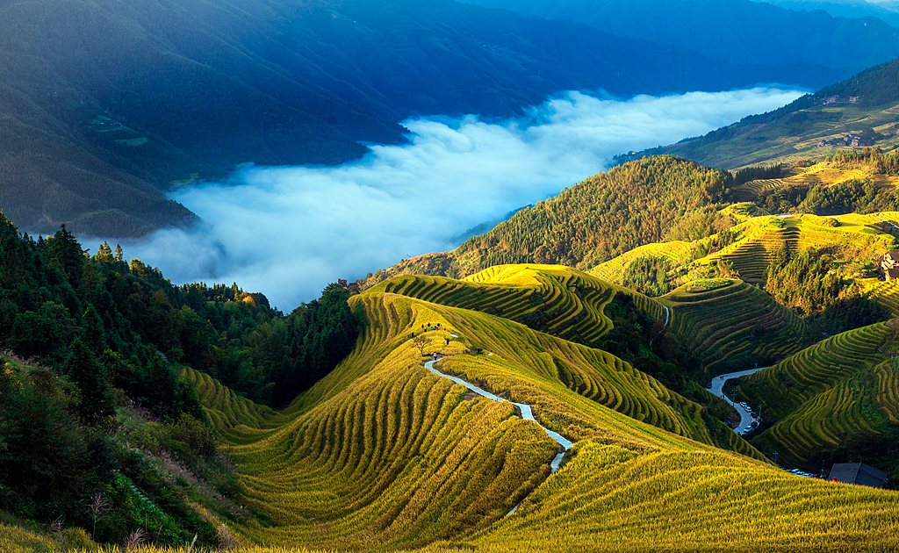
Day 3 Take a Dong Minority Village Tour; Drive to Guilin
Today, you will take a Dong Minority village tour to learn about cultures of the Dong group very different from that of Zhuang people. Dong people boast lots of traditions and the most impressive would be their traditional clothing and today you get to witness it yourself! They can still be seen wearing ethnic costumes, which are generally dyed cyan, blue, white or brown. As they believe in animism, they like to weave patterns of flowers, birds, fish, mountains, rivers, sun and other totems onto the fabrics, to pray to deities for blessing on peace, health and harvest. Dating back to a time immemorial, these totems are older than written language and are living fossils of ancient times, similar to symbols on ancient Greek clay artifacts and African stone statues.
Situated at the foot of mountains and surrounded by rivers, the Dong Village features well-preserved stilt houses and charming natural landscape. In the village, you will see the landmark construction, the Wind and Rain Bridge, which blends bridge, corridor and kiosk into a whole, reflecting the unique wisdom of the Dong people. The bridge, built with wood on stone piers, provided shelter for peasants working in fields; over time, it became a date place for young people and now a famous attraction to visitors.
Another iconic building in the Dong Village is the Drum Tower. There is at least one such tower in every Dong Village, serving as the political and cultural center. Every time the chief of the village beats the drum on the top floor, the villagers will know something important is about to take place, so they will stop their task at hand and gather around the Tower to listen to the chief’s announcement.
At the end of today’s trip, you will be transferred back for around 3.5 hours to your hotel in downtown Guilin.
Meals: Chinese Style Breakfast, Lunch
Accommodation: Amari Yangshuo Hotel
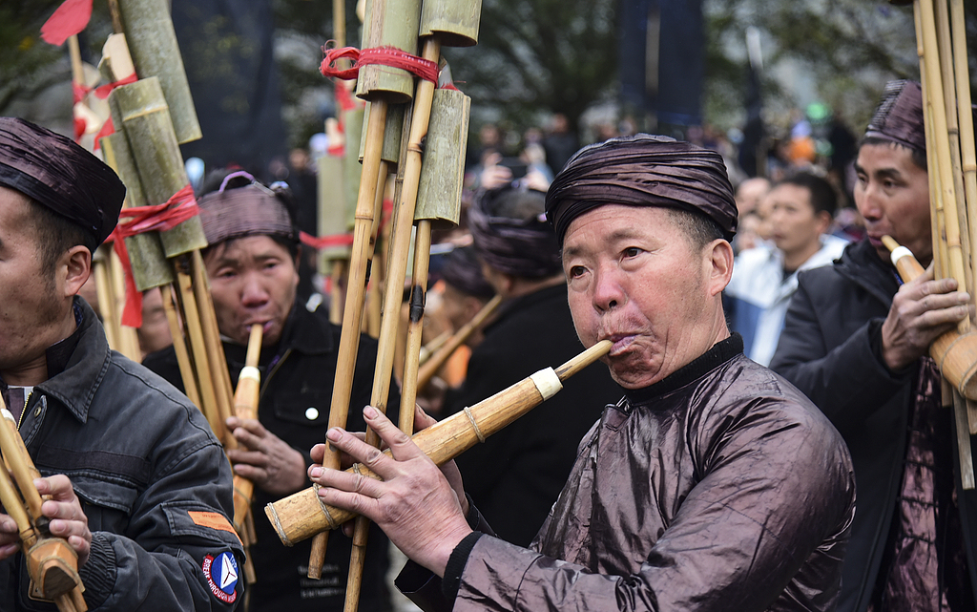
Day 4 Guilin to Yangshuo by Li River Cruise; Go Cycling in the Countryside
In the morning, take a cruise journey along Li River down to Yangshuo County. This will be the biggest highlight of your 6 days Guilin tour. You will be busy all along appreciating diverse picturesque sceneries: numerous karst hills and peaks flanking the river, their shadows reflected on the deep serene water, patches of fields decorating the banks, and so on. You will also pass by some natural wonders that can’t be categorized, like the Red Carp Hung onto Cliff halfway down the cruise route, where you see an image of a giant red carp engraved into a cliff face. Legend has it that it is the fossilized corpse of the Carp King from the water below, who one day jumped out, but was so mesmerized by the surrounding scenery that he didn’t realize he’d been hooked on a stalactite from the cliff, which caused him to hang there forever after.
As the cruise journey continues, you will have your lunch onboard. Upon arrival at Yangshuo, your guide will help you check into the hotel for a two-night stay.
After a short break, we will transfer you along the country road to enjoy the beautiful rural side of Yangshuo. We will rent a bike for you to have a round-trip cycling tour, the best chance to get even closer to the magical karst hills, in the absence of car noises. Of course, considering that you possibly can’t or don’t want to bike, we can drive you there to enjoy the rural views. You will be guided or driven along an arranged route until you arrive by Yulong River, where you get to admire the beauty offered by this lovelier version of the splendid Li River.
In Yangshuo town, there is a famous West Street, which is a lively traditional Southern Chinese street yet with an exotic flavor because of the large number of non-Chinese tourists here, some of whom, drawn by its ancient charm, even decided to settle here permanently. Tonight, you will explore night life here at a leisurely pace on your own.
► Dinner Suggestion:
When it comes to Guilin’s local cuisine, Beer Fish is at the top of the most-welcomed list. It is said that there are more Beer Fish restaurants than hills in Yangshuo, and almost every two steps you will meet such a restaurant. More fascinatingly, each eatery has its own distinctive taste because of different cooking methods. Try the dish at Fisherman Beer Fish Restaurant, a pretty well-known brand in Yangshuo. The interior is characterized by a portrait of an old fisherman on a wall and a stage for resident singers who are here every night to perform for guests. Enjoying local food to live music is sure to enhance your journey.
Average cost per person: CNY 60 (USD 8)
Address: No. 118 Yitian West Street, Yangshuo County
Meals: Western buffet breakfast, Lunch
Accommodation: Amari Yangshuo Hotel
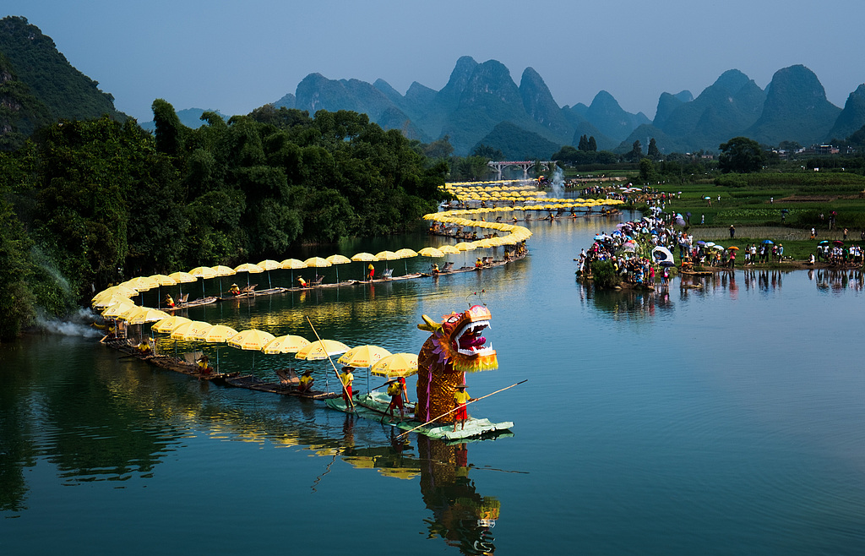
Day 5 Sightsee in Yangshuo: Ten-Mile Gallery, Bamboo Rafting on Yulong River & Silver Cave
This morning, an idyllic landscape painting gradually unfolds as you are driven through the Ten-Mile Gallery, a ten-mile north-south scenic belt stretching from Totem Ancient Path near Yangshuo to Moon Hill. It’s a natural gallery where you can catch a glimpse of the primitive ancestral life of the Neolithic Age, as well as some most stunning exclusive wonders of Guilin, like the Big Banyan Tree, which has lived for 1,400 years and spread to an area of 1,000 square meters (0.25 acres) – a spectacle to watch.
Then have a Bamboo Raft drifting tour along the Yulong River, the longest tributary of Li River in Yangshuo. The drifting experience might be the perfect cherry on top of your trip in Yangshuo. While immersing yourself in the serenity of the glassy water, don’t forget to savor the rural scenery on the banks.
After 50 minutes’ rafting, a short drive will take you to the Silver Cave, one of the most beautiful karst caves in the world. It’s a natural museum to exhibit karst stone formations developing from different historical periods. The cave is famous particularly for its cascading stalactites, which resemble frozen shooting stars and, lit with atmospheric lighting, shine with gloss of silver.
Finally, we will drive back to your hotel in downtown Yangshuo.
► Recommended Night Activity:
If you want to kill boredom in the evening, just go watch the grand outdoor show Impression Sanjie Liu on your own, which has been performed for 20 years. It is so popular that over the decades more than 8,000 performances have been conducted and 20 million people have watched it. The show is set against the backdrop of the natural landscape along the Li River, a form of show that you cannot see anywhere else in the world. Each time, more than 600 people are cast in the show, all of whom are local residents, and the lives of local people have improved dramatically because of the performance. According to rough statistics, local income has increased over 10 times than before the creation of Impression Sanjie Liu.
Meals: Western buffet breakfast
Accommodation: Amari Yangshuo Hotel
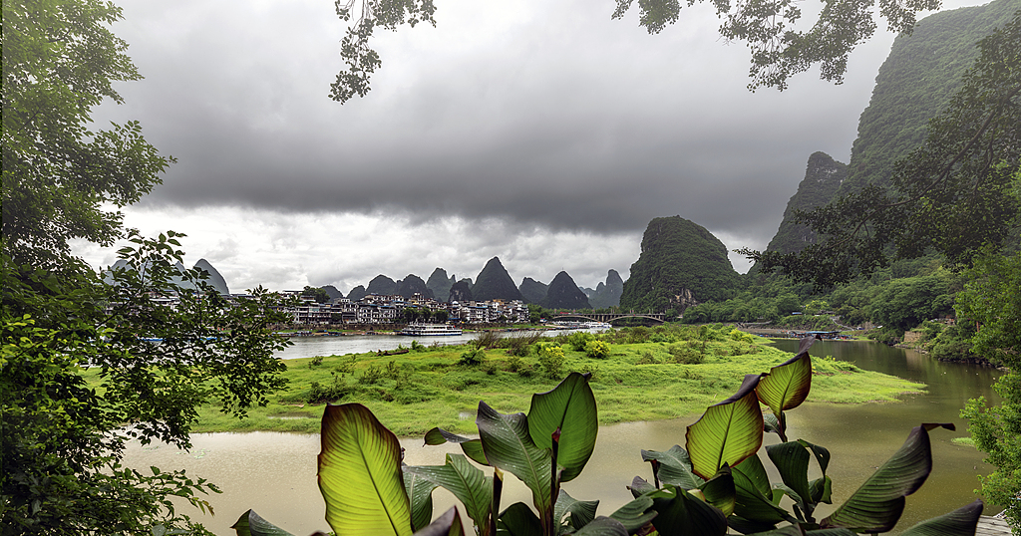
Day 6 Visit Daxu Ancient Town; See Off at Guilin Airport
After breakfast, we will drive to Guilin Airport. On the way, you will visit Daxu Ancient Town, one of the four ancient market towns in Guangxi, stretching 2 kilometers (1.24 miles) along Li River. Most ancient residences on road sides are two-storey buildings dating back to Ming and Qing dynasty (1368 – 1911 AD), with their rooms on the first floor converted to various shops selling Chinese-style trinkets, traditional services like acupuncture, etc. Strolling here, you are going to get an intimate look at the remote past of Guilin.
Afterwards, our private transfer will continue to take you to the airport for your departure flight. Farewell and have a pleasant trip onward!
Meals: Western buffet breakfast
