Packages detail
One Day Suzhou Tour from Shanghai
USD319（A minimum order of 2 people is required）

Overview
Humble Administrator's Garden - Suzhou Old Town - Tongli Water Town

Included & Excluded
Price Includes
• Private English-speaking guide
• Private driver & air-conditioned vehicle
• Entrance fees to tourist sites

Price Excludes
• Hotel accommodation with breakfasts
• Lunches and dinners
• Tips or gratuities for guide and driver

Itinerary
In the morning, our professional guide will wait for you at your self-booked hotel in Shanghai at about 08:30. Then we will set out for this private one day Suzhou tour from Shanghai by a comfortable car. During the 1.5-hour journey to Suzhou, our guide will briefly introduce Suzhou City to you, which is praised as the Oriental Venice.

1. Humble Administrator's Garden
Upon arrival, we will immediately accompany you to tour the Humble Administrator's Garden, which is the largest and best-known classical garden in the city, and even in China. With the typical South China’s traditional garden style, it was originally built in the Ming Dynasty (1368-1644), featuring intricately carved pavilions, zigzagging wooden bridges, clear lotus ponds, and craggy rockeries. You will be guided to sightsee the eastern, western and central parts, wandering leisurely to take in the poetic garden while the lush greeneries and blooming flowers are well matched with delicate galleries, stone walls with hollow patterns, long corridors, and ancient buildings.
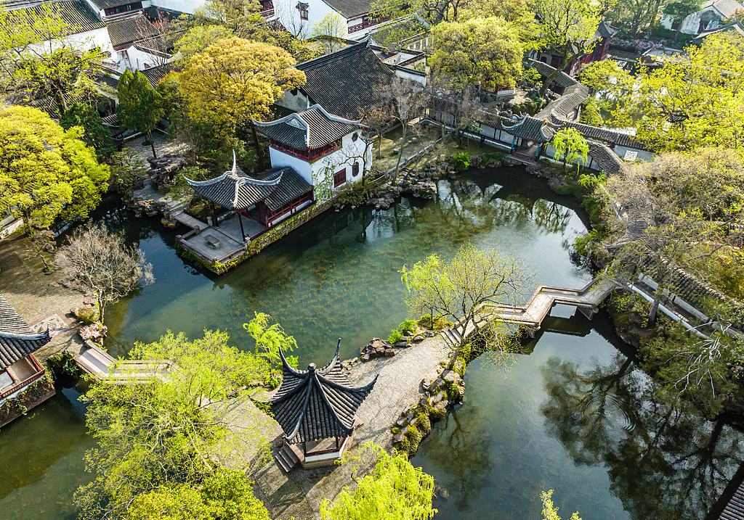
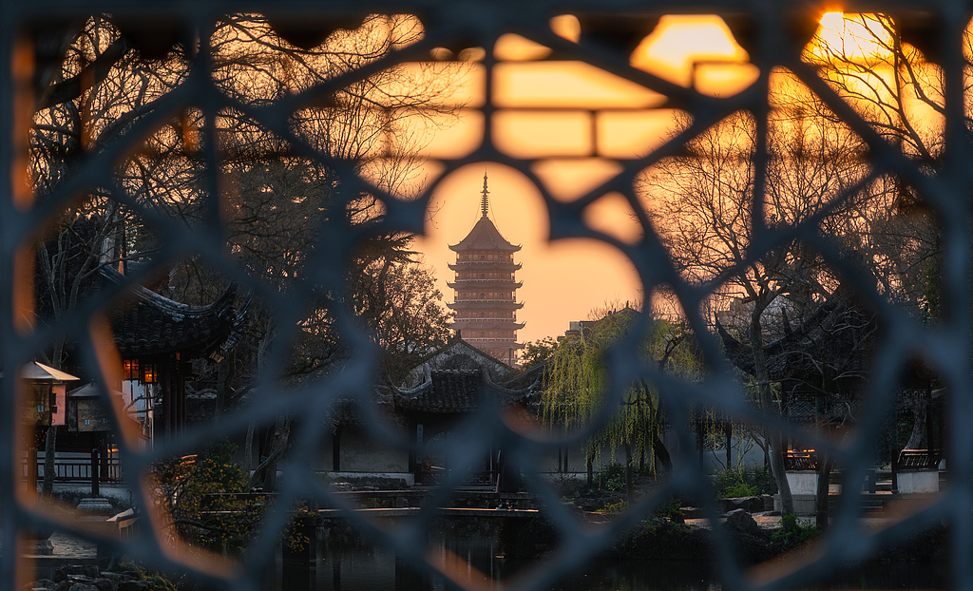
2. Suzhou Old Town
Then, we will go sightseeing through Suzhou Old Town. Sitting on the tricycle, you can have a nice glimpse of the ancient constructions existing over the years within the old block. This is also the best place to get a sense of Suzhou locals at play. Today's lunch is on your own, but our guide will recommend several local restaurants according to your preferences.
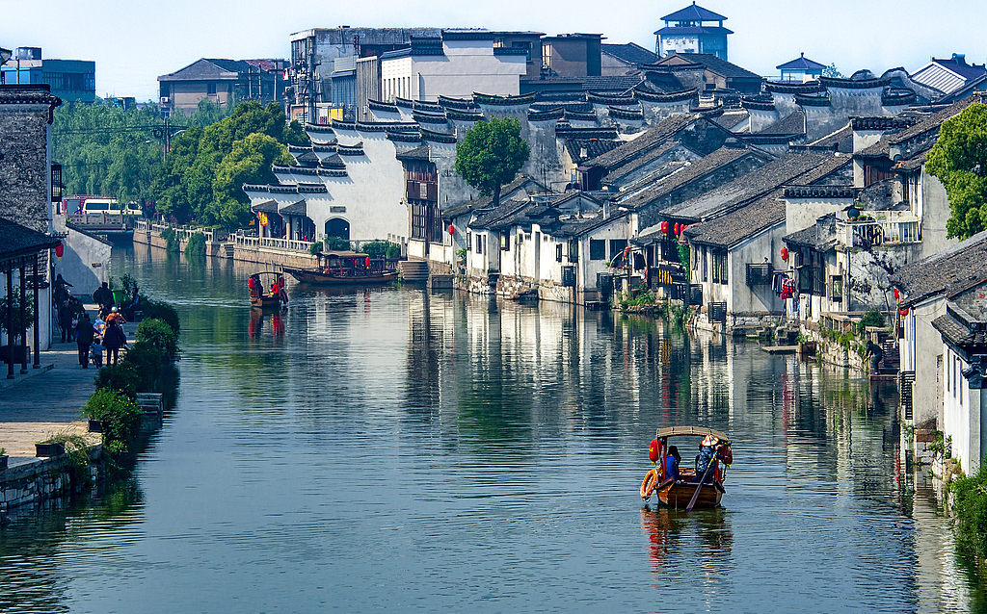
3. Tongli Water Town
After that, we will head to Tongli Water Town, which is one of the most beautiful water towns in Suzhou. With a history of 1,000 years, the picturesque and time-honored town is embedded with a net of waterways, where people can see 49 ancient bridges and 7 small isles segmented by the rivers and their branches. Strolling along the flagstone walkways around Tongli Town, you can find that almost all the folk dwellings are constructed at the water's edge with many boats berthing in the front. Residents have lived here for many generations. You will have a chance to observe their primitive life scenes. What’s more, you can appreciate the classic Retreat and Reflection Garden (Tuisi Garden), another highlight in Tongli with almost all the buildings inside standing by the jasper-like pond.
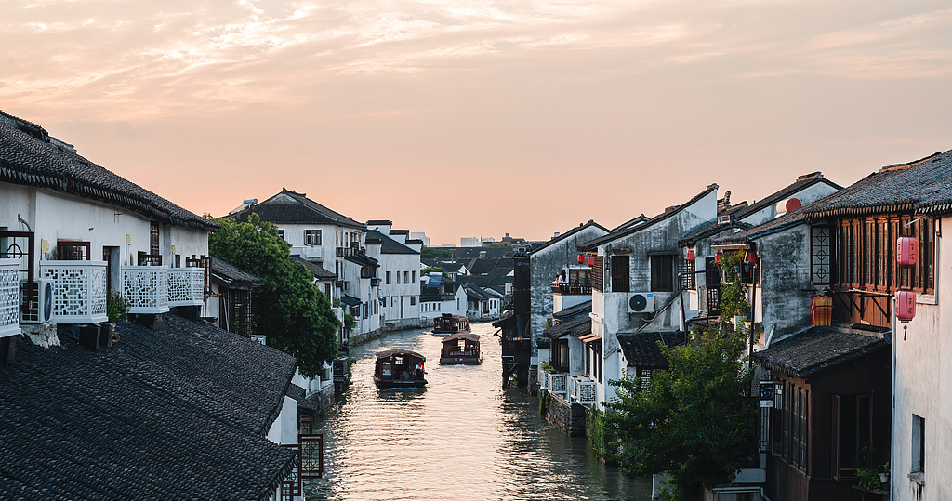
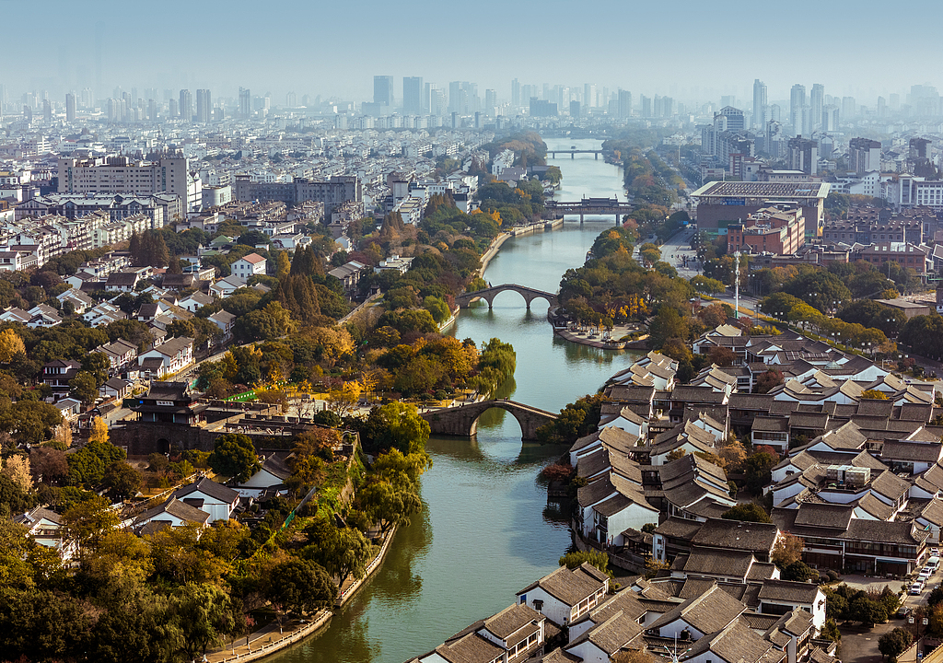
After enjoying the glamour and charm of the water town along the Yangtze River in China, your private Shanghai to Suzhou day tour will end here. Then we will escort you back to your hotel in downtown Shanghai. Hope you have spent a nice day and we are looking forward to traveling with you again!

