Packages detail
Xi'an Mini Group Full Day Tour, No Shopping
USD99（A minimum order of 2 people is required）

Overview
Terracotta Army Museum-Giant Wild Goose Pagoda-City Wall-Muslim Bazaar

Included & Excluded
Price Includes
•Entrance fees to the sights visited
•Pick-up & drop-off from your hotel
•Professional English speaking guide
•Experienced driver & air conditioned vehicle
•Unlimited bottles of drinking water for free
•Baby seat available for free

Price Excludes
•Hotel accommodation
•Bike rental fee on the City Wall
•Meals, advice freely available
•Gratuities to guide and driver

Itinerary
8:00 Hotel Pick-up
In the morning, your tour guide and driver will pick you up from your hotel at the appointed time. The guide will contact you the day before to confirm the exact departure time. We will have your back 24 hours through telephone and WeChat!

9:00 Drive to the Terracotta Army Museum
We will drive you to the Terracotta Army Museum by a clean and comfortable air-conditioned vehicle through the highway directly. During the one-hour drive, your expert guide will give you some background information about this world wonder. Surely, as promised, we will not stop at any tourist shop to waste your valuable time.

10:00 Visit the Terracotta Army Museum
Upon arrival, your guide will help you avoid the ticket line at the entrance of the Terracotta Army Museum, and then show you the three excavated pits where there are more than 8,000 pottery soldiers, horses, and chariots in total. You will have at least two and a half hours to explore this significant UNESCO World Heritage site. The information below may help you get a rough idea of the museum and enhance your visit.

Of the three pits, the Pit No. 1 is the largest one containing at least 6,000 life-sized terracotta figures and horses in battle formation, which is the main body of the army. Each warrior has different appearance and expression, which is worth an attention. The Pit No. 2 is the most spectacular one with more complicated battle formations and more arms of the services. You could see the high-ranking officer, the kneeling charioteer, the cavalryman and his saddled war horse here. The Pit No. 3 is the commanding center of the military groups in the other two pits, which is also the only one that hasn’t been burned.

On the 50th anniversary of the discovery and excavation of the Terracotta Army, an amazingly new permanent exhibition kicks off at the museum since September 08, 2024, with 230 undisclosed collections from the mausoleum site during the 50 years of excavations on display, including the rare colorful terracotta figures, full-scale majestic chariot, weapons, gold and silver artifacts, and many other valuable items. We will specially include the visit to this new exhibition for you.
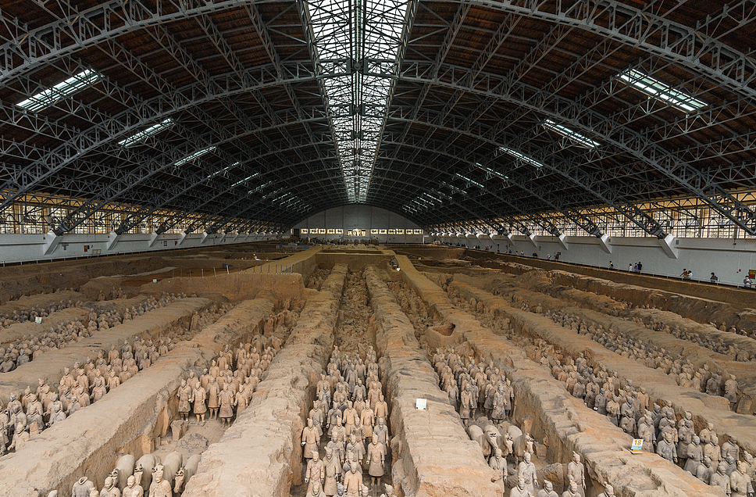
13:00 Free Time for Lunch
We leave the lunch on your own since there are no decent restaurants nearby. While some fast food chains offer adequate and hygienic lunch at around US$7 per person. Your guide is ready to assist you in selecting a place for lunch.

13:40 Drive back to downtown Xi'an
After lunch, we will drive back to downtown Xi'an. You could take a nap to recover and get ready for the afternoon sightseeing.

14:40 Visit the Giant Wild Goose Pagoda
The tour continues with a visit to the Giant Wild Goose Pagoda, which is a major participant along the Silk Road in translating and introducing Indian Buddhism. Interestingly, the Grand Ci’en Temple where it stands is not only associated with Buddhism, but was built by Tang Emperor Li Zhi in 648 when he was still a prince to commemorate his dead mother. It was four years later that Monk Xuanzang presided over the construction of the Pagoda. Now, it invites you to witness the history through its remains, and its unique cultural and immersive surroundings will also enhance your experience.
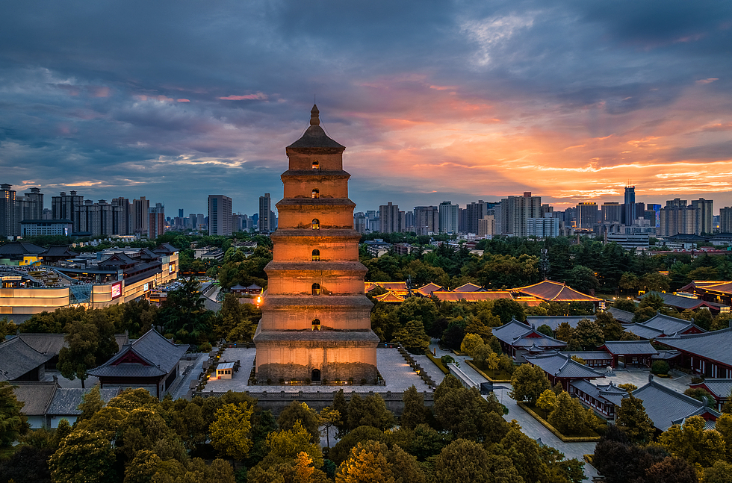
16:00 Visit the City Wall
Afterwards, your guide will take you to visit the ancient City Wall. With a history of over 600 years, it is the largest and most complete city wall that has survived in China. On the wall, you could take a leisurely walk to feel how the past meets present at this vibrant city. If you are good at cycling, you may rent a bike to ride on the wall, which will be an exciting and memorable experience. The rental fee is CNY45/US$6 per bike. The sightseeing car is also available to take you travel one circle. You are flexible to make a decision on the spot.
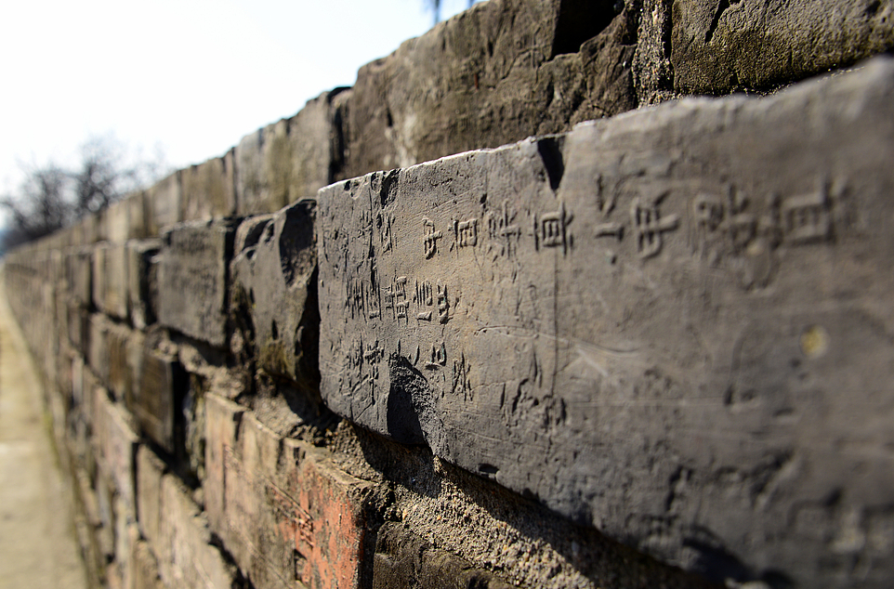
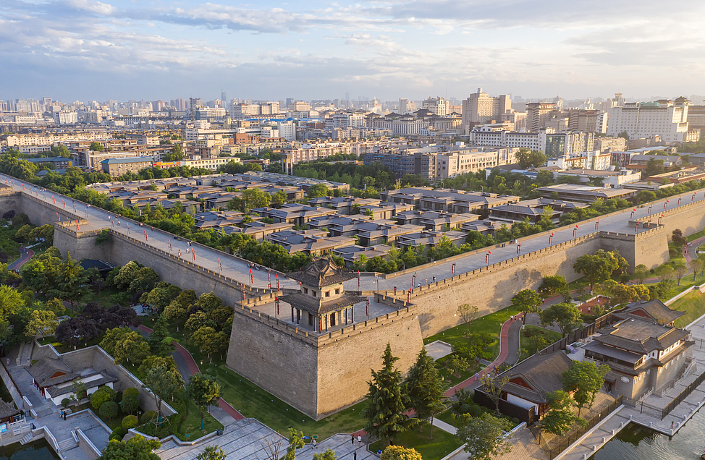

17:30 Muslim Bazaar and Hotel Drop-off
Our last stop today will be the Muslim Bazaar, the most thriving area in the center of the city, where there is a wide range of excellent choices of local foods and snacks for dinner. Besides, the Bell and Drum Towers nearby boast splendid night scenery with their ancient architecture illuminated by lights. Young people in Chinese traditional dress wandering there also become a landscape. It is indeed a good place to experience the city’s night life.
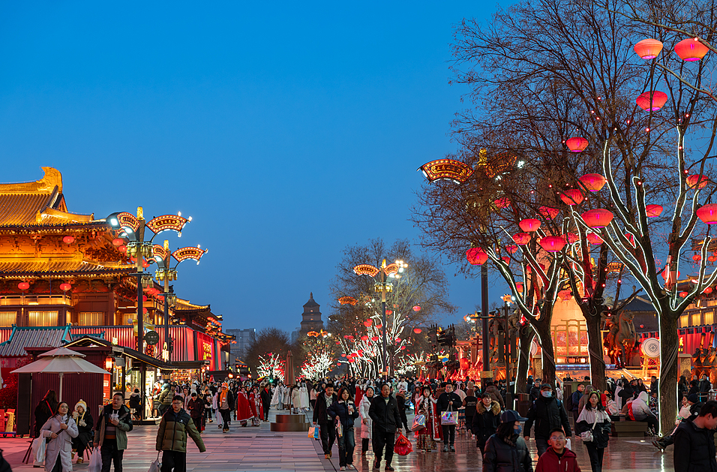
We will drive by here to drop off the clients who would like to explore the bazaar at their own pace and return to the hotel by themselves. The guide will provide advice on transportation. Then we will send the others back to the hotel. Thank you for travelling with us!

