Packages detail
Xi'an Mini Group Half Day Tour, No Shopping USD69（A minimum order of 2 people is required）

Overview
Half Day to Terracotta Army Museum with Hotel Pick-up
Trip Highlights
• Mini group of about 9 people, with lowest price and attentive service.
• Book tickets online in advance to avoid the long queue.
• Gain a deeper insight into Terracotta Army Museum.
• Equipped with headsets to keep away from the noisy surroundings.
• Unlimited bottles of drinking water for free.
• No optional tours, which are just a tourist trap that always leads to high mark-ups.

Included & Excluded
Price Includes
• Entrance fees to the sights visited (for bookings before Feb 15, 2025, tickets are not included and please pay to the guide.)
• Pick-up from your hotel
• Professional English speaking guide
• Experienced driver & air conditioned vehicle
• Unlimited bottles of mineral water per person
• Baby seat available for free
Price Excludes
• Hotel accomoodation
• Hotel drop-off after the tour
• Meals, advice freely available
• Gratuities to guide and driver

Itinerary
8:00 Pick up from Hotel
In the morning, your English speaking tour guide and the driver will pick you up from the lobby of your hotel to start this Terracotta Warriors tour. Your guide will inform you the exact pick-up time the day before. We are at your service all the time through telephone, WeChat, or email.
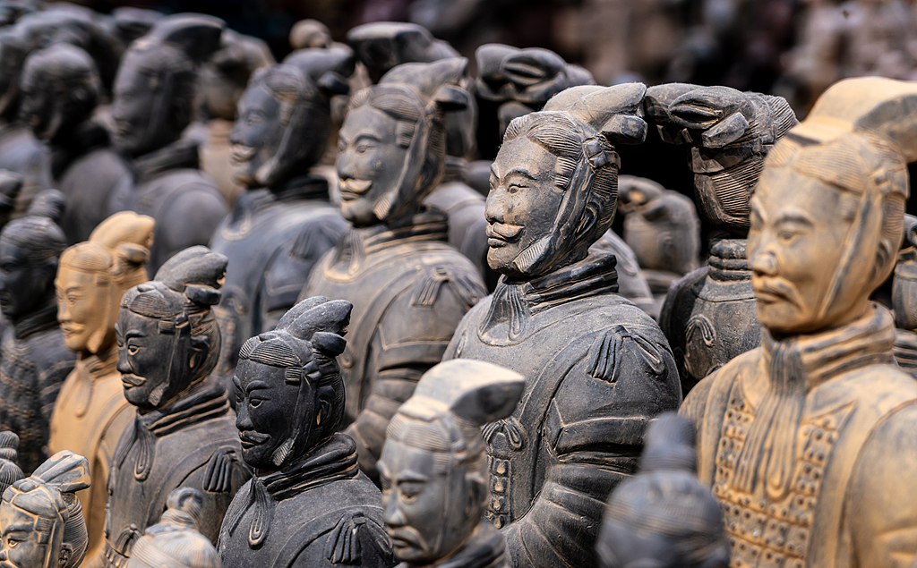
9:00 Drive to the Terracotta Army Museum
After gathering the group members, we will drive to the museum through highway directly, without any stopovers for tourist shops. It takes around one hour on the way, but you won't feel bored as your expert tour guide will give you a pre-knowledge of the cultural and historical background of the Terracotta Warriors.
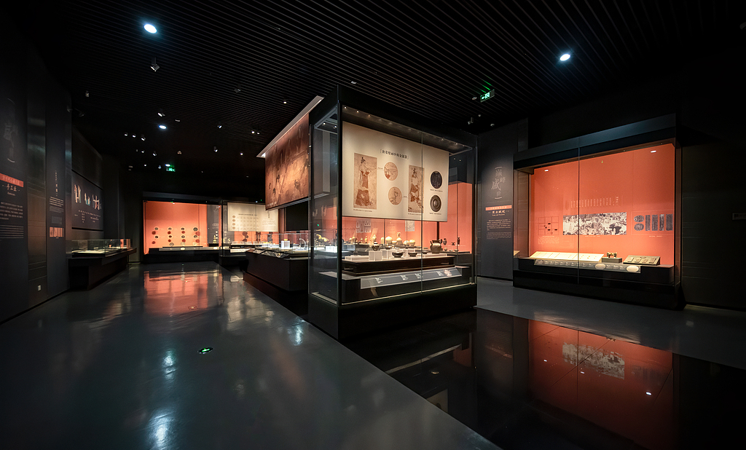
10:00 Visit the Terracotta Army Museum
Your guide has reserved the tickets for you online in advance. Upon arrival, you can enter the site directly without queuing. Accompanied by the guide, you will explore the Terracotta Army Museum by visiting the three excavated pits and the newly opened exhibition with many undisclosed collections. Although the clay warriors and horses have been buried for more than 2,200 years, they are still vivid with distinct appearances. We schedule no less than two and a half hours for you to delve into this miracle of ancient China.
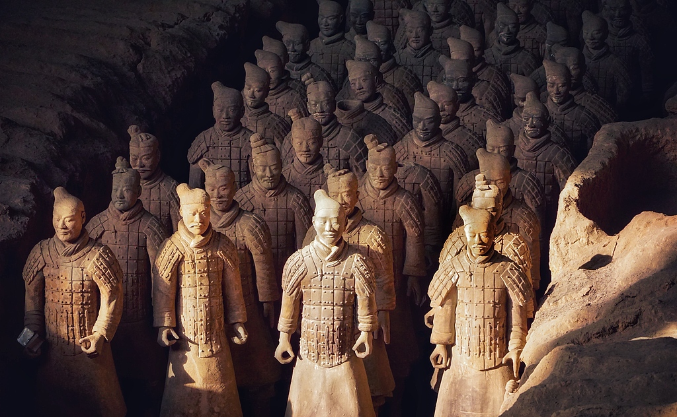
13:00 Free Time for Lunch
For lunch today, we leave it on your own to have more flexibilties. There are some fast food chains and local food eateries outside the museum offering adequate and hygienic food. You may choose one to have a simple lunch, which usually costs around US$7 per person. Your guide is always ready to offer suggestions and assistance.
13:40 Drive back to downtown Xi'an
In about one hour, we reach the Giant Wild Goose Pagoda area. Over here your half day Xi’an Terracotta Warriors tour comes to the end. With the Asia’s largest musical fountain in the North Square and the most prosperous Great Tang All Day Mall to the South Square, the Giant Wild Goose Pagoda area is a wonderful place to explore. You may stay here till night to see the amazing night view, or if you want to get back to the hotel directly, your guide will show you the subway station here. We appreciate your time traveling with us!
